National Emergency Response and Recovery Training Center

Hosted in conjunction with DHS/FEMA National Training Program, Texas A&M Engineering Extension Service (TEEX), Texas A&M University System and the National Emergency Response and Recovery Training Center (NERRTC)

You are invited to Attend

MGT-317 Disaster Management for Public Services
25th and 26th of January 2022
FTCC Law Enforcement Training Center Spring Lake NC

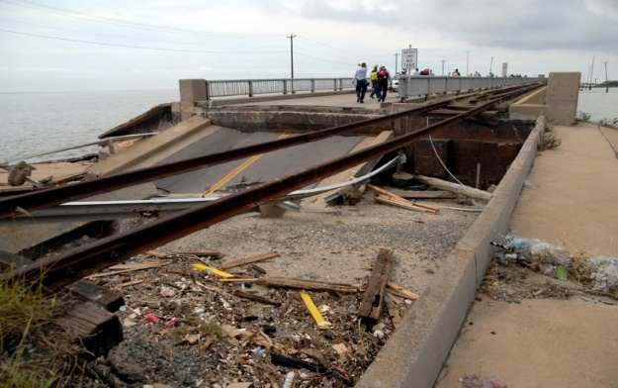
The Disaster Management for Public Services course brings together those emergency management personnel from within a jurisdiction who would be required to prevent, manage, or react to a natural, technological, or civil disaster within their community. The course introduces the natural, technological, and civil hazards to which public service systems may be vulnerable. It covers the process of emergency planning, mitigation, response, recovery and public information actions.

Topics Include:
- Threats to Public Services
- Mitigation
- Disaster Planning and Management
- Disaster Response
- Disaster Recovery
- Public Information
Participant Audience:
Disaster Management Law Enforcement Officers
Public Works First Responders
Building inspection Communications
Facilities management Parks and recreation
Street and road maintenance Traffic and transportation
Utilities (water, wastewater, electric, gas, and telephone)

Registration is free! Please contact:
Name: Your name Email: Your email address
Phone: Your number Fax #: Your fax number

FEMA Student ID Requirement

Prior to course delivery, all participants are required to establish a FEMA Student Identification Number (SID). This can be accomplished by registering at FEMA’s website. Participants must complete enrollment information through the TEEX student portal MGT317.

Recommended

Participants are also encouraged to have completed IS-100PWb, IS-200, IS-700 and IS-800. These courses can be found online at: http://training.fema.gov/IS/NIMS.aspx

