# Student Handout – Unit 2: Crescent City HazMat SCENARIO

**Purpose:**

The purpose of this activity is to provide you with an opportunity to apply what you have learned about fundamental ICS concepts to an incident involving a HazMat scenario.

**Instructions:**

Work in teams to complete the following activity:

1. Review the scenario and scenario map in your handouts.
2. Complete the following steps:

* Identify who would assume leadership of the ICS organization.
* Develop initial incident priorities and SMART objectives.
* Draw an organizational chart to support the objectives and manage resources. Your organization should maintain an effective span of control and include Command and General Staff, where appropriate.
* Describe the responsibilities delegated to the Command Staff and Sections that are activated.

1. Record your results on chart paper that can be seen by the entire class.
2. Select a spokesperson and be prepared to present in 30 minutes.

**Scenario-based activities are designed to help you apply what you are learning in this course. Although based on actual incidents, the scenarios have been altered to ensure that certain teaching points can be emphasized and work with the timeframe allocated. Therefore, the events and timing may differ from how you might experience the incident evolving in your jurisdiction or agency. It is important to focus on the learning activities rather than the details of the scenarios.**

# Scenario:

On August 4, at 0835, 10 cars of a southbound freight train derailed on the outskirts of Crescent City. Beginning with the car immediately behind the engine, the cargo includes:

* Cars 1-4: Newsprint
* Car 5: Molten sulfur
* Car 6: White phosphorus
* Car 7: Tallow
* Cars 8-10: Empty car carriers

The derailment occurred on a bridge over Wilson Creek near a residential area. Cars 5 through 7 are extensively damaged and on fire. The primary concern is the phosphorus car. Phosphorus self-ignites in the presence of oxygen, and is water reactive. Phosphorus fires can be controlled by excluding oxygen with water or foam, and/or reducing the temperature below the level required for self-ignition.

**Map:**

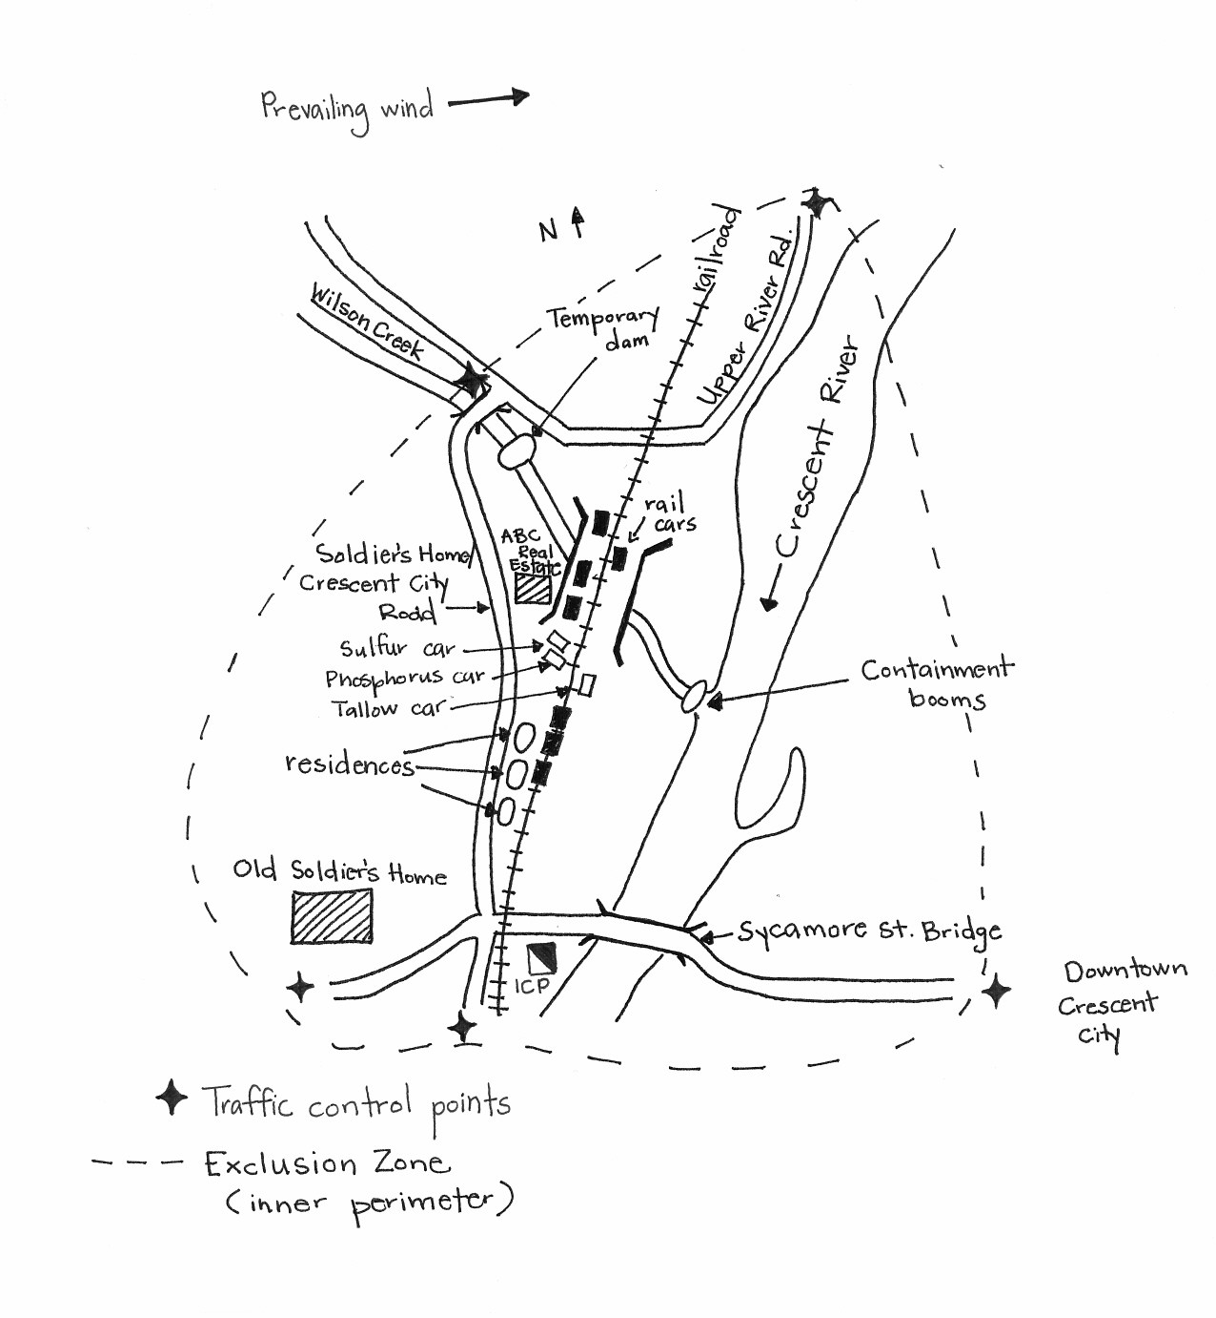

**Student Handout – Unit 3: CRESCENT CITY HAZMAT SCENARIO**

Purpose:

The purpose of this activity is to provide you with an opportunity to apply what you have learned about Unified Command.

**Instructions:**

Work in teams to complete the following activity:

1. Review the scenario update in your handouts.
2. Complete the following steps:

* List who would be included in the Unified Command structure.
* Describe the challenges facing the Unified Command.
* Describe the strategies the Unified Command structure will use to address these challenges and facilitate information flow and coordination.

1. Select a spokesperson and be prepared to present your work in 30 minutes.

**Scenario Update:**

The Incident Commander briefed the Emergency Manager on the potential need for major evacuation, and suggested they open the Emergency Operations Center (EOC) per the Emergency Operations Plan. The EOC has contacted a school bus service for buses and the American Red Cross to open shelter for evacuees. A Staging Area was established at Crescent City Junior High–Remar Street.

The EOC has briefed the mayor and police chief. The police chief is concerned about the location of the ICP. In conjunction with the Incident Commander, it was determined that a full Command and General Staff is required by the next operational period.

The Incident Commander has requested that a Police Duty Officer respond to the ICP to participate in the Unified Command.

# Student Handout – UNIT 4: Crescent City HazMat SCENARIO – Part 1

Purpose:

This activity will provide practical instruction on the methods and tools used to assess incident/event complexity. It focuses on the following issues:

* Types of agency policies and guidelines that influence management of incident or event activities.
* Processes for developing incident objectives, strategies, and tactics.
* Steps in transferring and assuming incident command.
* Incident objectives.

Instructions:

Work in teams to complete the following activity:

1. Review the scenario in your handouts.
2. Assign an Incident Commander to the Unified Command, Safety Officer, Public Information Officer, Operations Section Chief, Planning Section Chief, Logistics Section Chief, and Finance/Administration Section Chief. If there are enough people in your group you may also assign a Liaison Officer.
3. Develop incident objectives for the next operational period and revise the organization as needed. Document your objectives and organization on chart paper and the partially completed ICS Form 201. Make sure your objectives are SMART!
4. Complete the missing element within ICS Form 201.
5. By position, identify issues related to the incident.
6. Select a spokesperson and be prepared to present your work in 30 minutes.

**Scenario Update:**

The exclusion zone has been established and HazMat Teams have been reporting on contents of rail cars, hazards, evacuation zone, and strategic options.

Engine CC E-1, E-2, and E-3 have been assigned to primary search and evacuation of residences and businesses in the exclusion zone.

A railroad representative, Jim Neibuhr, is on site and participating as technical specialist.

The Old Soldier’s Home has 12 nonambulatory patients. Truck 1 was assigned to support the evacuation. Three engines and six BLS ambulances have been ordered for transport.

The County Emergency Manager has been asked to coordinate shelter location.

Incident Briefing (ICS 201)

| **1. Incident Name:** Crescent City HazMat | | **2. Incident Number:** | | **3. Date/Time Initiated:**  Date: 8-4-20XX Time: 0930 |
| --- | --- | --- | --- | --- |
| **4. Map/Sketch** (include sketch, showing the total area of operations, the incident site/area, impacted and threatened areas, overflight results, trajectories, impacted shorelines, or other graphics depicting situational status and resource assignment)**:**  **Hand-drawn map of incident site** | | | | |
| **5. Situation Summary and Health and Safety Briefing** (for briefings or transfer of command)**:** Recognize potential incident Health and Safety Hazards and develop necessary measures (remove hazard, provide personal protective equipment, warn people of the hazard) to protect responders from those hazards. | | | | |
|  | | | | |
| **6. Prepared by:** Name: IC Ralph Wilkins Position/Title: Signature: | | | | |
| **ICS 201, Page 1** | | Date/Time: | |

Incident Briefing (ICS 201)

| **1. Incident Name:** Crescent City HazMat | | **2. Incident Number:** | | **3. Date/Time Initiated:**  Date: 8-4-20XX Time: 0930 |
| --- | --- | --- | --- | --- |
| **7. Current and Planned Objectives:**  ***Based on the information provided, develop the initial incident objectives and summarize the current actions being taken.*** | | | | |
| **8. Current and Planned Actions, Strategies, and Tactics:** | | | | |
| Time: | Actions: | | | |
|  |  | | | |
|  |  | | | |
|  |  | | | |
|  |  | | | |
|  |  | | | |
|  |  | | | |
|  |  | | | |
|  |  | | | |
|  |  | | | |
|  |  | | | |
|  |  | | | |
|  |  | | | |
|  |  | | | |
|  |  | | | |
| **6. Prepared by:** Name: IC Ralph Wilkins Position/Title: Signature: | | | | |
| **ICS 201, Page 2** | | | Date/Time: | |

Incident Briefing (ICS 201)

| **1. Incident Name:** Crescent City HazMat | **2. Incident Number:** | | **3. Date/Time Initiated:**  Date: 8-4-20XX Time: 0930 | |
| --- | --- | --- | --- | --- |
| **9. Current Organization** (fill in additional organization as appropriate)**:**  **Safety Officer: Lt. Miller**  **Operations**  **Incident Commander(s)**  **Ralph Wilkins**  **Primary Search and Evacuation Group**  **Exclusion Group**  **HazMat  Evacuation Group**  **Old Soldier’s  Evacuation Group** | | | |
| **6. Prepared by:** Name: IC Ralph Wilkins Position/Title: Signature: | | | |
| **ICS 201, Page 3** | | Date/Time: | |

Incident Briefing (ICS 201)

| **1. Incident Name:** Crescent City HazMat | | **2. Incident Number:** | | | | | **3. Date/Time Initiated:**  Date: 8-4 Time: 0930 | |
| --- | --- | --- | --- | --- | --- | --- | --- | --- |
| **10. Resource Summary:** | | | | | | | |
| Resource | Resource Identifier | Date/Time Ordered | | ETA | Arrived | Notes (location/assignment/status) | |
| Police/marked vehicles (8) |  |  | | 0900 | X | Traffic control points (see map) | |
| HazMat Team | CC/LC  HazMat 1 |  | |  | X | ICP/Recon | |
| Passenger Buses (10-20) |  |  | | 1000 | ⬜ | To Staging/Evac Divs A & B | |
| Engines (3) | CC E-1, E-2, E-3 |  | | 0915 | X | Primary search/evacuation residences and business | |
| Trucks (1) | CC T-1 |  | | 0915 | X | Old Soldier’s Home | |
| Engines (3) | Wilsonville E-71, E-72, E-73 |  | | 0930 | ⬜ | Old Soldier’s Home | |
| BLS Ambulances (6) | Metroaid 1, 3, 45, 17, 20, 9 |  | | 0930 | ⬜ | Old Soldier’s Home | |
| ALS Ambulances | Metroaid ALS-10 |  | | 0930 | ⬜ | Old Soldier’s Home | |
|  |  |  | |  | ⬜ |  | |
|  |  |  | |  | ⬜ |  | |
|  |  |  | |  | ⬜ |  | |
|  |  |  | |  | ⬜ |  | |
|  |  |  | |  | ⬜ |  | |
|  |  |  | |  | ⬜ |  | |
|  |  |  | |  | ⬜ |  | |
| **6. Prepared by:** Name: IC Ralph Wilkins Position/Title: Signature: | | | | | | | | |
| **ICS 201, Page 4** | | | Date/Time: | | | | | |

**Assignments**

|  |  |
| --- | --- |
| **Assigned Position** | **Issues Identified** |
| **Incident Commander** |  |
| **Safety Officer** |  |
| **Public Information Officer** |  |
| **Liaison Officer (if assigned)** |  |
| **Operations Section Chief** |  |
| **Planning Section Chief** |  |
| **Logistics Section Chief** |  |
| **Finance/Administration Section Chief** |  |

Your Notes:

# Student Handout – UNIT 5: Crescent City HazMat SCENARIO – Part 1

**Purpose:**

The purpose of this activity is to select tactics for the next operational period and complete a Safety Analysis form.

Instructions:

Work in teams to complete the following activity:

1. Review the following in your handouts:

* Scenario Update
* Initial Incident Commander’s ICS Form 214 – Activity Log
* Technical Specialist Report
* Updated Incident Maps
* Emergency Resources Inventory
* Partially completed ICS Form 215

2. Complete the ICS Form 215 for Division D using the available information.

Note that the Operational Planning Worksheet (ICS Form 215) has the information needed to complete tactical direction for the controlled burn operation. Four Divisions have been established and additional law enforcement resources identified.

1. Based on the tactics selected in the ICS Form 215, complete the Safety Analysis (ICS Form 215A).
2. When you complete the worksheets, let the instructors know. The instructors will review the forms and provide feedback. After receiving feedback, proceed to the next part of the activity.

Scenario Update:

It is now 1200. Your Incident Management Team (IMT) has formally assumed command of the Crescent City incident. In the 2 hours since your identification of issues and setting of initial objectives, the Hazardous Materials Team’s technical report was submitted, the tactical recommendation was accepted, and (with your concurrence) two additional objectives have been implemented:

1. Keep runoff from entering Crescent River. Measures should be in place no later than 1200. (This has been completed: A containment system has been set up to limit pollution and capture runoff on Wilson Creek.)

2. Expand the evacuation zone to 2.5 miles downwind (east) of the incident, to be completed no later than 1500.

**Note:** These objectives have been developed and staffed, and have either been completed or are currently being implemented. Both will be complete before the next operational period begins. The rescue/evacuation of the businesses, residences, and Old Soldier’s Home have been completed.

Your team has decided to have a new operational period begin at 1800 August 4 and end at 0600 August 5.

In his final closeout with your team, Initial Incident Commander Ralph Wilkins points out that at 1800 all evacuations should be complete, and the tactical complexity of the incident will be reduced to maintaining the perimeter, containment of runoff, and monitoring the burnoff. To this point, exposure to the burnoff has not been a problem, but as the burnoff escalates, ABC Realty may be at risk. Because there is no immediate need for a medical response, the Incident Commander has put the EMS resources in Staging. Wilkins and your Incident Commander and Operations Section Chief have drafted some incident objectives for the next operational period, held a brief strategy meeting, and scratched out a possible organization structure.

The following updated incident objectives are provided by the Incident Commander:

1. Ensure safety of responders by all personnel operating within the exclusion zone and plume by wearing positive-pressure, Self-Contained Breathing Apparatus (SCBA) and full turn-outs for the duration of the incident.

2. Maintain evacuation perimeters. No unauthorized access without prior notification of and permission from the Incident Commander.

3. Move the Incident Command Post (ICP) at least 1 mile upwind of the incident no later than 1500.

4. Use barrier tape to mark the exclusion zone (inner perimeter) by 1900.

5. Maintain current hazmat containment until cleanup has been completed.

6. Provide exposure protection by 1900.

7. Maintain capability for medical response until cleanup has been completed.

Activity Log (ICS 214)

| **1. Incident Name:**  Crescent City HazMat | | | **2. Operational Period:** Date From: Date To:   Time From: Time To: | | |
| --- | --- | --- | --- | --- | --- |
| **3. Name:** | | **4. ICS Position:**  **IC** | | | **5. Home Agency** (and Unit)**:** |
| **6. Resources Assigned:** | | | | | |
| Name | | ICS Position | | | Home Agency (and Unit) |
| Ralph Wilkins | | IC | | | Crescent City Fire |
| Carl Miller | | Safety Officer | | | Crescent City Fire |
| Alice Johnson | | Staging Area Mgr. | | | Crescent City Fire |
| John Foglio | | HazMat BD | | | CC/LC HazMat 1 |
| Pete Carter | | LE BD | | | Crescent City Police |
| Jim Neibuhr | | Tech Spec. | | | Railroad |
|  | |  | | |  |
|  | |  | | |  |
| **7. Activity Log:** | | | | | |
| Date/Time | Notable Activities | | | | |
| 0935 | Evac. Group – evac of business and residences complete. Old Soldier’s Home estimate needs another 30 minutes. | | | | |
| 1000 | Technical report received. Add objectives:   1. Expand evacuation area to 2.5 miles down – wind (east). Complete by 1500. 2. Implement control measures to keep runoff from Crescent River. Complete by 1200. | | | | |
|  |  | | | | |
|  |  | | | | |
|  |  | | | | |
|  |  | | | | |
|  |  | | | | |
|  |  | | | | |
|  |  | | | | |
|  |  | | | | |
|  |  | | | | |
|  |  | | | | |
|  |  | | | | |
|  |  | | | | |
|  |  | | | | |
|  |  | | | | |
|  |  | | | | |
| **8. Prepared by:** Name: Position/Title: Signature: | | | | | |
| **ICS 214, Page 1** | | | | Date/Time: | |

Current Organizational Chart:

Organization chart with the incident commader at the top, assisted by the Safety officer, public information officer and liaison officer. The operations section chief, planning section chief, logistics section chief, and finance/admin section chief all report to the incident command. Under the operations section chief is the staging area manager, the sppression branch director (supported by the exlusion group - short term assignment, and the exposure group - 4 engines), the hazmat branch director (suppported by the assessment group - hazmat team, containment group - 2 engines, decon group - 2 engines, and tech specs - 1 hazmat and 1 railroad)  and the law enforcement branch director (supported by the perimeter division A - 5 officers, and the perimter division b - 10 officers. Under the planning section chief is the resources unit leader and the situation unit leader. Under the logistics section chief is the supply unit leader, the communications unit  leader, the facilities unit leader, and the medical unit leader. Technical Specialist Report: 8-4: 1000 hours

Hazard Analysis:

* Tanker 5 contains molten sulfur.
* Tanker 6 contains white phosphorus.
* Tanker 7 contains tallow.
* Other cars are empty or not involved.

When burned in dry air, phosphorus generates phosphoric anhydride (phosphoric acid) as a by-product of combustion. In addition to being corrosive to skin and tissue, exposure to phosphoric anhydride may cause severe gastrointestinal irritation, nausea, vomiting, and breathing difficulties.

Because the phosphorus car and the molten sulfur car are both breached, the resultant combined products of combustion are also of concern. These include phosphorus pentasulfide, which is readily converted in the presence of moisture to hydrogen sulfide gas and phosphoric acid. Hydrogen sulfide is a rapid systemic poison that induces respiratory paralysis with consequent asphyxia at high concentrations. Serious health effects such as central nervous system distress, pulmonary edema, and gastrointestinal disturbances may be observed at lower concentrations. Samples indicate that the two products have combined.

In addition to the hazards presented by the sulfur and phosphorus, the tallow also presents an environmental problem. Tallow coats the gills of fish. Tallow has entered Wilson Creek, and dead fish are already present.

**Weather:** No significant change in the next 24 to 36 hours.

**Technical Specialist Report (Continued)**

|  |  |
| --- | --- |
| **Strategic/Tactical Option** | **Analysis** |
| 1. Patch phosphorus tanker. | **Not recommended.** Tear is too extensive, success uncertain, and hazards to responders too great. |
| 2. Foam phosphorus tanker. | **Not recommended.** Adequate amounts of foam will take  48-72 hours to arrive. |
| 3. Bury tanker in wet sand or dirt. | **Not recommended.** Car cannot be moved safely without potential of catastrophic breach and release. Car is pre-1970 construction and predates additional safety regulations imposed at that time. |
| 4. Continue current strategy. | **Not recommended.** Water supply is not adequate to provide enough water to control fire, and does nothing to promote resolution of the incident. In addition, more water will continue to erode the bridge abutment, and increase the contamination in Wilson Creek. Fog stream causes caustic by-products to form, endangering responders and the environment. |
| 5. Conduct controlled burn-off until amount of phosphorus has been reduced to the point where car can be moved safely. | **Recommended.** Rate of burn will depend on surface area exposed to oxygen. At current rate of burn, estimated time to burn off remaining phosphorus is 36-48 hours. Projected weather conditions, negative health effects are possible up to 2 miles downwind. Population in impact area: 3,000.  **Special considerations:** City Hall, Police Department, and Fire Station 1/Administration buildings are within the 2-mile zone. Crescent City General Hospital is .25 miles outside the 2-mile zone. Custer Circle Assisted Living Center is within the 2-mile zone. All facilities have the ability to shelter in place. |

**Incident Map:**

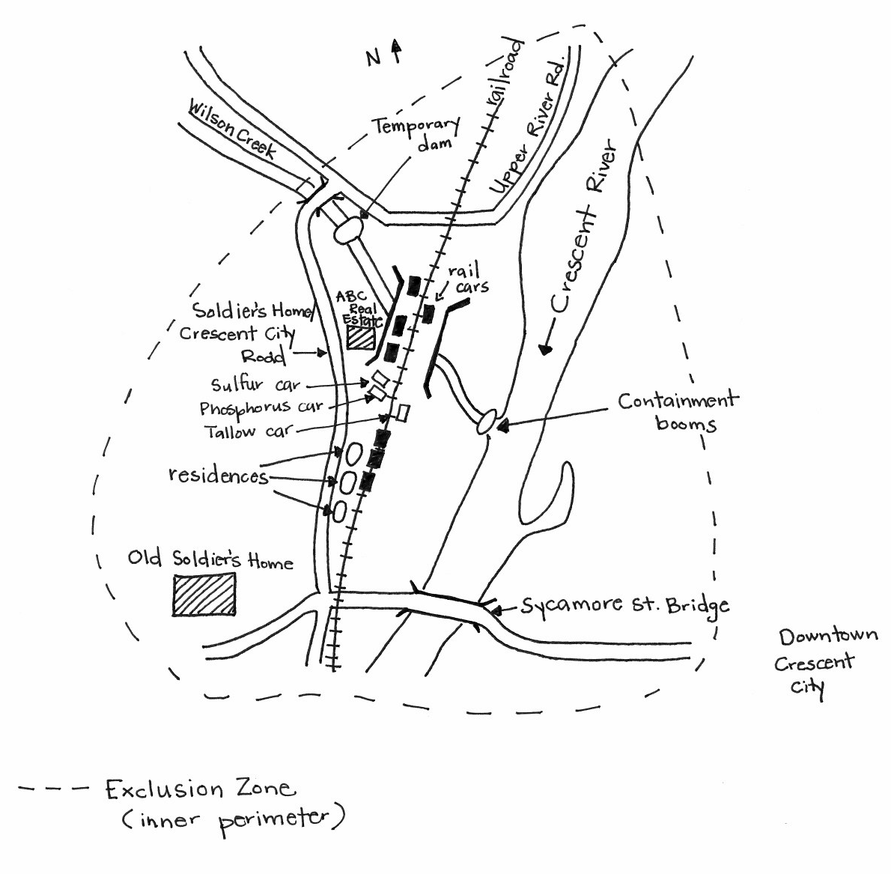

**Incident Map:**

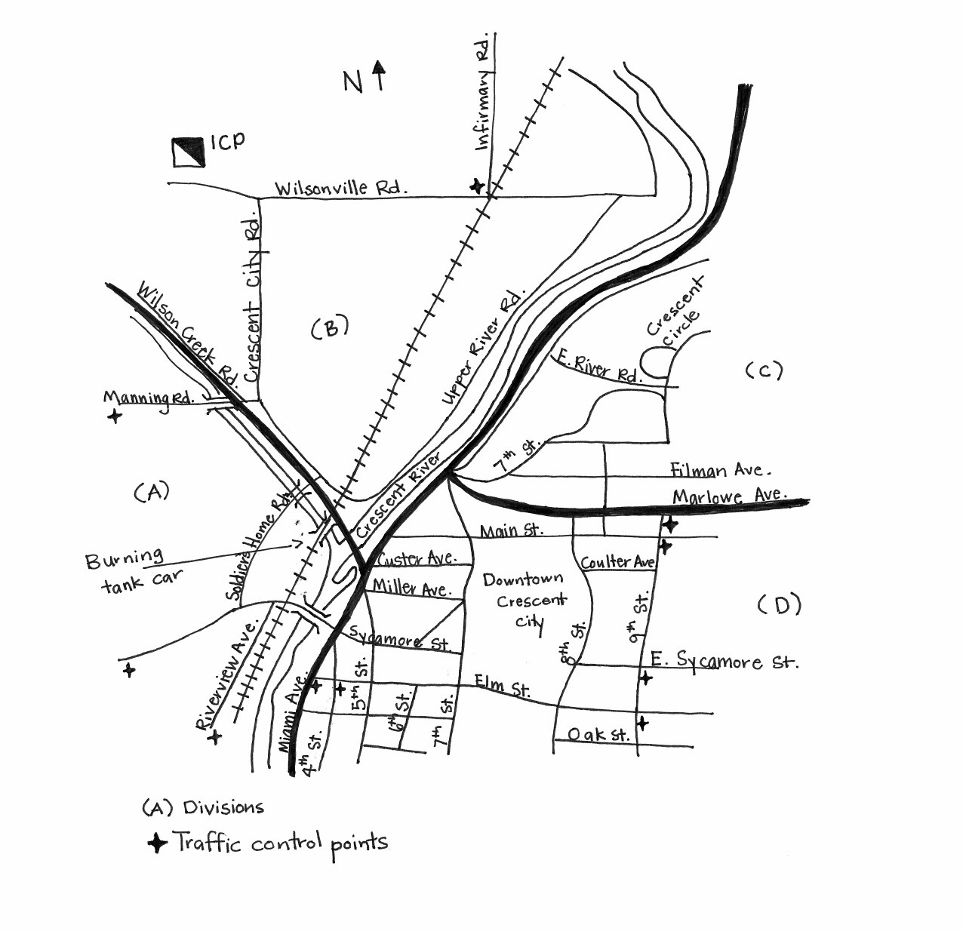

# Resources From Jurisdiction’s Emergency Resource Inventory:

|  |  |  |
| --- | --- | --- |
| **Resource** | **Kind** | **Number & Type** |
| Crescent City Police | Patrol Car | 4 marked units: M-1, M-2, M-3, and M-4  2 unmarked units: M-5 and M-6 |
| Wilsonville Police | Patrol Car | 4 marked units: P-1, P-2, P-3, and P-4 |
| Liberty County Sheriff | Patrol Car | 6 marked units: O-1, O-2, O-3, O-4, O-5, and O-6 |
| State Police | Patrol Car | 1 marked unit: SP-1  1 unmarked unit: SP-2 |
| Crescent City Fire/Rescue | Engine Company  Truck Company  Rescue Company  Heavy Rescue | 3 companies: CCE-1, CCE-2, and CCE-3  2 companies: CCT-1 and CCT-2  1 company: CCR-1  CCHR-1 |
| Other Local Fire  Wilsonville | Engine Company  Truck Company  Rescue Company | 5 companies: OF-1, OF-2, OF-3, OF-4, and OF-5  3 companies: OTR-1, OTR-2, and OTR-3  1 company: OHR-1 |
| Crescent City EMS | BLS  ALS  Medevac  Off-Duty Personnel (full-time and volunteer) | 3 units: CCBLS-1, CCBLS-2, and CCBLS-3  2 units: CCALS-1 and CCALS-2  Lifelight 324CC Helicopter  33 |
| Crescent City Public Works | Front-End Loaders  Dump Trucks | 3  4 |
| Other Local EMS | BLS  ALS | 5 units: OBLS-1, OBLS-2, OBLS-3, OBLS-4, and OBLS-5  2 units: OALS-1 and OALS-2 |
| Other Local Resources | Crescent City/Liberty County Regional Hazmat Team  School Buses  Electrical Utility Company  Gas Company | 1  12  2  4 |
| Available through mutual aid with adjacent counties and their communities | Engine Company  Truck Company  Patrol Car  County Dump Truck  Front-End Loader  Bulldozer  Crime Scene Investigation  County and State Engineer | 6  4  12  5  2  2  1 unit  3 |

Additional Available Resources:

National Guard:

80 personnel

5 five-ton trucks

1 engineer unit with 8 personnel

2 heavy front-end loaders

1 bulldozer

Air Operations:

2 helicopters and support assets capable of basic medical transport

3 State Police helicopters, MEDEVAC equipped

State Police:

15 marked units

Hazardous Materials Response Team

Incident Communications:

Crescent City and Liberty County have a shared 800-mHz radio system. Talk Groups include:

* Fire: Talk Groups 1, 2, 3
* Law Enforcement: Talk Groups 4, 5, 6
* EMS: Talk Groups 7, 8
* Regional Mutual Aid: Talk Groups 9, 10
* State Mutual Aid: Talk Group 11

The railroad company does not share a radio frequency or talk group with any of the above.

Crescent City General Hospital is 10 minutes flight time, 45 minutes driving time away from the incident. Operations have kept 1 ALS and 3 BLS ambulances in Staging.

**OPERATIONAL PLANNING WORKSHEET (ICS 215)**

|  |  |  |  |  |  |  |  |  |
| --- | --- | --- | --- | --- | --- | --- | --- | --- |
| **1. Incident Name:** Crescent City HazMat | | | | | | | | |
| **3. Branch** | **4. Division, Group, or Other** | **5. Work Assignment & Special Instructions** | **6. Resources** | Engines | Law Enforcement | Fuel Tender Trucks | Ambulances | HazMat Teams |  |  |  |  | **7. Overhead Position(s)** | **8. Special Equipment & Supplies** | **9. Reporting Location** | **10. Requested Arrival Time** |
|  | Contain-ment Group | Maintain temporary dam upstream. Maintain absorbent boom downstream. Skim and contain tallow. | Req. | 2 |  |  |  | 1 |  |  |  |  |  |  | ICP Auditorium | 0530 |
| Have | 2 |  |  |  | 1 |  |  |  |  |
| Need | 0 |  |  |  | 0 |  |  |  |  |
|  | Exposure Group | Provide exposure protection to B/C/D side of ABC Realty. E-1 draft out of temporary dam on Wilson Creek to supply E-2 (B/C sides) and E-3 (D side). Unmanned fog streams. Complete by 1900. | Req. |  |  | 1 |  |  |  |  |  |  |  |  | ICP Auditorium | 0530 |
| Have |  |  | 0 |  |  |  |  |  |  |
| Need |  |  | 1 |  |  |  |  |  |  |
|  | Exclusion Group | Barrier tape exclusion zone as depicted on map. Authorized access pt. at Wilson Creek. E-2/3 companies to complete then reassign to Exposure Group. Complete by 1900. | Req. | 2 |  |  |  |  |  |  |  |  |  |  | N/A |  |
| Have | 2 |  |  |  |  |  |  |  |  |
| Need | 0 |  |  |  |  |  |  |  |  |
|  | Division A | Control Pts: Riverview Ave., Sycamore St., Manning Rd., Wilsonville Rd., & Infirmary Road. No access without prior command approval. | Req. |  | 5 |  |  |  |  |  |  |  |  |  | ICP Auditorium | 0530 |
| Have |  | 5 |  |  |  |  |  |  |  |
| Need |  | 0 |  |  |  |  |  |  |  |
|  | Division B | Control Pts: Crescent City Rd., Wilsonville Rd., Upper River Rd. No access without prior command approval | Req |  | 3 |  |  |  |  |  |  |  |  |  | ICP Auditorium | 0530 |
| Have |  | 3 |  |  |  |  |  |  |  |
| Need |  | 0 |  |  |  |  |  |  |  |
|  | Division C | Control Pts: Marlowe Ave., Miami Ave., E. River Rd. No access without prior command approval. | Req |  | 3 |  |  |  |  |  |  |  |  |  |  |  |
| Have |  | 3 |  |  |  |  |  |  |  |
| Need |  | 0 |  |  |  |  |  |  |  |
|  | Division D |  | Req. |  |  |  |  |  |  |  |  |  |  |  |  |  |
| Have |  |  |  |  |  |  |  |  |  |
| Need |  |  |  |  |  |  |  |  |  |
| Have |  |  |  |  |  |  |  |  |  |
| Need |  |  |  |  |  |  |  |  |  |
| **ICS 215** | | **11. Total Resources Required** | |  |  |  |  |  |  |  |  |  |  | **14. Prepared by:**  Name:  Position/Title:  Signature:  Date/Time: | | |
| **12. Total Resources Have on Hand** | |  |  |  |  |  |  |  |  |  |  |
| **13. Total Resources Need To Order** | |  |  |  |  |  |  |  |  |  |  |

**Incident Action Plan Safety Analysis (ICS 215A)**

|  |  |  |  |  |  |
| --- | --- | --- | --- | --- | --- |
| **1. Incident Name:** | | | | **2. Incident Number:** | |
| **3. Date/Time Prepared:**  Date: Time: | | **4. Operational Period:** Date From: Date To:  Time From: Time To: | | | |
| **5. Incident Area** | **6. Hazards/Risks** | | | | **7. Mitigations** |
|  |  | | | |  |
|  |  | | | |  |
|  |  | | | |  |
|  |  | | | |  |
|  |  | | | |  |
|  |  | | | |  |
|  |  | | | |  |
|  |  | | | |  |
|  |  | | | |  |
|  |  | | | |  |
|  |  | | | |  |
|  |  | | | |  |
| **8. Prepared by** (Safety Officer)**:** Name: Signature: | | | | | |
| **Prepared by** (Operations Section Chief)**:** Name: Signature: | | | | | |
| **ICS 215A** | | | Date/Time: | | |

# Student Handout – UNIT 5: Crescent City HazMat SCENARIO – Part 2

Purpose:

The purpose of this activity is to complete the planning cycle by developing a written Incident Action Plan (IAP) and conducting an operations briefing for a simulated incident.

Instructions:

Work in teams to complete the following activity:

1. Prepare an Incident Action Plan, using (at a minimum) ICS Forms 202, 203, 204(s), 205, and 206.
2. Outline the agenda for the operations briefing.
3. Select a spokesperson to present your IAP as a concise 5- to 10-minute operations briefing. Be prepared to present in 60 minutes.

Your Notes:

# Student Handout – UNIT 6: Crescent City HazMat SCENARIO

Purpose:

The purpose of this activity is to gain an understanding of how resources are ordered and to understand the challenges and strategies for managing resources during an incident.

Instructions:

Work in teams to complete the following activity:

1. Review the Operational Planning Worksheet (ICS Form 215) and Safety Analysis (ICS   
   Form 215A) completed in the previous unit.
2. Describe how resources will be ordered (single point or multipoint) for this incident, from what sources resources will be acquired, and how long they will need to be deployed.

3. Identify the top challenges and strategies for managing resources during this incident.

4. Describe the method for evaluating resource effectiveness.

5. Select a spokesperson and be prepared to present your work in 30 minutes.

Your Notes:

# STUDENT HANDOUT – UNIT 7: CRESCENT CITY HAZMAT SCENARIO

**Purpose:**

The purpose of this activity is to develop a Demobilization Plan for a simulated incident.

**Instructions:**

Work in teams to complete the following activity:

1. Review the information you developed in the previous activities and the scenario update.

2. Write a Demobilization Plan using the five elements described in Unit 7.

3. Develop a detailed transfer of command briefing to be delivered to the Incident Commander who will supervise the cleanup. The incoming Incident Commander is an employee of the contract cleanup company, so your briefing should include any issues associated with a cleanup company contract.

4. Be prepared to present the main points of the Demobilization Plan using a transfer of command briefing format/outline.

5. Select a spokesperson and be prepared to present your work in 30 minutes.

# Scenario Update:

* It is now 1200 August 8, nearly 48 hours since the controlled burn-off began.
* Enough phosphorus has burned off that it is now safe to move the tank cars involved in the derailment.
* The outer perimeter has been released.
* Evacuees have been allowed to return and businesses to reopen.
* The National Transportation Safety Board (NTSB) has completed its on-scene investigations.
* Incident Command determines that the incident priorities will now be restructured to focus on debris removal and cleanup rather than response.

New Incident Objectives:

* Provide for responder safety as per department SOP for the duration of the incident.
* Evaluate, and report back, the structural integrity of the rail bed to allow for safe removal of rail cars by 1600 August 8.
* Maintain inner perimeter until exclusion zone is declared safe by HazMat team. Limit access to authorized personnel wearing appropriate Personal Protective Equipment (PPE). (See Safety Message for specific PPE instructions.)
* Conduct soil and water sampling by 1600 on August 8 to determine extent of cleanup required. Water and soil should be sampled to depth and lateral distance indicated by plume model.

Current Organization Chart:

**Incident   
Command**

**Public Information Officer**

**Safety Officer**

**Inner Perimeter Group Supervisor**

**Sampling HazMat 1**

**(Single Resource)**

**Decon   
HazMat 1**

**(Single Resource)**

**CC Engine 2**

**Liaison Officer**

**Operations Section Chief**

**Planning Section Chief**

**Logistics Section Chief**

**Finance/  
Administration Section Chief**

**CC Engine 1**

Your Notes: