
Public Information Basic
E/L/K0105
Student Manual

December 2024

Version 1.0


Table of Contents
Table of Contents i
Module 1: Course Administration 1
Administration 2
Duration 2
Terminal Learning Objective (TLO) 2
Enabling Learning Objectives (ELOs) 2
Administrative Information 3
NEMBA Resident Courses 4
Training Course Pyramid 5
Activity 1.1: Introduction “Interviews” 6
Course Agenda 7
Our Expectations 1
Course Purpose 2
Course Objectives (1 of 3) 3
Course Objectives (2 of 3) 4
Course Objectives (3 of 3) 5
Course Resources 6
Assessment and Evaluation Process 7
Pre-Course Assessment 8
Module Summary 9
Module 2: Introduction to Public Information 10
Administration 11
Duration 11
Terminal Learning Objective (TLO) 11
Enabling Learning Objectives (ELOs) 11
Activity 2.1: Why Is It Important? 12
A Fundamental Principle 13
Lessons Learned 14
Importance of Information 17
What is Public Information? 18
Functions of Public Information 20
Functions of Warnings 22
Discussion Question 23
Flow of Emergency Communications 24
Module Summary 26
Reference List 27
Module 3: Strategic Communications Planning 28
Administration 29
Duration 29
Terminal Learning Objective (TLO) 29
Enabling Learning Objectives (ELOs) 29
Strategic Communications Plan 30
8-Step Communications Model 31
Step 1: Assess Current Situation 32
Step 2: Set Communication Goals 34
Examples of SMART Objectives 36
SMART Objective Template 38
Step 3: Identify Intended Audiences 39
The Basics 41
Step 4: Develop and Pretest Messages 42
Message Mapping 45
Step 5: Select Channels and Activities 47
Step 6: Develop an Action Plan 48
Step 7: Develop and Pretest Materials 49
Step 8: Implement, Evaluate, and Modify Plan 51
Purpose of Public Awareness Campaigns 53
Public Awareness Campaigns and the 8-Step Strategic Communications Model 54
Activity 3.1: Public Awareness Campaign 55
Incident Planning and the 8-Step Model 57
Activity 3.2: Incident Communication Strategy 58
Module Summary 60
Reference List 61
Module 4: PIO Roles and Responsibilities 62
Administration 63
Duration 63
Terminal Learning Objective (TLO) 63
Enabling Learning Objectives (ELOs) 63
Public Information Officer - A Command Staff Position 64
PIO Adds Value 65
PIO Has Changed 66
Day-to-Day vs. Incident Tasks 67
Manage Information (1 of 2) 68
Manage Information (2 of 2) 70
Getting Information to the Public 71
Whole Community Needs 72
Conduct Interviews 73
Work with the Media 75
Coach Speakers 78
Activity 4.1: Difficult Situations 80
Personal Readiness 83
Discussion: Alert and Warning Systems 85
Module Summary 86
Reference List 87
Module 5: PIO Content Skills Workshop 88
Administration 89
Duration 89
Terminal Learning Objective (TLO) 89
Enabling Learning Objectives (ELOs) 89
Types of Written Products 90
External Products 91
Internal Products 93
News Releases 94
Talking Points 95
Activity 5.1: Writing an External Product 96
Approval Process 100
Dissemination Process 101
Tracking Process 102
U.S. Facts: Adults Over 16 103
Social Media for Public Safety 104
Creating Content for the Web 106
How People Read Online 107
Techniques for Web Writing 109
Multimedia Options 111
Activity 5.2: Make it Social 112
Social Media Training Resources 113
Emergency Messages 114
Emergency Messages Guidance 116
Message Anatomy – Wireless Emergency Alerts (WEA) 117
Example WEA Message 120
Basic Concepts Do Not Change 121
Bottom Line: Communicate! 122
Module Summary 123
Reference List 124
Module 6: Interview Skills 125
Administration 126
Duration 126
Terminal Learning Objective (TLO) 126
Enabling Learning Objectives (ELOs) 126
Determining the Objective 127
Understanding the Audience 128
Developing the Message 129
Preparing for the Interview 130
Size Up the Situation 132
Outward Perceptions of the PIO 133
Nonverbal Communication Tips 134
Managing the Interview 136
Transitional Phrases or “Bridging” 137
Paraphrasing 138
Alternatives to “No Comment” 139
Reversing a Negative Question 140
Hostile Reporter Interviews 141
Mental Checklist 142
Interview Types and Locations 143
Interview Environment 144
On-Scene “Breaking News” Interviews 145
Your Location 146
In-Studio Interviews 147
Remote Interviews 148
Pre-Interview Checklist 149
Post-Interview 150
What Can You Do Now? 151
Activity 6.1: On-Camera Interviews 152
Module Summary 155
Reference List 156
Module 7: Crisis/Emergency Communications 157
Administration 158
Duration 158
Terminal Learning Objective (TLO) 158
Enabling Learning Objectives (ELOs) 158
8-Step Communications Model 159
Activity 7.1: Crisis Communications Intro Part 1 160
PIO Activities: 95% is Preparation 163
PIO Activities: 5% is Crisis 164
Risk vs Crisis 165
Crisis Can Originate from... 166
Example: Single Organization Crisis 167
Multiple Organization Crisis 168
PIO Primary Goal 169
Objectives During a Crisis 170
Disclosure with Minimal Delay 171
Communication Tools 172
7 C’s of Communication 173
Holding Statements by Onset of Event 176
Use Your 27-9-3 Message Map 177
Media Interview Preparation 178
The Three “C’s” of Crisis Media Relations 179
Common Barriers to Releasing Information 180
Factors Affecting Public Response 181
Activity 7.2: Crisis Communications Part 2 183
Types of Warning Systems 186
Warning Systems 187
Integrated Public Alert and Warning System (IPAWS) 188
IPAWS Video 189
IPAWS Emergency and Warning 191
Warning Message Components 192
Warning Message Example 194
Improving Compliance 195
Creating Accessible Messages 196
Public Response Myths: Fake or Fact 197
Emergency Operations Plan 199
Activity 7.3: Warning Message 200
Crisis Communications Preparedness 203
Reaching the Whole Community 204
Module Summary 205
Reference List 206
Module 8: Media Relations at the Scene 207
Administration 208
Duration 208
Terminal Learning Objective (TLO) 208
Enabling Learning Objectives (ELOs) 208
Why Coordination at the Scene Matters 209
To Make It More Interesting . . . 211
Initial Actions That Can Make It Work 212
Know the Law Ahead of Time! 214
The PIO-Media Partnership 215
Media Needs at the Scene 216
PIO Needs at the Scene 218
Media Staging Areas 219
Media Staging Areas (additional information) 221
Media Pools 223
News Conference Responsibilities 224
Location, Location, Location 225
News Conference Cycle 227
News Conference Cycle (additional information) 229
Module Summary 230
Reference List 231
Module 9: Leading a Joint Information Center 232
Administration 233
Duration 233
Terminal Learning Objective (TLO) 233
Enabling Learning Objectives (ELOs) 233
Activity 9.1: (Table Group) 234
Activity 9.1: (Report-Outs) 235
What is a JIS? What is a JIC? 236
Benefits of a JIS 237
Benefits of a JIC 238
Barriers to Getting Information Out 239
Challenge of Multiple Audiences 240
How a JIS Meets These Challenges 241
Triggers for JIC Activation 242
What Does a JIC Look Like? 243
Types of JICs 244
JIC Location 246
How to Make this Happen in a JIC 247
JIC Functions 249
A “Lead” PIO 250
Logistics 251
Liaisons 252
Other JIC Positions 254
Multiple Roles 255
Dealing With Stress 256
Module Summary 257
Reference List 258
Module 10: Wrap-Up Exercise 259
Administration 260
Duration 260
Terminal Learning Objective (TLO) 260
Activity 10.1: News Conference Activity 261
Exercise Brief-Out 267
Module Summary 268
Reference List 269
Module 11: Course Summary 270
Administration 271
Duration 271
Terminal Learning Objective (TLO) 271
Enabling Learning Objectives (ELOs) 271
Did We Meet Our Course Goal to…? 272
Continuing Your Development 273
Assessment 275
Feedback 276
Module Summary 277
Reference List 278

Module
1
Course Administration

Administration
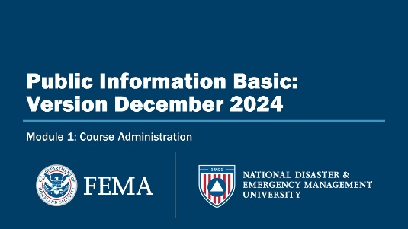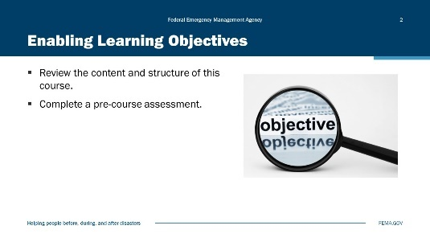
Visual 1, Course Administration Visual 2, Enabling Learning Objectives

Duration
45 minutes

Terminal Learning Objective (TLO)
By the end of this module, you will be able to understand the course administrative areas.

Enabling Learning Objectives (ELOs)
By the end of this module, you will be able to:
- Review the content and structure of this course.
- Complete a pre-course assessment.

Administrative Information
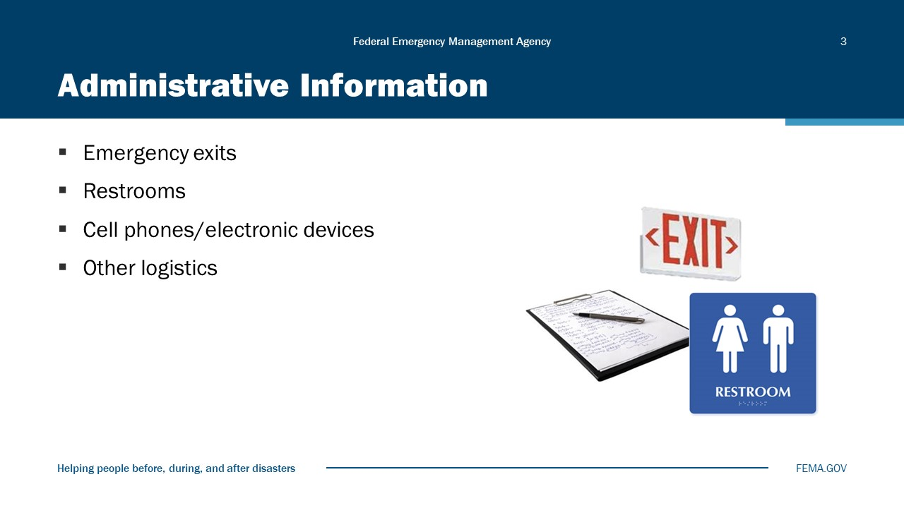
Visual 3, Administrative Information

- Please observe safety practices and use emergency exits if needed.
- Professional classroom behavior is required.
- Be prompt.
- Silence all cell phones/electronic devices.
- Refrain from e-mail (multi-tasking) during class.

NEMBA Resident Courses
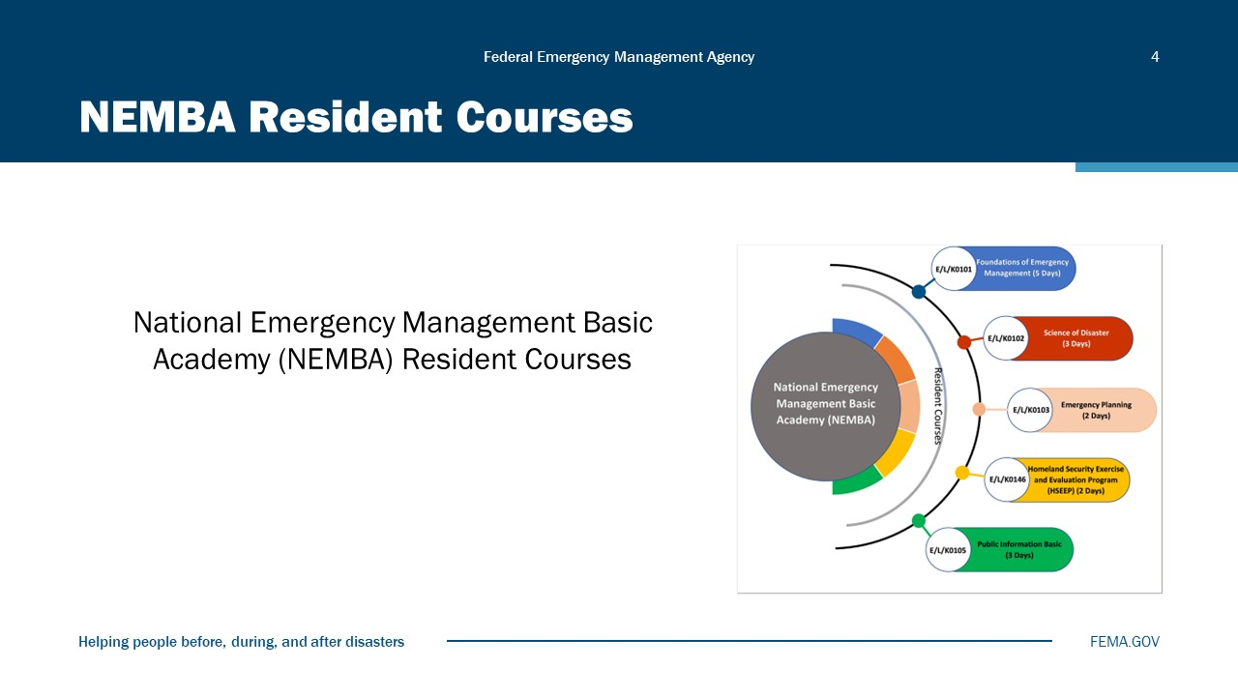
Visual 4, NEMBA Resident Courses

Training Course Pyramid
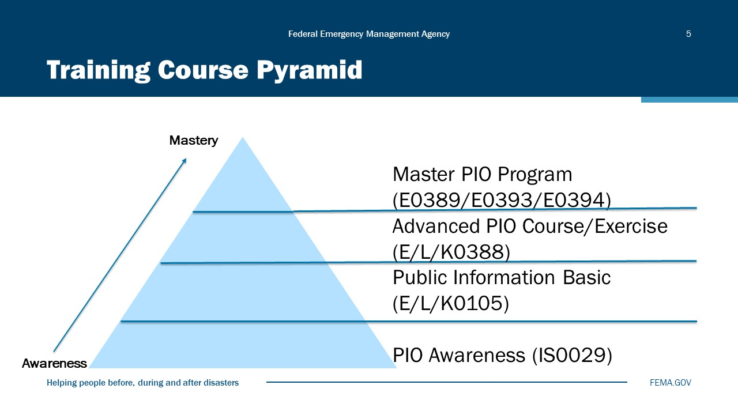
Visual 5, Training Course Pyramid

This course is the first of four courses in the Public Information Training Series. It is part of a tiered training approach in that it provides the foundation for more advanced training that takes participants from the awareness level to the mastery level in their public information careers.
This course is a prerequisite for the Advanced PIO course, which is followed by the Master PIO course.
This course is grounded in the National Incident Management System (NIMS), the Incident Command System (ICS), and the National Response Framework (NRF).
This course is one of five courses that comprise the NEMBA.

Activity 1.1: Introduction “Interviews”
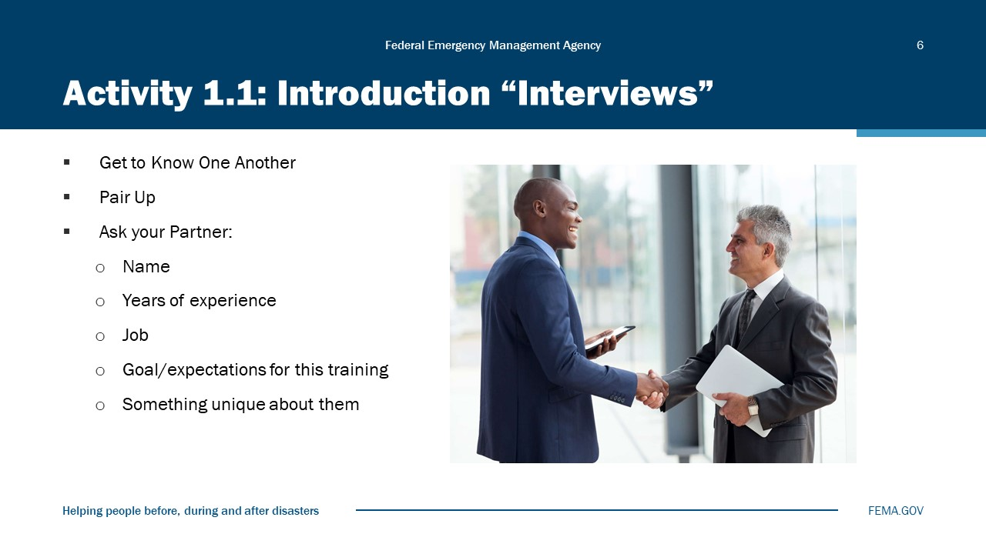
Visual 6, Activity 1.1: Introduction “Interviews”

Refer to the instructions on the visual; pair up with another participant and “interview” one another. Then you will introduce your partner to the class. Keep your introductions of one another to 1 to 2 minutes.

Course Agenda
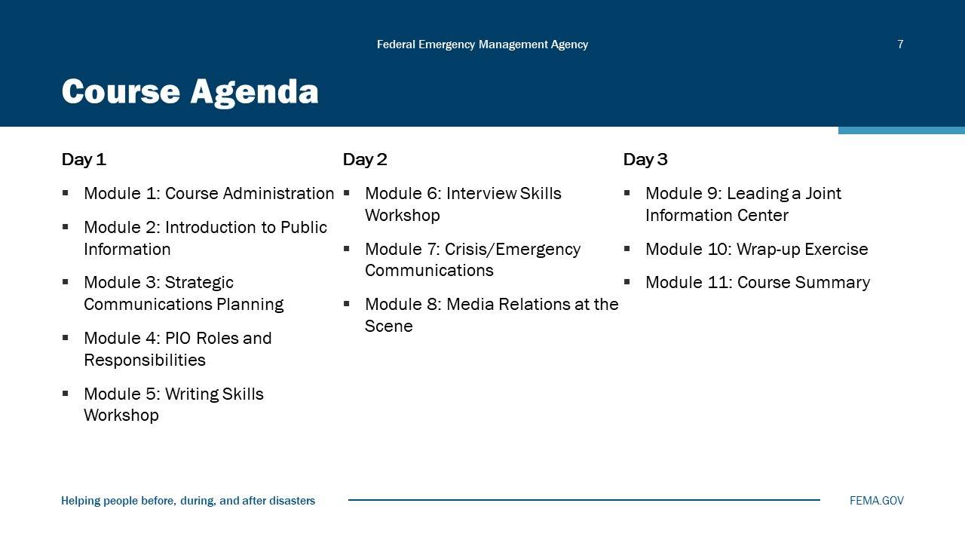
Visual 7, Course Agenda

Day 1
Module 1: Course Administration
Module 2: Introduction to Public Information
Module 3: Strategic Communications Planning
Module 4: PIO Roles and Responsibilities
Module 5: Writing Skills Workshop
Day 2
Module 6: Interview Skills Workshop
Module 7: Crisis/Emergency Communications
Module 8: Media Relations at the Scene
Day 3
Module 9: Leading a Joint Information Center
Module 10: Wrap-up Exercise
Module 11: Course Summary

Our Expectations
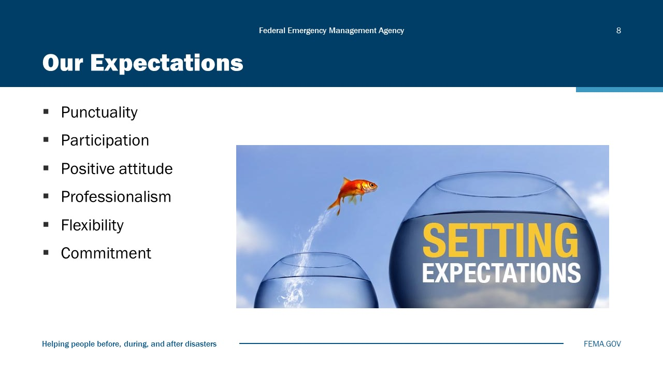
Visual 8, Our Expectations

Review the ground rules for class participation.

Course Purpose
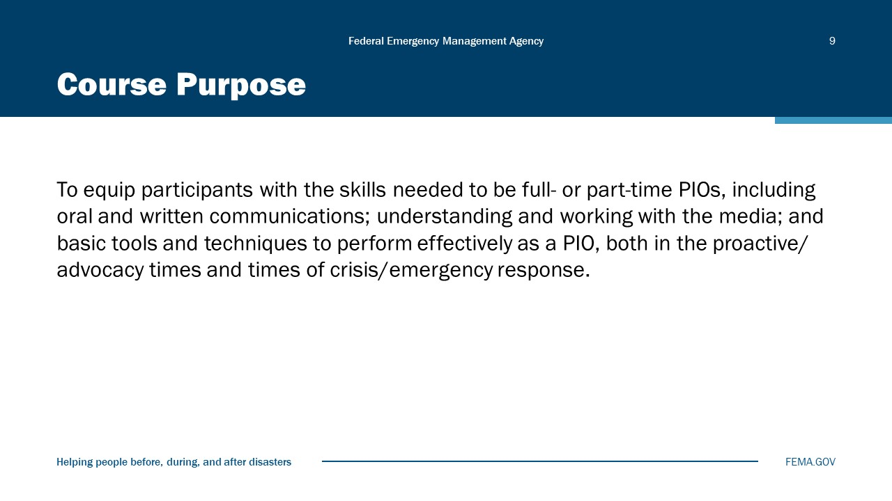
Visual 9, Course Purpose

Review the course purpose:
- PIOs in public safety and emergency management organizations are responsible for ensuring that the affected public receives accurate and timely information during an emergency. Armed with useful information, people can make good decisions that contribute to the overall response goal of saving lives and protecting property.
- After this training, you may decide you need further development on one or more of the topics addressed. Your instructors and fellow class members may have recommendations for courses or reference materials that can help you. Please use this opportunity to think about your continued development in the field of public information and ask for help and advice as needed.

Course Objectives (1 of 3)
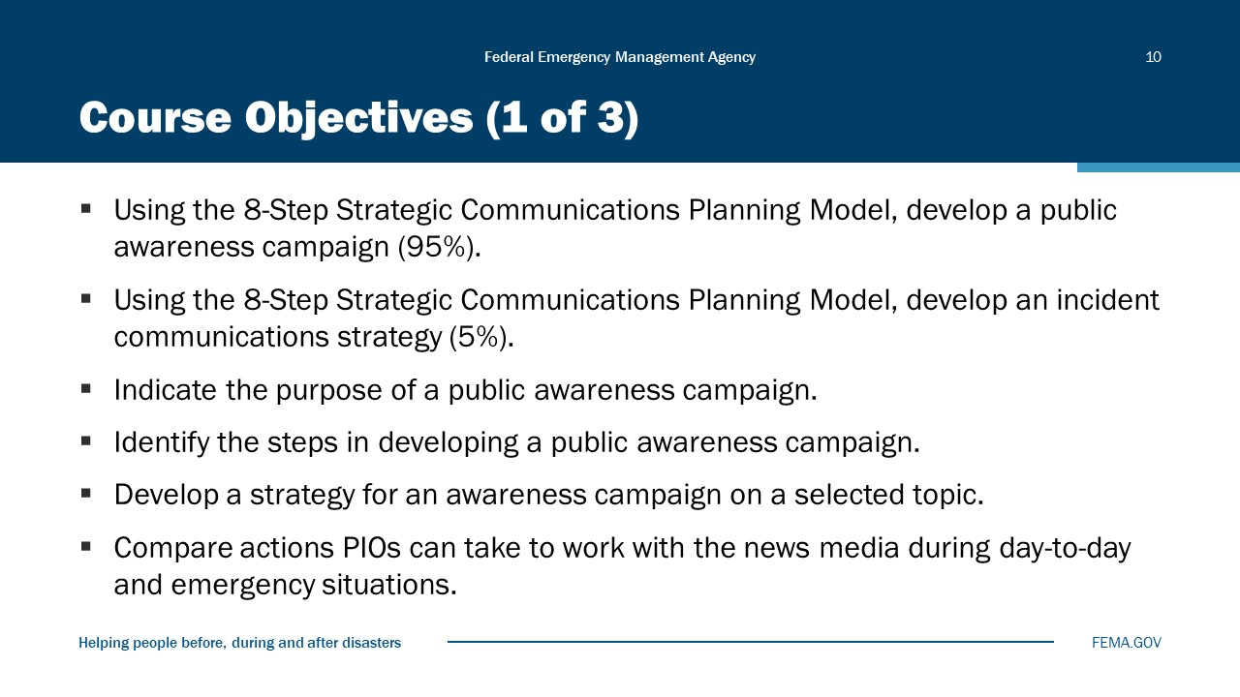
Visual 10, Course Objectives (1 of 3)

- Using the 8-Step Strategic Communications Planning Model, develop a public awareness campaign (95%).
- Using the 8-Step Strategic Communications Planning Model, develop an incident communications strategy (5%).
- Indicate the purpose of a public awareness campaign.
- Identify the steps in developing a public awareness campaign.
- Develop a strategy for an awareness campaign on a selected topic.
- Compare actions PIOs can take to work with the news media during day-to-day and emergency situations.

Course Objectives (2 of 3)
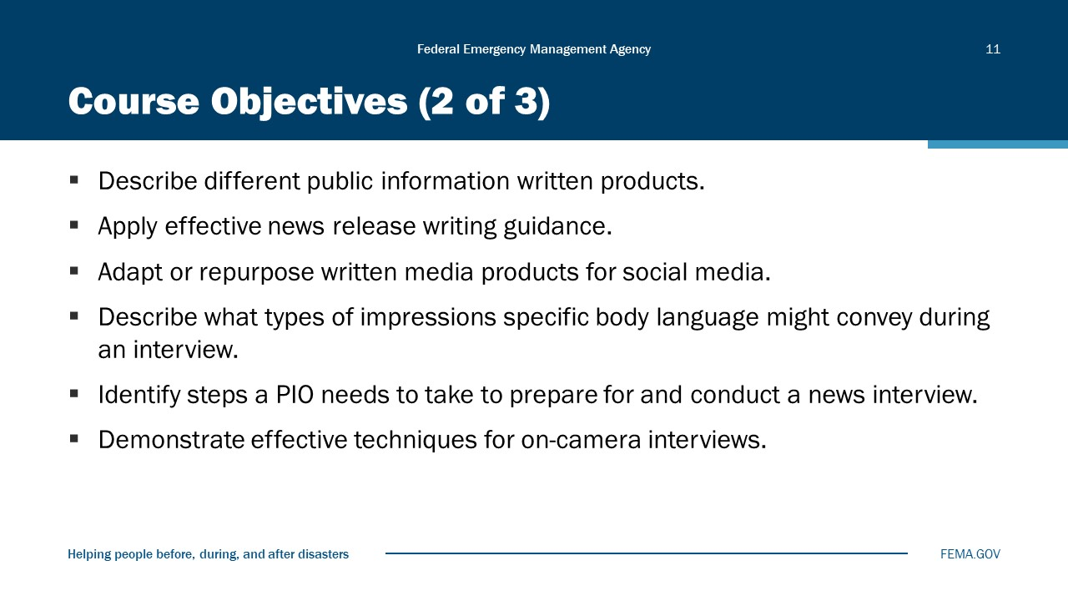
Visual 11, Course Objectives (2 of 3)

- Describe different public information written products.
- Apply effective news release writing guidance.
- Adapt or repurpose written media products for social media.
- Describe what types of impressions specific body language might convey during an interview.
- Identify steps a PIO needs to take to prepare for and conduct a news interview.
- Demonstrate effective techniques for on-camera interviews.

Course Objectives (3 of 3)
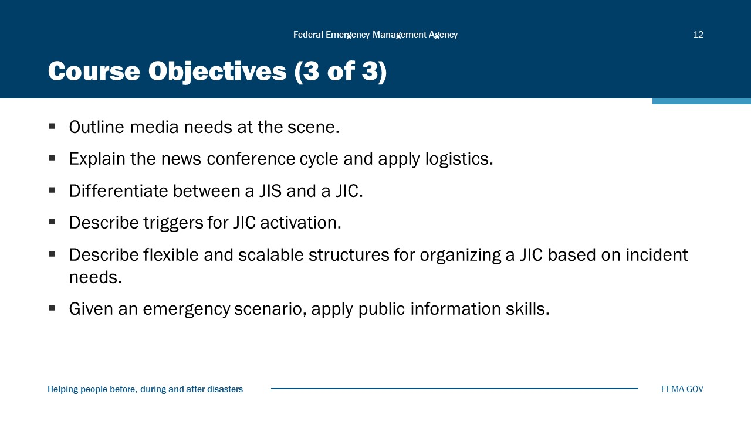
Visual 12, Course Objectives (3 of 3)

- Outline media needs at the scene.
- Explain the news conference cycle and apply logistics.
- Differentiate between a JIS and a JIC.
- Describe triggers for JIC activation.
- Describe flexible and scalable structures for organizing a JIC based on incident needs.
- Given an emergency scenario, apply public information skills.

Course Resources
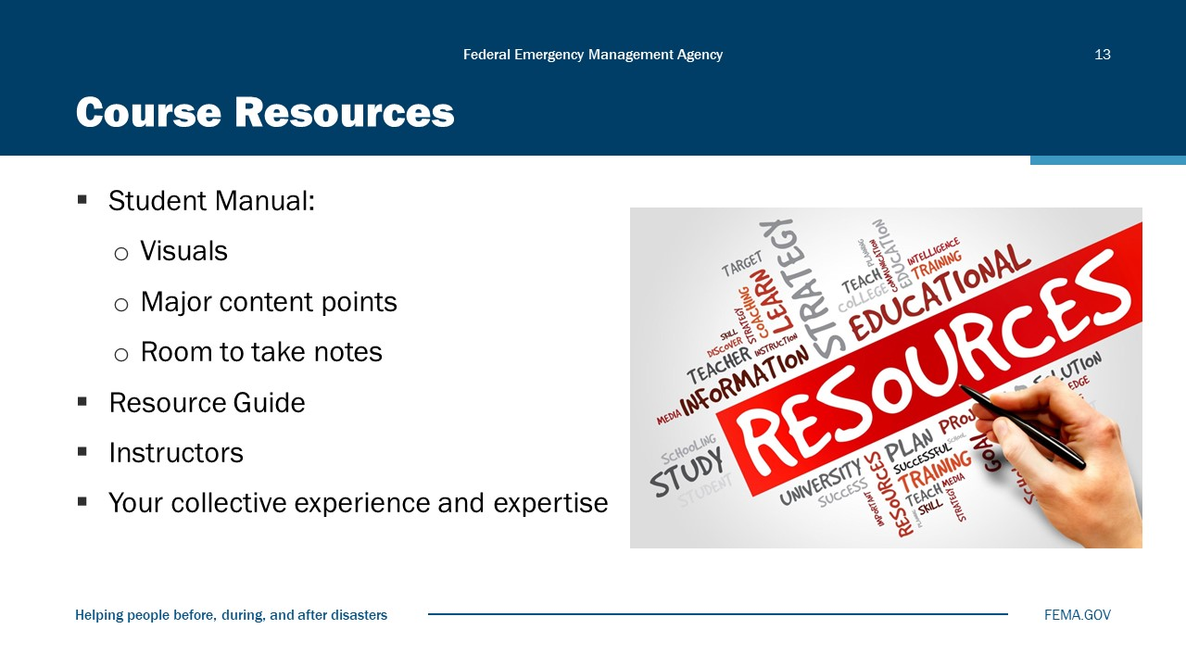
Visual 13, Course Resources

The Student Manual includes the visuals you will see in class and major content points, as well as room to take notes.
The Public Information Training Series Resource Guide includes activities, tips, templates, and general information useful before, during, and after an emergency or disaster. It may provide some ideas of programs and processes to implement in your organization.
The instructors are available to answer questions during class and at breaks.
The collective experience and expertise of the group is an important resource for this training. Please participate fully and share your ideas.

Assessment and Evaluation Process
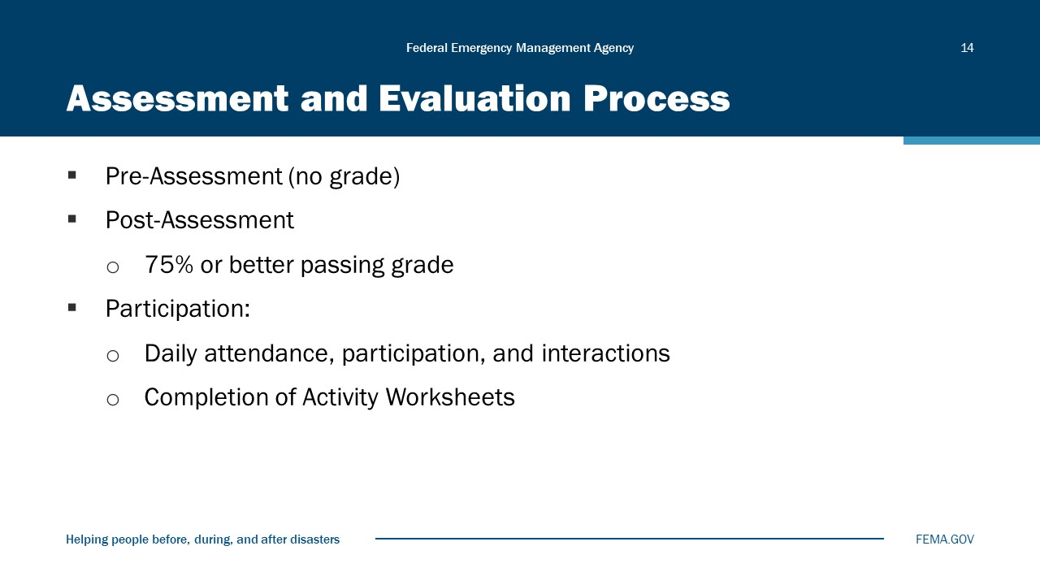
Visual 14, Assessment and Evaluation Process

Pre-Course Assessment
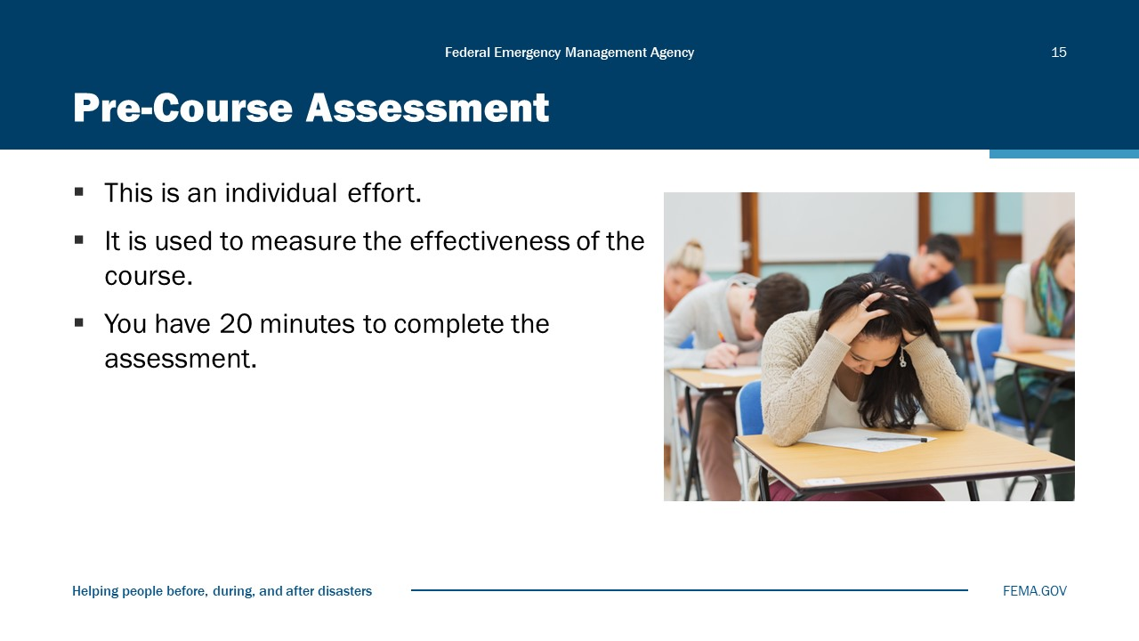
Visual 15, Pre-Course Assessment

Module Summary
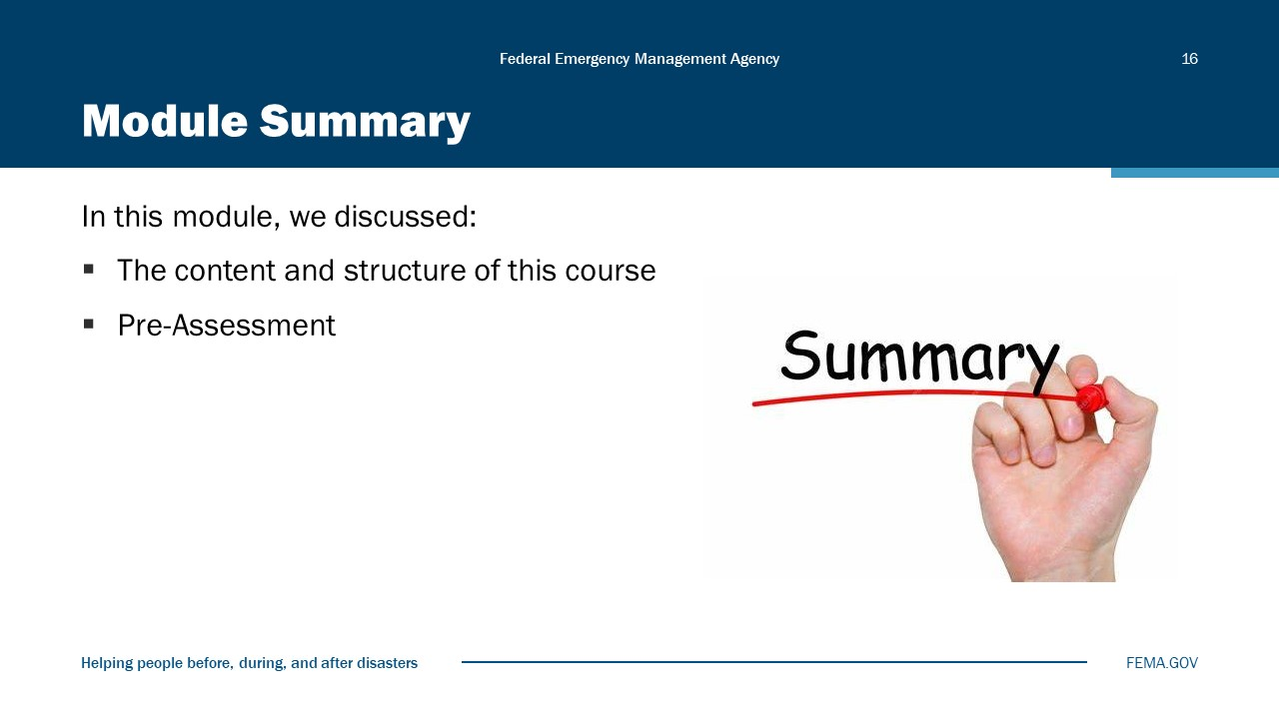
Visual 16, Module Summary

Module
2
Introduction to Public Information

Administration
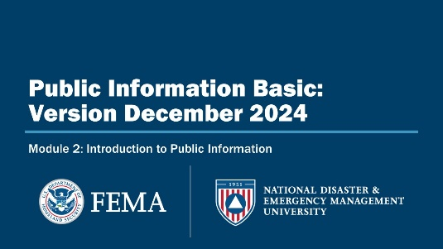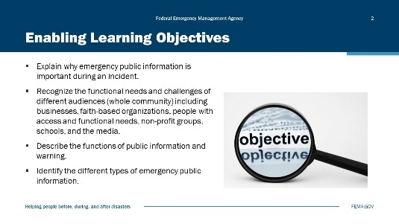
Visual 1, Introduction to Public Information Visual 2, Enabling Learning Objectives

Duration
45 minutes

Terminal Learning Objective (TLO)
By the end of this module, you will be able to understand the basic functions of public information within the whole community.

Enabling Learning Objectives (ELOs)
By the end of this module, you will be able to:
- Explain why emergency public information is important during an incident.
- Recognize the functional needs and challenges of different audiences (whole community) including businesses, faith-based organizations, people with access and functional needs, non-profit groups, schools, and the media.
- Describe the functions of public information and warning.
- Identify the different types of emergency public information.

Activity 2.1: Why Is It Important?
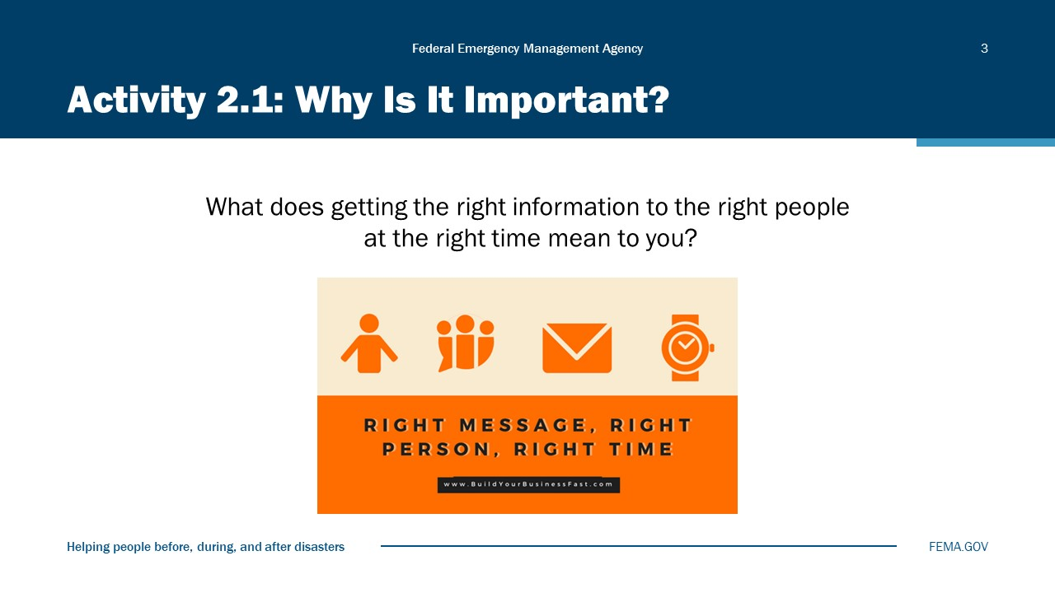
Visual 3, Activity 2.1: Why Is It Important?

Purpose: To identify the importance of public information.

A Fundamental Principle
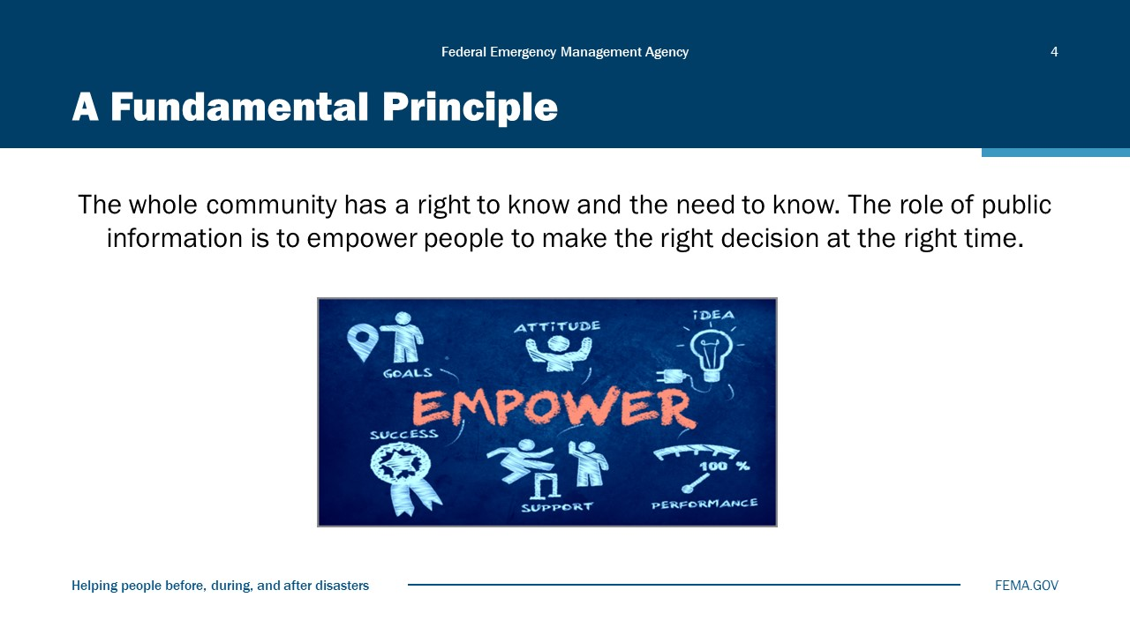
Visual 4, A Fundamental Principle

The whole community has a fundamental right to know about the risks they face, and they have a need to know. Such knowledge enables them to make informed choices that affect their health and well-being.
This fundamental principle is the basis for public information in this country. The role of public information is to empower people to make the right decision at the right time.

Lessons Learned
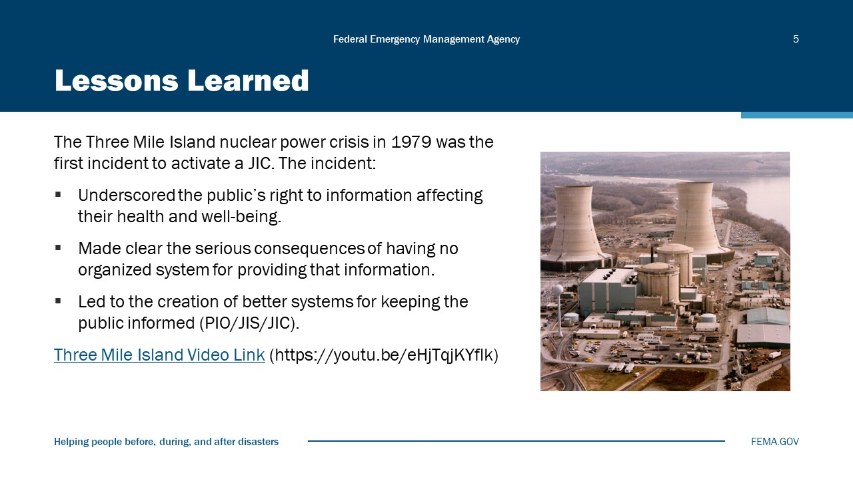
Visual 5, Lessons Learned

In 1979, a relief valve in a nuclear reactor coolant system at the Three Mile Island (TMI) nuclear powerplant in Pennsylvania failed, leading to offsite releases of radioactivity in the areas surrounding the plant and an emergency that spanned 5 days.
The incident is often cited as a case study in the mismanagement of public information during an emergency. This mismanagement concerned both the sources of information at Metropolitan Edison (Met Ed) and at the Nuclear Regulatory Commission (NRC), on the one hand, and media coverage of the accident on the other. Studies of the TMI accident have concluded that neither the utility nor the NRC’s handling of the public relations aspect of the crisis served the interests of the general public, especially the resident population close to the TMI facilities. The following are examples of information problems that occurred:
- Neither Met Ed nor the NRC had a “disaster” public information plan.
- Met Ed and the NRC spoke with different voices, often giving conflicting statements.
- The public in turn was left in a state of confusion and uncertainty.
- Public acknowledgment of the seriousness of the situation was slow in coming, and Met Ed consistently downplayed the seriousness of the accident.
- The media and the local population were perplexed, and both came to suspect that the confused and vague explanations from Met Ed indicated a withholding of information on the seriousness of the reactor’s problems. This suspicion destroyed the credibility of Met Ed as a source of reliable information.
- The sheer number of reporters that swarmed to the scene overwhelmed the utility’s efforts to communicate with them.
- There was a problem with terminology. Engineers at the facility used highly technical language in explaining the situation, and the utility did not provide sufficient information or technical briefings to help journalists interpret what they were being told.
The Three Mile Island incident shined the spotlight on the public’s right to know the facts about situations that affect their well-being.
In the wake of the incident, the Federal Government was criticized for having no organized system to ensure that the public received the information that they had the right to know.
To correct the problem, FEMA created a mechanism for coordinating the flow of information from all Federal agencies during disasters—the Joint Information Center (JIC), which you will learn about in a later module.
Three Mile Island Video Link (https://youtu.be/eHjTqjKYflk)
Three Mile Island Video Transcript
Ross: “Everything is under control; there is no danger to public health and safety.” Those reassuring words came from Lieutenant Governor William Scranton, at a hastily called news conference on Harrisburg’s Capitol Hill dealing with the emergency at Three Mile Island. Scranton, who monitors energy matters for the Commonwealth, said all safety systems functioned properly, and that the nuclear reactor plant was shut down as it was designed to do when the turbine tripped. This occurred at 4 a.m. and only a skeleton crew of essential workers was on hand at the time. No one was reported exposed to any of the radiation that leaked in the cooling system. William Dornsife, a nuclear engineer for the Department of Environmental Resources, explained what happened.
Dornsife: The plant was operating at 100-percent power and some, some fault in the non-safety system, the turbine plant, or, or in the electrical system, caused the valves going to turbine to shut. This is a normal anticipated transient, for the plan to go through this type of transient during start-up procedure, its start-up program. It’s immediately after the turbine valves closed, there was a buildup of pressure and temperature in the primary system and, as designed, the primary relief valves lifted, releasing radioactivity to the primary containment, which is also a safeguard system that’s designed to contain that activity with minimal leakage.
Ross: He said some radioactive iodine was found on the ground to the plant, but the levels would not cause any inhalation problems. Metropolitan Edison has been and is continuing to monitor the air in the vicinity of the plant. So far, they have found no increase of any radiation levels. One question still unanswered tonight is why the 3-hour delay until the Commonwealth was notified, which was at 7 a.m. Der says it wasn’t privy to what the situation was at the plant during the interim the emergency was declared. But Scranton said that there would be a thorough probe on that point.
Scranton: If there is a situation where there was a perception of an emergency, and the Pennsylvania Emergency Management Agency Council were not notified, we intend to find out. That would be extremely disturbing. We will make a thorough investigation into that.
Ross: A team from the Federal Government’s Nuclear Regulatory Commission is already on the site and is conducting its own investigation. Indications are at this hour that the minimal contamination would appear in the milk cows that graze in the area within a week. But, as one expert said, there’s nothing to worry about, and no evacuation of anyone in the plant area is anticipated.
This is the first time an incident or accident like this has happened in Pennsylvania, which has five nuclear reactor units involving three power companies, which, of course, includes Three Mile Island. There was no possibility of an explosion, said officials because of the low enrichment of the fuel. Mike Ross, TV 27 News, at the Capitol

Importance of Information
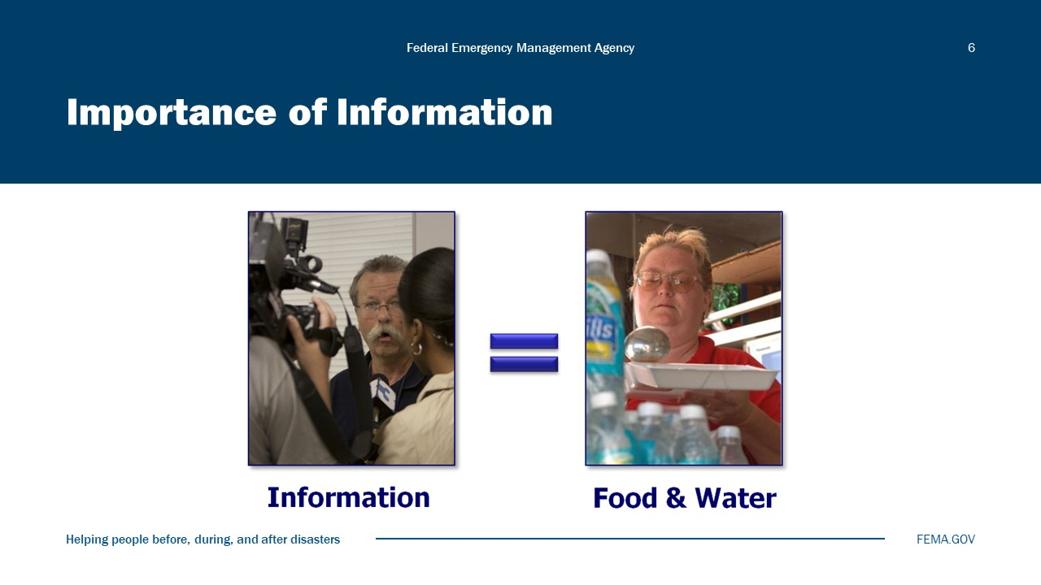
Visual 6, Importance of Information

Why might information be as important to disaster survivors as food and water?

What is Public Information?
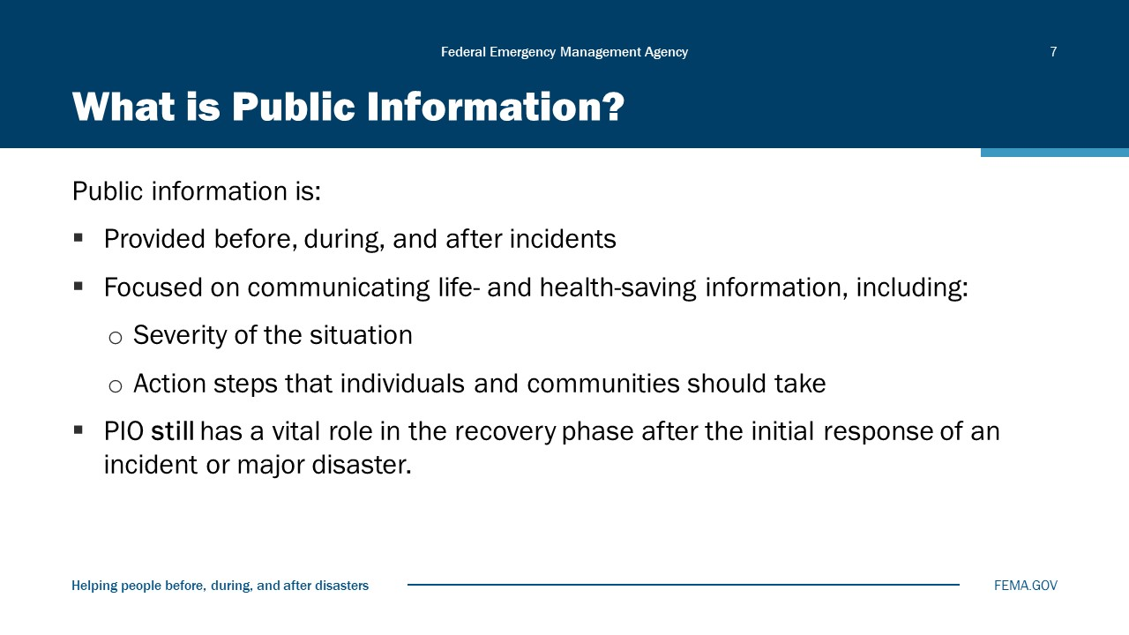
Visual 7, What is Public Information?

Public information is information that is collected, assembled, or maintained by an organization in connection with the transaction of official business and is made available for dissemination to the public.
Emergency public information is developed and disseminated in anticipation of, during, or after an incident to provide specific life- and health-saving information, including the severity of the situation and any action steps that individuals and communities should take to minimize risk.
PIO still has an active role after the initial response as communities begin to recover.
The responsive dissemination of public information plays a critical role in the recovery process, and it begins the moment a crisis occurs. Regular communication about recovery efforts, even though response efforts may not be over, reassures the public that government agencies are working together to resolve the situation and to bring assistance to those who need it.
Communications among PIOs and the impacted audience should occur as often as necessary and continue until recovery is complete. This coordination may be accomplished through the JIC (which may still be active during the recovery phase).
- This information should be updated regularly and may include the following:
- actions the public should take.
- a summary of the incident or planned event.
- the impact of the incident or planned event.
- actions the response agencies are taking.
- actions the public, businesses, and industries may take to gain access to recovery programs and information on how these programs work.
- information on how to repair or restore damaged property.
- debris removal information.
- overall steps to be taken by the government and citizens to return to normal.
- any other crisis-specific recovery information.
- PIOs should:
- emphasize, as soon as appropriate, when the danger has passed, or the situation has transitioned from response to recovery.
- be prepared to direct questions concerning volunteers and financial contributions to the appropriate organizations.
- inform local businesses about special programs designed to assist them through the news media, appropriate business channels, and community outreach efforts.
- communicate information on service animals, pets, and livestock.
- coordinate with their PIO counterparts at appropriate agencies concerning environmental, ecological, and agricultural impacts.
Recovery Evaluation
To help determine the effectiveness of recovery communication during an incident or planned event, PIOs should closely monitor media reports and assess public inquiries to determine if information is received and understood by its intended audiences. Following an incident or planned event, PIOs should create a comprehensive report of media coverage, media inquiries, and public inquiries to determine the effectiveness of the recovery communications efforts. This report, or conclusions of the report, can be forwarded to the ICS Planning Section for inclusion in the After-Action Report (AAR). The PIO should also participate in AAR reviews.
Typically, AARs contain the following components:
- Executive Summary
- Incident Overview
- Analysis of Capabilities
- Major Strengths
- Areas of Improvement
- Lessons Learned

Functions of Public Information
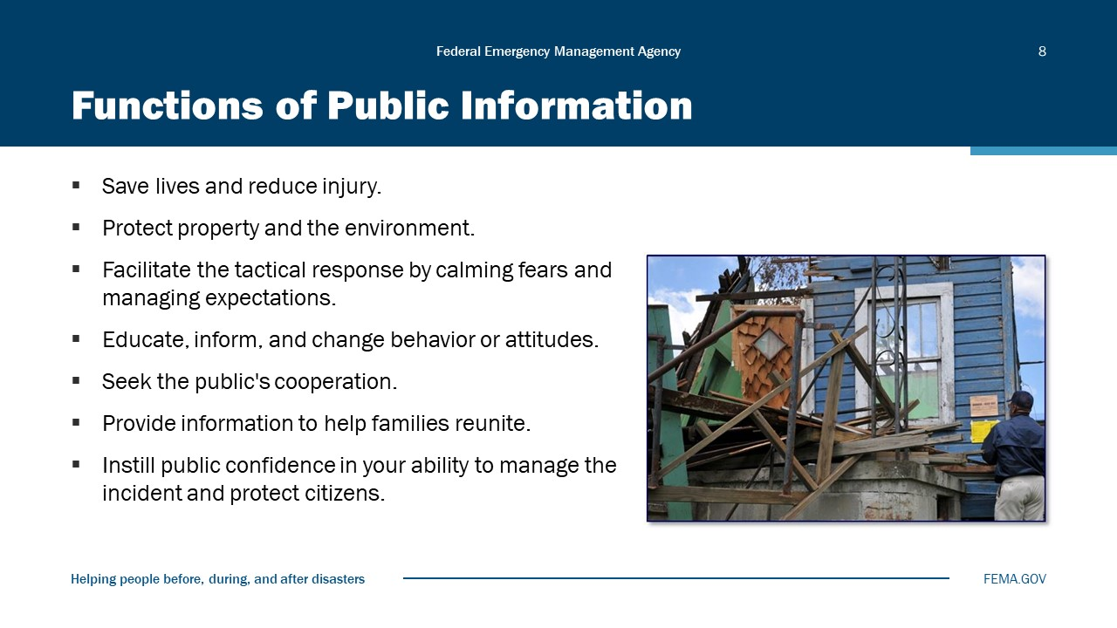
Visual 8, Functions of Public Information

Emergency public information serves many important functions. It can:
- Save lives and reduce injury. Knowing the proper protective actions to take enables people to reduce their risk.
- Protect property and the environment. Understanding how to mitigate risk to property and the environment may lessen the damage inflicted by disasters.
- Facilitate the tactical response by calming fears and managing expectations. People who know what to expect are more likely to follow instructions and allow responders to do their jobs.
- Educate and inform the public and change behavior or attitudes. An educated public is more likely to prepare for emergencies and be ready when they occur.
- Seek the public’s cooperation and call people to action. Whether the need is for volunteers to help with sandbagging, citizens to cooperate with investigators, or residents to evacuate their homes, public information is an instrument that can help make it happen.
- Provide information to help families reunite. After a disaster, few things are more distressing than being separated from loved ones. Public information about shelter message boards, hot lines, survivor registries, and other linkages can help reunite families and enable them to move forward with their recovery.
- Instill public confidence in the jurisdiction’s ability to manage an incident and protect citizens. Providing timely, accurate, and understandable information builds confidence in emergency management’s competence.

Functions of Warnings
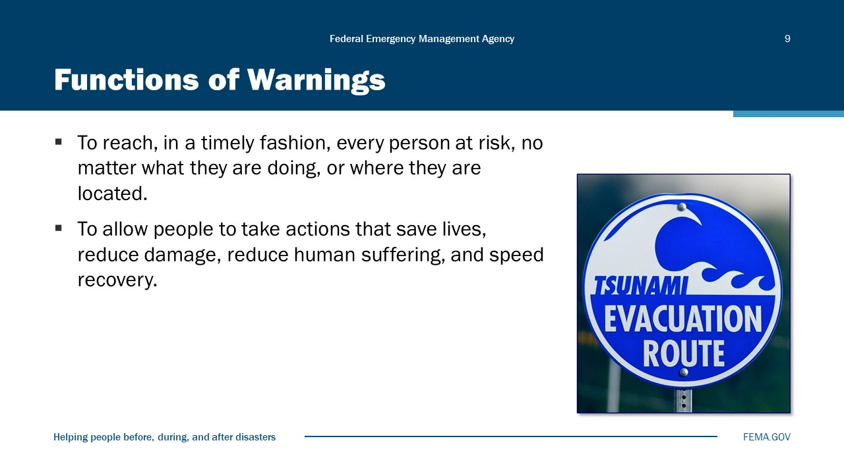
Visual 9, Functions of Warnings

Warnings are intended to allow people to take actions that save lives, reduce damage, reduce human suffering, and speed recovery.
To fulfill this purpose, warnings must reach every person who is at risk, no matter what they are doing or where they are located and must do so in a timely fashion.

Discussion Question
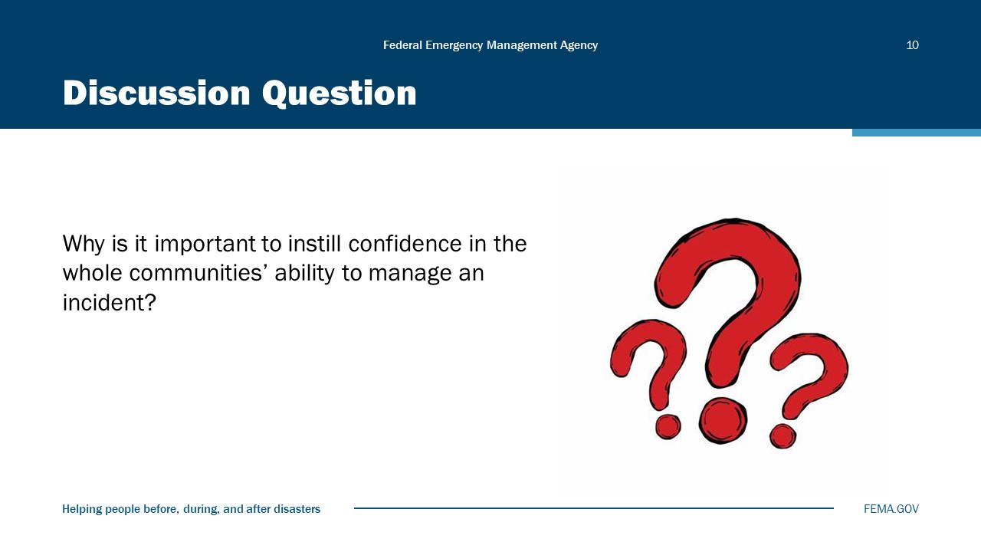
Visual 10, Discussion Question

Flow of Emergency Communications
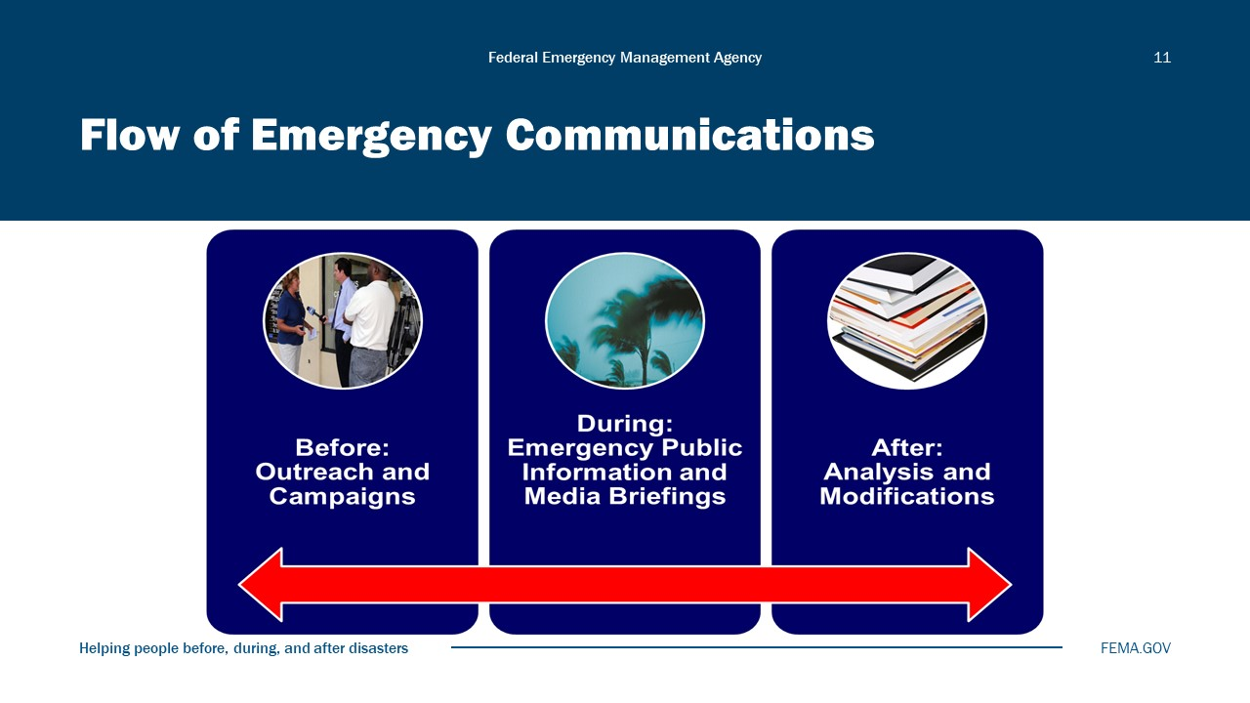
Visual 11, Flow of Emergency Communications

The flow of emergency communications extends from the pre-incident phase, through the incident, and into the post-incident phase.
Before an incident, public information activities can include:
- Outreach to the news media to educate reporters unfamiliar with your organization or program, outreach campaigns, and building relationships. Examples include:
- Regular contact through phone calls or news releases (as long as there is a newsworthy reason behind the call or news release); and
- Facility tours or ride-alongs (especially for reporters new to your beat).
- Public awareness campaigns, which can address such topics as:
- Smoke detector campaigns (get smoke detectors, replace batteries, etc.).
- Home preparedness plans.
- Weather-related messages (hurricane, tornado, and earthquake preparedness, etc.).
- Home swimming pool safety.
- Food safety.
- Health-related issues (e.g., cold and flu prevention, child immunization).
During any type of crisis, the public needs information in order to make informed and rational decisions. This information must be accurate, easy to understand, and delivered in a rapid fashion to:
- Save lives and reduce injuries.
- Protect property.
- Calm fears.
After an incident, you must analyze how the communication process went. Good information can lead to good outcomes, but bad information can lead to very bad outcomes!
Media monitoring/analysis takes place throughout the cycle and is used to continually evaluate and adjust public information efforts.

Module Summary
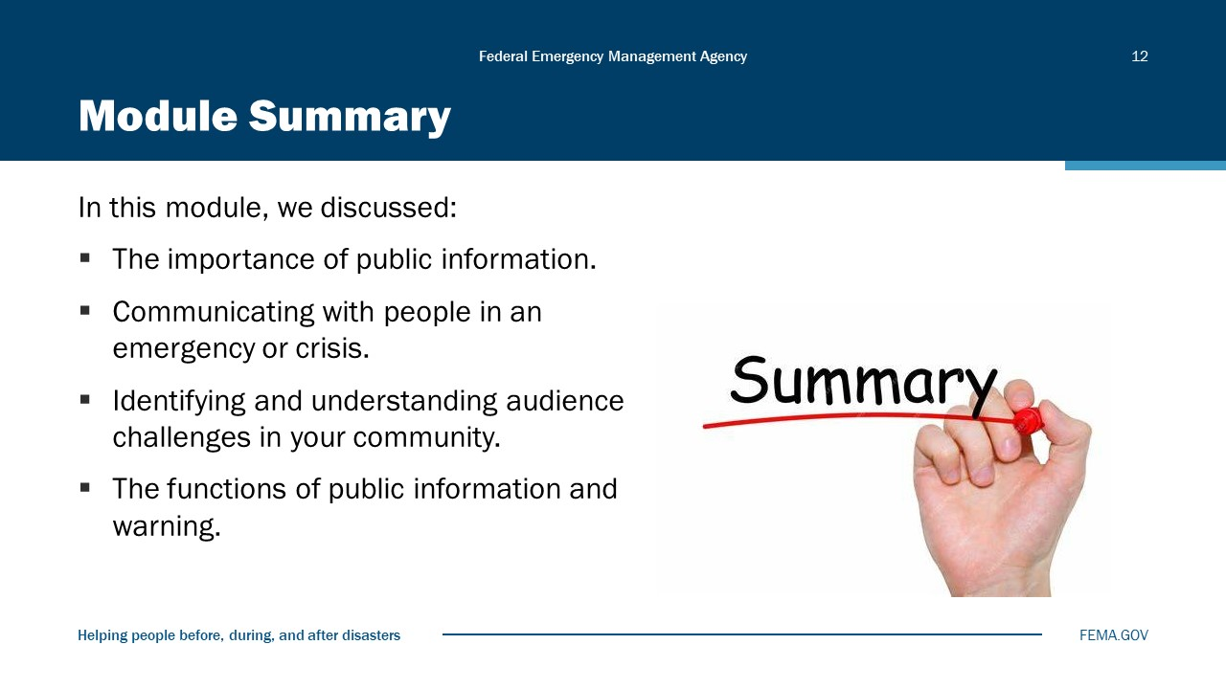
Visual 12, Module Summary

Reference List
Emergency Management Professional Program (EMPP) (https://training.fema.gov/programs/empp/)

Public Information Officer Program (https://training.fema.gov/programs/empp/pio/)

3 Mile Island Video (https://youtu.be/eHjTqjKYflk)

National Incident Management System (NIMS) (https://training.fema.gov/nims/)

National Response Framework (https://www.fema.gov/sites/default/files/2020-04/NRF_FINALApproved_2011028.pdf)

Module
3
Strategic Communications Planning

Administration
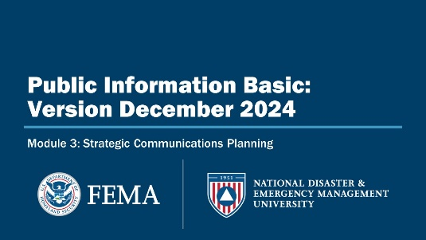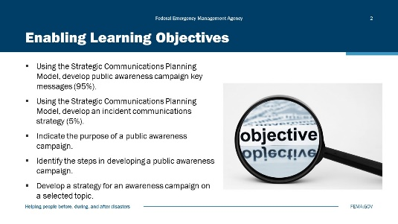
Visual 1, Strategic Communication Planning Visual 2, Enabling Learning Objectives

Duration
3 hours; 30 minutes

Terminal Learning Objective (TLO)
By the end of this module, you will be able to identify the steps of the Strategic Communications Plan and develop products.

Enabling Learning Objectives (ELOs)
By the end of this module, you will be able to:
- Using the Strategic Communications Planning Model, develop public awareness campaign key messages (95%).
- Using the 8-Step Strategic Communications Planning Model, develop an incident communications strategy (5%).
- Indicate the purpose of a public awareness campaign.
- Identify the steps in developing a public awareness campaign.
- Develop a strategy for an awareness campaign on a selected topic.

Strategic Communications Plan
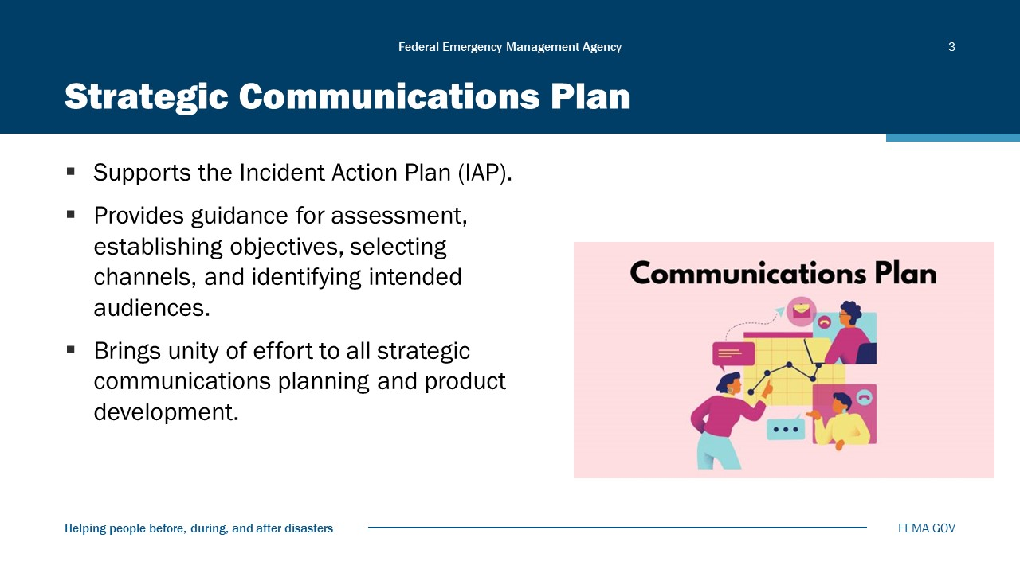
Visual 3, Strategic Communications Plan

Incident Action Plan (IAP): A plan that the NIMS glossary defines incident as is central to managing the response to an incident using “an occurrence, natural or manmade, that ICS. The team that is managing an incident develops and requires a response to protect life or IAP each operational period, the time scheduled for property.” For the purposes of this guide, executing a given set of actions as specified in the IAP, the term incident is used to refer to using the standard ICS incident action planning process. incidents in which FEMA is involved, generally in support of and in partnership. The IAP itself communicates the incident objectives and with State, Local, Tribal, and Territorial the tactics that will be used to manage the incident during (SLTT) governments. the operational period that the plan covers.
The incident action planning process provides a tool to synchronize operations at the incident level and ensures that incident operations are conducted in support of incident objectives. A disciplined system of planning phases and meetings fosters collaboration and partnerships and focuses on incident operations.

8-Step Communications Model
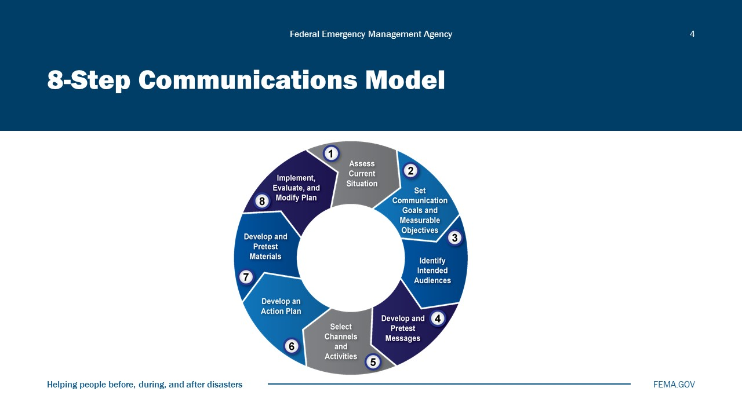
Visual 4, 8-Step Communications Model

The 8-Step Communications Model outlines the communication between the sender of the message and the receiver. The visual displays that model for carrying out a strategic communications process based on the social marketing approach. The overview of this model was covered in IS0029.

Step 1: Assess Current Situation
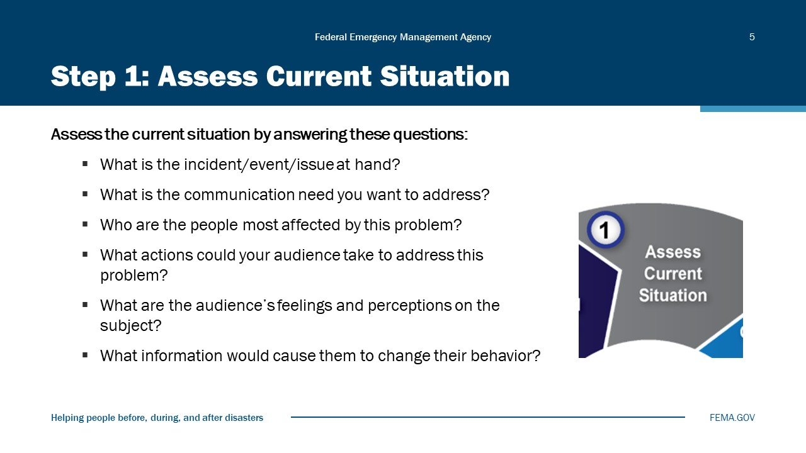
Visual 5, Step 1: Assess Current Situation

Using the 8-Step Model, as a first step you will need to collect information to help you make strategic planning decisions. This step sets the stage for the entire communication process.
Many communicators try to shortcut this step and proceed with developing products, but that can mean major mistakes in their assumptions about what their audience needs and wants. Remember, we said that the social marketing approach is based on understanding your audience.
You must begin by acquiring a thorough understanding of the problem, the audience, and the action you want the audience to take.
You obtain this understanding by asking yourself the following questions:
- What is the incident/event/issue at hand?
- What is the communication need you want to address?
- Who are the people that are most affected by this problem?
- What actions could your audience take to address this problem?
- What are your target audience’s feelings/behavior on this issue?
- What information would cause them to change their behavior?

Public Awareness Campaign
To start developing an awareness campaign, first you need to determine what the concerns and issues are in your community.
To determine the issues, ask:
- What are the threats and hazards in your community?
- Who is at risk?
- What are people concerned about?
- What is their current level of preparedness?

Step 2: Set Communication Goals
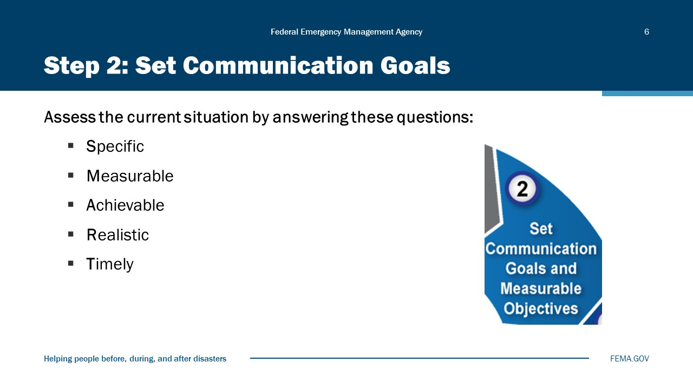
Visual 6, Set Communication Goals

When setting your communication goals, you need to also develop objectives for implementing those goals. The objectives should be SMART objectives. That is, they should be:
Specific
Specific goals have a desired outcome that is clearly understood. This might be a sales number or a product rollout goal. No matter what it is, the goal should be clearly articulated so that everyone is on the same page with the objective. Define what will be accomplished and the actions to be taken to accomplish the goal.
Measurable
These are the numbers used with the goal. You need to have a quantifiable objective so that you can track progress. Define what data will be used to measure the goal and set a method for collection.
Achievable
Goals need to be realistic to maintain the enthusiasm to try to achieve them. Setting lofty goals is good, but you may want to break them down into smaller, bite-sized chunks. If the goal is not doable, you may need to first ramp up resources to give yourself a shot at success. Ramping up resources would likely be its own SMART goal.

Realistic
Goals should be aligned with the mission of the company. Don’t set goals just as an exercise for something to do. One way to determine if the goal is relevant is to define the key benefit to the organization.
Timely
Goals should have a deadline. A goal without a deadline doesn’t do much. How can you identify success or failure? This is why SMART goals set a final date. This doesn’t mean that all the work is done, but it means that you can evaluate the success of the endeavor and set new goals.
Without clear and specific outcome measures, communication can lack direction and effect. Goals can be broad statements that describe the purpose and meaning of the task. Objectives are those things that lead to the accomplishment of your goals.

Examples of SMART Objectives
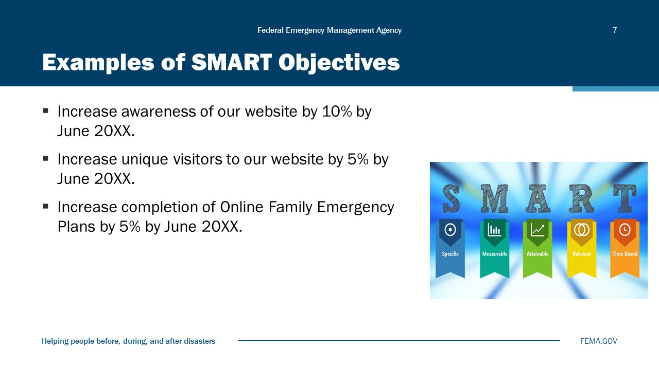
Visual 7, Examples of SMART Objectives

Professional Goal: “I’m going to increase sales.”

Specific: “I am going to learn about social media marketing and invest in a social media management platform to start growing an online audience of potential customers.”
Measurable: “The goal is to increase sales by 30% within the next quarter.”
Achievable: “I can afford a subscription to Zoho Social, and I have a moderately successful business that can handle a large increase in customer demand.”
Relevant: “I want to grow my sales volume so that I can buy a new vehicle for my business.”
Time-bound: “I will subscribe to Zoho Social tomorrow and go through all of their instructional material to learn how the platform works. I will build a social media strategy and deploy it in 2 weeks.”

Personal Goal: “I’m going to get in shape.”

Specific: “I am going to get at least 30 minutes of exercise 3 days a week and cut my caloric intake by 25%.”
Measurable: “My goal is to lose 15 pounds within the next 3 months.”
Achievable: “I already have a rowing machine and can afford to buy fresh, nutritious food for myself and my family.”
Relevant: “I want to live a healthier lifestyle so that I feel better physically and mentally in my daily life.”
Time-bound: “I will go to the grocery store tomorrow after work and buy healthy food for the week. I will use my rowing machine for 30 minutes before cooking dinner. I will use the rower three times per week.”

SMART Objective Template
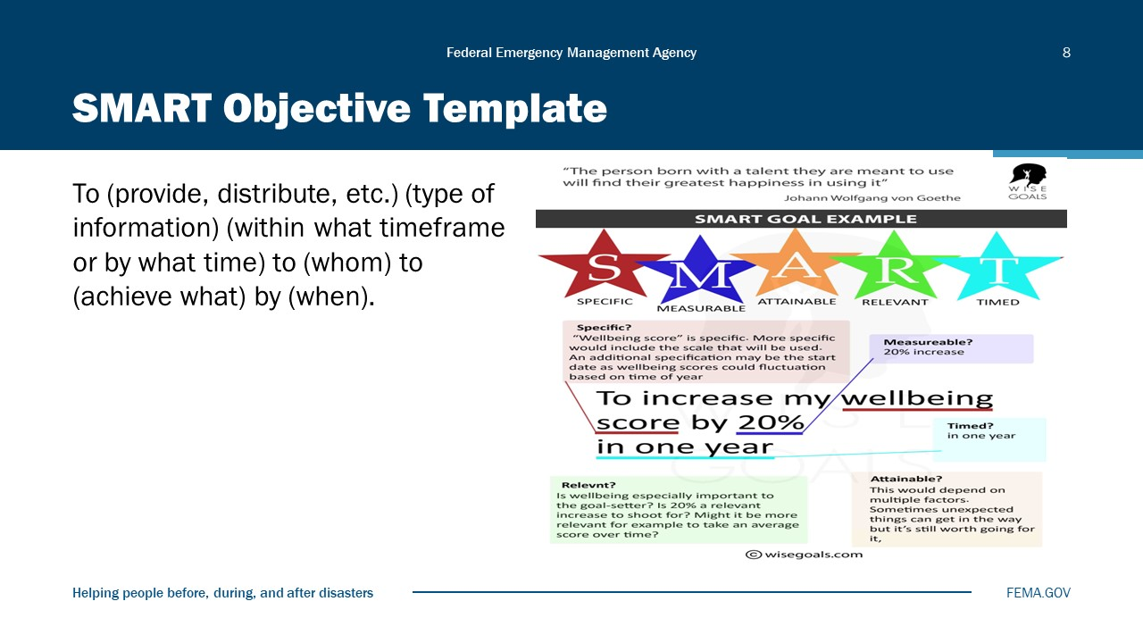
Visual 8, SMART Objective Template

Step 3: Identify Intended Audiences
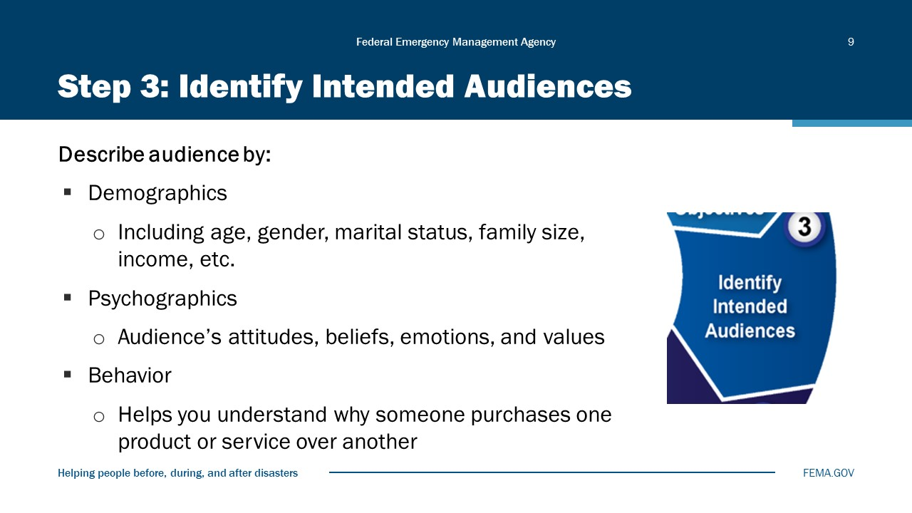
Visual 9, Step 3: Identify Intended Audience

Once you identify your audiences, go one step further and analyze the audiences. You have determined what segments of the population that you will be targeting. Now you will enhance your analysis by focusing your analysis to be more comprehensive.
When we segment down to a very specific audience, we learn what makes that group tick. And we can use that information to create messages that will align with the needs, beliefs, values, and priorities of our audiences.
While some of your messages may apply to everyone, you may want to communicate differently to one or more segments.
A potentially endless number of audience segments could exist. Making judgments based on which would provide the biggest “bang” for the effort invested in communication is essential. Describe your audience:
- Demographics: Demographic characteristics include age, gender, marital status, family size, income, education level, occupation, race, and religion. Demographic information can often be found online as a compilation of different reports the Federal government runs. Check the Census Bureau and Commerce Department Websites.
- Psychographics: Psychographic information tells you about your audience’s attitudes, beliefs, emotions, and values. It includes your target market’s family stage, hobbies, and interests, type of entertainment they engage in, and lifestyle. Psychographic information is often found through surveys or focus groups. Though you can set these up yourself, it would be beneficial to hire a marketing research firm to help you structure the surveys, word questions carefully, and engage with focus groups in an effective way.
- Behaviors: Behavior information helps you understand why someone purchases one product or service over another. It includes how often your target audience would use the service or buy the product, how much or how many they would use, if there was a specific occasion for using it, and how long it took them to decide to use or buy that product.
Relate this concept to the public awareness campaign you selected. For example, if you selected preparing a family emergency plan, you might point out that “families with pets” are a segment of the larger audience. Your message to this group and how you disseminate the message might be different.
Public Awareness Campaign
- Who is your audience?
- What are their communications needs and preferences?
- Where do they live?
- What types of media do they use?
- Where? What types of messages will be most effective?
- Who can deliver the message most effectively?

The Basics
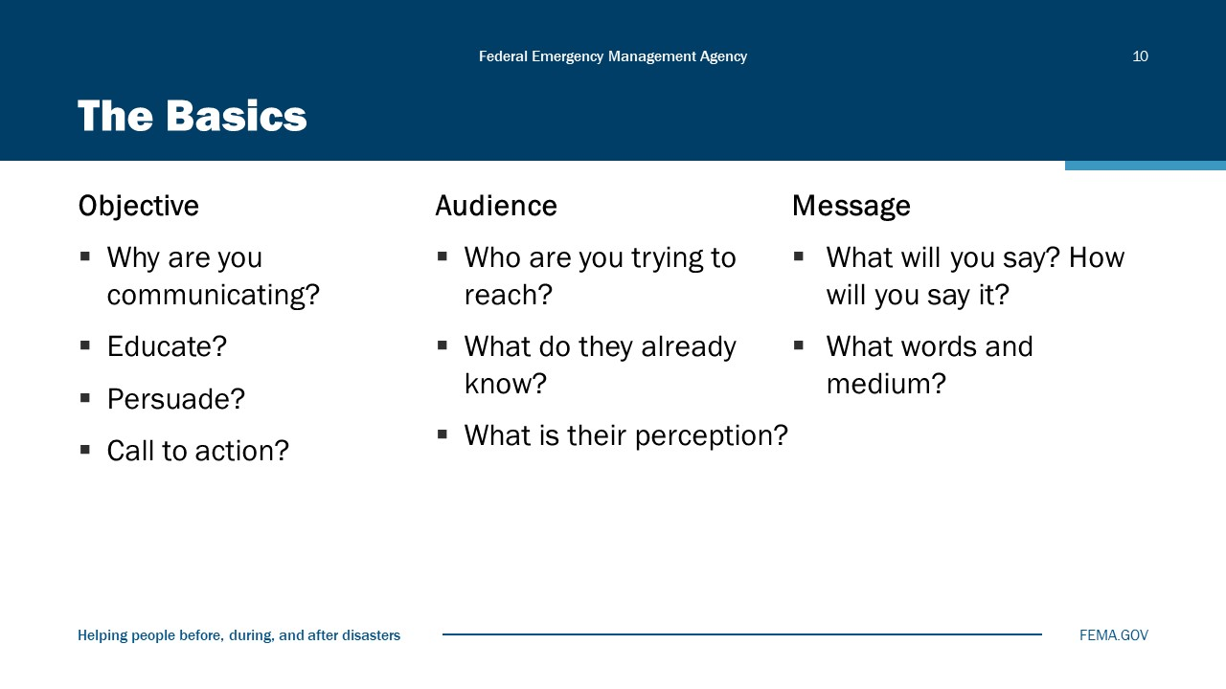
Visual 10, The Basics

The concepts discussed are relevant whether you are preparing to be interviewed yourself or whether you are preparing someone else—for example, the Police Chief—to be interviewed.
Preparation starts by asking yourself some basic questions:
- Why are you communicating? Is your objective to:
- Educate? (e.g., explain that a new flu virus is going around)
- Persuade? (e.g., encourage people to support a clothing drive for the homeless)
- Call to action? (e.g., get people to evacuate before a hurricane strikes)
- Damage control—to get in front of misinformation or rumors—is also a reason for communicating.
- Who are you trying to reach? Is your audience:
- Already knowledgeable on the topic?
- Biased (or holding preconceived notions) on the topic?
- Given your objective and your audience, what is your message? In other words:
- What will you say? How will you say it?

Step 4: Develop and Pretest Messages
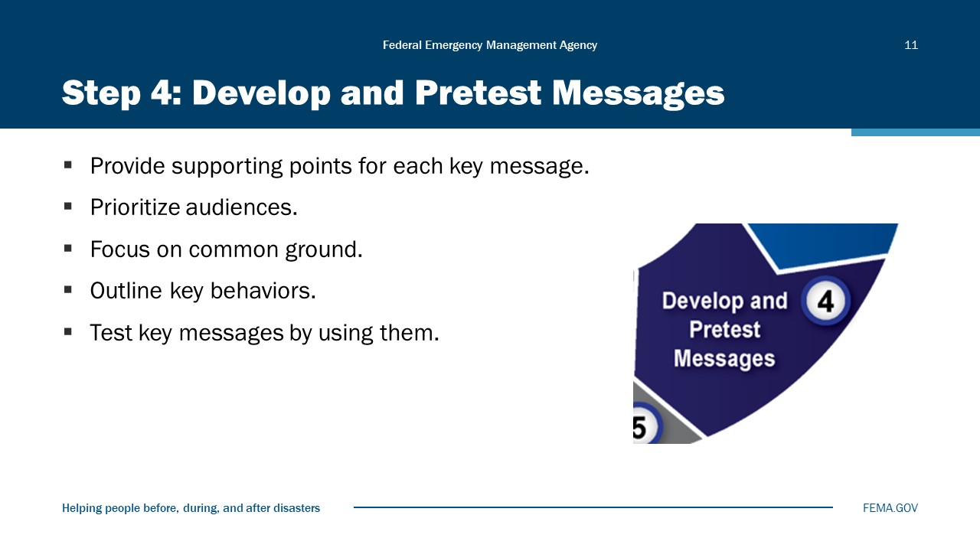
Visual 11, Step 4: Develop and Pretest Messages

If you don’t understand the audience, your message will get lost. That’s why before we put pen to paper, you had to go through Step 3, so that you know the audience you are addressing.
Messages can be:
- Informative: providing information without necessarily trying to change attitudes, beliefs, or values.
- Persuasive: trying to create and/or request change or giving a call to action.
- Or Both.
Effective messages:
- Don’t use jargon (including most acronyms).
- Make it easy for your audience to understand.
- Are direct and concise.
- Communicate the benefits to your audience.
Develop and pretest messages:
- Provide supporting points for each key message.
- Define and prioritize the audiences who will receive the messages.
- Focus on the common ground between them.
- Outline the key behaviors and expectations for each audience receiving the messages. You need to be able to use your messages to drive action. To get there, you need to articulate those messages in a clear way that outlines the specific actions expected of each audience.
- Test key messages.
Public Awareness Campaign
- What is the goal of your campaign?
- What is the message?
- When should it be delivered?
- What partnerships will help you succeed?
- What are your constraints?
- What medium suits the audience and the message?
Key Points:
When developing and implementing the campaign, you need to:
- Keep your goal in mind and develop a message to meet that goal.
- Look at the cost of your campaign and your budget to make other determinations about media, timing, frequency, etc.
- Identify partnerships in the community that can help you get your message out.
- Identify your time constraints. (For example, when do you need to get your preparedness message out for hurricane season?)
- Identify occasions during the year that might relate to a message you want to convey. Note: On the next page are examples of monthly remembrances, events, and milestones to which awareness campaigns can be linked.
- Identify the medium that would be best to get your message to the audience: print, television, radio, Internet, or other news media. You may want to consider using several different ways and places to get your message out because this may increase the effectiveness and impact of your campaign.
Examples of Monthly Events and Milestones to Which Awareness Campaigns Can Be Linked:
January: National Volunteer Blood Donor Month, Haiti earthquake anniversary, Martin Luther King, Jr. Day of Service
February: Earthquake Awareness Month, National Burn Awareness Week, Chile earthquake anniversary
March: American Red Cross Month, Flood Safety Awareness Week, National Hurricane Conference
April: National 9-1-1 Education Month, National Volunteer Week, Earth Day, National Severe Weather Preparedness Week
May: Mental Health Month, National Older Americans Month, Public Service Recognition Week, National Police Week, National Public Works Week, National EMS Week, National Hurricane Awareness Week, Memorial Day (usually preceded by grilling safety fire awareness news release)
June: National Safety Month, National Congress of the American Indian mid-year conference, Lightning Awareness Week, American Radio Relay League Field Day
July: Independence Day (usually preceded by fireworks safety news release), National Governor’s Association Annual Conference, Anniversary of the Signing of the Americans with Disabilities Act
August: Annual National Night Out, NOAA Updated Hurricane Outlook, Hurricane Katrina anniversary
September: National Preparedness Month, Labor Day, National Assisted Living Week, Child Passenger Safety Awareness Week; Patriot’s Day (911 remembrance)
October: Crime Prevention Month, Celebrate Safe Communities, Fire Prevention Month, America’s Safe Schools Week, Make a Difference Day
November: National American Indian Heritage Month, end of Daylight-Saving Time (check smoke detectors), Veterans’ Day, seasonal interest—holiday/cooking fire safety, end of Atlantic Hurricane Season
December: Winter Storm Awareness, International Day of Persons with Disabilities

Message Mapping
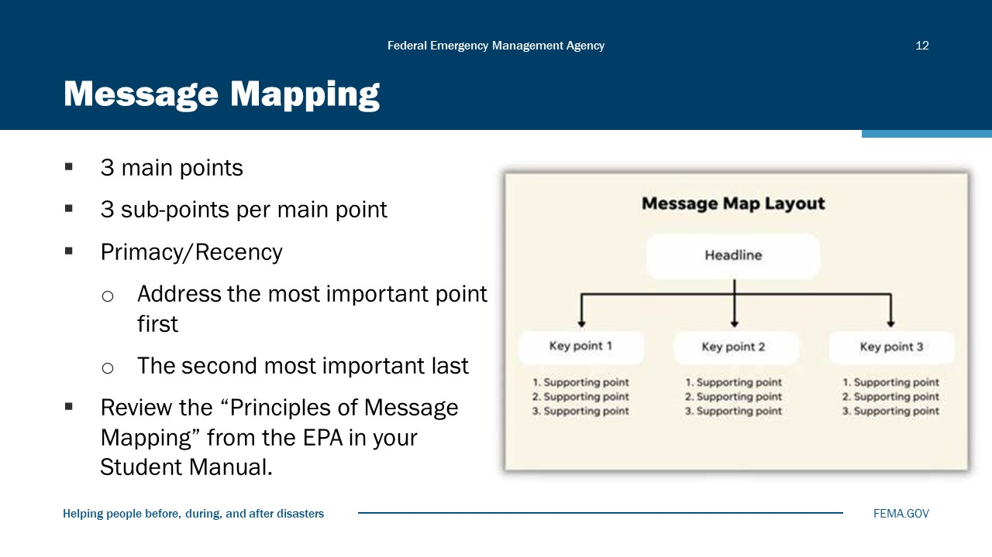
Visual 12, Message Mapping

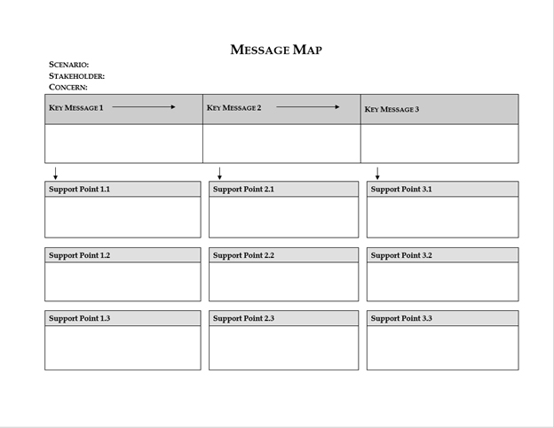

Step 5: Select Channels and Activities
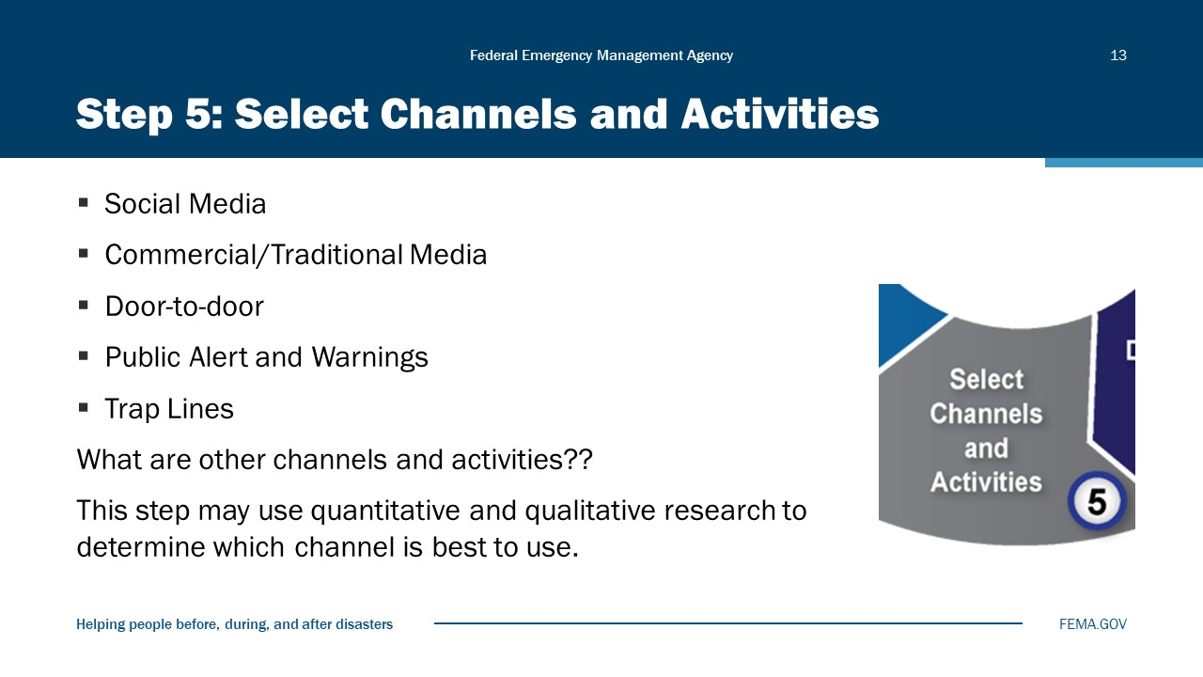
Visual 13, Step 5: Select Channels and Activities

Step 6: Develop an Action Plan
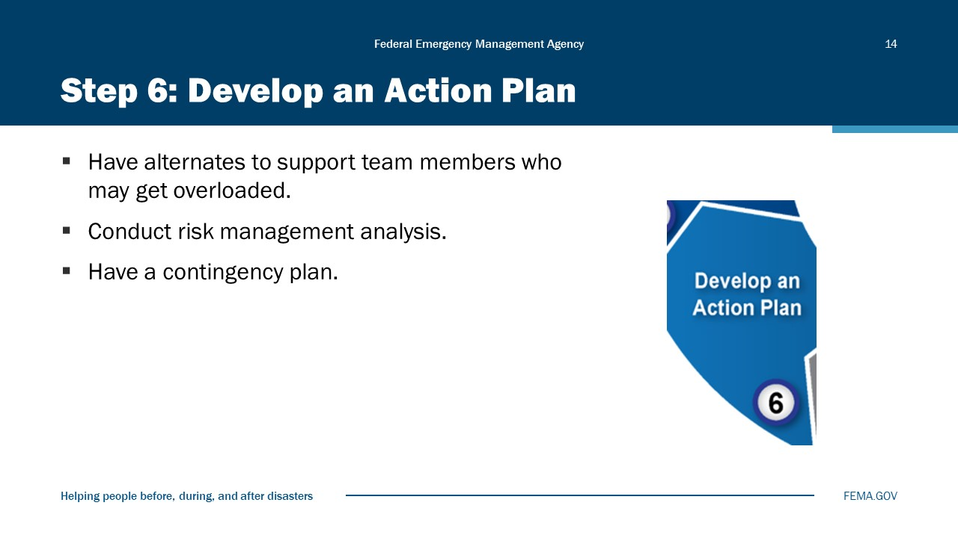
Visual 14, Step 6: Develop an Action Plan

An action plan is a document that lists what steps must be taken in order to achieve a specific goal. The purpose of an action plan is to clarify what resources are required to reach the goal, formulate a timeline for when specific tasks need to be completed, and determine what resources are required.
Action plan tips include:
- Have backup staff set up as alternates to make sure all elements of the plan are completed, as some team members may become overloaded, be moved to another disaster, or through other means, may become unavailable for the project. If there is someone who knows the process and is up to speed on what is happening on the project, then they can more easily step in and make sure that this task is completed.
- Conduct a risk management analysis early in the project and keep revisiting it to create a list of potential risks that could get the communication project off-course or affect the communications. It is recommended that you involve multiple team members in this analysis. Then you can prepare for these risks.
- Finally, you will want to have a contingency plan in case these risks do materialize.

Step 7: Develop and Pretest Materials
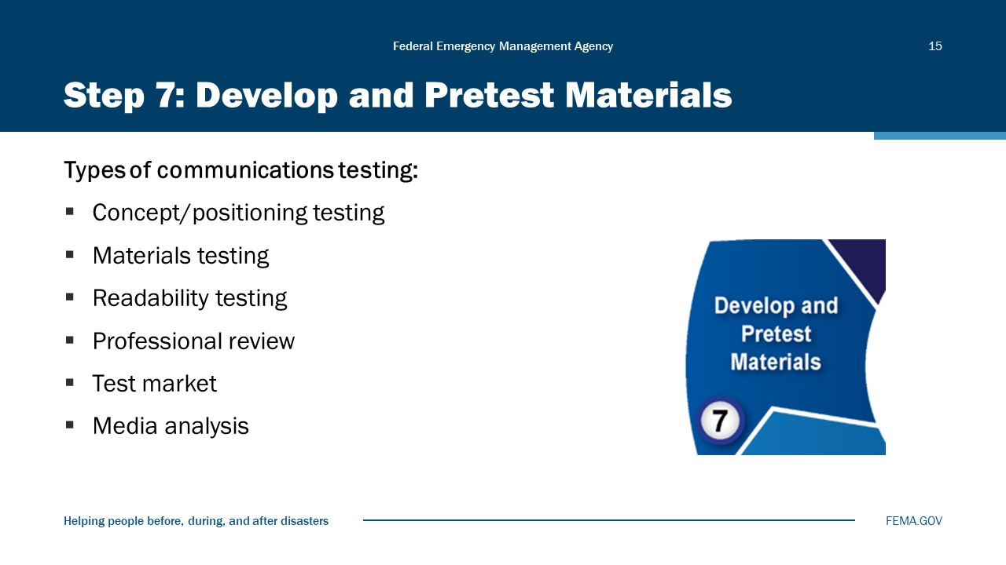
Visual 15, Step 7: Develop and Pretest Materials

Types of communications testing include:
- Concept/positioning testing: The objectives of positioning or concept testing are to determine the level of interest in the service or product, what the concept statement communicates to the audience, and whether the audience feels it is relevant. This can be done through focus groups or in-depth interviews.
- Materials testing: Using the information obtained from the concept testing, materials are created and then tested using pre-finished executions. These materials should be evaluated in terms of memorability, impact, communication, comprehension, believability, acceptability, image, persuasion, and other key attributes. Focus groups are a great way to conduct materials testing.
- Readability testing: With printed materials, the readability of the text is crucial, particularly for those who have lower reading levels than the general population. The readability of printed text is assessed, either by hand or by using a computer program, using standard formulas that analyze sentence length and number of polysyllabic words. Longer sentences and more syllables mean that a higher reading level is needed by the intended audience to fully understand the material. Readability testing is generally recommended for materials that have a lot of text, such as longer print ads, brochures, or information kits.
- Professional review: In addition to testing the materials with the target audience, it is often helpful to have communication peers and representatives of similar organizations review them as well. The professional reviewers evaluate the pre-finished materials, and comment on appropriateness, clarity, design, and comprehensiveness. This may be done over the phone or through a written questionnaire.
- Test market: The best way to gauge potential success of the social marketing program is the test market. By bringing together all the elements of the marketing mix in a real situation, the test market provides a “dress rehearsal” before launching the program everywhere. A key to the accuracy of the results is the selection of the location for the test market. The findings may be different, based upon variables such as ethnicity and size of the area, and this must be accounted for. Using an experimental design, with one or more control markets, may help to reduce some of these uncertainties.
- Media analysis: A comprehensive media analysis is an important step, which incorporates both Step 1 (Situational Awareness) and Step 8 (Evaluate and Modify the Plan). A true media analysis will examine traditional media sources (broadcast, print, etc.), social media (all platforms), and emerging media (vloggers, bloggers, citizen journalists, etc.). The analysis should examine who is reporting on the issue, who is NOT reporting on the issue, how often is it being reported, what is the context of the message as reported, how extensive is the coverage (local, regional, statewide, national, international), and is there a bias to the reporting? This is not an exhaustive list. Refer to the attached Resource Guide.
Subscribe to Media Bias Chart® (https://adfontesmedia.com/) for ongoing updates.

Step 8: Implement, Evaluate, and Modify Plan
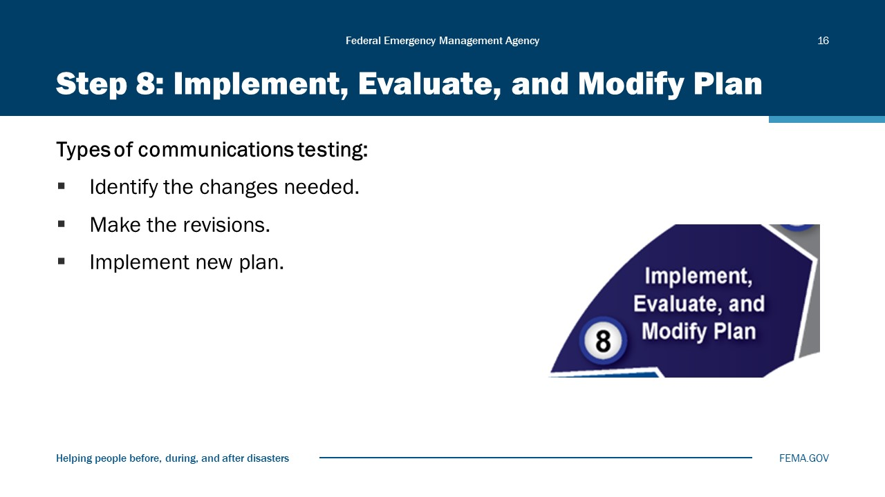
Visual 16, Step 8: Implement, Evaluate, and Modify Plan

To implement, evaluate and modify your plan:
- Review the action plan periodically to ensure that it still meets your needs.
- Remember to incorporate a comprehensive media analysis in your evaluation.
- Identify the changes needed. It is recommended that you use a cross-functional team to identify both necessary changes and potential upgrades to the action plan. Using this team should help to identify issues with the existing document, while ensuring that proposed new actions are appropriate and achievable. These actions should be aligned to broader business strategies and external influences, be resilient to change, and lead to measurable outcomes.
- Make the revisions and then have senior management review and approve the revised action plan. Make sure that actions and target audiences are linked, and that objectives, milestones, and schedules are all measurable and achievable.
- Then implement the new plan.
Public Awareness Campaign
Once you have implemented your awareness campaign, you need to start evaluating it.
- Did the message reach the targeted audience?
- Did the message call people to action?
- Was the action significant?
- How did you measure the action?
- What will you change in future campaigns? (And what can you change in this campaign to address any issues?)

Purpose of Public Awareness Campaigns
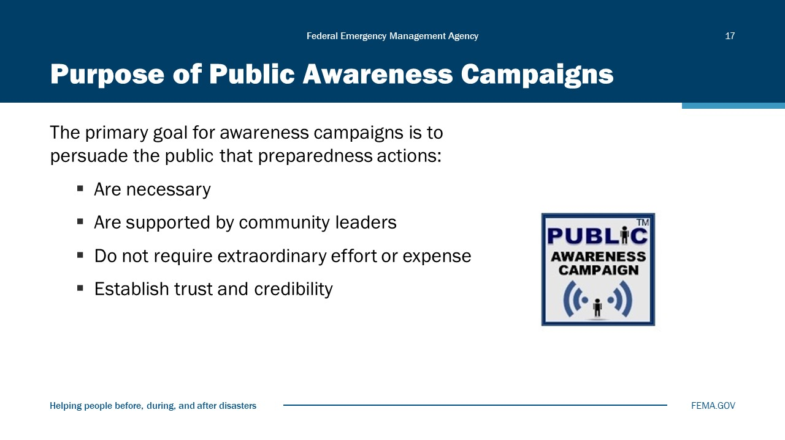
Visual 17, Purpose of Public Awareness Campaigns

Public Awareness Campaigns and the 8-Step Strategic Communications Model
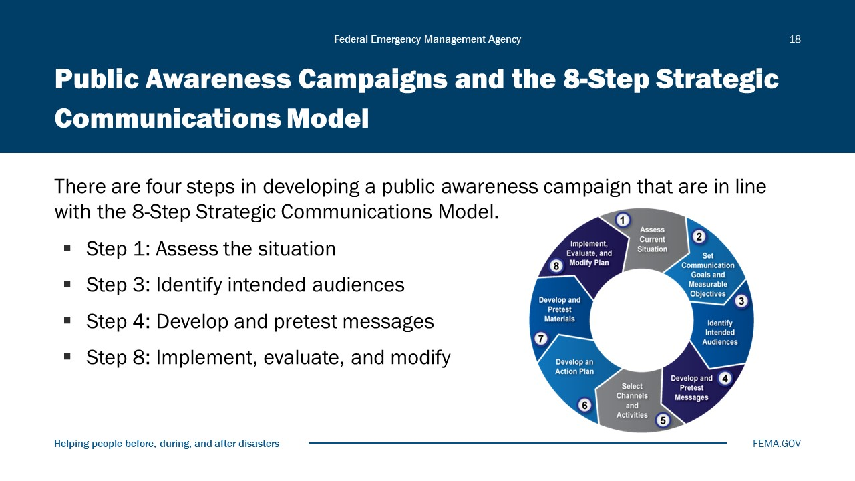
Visual 18, Public Awareness Campaigns and the 8-Step Strategic Communications Model

Activity 3.1: Public Awareness Campaign
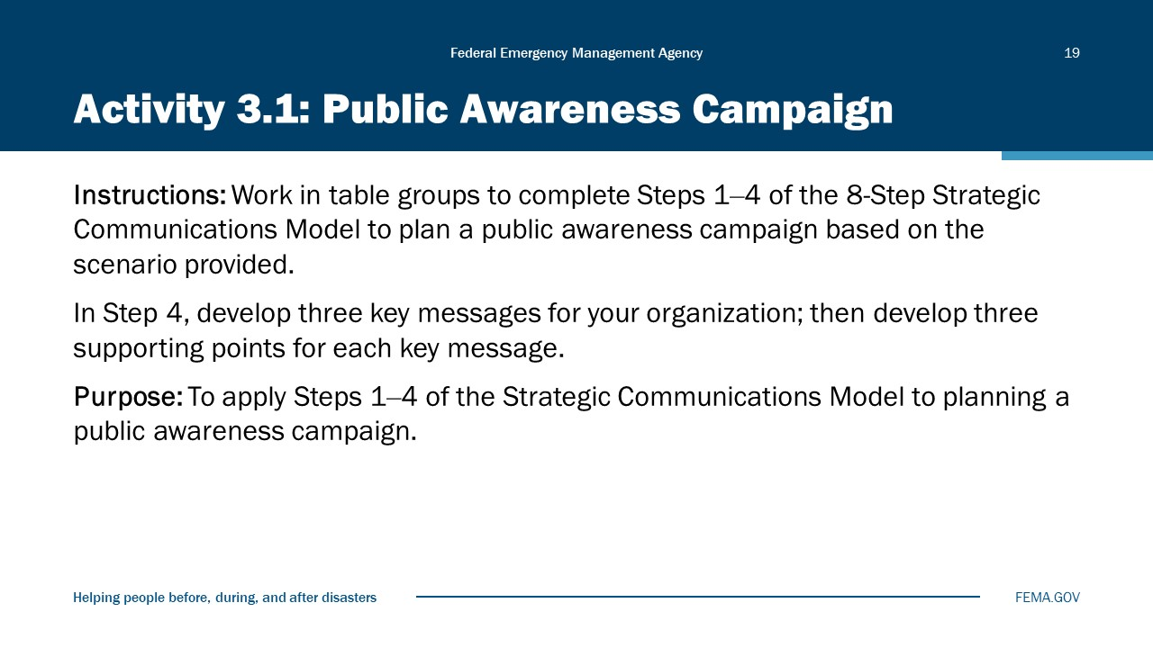
Visual 19, Activity 3.1: Public Awareness Campaign

Total Time for Activity: 40 minutes
Purpose of Activity: The purpose of this activity is to provide you with the tools and skills to plan a public awareness campaign. You will work individually to plan a public awareness campaign through Step 4 of the 8-Step Communications Model.
Instructions:
- You have 30 minutes to complete the activity.
- This is an individual activity, but you may consult with members of your table group.
- Read the scenario. Refer back to Steps 1 through 4 of the Strategic Communications Model (Visuals 3.5‒3.11).
- Using the message map in your Student Manual, fill out Steps 1 through 4 of the Strategic Communications Plan.
- At the end, we will have volunteers report out to the class (10 minutes).

Scenario:
Columbia State University (CSU) is a campus of 15,000 undergraduate and graduate students seeking degrees from the University’s 19 different departments. CSU’s main campus is located in Central City. Roughly one-third of the students live on campus in 13 dormitories and 15 Greek letter houses. The rest of the students are commuters who live in the Liberty County/Central City area. The University has a marine biology research station on the Columbia Bay (Gish Island).
CSU is a member of National Collegiate Athletic Association (NCAA) Division 1-A. The CSU Warhawks field teams in nine men’s and women’s sports. This year, CSU will be hosting the NCAA basketball championship game against its perennial rival, the Wilmington State University Bulldogs. The field house will seat 20,000 and, in the past, has been sold out for championship games, especially against the WSU Bulldogs.
Law enforcement intelligence suggests that student organizers are threatening to demonstrate to protest the use of animals for research in the biology department that located in Young Hall. Recent protests have drawn crowds estimated at greater than 5,000, and it has been rumored that this protest may be held in the parking lot in front of the Phillips Field House prior to the game.
CSU is anticipating a capacity crowd of 20,000 fans for this championship game and wants to make certain that the crowd is managed safely and that there are no security issues that may endanger the fans or reflect poorly on the University. The mayor of Central City has asked all city departments to cooperate in planning for this event.
Task:
You are the Central City PIO. You have been tasked with developing a public awareness/public information campaign about the upcoming basketball game, aiming to avoid security issues leading up to, during, and after the game. Use the 8-Step Communications Model to start planning your campaign. For this activity, you are only filling out Steps 1 through 4.

Incident Planning and the 8-Step Model
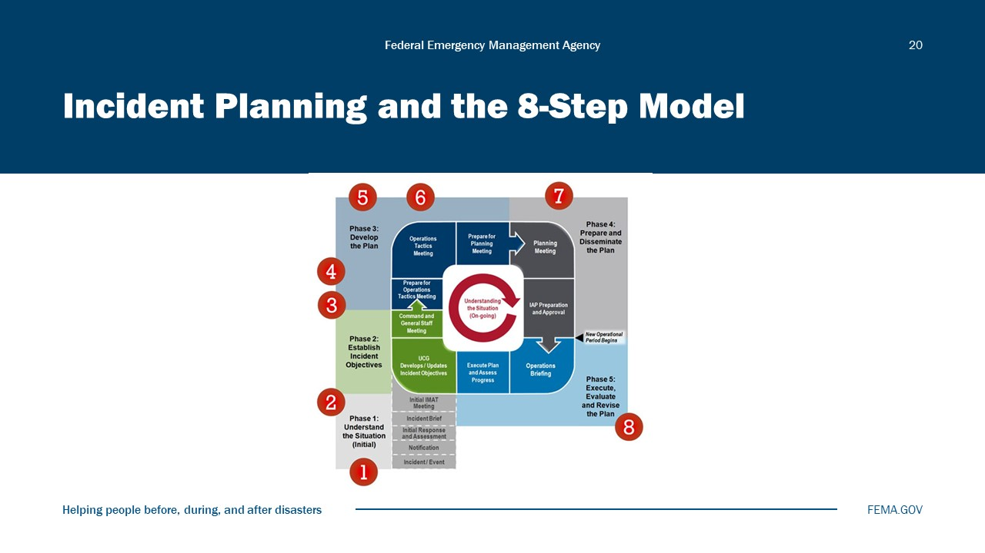
Visual 20, Incident Planning and the 8 Step Model

The Incident Action Plan (IAP) and the 8-Step Strategic Communications Model are part of the overall incident planning process, and they reflect broader goals as well as specific objectives.
The 8-Step Model presents some broad concepts (e.g., social marketing), and the Model is particularly well-suited to specific projects that may be undertaken in support of objectives from a functional plan or the overall strategic communications plan.
The concepts presented in the 8-Step Model (marketing mindset, SMART objectives, audience segmentation, partnership relationships, etc.) are all valid techniques for developing a strategic communications plan in line with the Incident Commander’s priorities.

Activity 3.2: Incident Communication Strategy
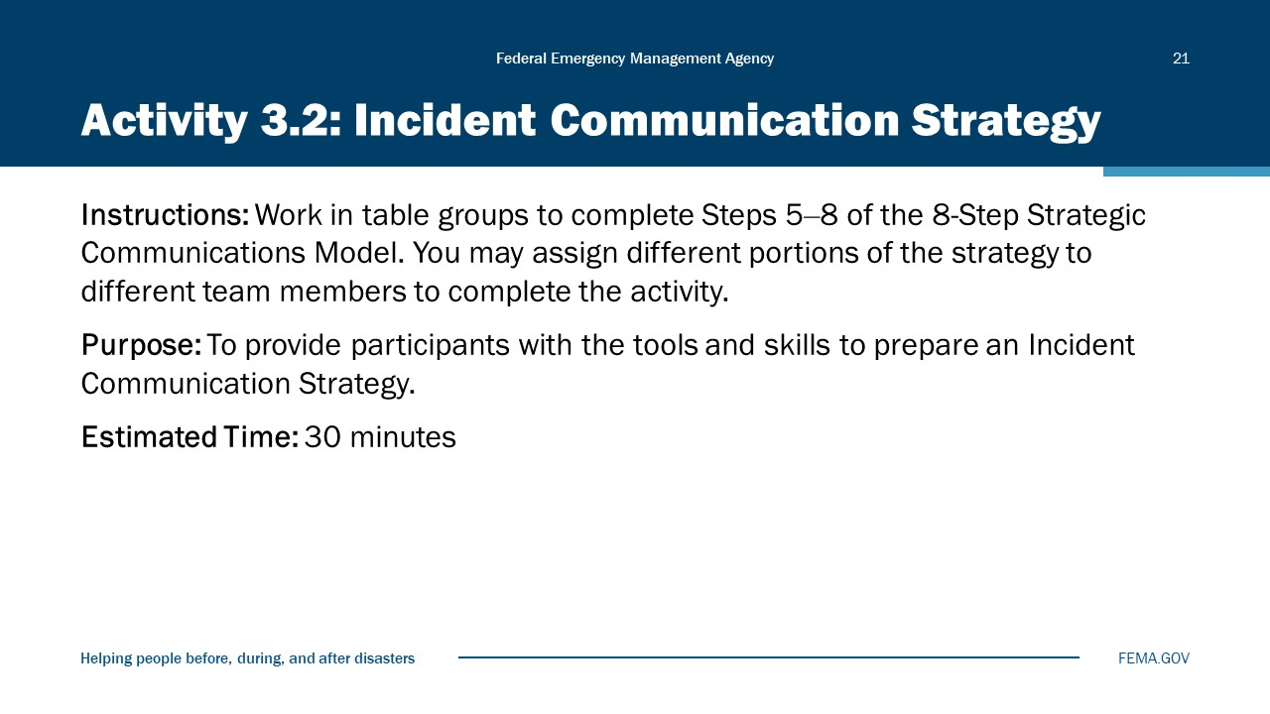
Visual 21, Activity 3.2: Incident Communication Strategy

Purpose of Activity: The purpose of this activity is to provide you with the tools and skills to prepare an Incident Communication Strategy. You will work in groups to develop a high-level strategy and will then report out to the class.
Instructions:
- Working in your table group, develop an Incident Communication Strategy based on the scenario update on the next page. You may consult the main scenario from Activity 2.1.
- Make sure to fully develop Step 4.
- Complete Steps 5, 6, 7, and 8 only after fully developing Steps 1‒4.
- You have 30 minutes to complete this activity.
Scenario Update:
Approximately 20,000 fans are expected to attend the championship game. The traditional rivalry between the Columbia State University Warhawks and the Washington State University Bulldogs has resulted in physical conflicts between the opposing fans in past games. Inclement weather including heavy snowfall and cold weather prior to the game will increase the difficulty for Central City DPW to clear the parking lots and streets in preparation for the big game. The possibility of a student protest prior to the game may reflect poorly on the University. Law enforcement intelligence does not indicate any serious threats of violence; however, student protests of a similar nature in other states have resulted in damage to buildings along with threats to researchers.
Task:
You are the Central City PIO. You have been tasked with developing an incident communications strategy in the event of fan unrest and potential violence among protestors. Use Worksheet 2.2 to plan the strategy and your message. Refer to the 8-step process for information on each step.

Module Summary
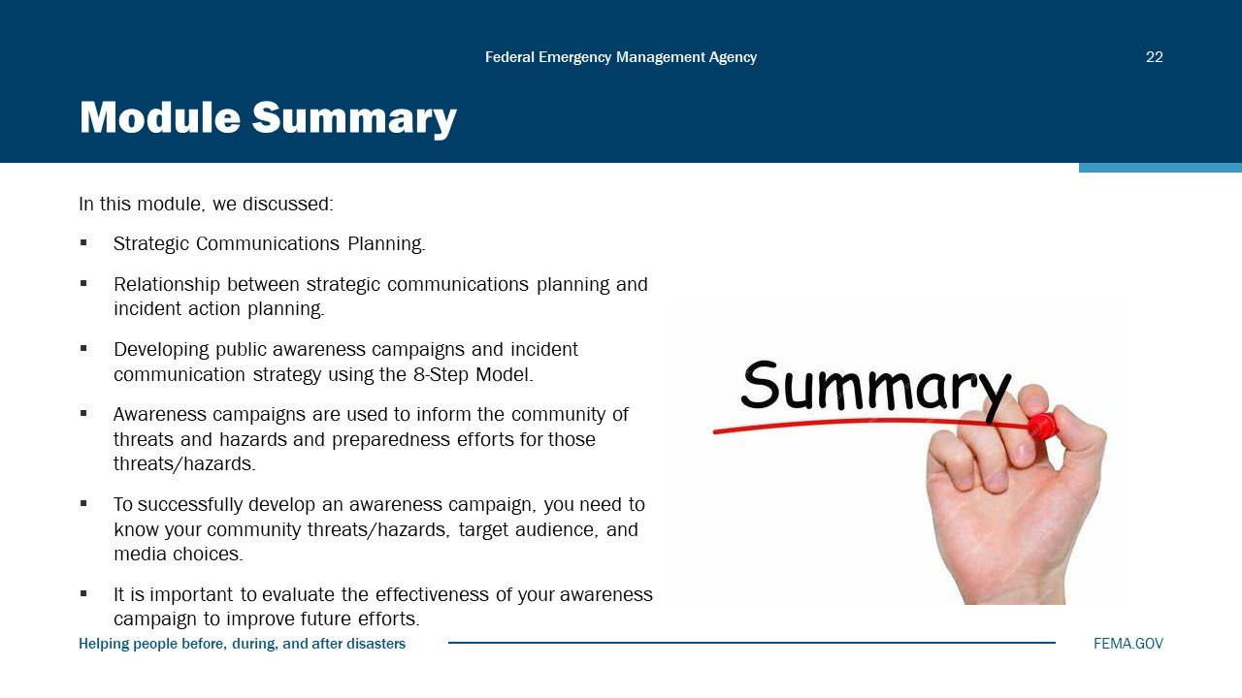
Visual 22, Module Summary

In this module, we discussed:
- Strategic Communications Planning.
- Relationship between strategic communications planning and incident action planning.
- Developing public awareness campaigns and incident communication strategy using the 8-Step Model.
- Awareness campaigns are used to inform the community of threats and hazards and preparedness efforts for those threats/hazards.
- To successfully develop an awareness campaign, you need to know your community threats/hazards, target audience, and media choices.
- It is important to evaluate the effectiveness of your awareness campaign to improve future efforts.

Reference List
FEMA 8-Step Strategic Communications Model (https://emilms.fema.gov/is_0029a/groups/81.html)

The Ultimate Guide to SMART Goals (https://www.forbes.com/advisor/business/smart-goals/)

FEMA Ready Campaign (https://www.ready.gov/about-us)

Preparedness Calendar (https://www.ready.gov/calendar)

Incident Action Planning Guide (https://www.fema.gov/sites/default/files/2020-07/Incident_Action_Planning_Guide_Revision1_august2015.pdf)

Module
4
PIO Roles and Responsibilities

Administration
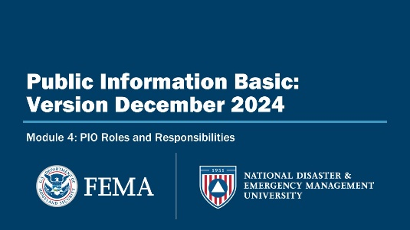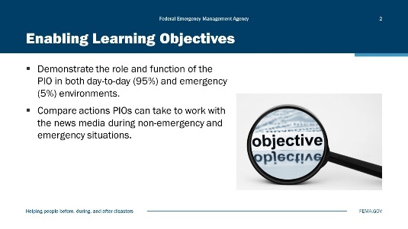
Visual 1, PIO Roles and Responsibilities Visual 2, Enabling Learning Objectives

Duration
1 hour; 30 minutes

Terminal Learning Objective (TLO)
By the end of this module, you will be able to explain the roles and function of the PIO.

Enabling Learning Objectives (ELOs)
By the end of this module, you will be able to…
- Demonstrate the role and function of the PIO in both day-to-day (95%) and emergency (5%) environments.
- Compare actions PIOs can take to work with the news media during non-emergency and emergency situations.

Public Information Officer - A Command Staff Position
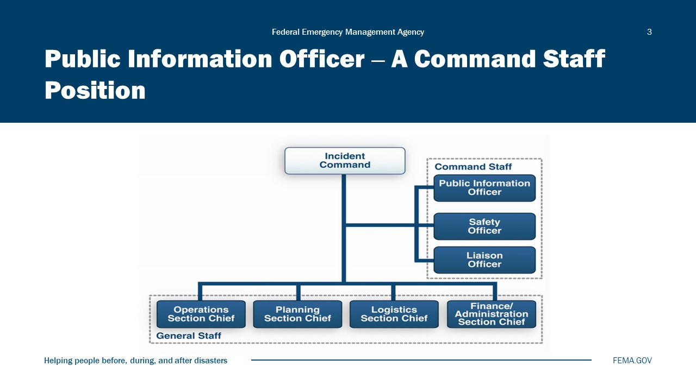
Visual 3, Public Information Officer - A Command Staff Position

PIO Adds Value
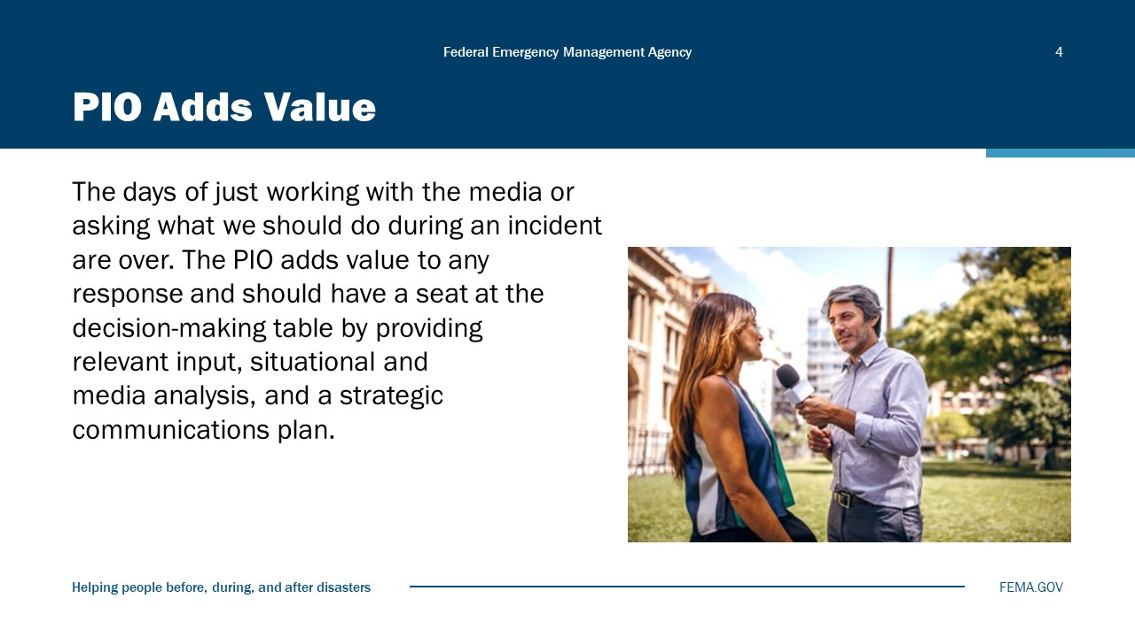
Visual 4, PIO Adds Value

This module provides you with an overview of the need for, nature of, and importance of public information in support of emergency management. Proactive decision-making is important. Earn the respect of the Incident Commander as part of the Command Staff—you have a seat at the table.

PIO Has Changed
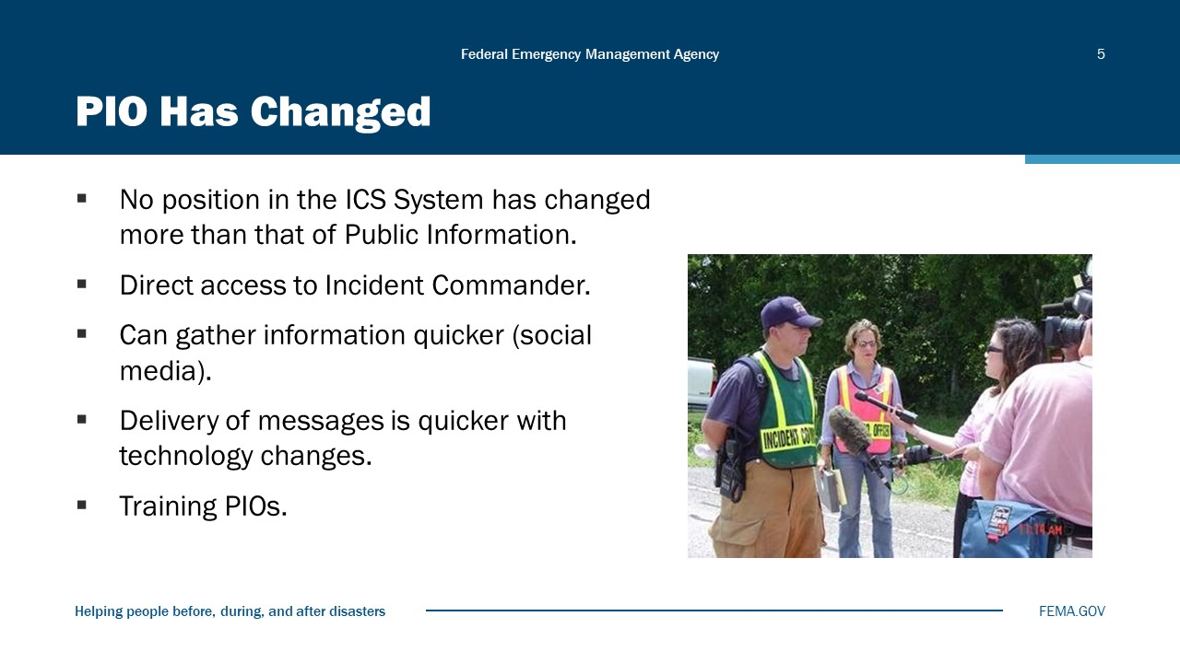
Visual 5, PIO Has Changed

Day-to-Day vs. Incident Tasks
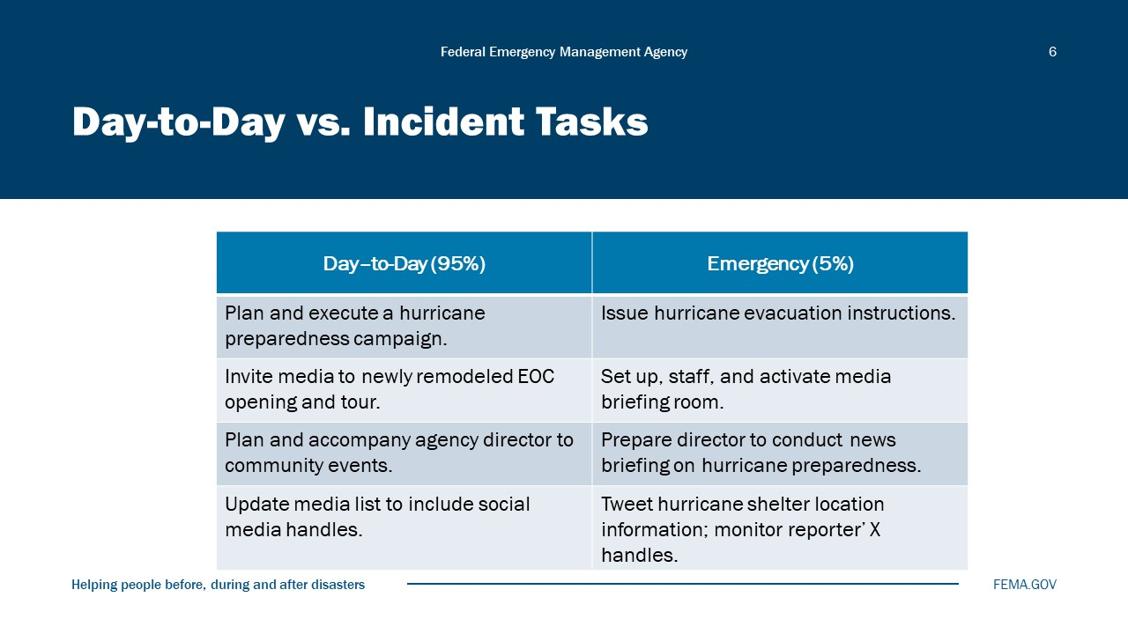
Visual 6, Day-to-Day vs Incident Tasks

Day-to-Day (95%) | Emergency (5%)
Plan and execute a hurricane preparedness campaign. | Issue hurricane evacuation instructions.
Invite media to newly remodeled EOC opening and tour. | Set up, staff, and activate media briefing room.
Plan and accompany agency director to community events. | Prepare director to conduct news briefing on hurricane preparedness.
Update media list to include social media handles. | Tweet hurricane shelter location information; monitor reporters’ X handles.

Manage Information (1 of 2)
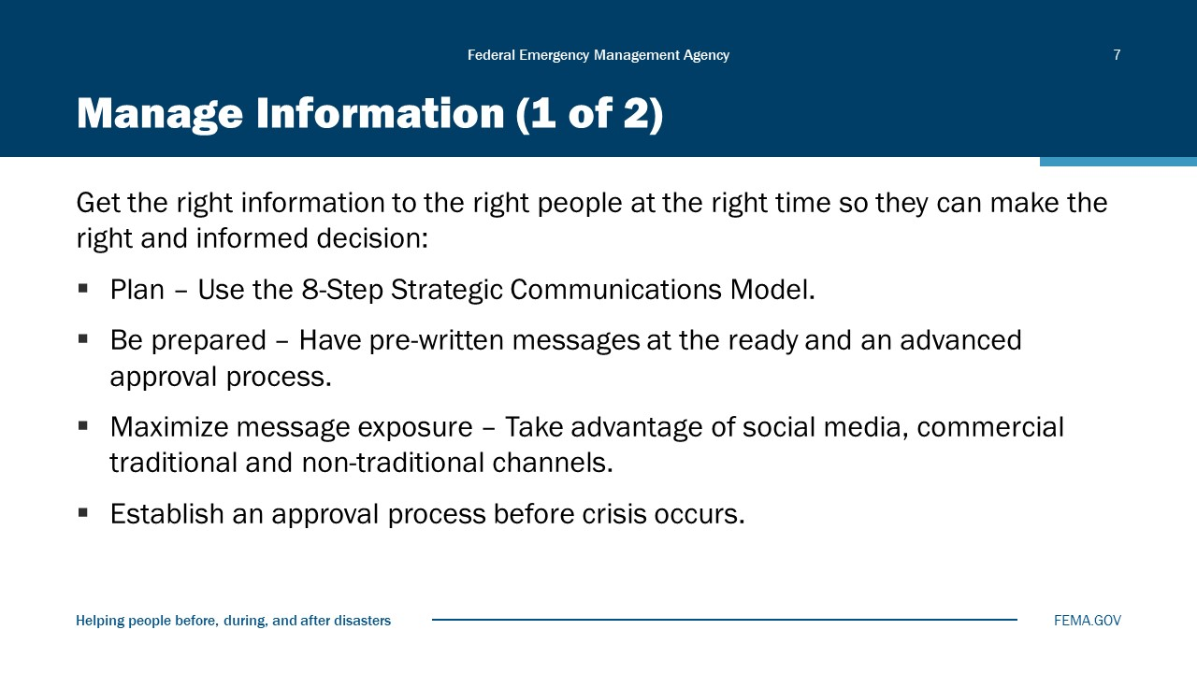
Visual 7, Manage Information (1 of 2)

As defined in NIMS, public information consists of the processes, procedures, and systems for communicating timely, accurate, and accessible incident information. Public information, education strategies, and communications plans help ensure that numerous audiences receive timely, consistent messages about lifesaving measures, evacuation routes, threat and alert system notices, and other public safety information.
The process of getting information to the public during an incident is an ongoing cycle that involves four steps:
- Gathering information
- Verifying information
- Coordinating information
- Disseminating information
Plan – Start by using the 8-Step Strategic Communications Model. The 8 steps are:
- Assess the current situation.
- Set measurable communication goals.
- Define your intended/”target” audiences.
- Develop and pretest your messages.
- Select the best ways to deliver those messages.
- Create an action plan.
- Develop and pretest materials.
- Implement and evaluate the plan.
Be prepared – Develop your key messages ahead of time and have them ready. Make sure that everyone on your team knows the key messages and supporting messages and has practiced using them. It is often easy to get off topic, and practicing these messages and having them written in front of you to remind you will help you use them most effectively.
Maximize message exposure – Take advantage of social media. Use X (formally known as Twitter), Facebook, YouTube, and other social media to get your message out. You should have already established accounts, or if you don’t, work with someone who does to ensure the information gets out in a timely fashion. Build a cadre of followers as these people will help get your message out during a disaster. Also remember when using social media in a disaster to use the following tips:
- Take some precautions and turn off automatic feeds so inappropriate items don’t go out.
- Craft your messages carefully to get the important information out and so that it can be easily distributed.
- Establish locations where people can get additional information and timeframes of when new information will be available.

Manage Information (2 of 2)
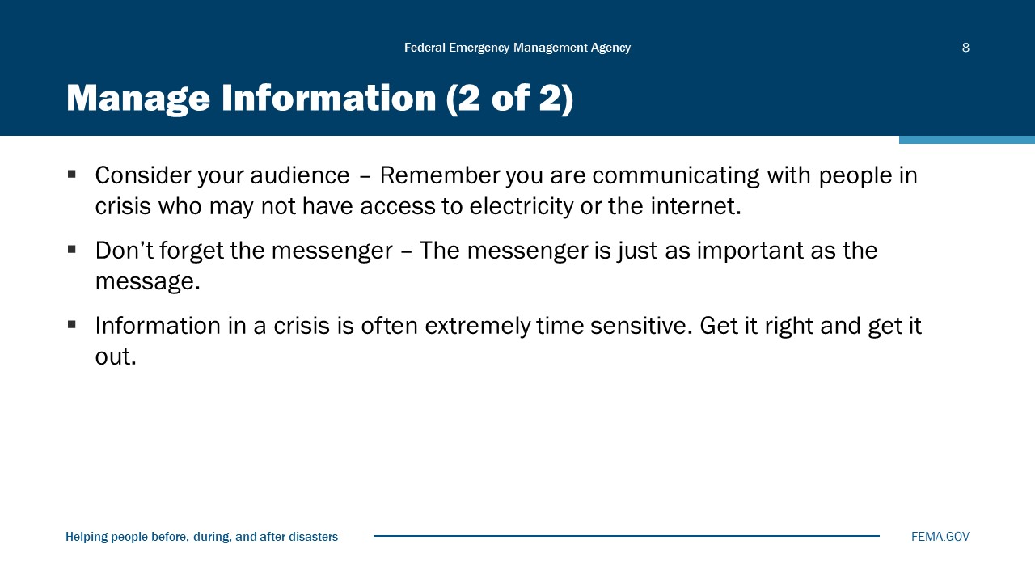
Visual 8, Manage Information (2 of 2)

Consider your audience – Remember you are communicating with people in crisis. Be careful to communicate with those affected and family members first. Realize that these people will be under stress. Be aware of how you phrase things and the impact this can have on those in the crisis. Don’t talk about the opportunity for few survivors with the media with the families standing there. Be situationally aware of who is around you, who could be listening, and how quickly information can travel in the day of instant news through social media.
Don’t forget the messenger – The messenger is just as important as the message. Make sure that you have reliable and respected spokespersons to deliver your message. Find those people in the community that have strong networks to help get your message across. If you don’t know who those people are, you can establish who those networkers are by conducting interviews with your target audience and asking them who they turn to for information, who they trust, and who they know with a strong network in the community.

Getting Information to the Public
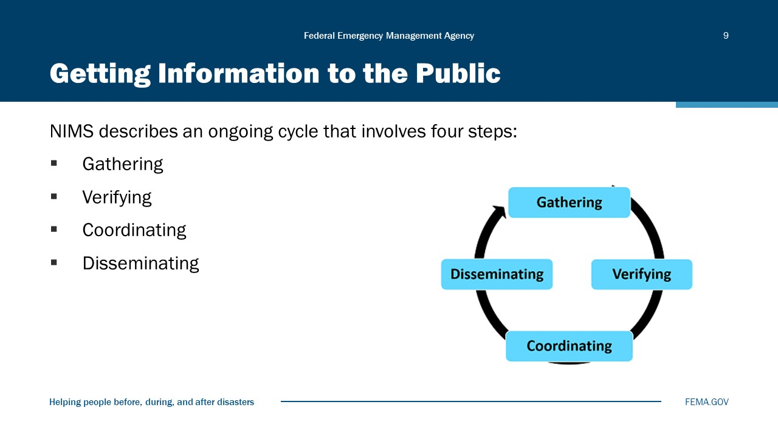
Visual 9, Getting Information to the Public

Whole Community Needs
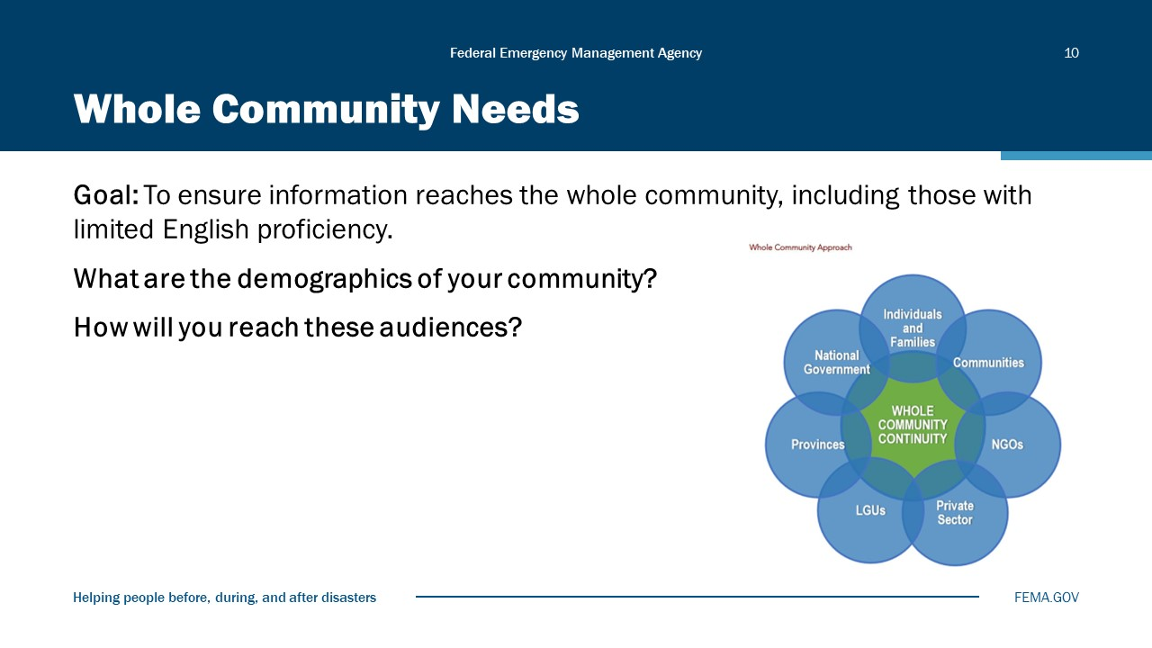
Visual 10, Whole Community Needs

Conduct Interviews
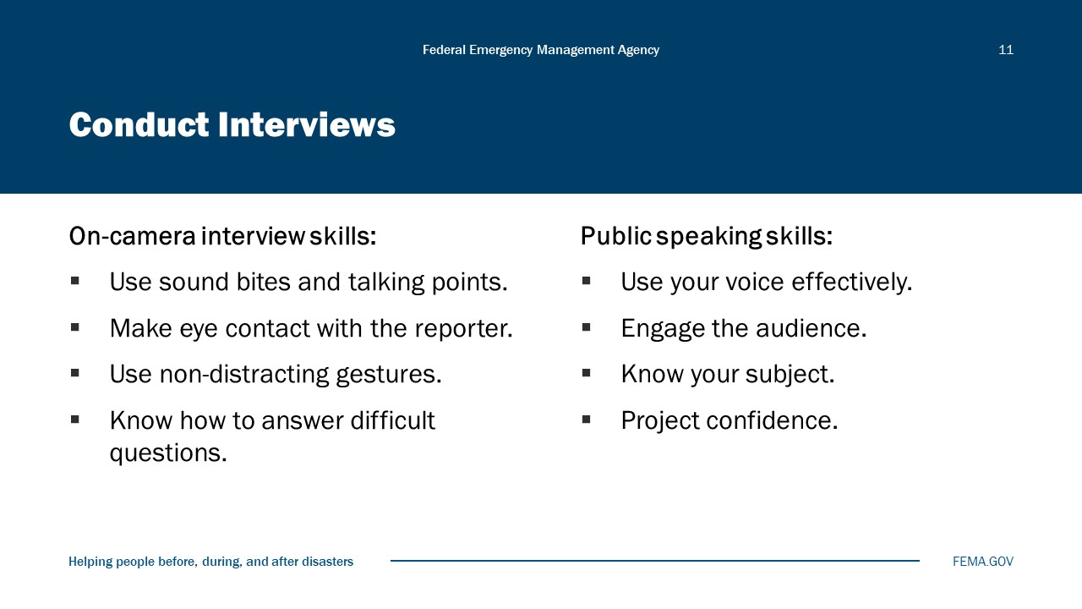
Visual 11, Conduct Interviews

Brush up on interview techniques. Consider the following do’s and don’ts for on-camera performance:
DO:
- Know what you want to say. It is the best way to control the interview and accomplish your objectives.
- Know your main point and stick to it. Too many messages will be confusing to the reporter and the public.
- Be positive, yet realistic. Turn a negative question around and answer it in the positive. If asked, “Why didn’t the police department use search dogs immediately?” instead of saying, “We didn’t use search dogs earlier because . . .,” say: “We have used a full range of search strategies, including search dogs.”
- Show compassion and empathy.
- Know when to stop. Stop talking when you’ve made your point. Don’t speculate and don’t feel that you must fill empty air space.
- Whenever possible, summarize your key points at the end of the interview.

DON’T:
- Don’t speculate. If you don’t know the answer to something, say so. Don’t offer your opinion.
- Don’t answer hypothetical questions. Hypothetical questions often begin: “What if . . .” Don’t answer questions that require you to make assumptions.
- Don’t comment on other organizations, unless to thank them for their efforts.
- Don’t comment on what others have said, particularly if you haven’t heard or read it yourself. It may cause you to verify something that might not be true. Don’t lose your temper. You can stand your ground without losing it.
- Never lie. NEVER!
- Don’t say anything to a reporter you don’t want to see online, in print, or on TV. Always assume that microphones are turned on.
- Don’t use “off the record” even if you have a long-standing relationship with a reporter. Consider this: if the information gets out from a source other than you, other reporters may run with the information while the reporter you trusted misses out on the story by respecting your request to keep the information off the record.
- Don’t say “no comment.” There is always an alternative, such as admitting you don’t have an answer but promising to get one.

Work with the Media
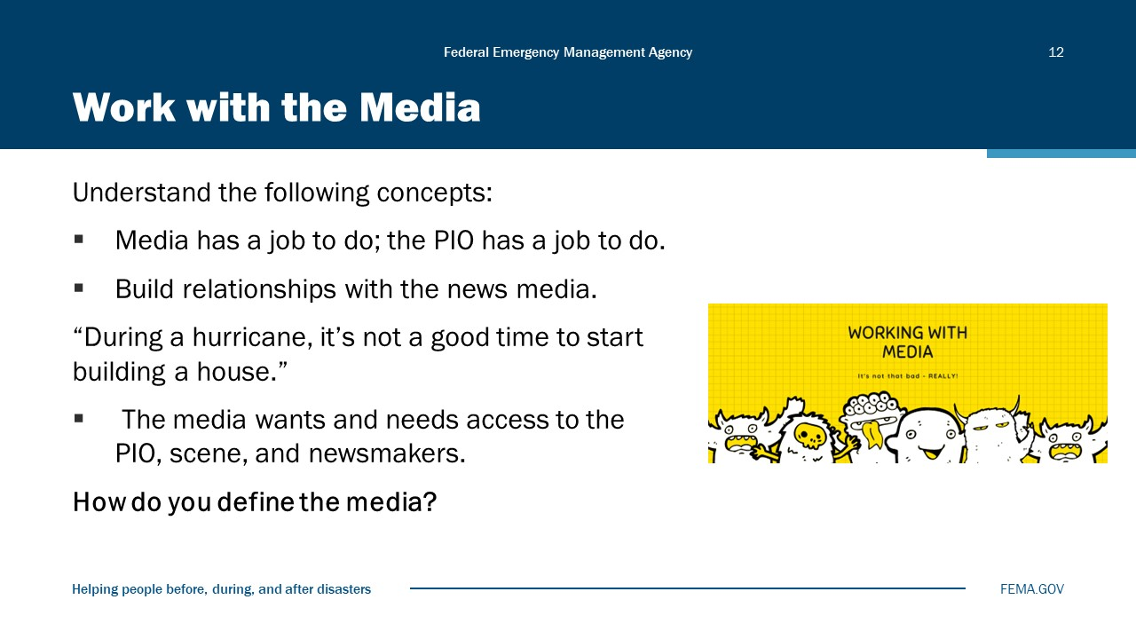
Visual 12, Work with the Media

Working with the news media
- Understand the things you can do to build relationships with the news media:
- Be accessible and return calls, texts, and e-mails promptly. Even if you don’t have all the information immediately, being accessible and responsive builds your credibility.
- Coordinate access to the scene and to policymakers, responders, and survivors.
- Treat all media fairly, meaning you don’t play favorites with media or reporters.
- If you have breaking news, share it with everyone.
- Understand that the media wants and needs access:
- The First Amendment provides for freedom of the press.
- At the Federal level, the Freedom of Information Act (FOIA) defines agency records subject to disclosure and outlines mandatory disclosure procedures.
- Local sunshine laws also ensure that the news media have access to information.
- Understand the types of news media and their needs:
- All print media, especially newspapers:
  - For longer stories, may need more detailed information.
- Stories can vary from brief to highly detailed. For example, a newspaper will run personnel items such as appointments and promotions when other media may not.
- For longer stories, print media may need help in collecting long-term statistics, biographies, etc.
- Need information several hours before going to press, BUT online editions of print media change this limitation as deadlines are reduced or eliminated.
- Magazines:
- Are issued on a less frequent basis and require more advanced planning.
- Can be a good option for some in-depth feature stories.
- May be more targeted to a particular audience you want to reach.
- Television:
- Seeks stories with drama or dramatic visual content. One producer described his evening news as “the was and the fuzz,” because it focused on deaths and law enforcement.
- Is less likely to want an in-depth feature, although it can happen.
- May want a staging area for live broadcasts from the scene of a story.
- May accept your video clips (this is market-dependent; know your market!).
- Radio:
- May or may not have a field reporter, so is more likely to rely on you to contact them. Nationally, it is becoming more and more common for local radio stations to have no news staff or even live announcers.
- Review your contact list to make sure you have an electronic contact to send them sound bites or short interview sound clips.
- Wants you to pay attention to the station’s theme or strong focus, such as news, farm, or youth orientation.
- Social Media:
- Can add news items very quickly but may edit its Website at only certain hours of the day. Be aware of the site’s operating procedures.
- Often tied to print or television outlet and prefers to pick up news from that outlet.
- In terms of news releases and content, should be treated like a newspaper.
- Understand the impact of changing technology:
- Local media of all formats use Websites and want breaking news fast. They want to be the first with the headline, Tweet, or RSS feed and often seek a quick rundown as the incident breaks. And they post “breaking” news to their Website long before their newscast takes place.
- They may not wait for validation of information, which means that media monitoring is essential. Fact checking is ongoing; information is published/broadcast first, then “updated” later.

Coach Speakers
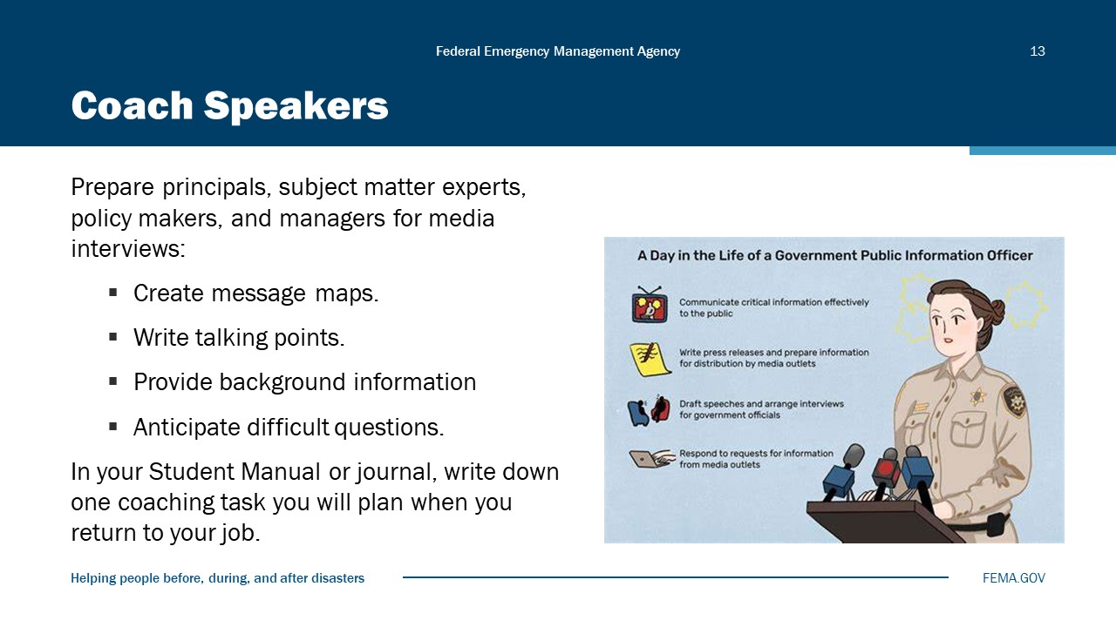
Visual 13, Coach Speakers

An important part of a PIO’s job is to make sure spokespersons are trained and ready to speak to the media at a moment’s notice.
During steady state (95%):
- Plan to hold group training and practice sessions with potential spokespersons in your organization. Spokespersons should know the basic techniques for handling print, radio, and television interviews.
- Once or twice a month, schedule one-on-one practice sessions with potential spokespersons within your organization. Practice ideas include:
- Simulate a radio interview by making an audio recording of the spokesperson answering four or five questions within their area of expertise. Keep the questions simple. Play back the audio file and discuss strong points and areas for improvement.
- Practice sound bites. Again, keep it simple. Depending on their level of expertise, you can record them answering questions about what they had for breakfast (emphasizing speaking in sound bites) or more complex program questions if the person is ready.

During an incident (5%):
- Brief spokespersons on key messages, background information, incident-specific hot-button issues, and any other pertinent information.
- Remember that the message is as important as the messenger. Choose wisely.

Activity 4.1: Difficult Situations
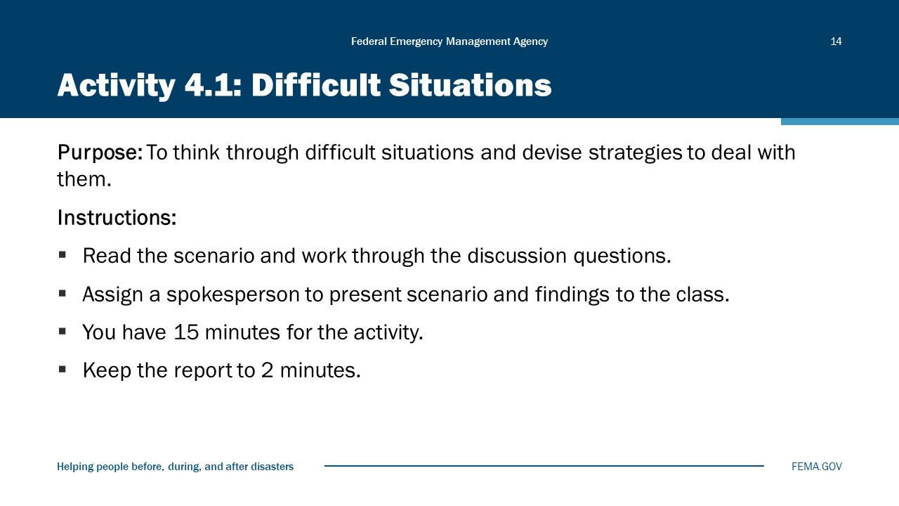
Visual 14, Activity 4.1: Difficult Situations

Purpose: To think through difficult situations and devise strategies to address them.
Instructions: Read the scenario assigned to your table group and work through the discussion questions. Assign a spokesperson to recap your group’s scenario before presenting findings to the class. When reporting your findings, provide a very brief synopsis (three to four sentences) of your scenario and explain key strategies your group came up with using the 8-Step Strategic Communications Model. Keep the report to 2 minutes. The scenarios are:
- Scenario 1: Pool Party
- Scenario 2: Loaded Question
- Scenario 3: News Conference Gone Wrong
- Scenario 4: Social Media Bites Back (#Fail)
- Scenario 5: The Misquote
Time: 10 minutes for the table group discussion; 10 minutes for reports and debrief.

Scenario 1 – “Pool Party”
The wildfire had burned for 7 days, fueled by high temperatures, windy conditions, and dry terrain. Hundreds of firefighters had responded, and hundreds of acres had gone up in flames, including at least one neighborhood of high-priced homes. Roadblocks have kept reporters away from the devastation and the active firefight, although they’ve had access to a staging area and have been able to interview firefighters. The fire is now 90-percent contained, and you are willing to take a pool into the devastated neighborhood. You’ve selected one network-affiliated TV reporter, one AP photographer, and a reporter from the large daily paper in your state. However, the other reporters are very vocal about their displeasure with the size of the pool and the press members you’ve selected. Most want a larger pool, or a second pool, but a few are demanding complete access to the site.
Discussion questions: How do you respond? What do you do to prevent such a situation from happening again? What is the best way to “pick” pool members?
Scenario 2 – Loaded Question
Your agency director is taking questions at a news conference. It is the first anniversary of a particularly high-profile issue (lack of adequate and geographically accessible shelters) that affected primarily an economically depressed neighborhood. Your agency has done a good job putting in place new policies and protocols to address the issue, and you have fully briefed your agency director on the accomplishments to date. A reporter stands up to ask a question. He begins by recapping the issue and citing several “facts.” He states that your agency continues to ignore the needs of the community, as there are no designated shelters to date. Then the reporter asks: Don’t you think this is clear evidence of extremely discriminatory practices?
Discussion questions: How do you handle this situation while it is happening? What could you have done to reduce the consequences?
Scenario 3 – News Conference Gone Wrong
You are holding a news conference updating reporters on the status of a school shooting. The shooter—a student armed with his father’s hunting rifle—has been killed; seven other students and two teachers have been wounded and taken to local hospitals. They are expected to survive. You start by reading a statement recounting the facts and then open the floor for questions. The first questions are appropriate—how many officers responded, where did the shootings occur, what was the motive? Then a reporter begins to ask questions about the shooter’s parents, their gun history and the state’s gun control laws. Other reporters jump on the gun control angle and begin asking for your opinion on the National Rifle Association, the Second Amendment, and the ability of people to buy unregistered guns at gun shows.
Discussion questions: How do you handle the situation while it is happening or right after? What would you do next time to reduce the chance of this happening again?

Scenario 4 – Social Media Bites Back
Your agency had been slow to accept social media and has just started a Twitter feed. Although you already have 2,500 followers, you’d like to see that number grow 10-fold. To create some excitement and energy, you send out a tweet: We’re here to support you. Tweet photos of your interactions with our officers and use the hashtag #goodnewsaboutus. Unfortunately, the photos coming thick and fast are not images of happy interactions. They show a variety of negative encounters, including one that appears to show an officer shooting a dog.
Discussion questions: How do you handle this onslaught of negative images on social media? How do you handle the resulting news story about the campaign? What social media policy do you put in place to help prevent this from happening again?
Scenario 5 – The Misquote
Your agency director has granted an interview to a newspaper reporter from your city. You have developed a good rapport with the reporter and feel it is a good time to go “on the record” about the issue. The issue at hand is complicated—and controversial—but your director does a good job fully explaining the situation and why your agency has taken the action it did. You feel the interview went well and are optimistic about the upcoming story. However, when the story runs a week later, above the fold on the front page, you’re not sure you were sitting in the same interview as the reporter. The facts are incomplete, the quotes are taken out of context, and there are places where it’s clear the reporter failed to understand the intricacies of the situation. The headline, particularly, is a nightmare.
Discussion questions: What options do you have to push back against the story? What could you have done differently? What will you do differently in the future?

Personal Readiness
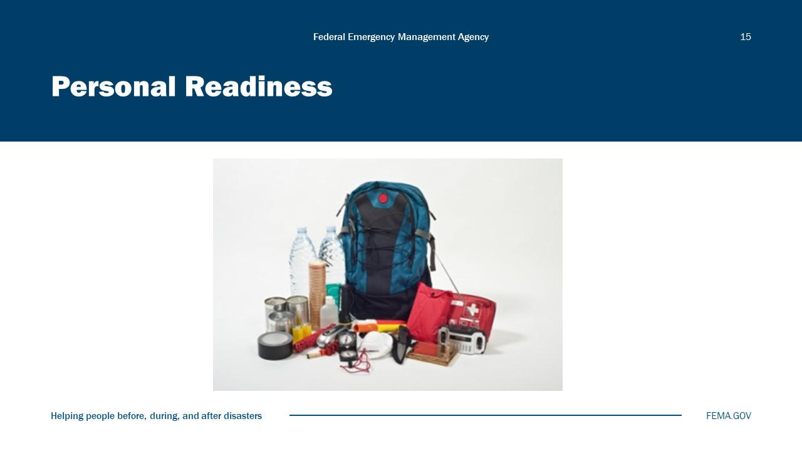
Visual 15, Personal Readiness

A go-kit is a mobile response kit that allows PIOs to function in the event that they are working outside of their normal place of operation. When using a go-kit during a disaster, consider having a second phone or phone number in case reporters all call one phone number.
Complete the checklist on the next few pages. Check off the things you would plan to include in your go-kit and add other items as you see fit.
To enhance your answers to the checklist, frame your decisions along the following scenario:
- Through a mutual aid agreement, you are deployed to a nearby community to help out the local emergency management Public Information Officer responding to a deadly mudslide. You are deployed on day two of the incident. There are no hotel rooms available, but logistics is setting up short-term lodging camps for responders. You are told to bring all the essentials you need as the camp will only have the bare necessities available, especially in the first few days. Cell and internet connectivity may be spotty.
- Considering this scenario, complete the checklist below.
PIO Go-Kit Checklist
Equipment
- Computer(s) with wireless capability
- Mobile devices with chargers and spare batteries; additional phone; portable chargers
- Digital camera (most people use their mobile devices but carry one as a backup)
- Other:
Information
- Elements of the crisis communications plan in electronic and print format (including PIO team contact lists and information materials). Note that print copies are important in case there is no electricity. Include information in various electronic formats (external memory, bookmarked resource Websites, etc.)
- Updated media contact list, including outlet Website addresses and reporters’ social media handles
- Manuals and background information necessary to provide needed information to the public and media
- Topic-specific fact sheets, backgrounders, talking points, and news release templates (hard copy and electronic)
- Other: Paper, pens, markers, flagging tape, stapler for message boards, etc.
Other Resources
- Business cards with 24/7 contact information
- Funding mechanism (i.e., credit card, etc.) that can be used to purchase operational resources as needed
- Paper forms in case there is no electronic access (i.e., no Internet access, power outage, etc.). Incident notebook to document your actions and observations.
- Other:
Personal Care and Comfort Items
- Glasses/contacts (spares)
- Prescription medications; basic first-aid supplies
- Weather-appropriate gear (e.g., rain poncho, umbrella, gloves, sunscreen)
- Hand sanitizer, wipes, paper towels
- Energy bars, nuts, water
- Emergency contact information in case your family cannot get through to your cell phone
- Other:

Discussion: Alert and Warning Systems
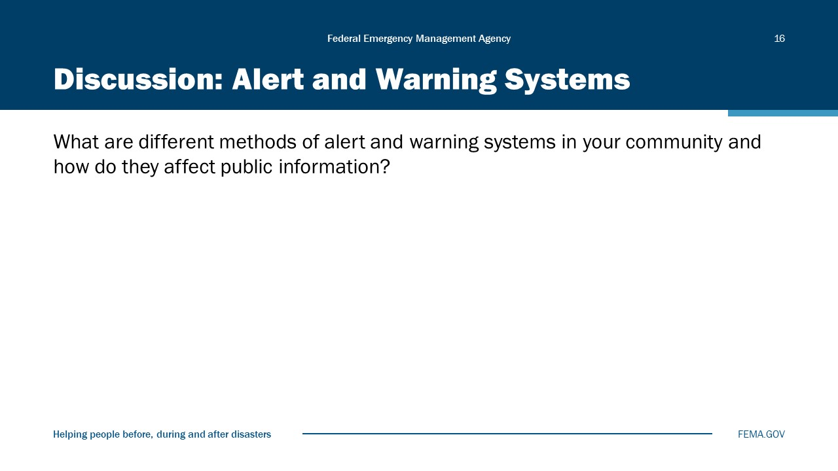
Visual 16, Discussion: Alert and Warning Systems

Module Summary
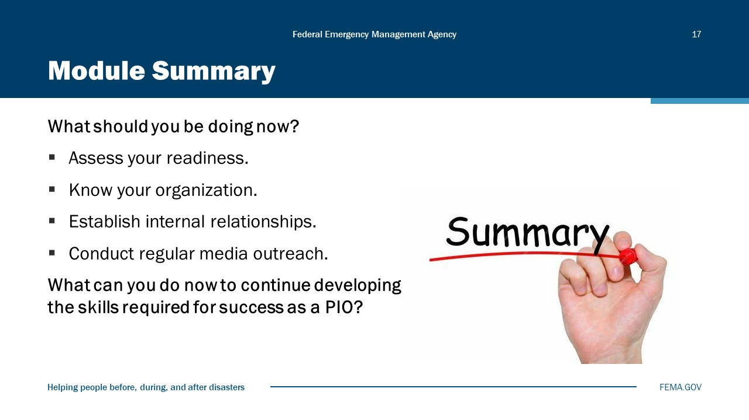
Visual 17, Module Summary

Reference List
A Whole Community Approach to Emergency Management (https://www.fema.gov/sites/default/files/2020-07/whole_community_dec2011__2.pdf)

Build a kit (https://www.ready.gov/kit)

Module
5
PIO Content Skills Workshop

Administration
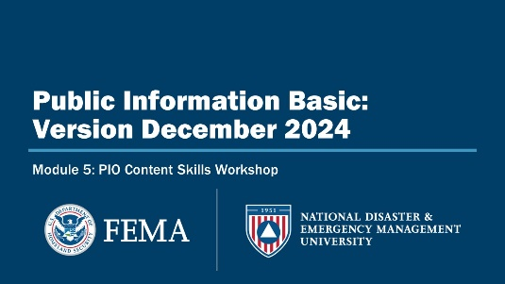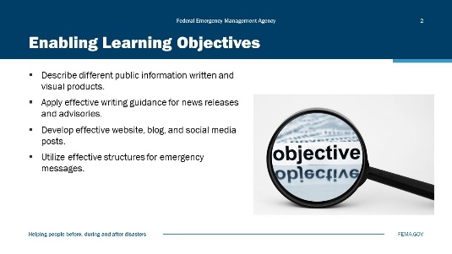
Visual 1, PIO Content Skills Workshop Visual 2, Enabling Learning Objectives

Duration
2 hours.

Terminal Learning Objective (TLO)
Describe and apply proper writing to build written public information products.

Enabling Learning Objectives (ELOs)
By the end of this module, you will be able to…
- Describe different public information written and visual products.
- Apply effective writing guidance for news releases and advisories.
- Develop effective Website, blog, and social media posts.
- Utilize effective structures for emergency messages.

Types of Written Products
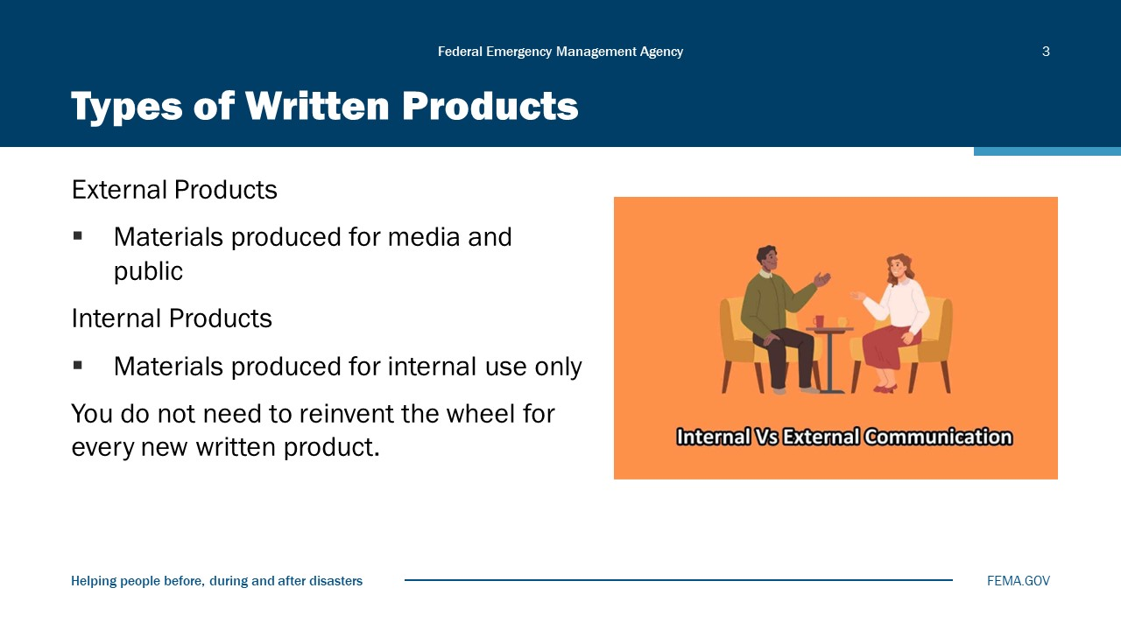
Visual 3, Types of Written Products

Review the two types of written products:
- External Products
- Internal Products
You do not need to reinvent the wheel for every new written product. You can repurpose written products. For example, information from a press release can be repurposed for social media posts, talking points, etc.

External Products
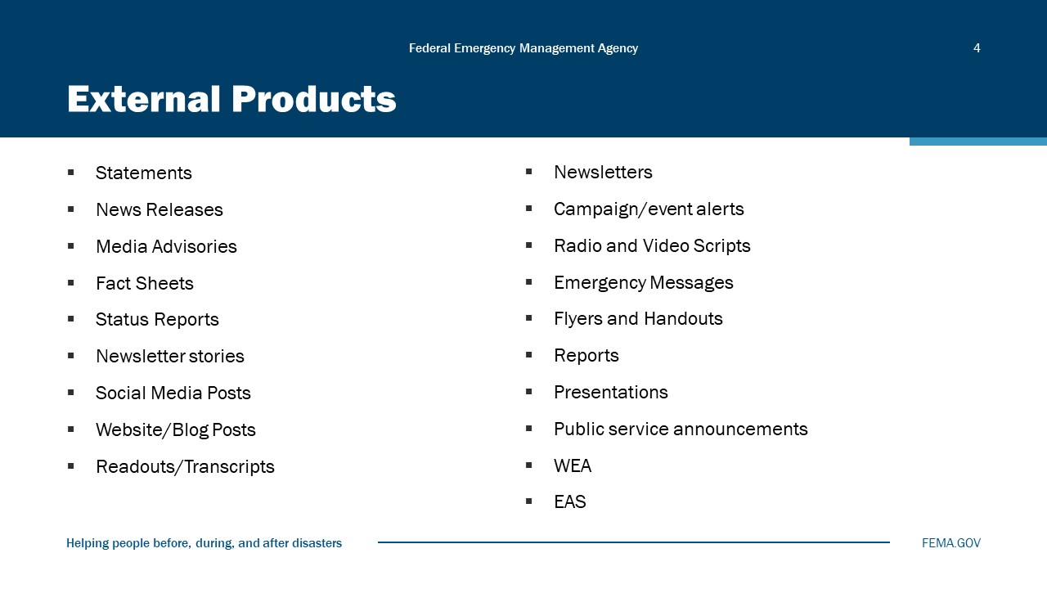
Visual 4, External Products

There are several external products used by the PIO, including:
- Statement: Used in lieu of a news release. Issued in print; less detailed than a press release. Good to use when you’ve received multiple media calls on the same topic.
- News release: Used when there is a factual report of an activity or incident of news value.
- Fact sheet: Used when you need to provide more detail than possible in a news release.
- Media advisory: Used to invite the media to an event or news conference. Provides basic information (what, where, when, and why); provides directions.
- Talking points: Used to prepare yourself or someone else for a telephone or broadcast interview. Written as sound bites—concise, simple to understand. For internal use only—not for distribution to the news media.
- Web and social media products: An increasingly important avenue; includes web pages, blogs, and Tweets. Emphasize that you do NOT have to reinvent the wheel for every written item. You can repurpose much of the material from a press release for social posts, talking points, etc.
- Public Service Announcements (PSAs): Used when you want to enlist the cooperation of the electronic media in promoting an important message.
- Newsletter articles: Used to communicate within the organization or may be a feature in a newsletter that reaches another audience.
- Brochures, fliers, and other handouts: Used to provide background information to supplement a news release, provide photos or graphics, etc. Remember not to overwhelm the reporter with too much or extraneous information. Sometimes “less is more.”
- Wireless Emergency Alerts (WEAs): Short emergency messages from authorized Federal, state, local, tribal, and territorial public alerting authorities that can be broadcast from cell towers to any WEA‐enabled mobile device in a locally targeted area.
- Emergency Alert System (EAS) messages: Formerly known, until 2022, as an Emergency Action Notification; the national activation of the Emergency Alert System (EAS) used to alert the residents of the United States of a national or global emergency such as a nuclear war or any other mass casualty situation.
Each of these products has value in a public information program.

Internal Products
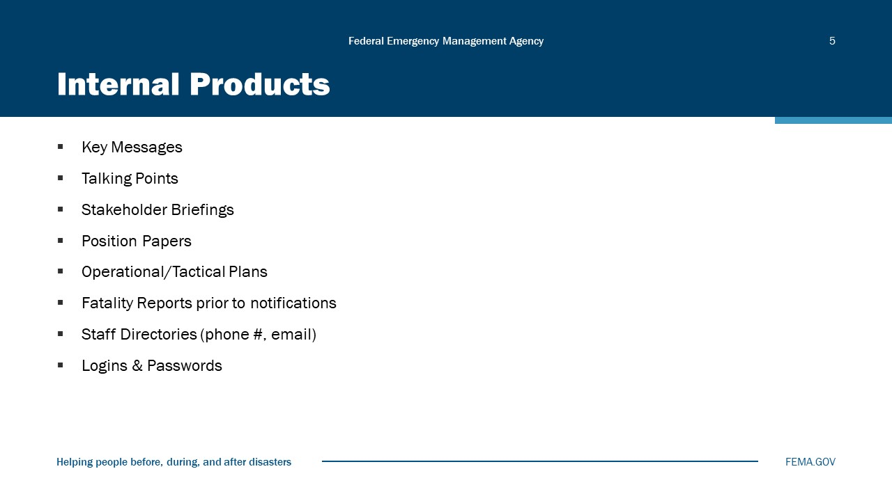
Visual 5, Internal Products

Internal products are those drafted for internal use only and include:
- Key messages are the core messages you want your target audience to hear and remember. They create meaning and headline the issues you want to discuss.
- Talking points are used to prepare yourself or someone else for a telephone or broadcast interview. Written as sound bites—concise, simple to understand. For internal use only—not for distribution to the news media.
- Position papers, operational or tactical backgrounders, and back-pocket information. The purpose of a position paper is to generate support on an issue. It describes a position on an issue and the rationale for that position. The position paper is based on facts that provide a solid foundation for your argument. Backgrounders are written in chronological order or narrative fashion and are used to provide important ‘background information’ to contextualize an event, person, or issue. Back-pocket information refers to additional information available verbally only if someone asks for it.

News Releases
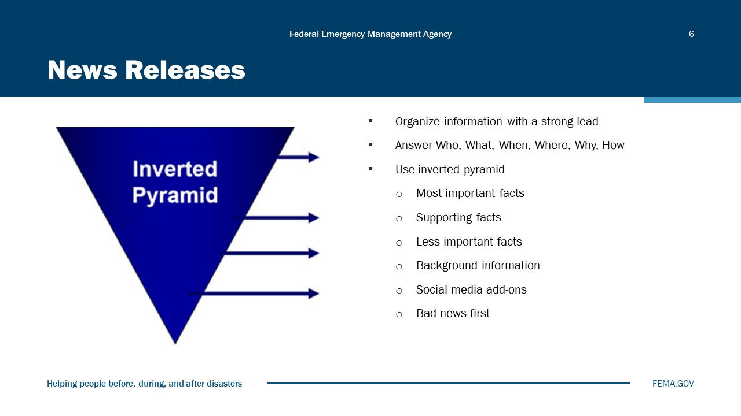
Visual 6, News Releases

Talking Points
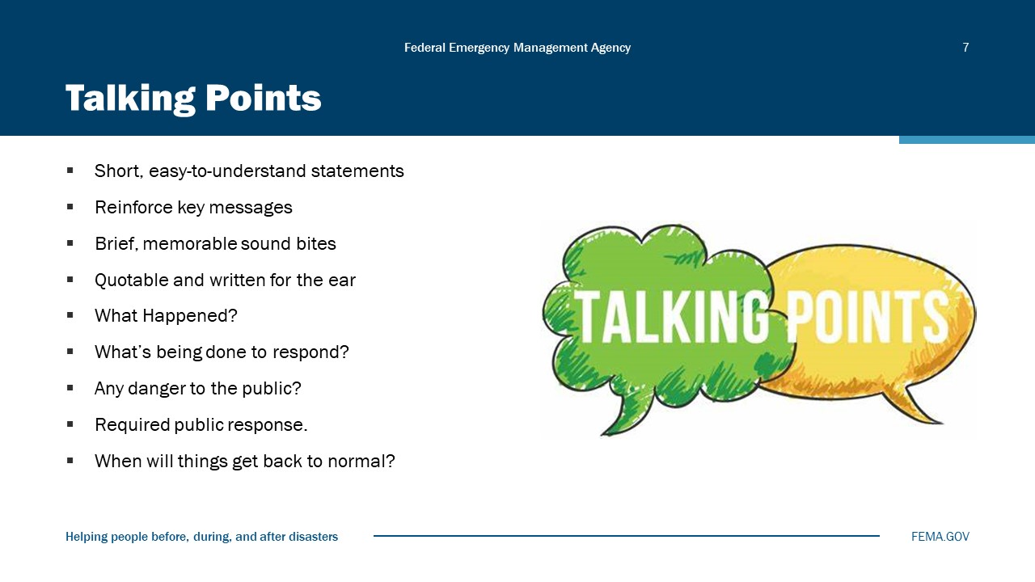
Visual 7, Talking Points

- What happened?
- What are you doing about it?
- What’s the current public threat?
- What should the public do right now?
- Who, if anyone, is coming to help?
- If affected, where to get assistance?
- When will the danger/threat be over?
- How long will it take to get back to “normal?”

Activity 5.1: Writing an External Product
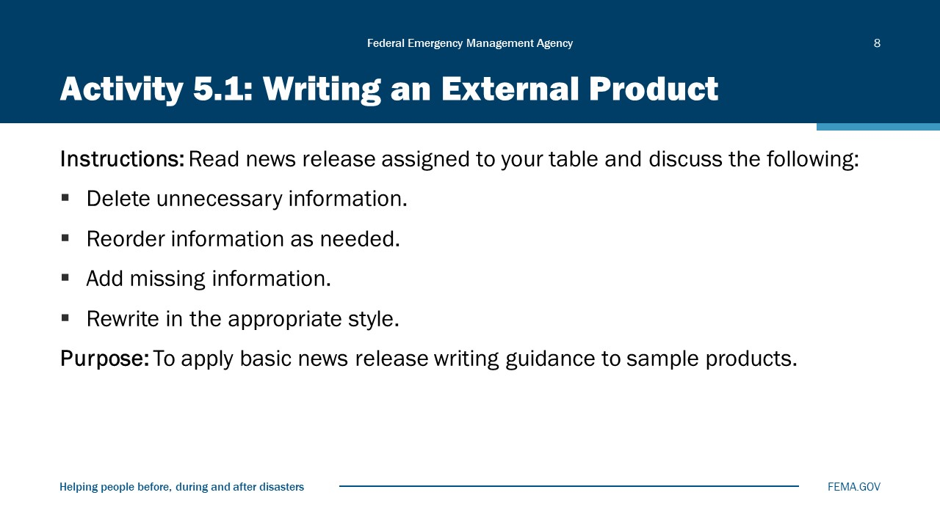
Visual 8, Activity 5.1: Writing an External Product

Total Time for the Activity: 30 minutes
Purpose of the Activity: To apply basic news release writing guidance to written products.
Instructions:
Use resource materials available (i.e., dictionary, thesaurus, AP Stylebook).
Work in your table groups to edit a written product so that it fits its purpose and reflects good journalistic style.
- Turn to the sample written products in the Student Manual. Each table group will be assigned one written product.
- Work in your table groups to edit your assigned product by:
- Deleting any information that does not belong in the written product.
- Reordering the information, as needed.
- Rewriting in the appropriate style.
- Be prepared to report out in 15 minutes. In your report, include:
- Which written product you edited.
- What information you deleted (if any).
- How you rewrote the document (e.g., read aloud rewritten portions).
Written Product #1
Contact: J. R. Jordan Department of Emergency Mgmt. (800) 555-0321
NR #3 FOR IMMEDIATE RELEASE October 2, 2024
State Notified of Alert at Nuclear Power Station
CAPITAL CITY – The Columbia Department of Emergency Management has been notified by Municipal Power that an Alert was declared at a Nuclear Power Station today. The Alert notification ensures that emergency response personnel are available and on standby should the situation worsen.
As designated in the Columbia Radiological Emergency Response Plan, Annex Q, Sections 15.a to 15.j (rev) and pursuant to State law, the Columbia Emergency Operations Center is being augmented with additional personnel trained in emergency response, and local governments surrounding the plant have been notified and are on standby.
The affected power station—named Norton Station after the renowned physicist, Karl Norton—is located in the Smythson County.
Should the situation worsen, the Emergency Alert System (EAS) will be activated, and people residing or working in Protective Action Zone 1 will be advised to stay indoors, with all doors and windows closed and air conditioners and fans turned off until otherwise notified. Information to help citizens determine the Protective Action Zone in which they reside or work can be found in the Yellow Pages section of area telephone directories.
Currently, there is no danger or cause for concern for people living near the nuclear facility or in other areas of the County, according to state officials.
# # #
Written Product #2
Contact: Pat Kelly
#31 FOR IMMEDIATE RELEASE July 21, 2024
Homestead Police Announce Holiday Program
The Homestead Police Department’s mission is to protect and serve the people of Homestead. To that end, this year the department is reaching out to those in need to make the holidays a little brighter. This includes working with Project Head Start to bring Santa to the classroom and the popular “Shop-With-A-Cop” program.
Shop-With-A-Cop pairs police personnel with Head Start students for a holiday shopping trip. Merchants provide a selection of discounted gifts, which are paid for through the Police Community Association (PCA). Each child gets to pick up to five gifts for their friends and family members.
Members of the news media can take advantage of photo opportunities by calling 800-555-9887.
# # #
Written Product #3
Contact: CDEM Public Affairs (800) 555-6793
Saturday, December 12, 2024
Stay safe from chemical spills and terrorist attacks
CAPITAL CITY – The Columbia Department of Emergency Management (CDEM) urges citizens to stay away from Exit 9b on the cross-state Turnpike to avoid injury or death from a potentially dangerous chemical spill. Chemical agents can include poisonous gases, liquids, or solids that have toxic and lethal effects on victims. Do not attempt to rescue a victim of a chemical attack—you may become a victim yourself, say experts.
If you are at home when officials indicate evacuation is necessary:
- Gather emergency supplies of food, clothing, and water.
- If you are instructed to do so by local authorities, turn off all utilities at the main switch and close the main gas valve.
- Secure your dwelling by closing and locking windows and doors.
- Make arrangements for your pets. Public shelters may not allow pets.
- As soon as you are ordered to evacuate, do so promptly.
- Tell someone outside of the area where you are going.
- Follow recommended evacuation routes—shortcuts may be blocked.
If you are at work when officials indicate evacuation is necessary:
- Listen to your radio for guidance on protective actions.
- Follow your employer’s instructions to shelter in place or evacuate.
Written Product #4
News Release
FOR IMMEDIATE RELEASE
Contact: Dana Jordan (800) 555-0321 October 9, 2024
Dinwoody Police Officers Discover Marijuana
Dinwoody Police Officers looking for a lost child in the ten-mile area surrounding Wood Lake discovered marijuana plants growing in the St. John Botanical Gardens.
The plants were well disguised by thick plantings of bamboo and other Asian plants. The child had been separated from its parents who were visiting the Botanical Gardens. They were reunited at the visitor center.
The Officers and agents from DEA eradicated over 200 marijuana plants with an estimated street value of $65,000. The discovery is one of the largest seizures of live marijuana plants in the State this year.
The parents of the lost child were not available for comment.
Written Product #5
FOR IMMEDIATE RELEASE Contact: Jay Moore, PIO, NPEM
News Release #5-2024 24/7: 800-555-9966
Volunteer Sandbaggers Needed
NORTH PLAINVIEW, Columbia—Volunteers have started a sandbagging operation in North Plainview in an attempt to seal off the water from flowing under the railroad tracks that run parallel along Highway 97 between Main and Cherry Streets in North Plainview. Emergency Management needs about 2,000 sandbags for the levees in Plainview County should the water begin to overflow.
Due to mudslides several roads have been closed in Plainview and traffic is being diverted. The City of North Plainview experienced extremely heavy rains over the past 5 days, resulting in flash flooding on the East side of town.
Currently, we are asking for volunteers to fill sandbags in anticipation of the rising Columbia River.
Written Product #6
Contact: Jan Morrison (800) 555-1234
NR #18 FOR IMMEDIATE RELEASE August 19, 2024
Media Advisory
(Not for Publication)
MEDIA BRIEFING SCHEDULED
GREENVILLE, Columbia – State Coordinator Casey Morton will hold a news conference at 6 p.m., Sunday, September 24, at the Greenville Emergency Operations Center to brief the media on the latest developments in the ongoing response to Hurricane Horatio. CDOT, CDH, and ARC will also attend the briefing.
The Columbia Department of Emergency Management (CDEM) has opened the Joint Information Center to provide people with updates on the hurricane response and information on disaster assistance. The phone number is (800) 555-1234.
CDEM requests that media representatives present identification at the entrance to the briefing.
Future briefings will be announced on a timely basis and as conditions warrant.

Approval Process
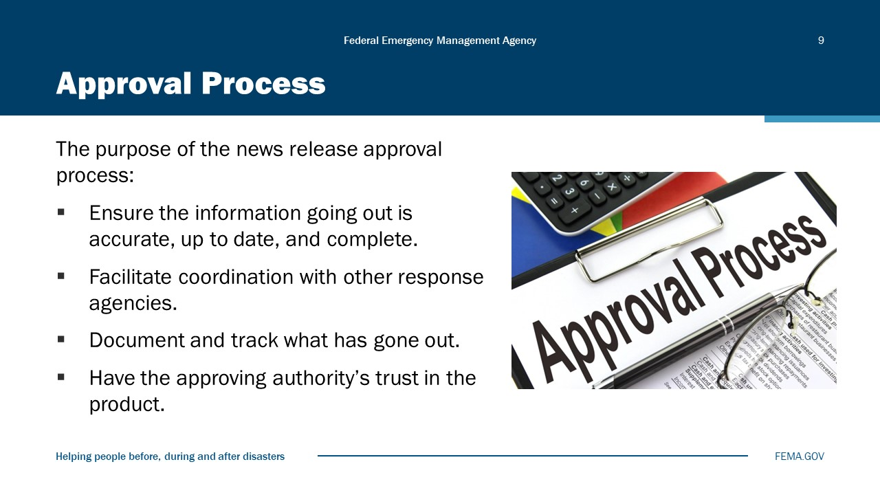
Visual 9, Approval Process

Approval processes for news releases will vary depending upon the organization and the incident, but the purposes remain the same:
- To ensure the information going out is accurate, up to date, and complete.
- To facilitate coordination with other response agencies.
- To document and track what has gone out.
- To have the approving authority’s trust in the product

Dissemination Process
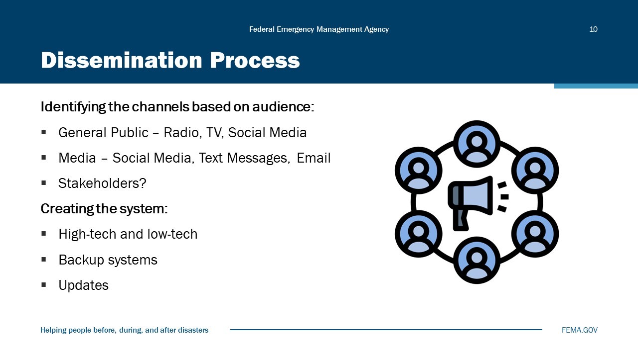
Visual 10, Dissemination Process.

The next process is dissemination—getting the message out—and the first step is identifying the channels you will use.
Never miss an update if you mentioned there will be one in previous briefings.
In place of mentioning an update at a specific time; use “updates will occur when we receive additional information.”

Tracking Process
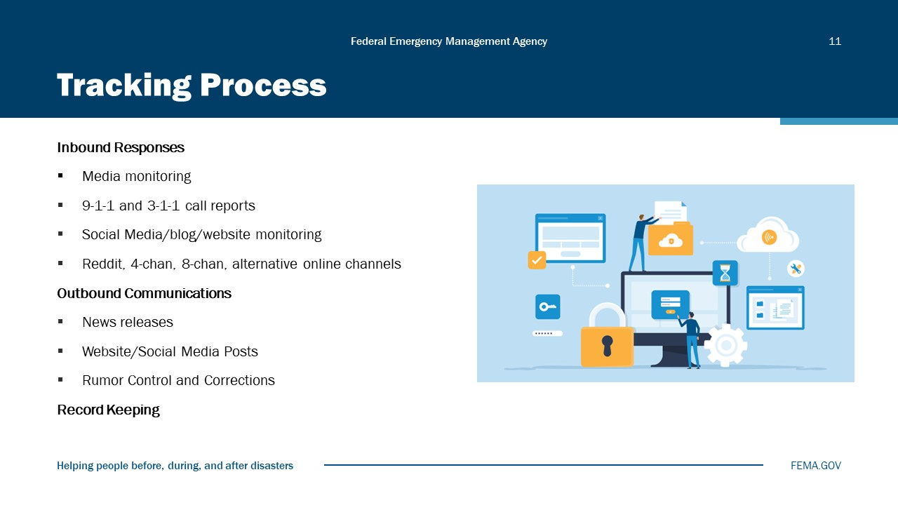
Visual 11, Tracking Process

U.S. Facts: Adults Over 16
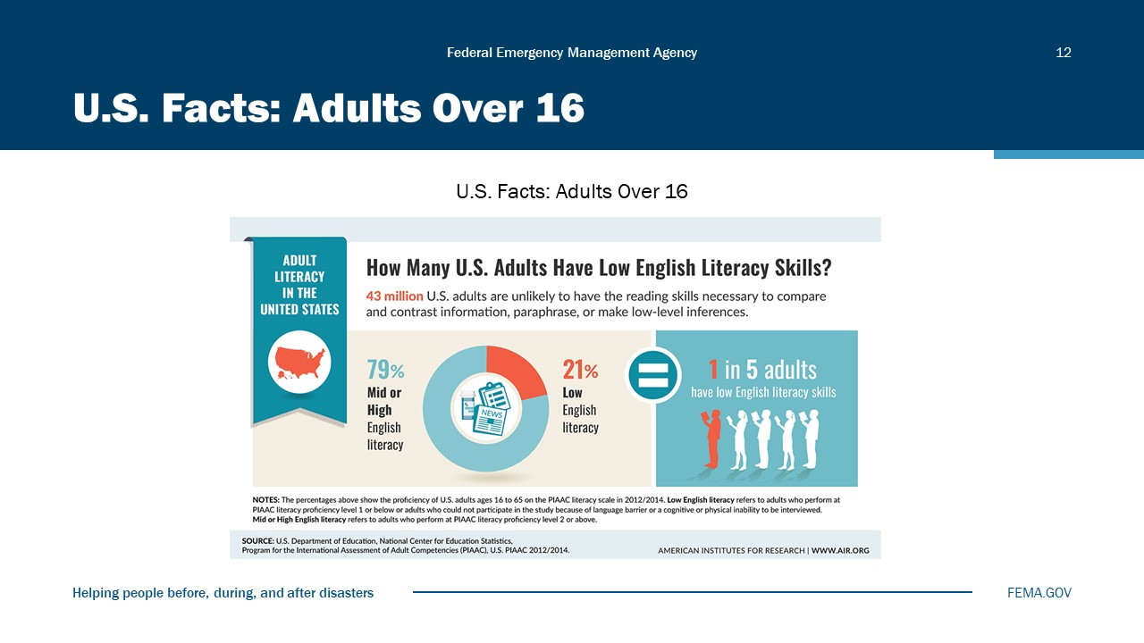
Visual 12, U.S. Facts: Adults Over 16

U.S. Facts: Adults Over 16
- U.S. Facts: Adults Over 16 (https://literacyproj.org/)
- On average, 79% of U.S. adults nationwide are literate in 2024.
- 54% of adults have a literacy below a 6th-grade level (20% are below 5th-grade level).
- Currently, 45-million Americans are functionally illiterate and cannot read above a 5th-grade level.
- 50% of adults cannot read a book written at an 8th-grade level.

Social Media for Public Safety
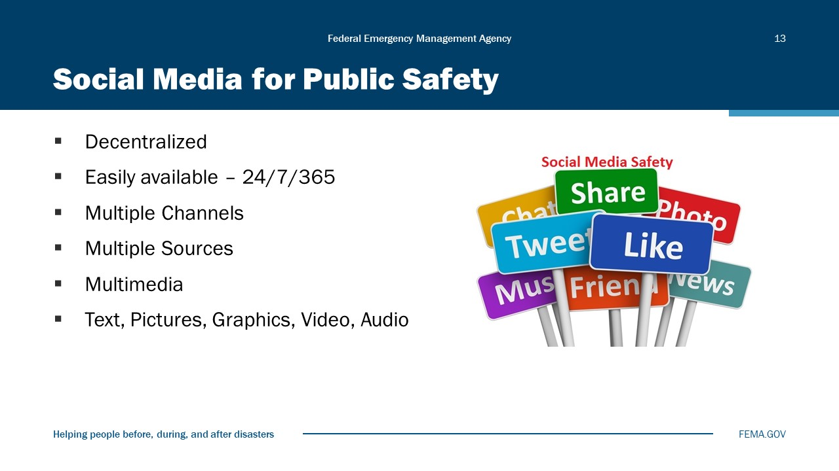
Visual 13, Social Media for Public Safety

Social media is different in that it changes media communication for emergency management in some key ways:
- It is decentralized and non-hierarchical. Not controlled by one or more entities. Anyone with access (any web enabled device, e.g., basic computer, phone) and minimal skills can post and view.
- It is usually immediate and available globally. What is publicly posted can be viewed immediately and by all, including those throughout the world.
- Multi-channel (two or more ways), multivariate, and multimodal. Multi-channel (two-way or more) posts can go out to a number of different services at one time. Posting on Twitter, Facebook, and to a blogpost all at once is not unusual. Media are multivariate as the way and the volume of the content posted may differ depending on the medium. A Facebook and Twitter post differ by the number of characters, the way they are displayed, and how the recipient receives them. Also, they may differ in the number of people who receive the message and the number of times it may be repeated, through “re-tweets,” linking, and reposts. Multimodal media can consist of text, pictures, video, or a combination thereof, and can be edited and reformulated with little control over how it might be presented.
- The public obtains its news from multiple sources and contributes to the media discourse. The public now obtains its news and information from multiple sources (TV, radio, and the Web) and chooses what, when, and how it wants it. In some ways, this can be viewed not as broadcasting, but as micro-channels.
Changes in media and public information.
Traditional Media
- One-way communication
- Press release
- Passive audience
Social Media
- 24-hour news cycle
- Media access everywhere
- Active audience
Traditional media was predominantly one-way communication born from radio and TV, the model of broadcast mass media. The press release was the main medium for emergency managers to release critical information. The target audience for media was passive and the news cycle was much slower paced, allowing for careful coding of the outgoing message to the media, public, and coordinating and cooperating agencies. Strongly based on command-and-control models, it worked well in controlling message content and timing as long as the news cycle maintained a consistent pace.
With the advent of the Internet and World Wide Web, the news media moved to a 24-hour cycle, and access to media at the site of a disaster event became more accessible and immediate. Now social media sites allow average citizens to post text, pictures, video, and links that disperse content quickly and widely. This new medium has outstripped the pace and volume of the standard press release and of mainstream and local media as well.

Creating Content for the Web
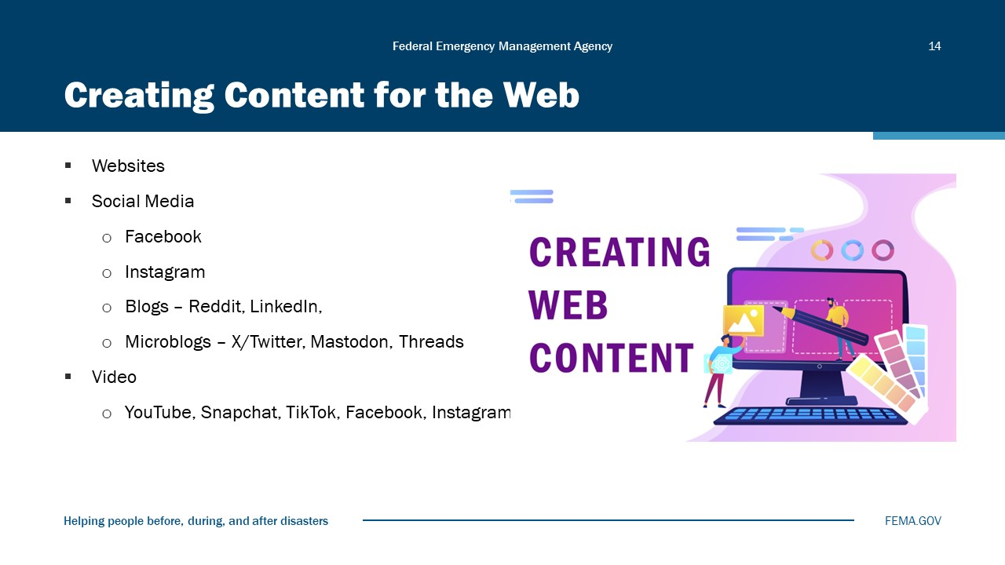
Visual 14, Creating Content for the Web

How People Read Online
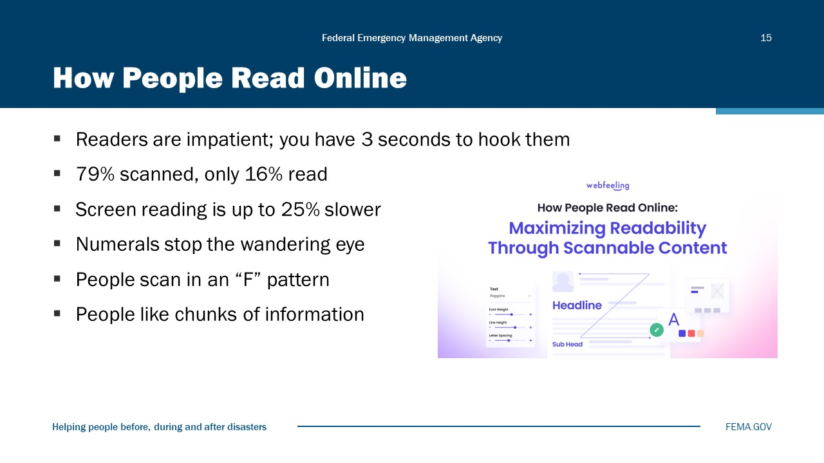
Visual 15, How People Read Online

According to Web usability studies:
- Some 79 percent of users always scanned any new page they came across; only 16 percent read word-by-word.
- Reading on a screen takes longer than a printed page. Some studies have shown that reading on a monitor is up to 25% slower than reading on a page.
- Numerals often stop the wandering eye and attract fixations, even when they’re embedded within a mass of words that users otherwise ignore.
- People scan Web pages in an “F” pattern: two horizontal stripes followed by a vertical stripe.
- Readers are impatient. You have 3 seconds or less to encourage people to read more.
- People like chunks of information– stand-alone blocks of text of about 100 words or less.
- We don’t like to scroll. We’re getting more accepting of it, but we don’t really like it.
Headlines, page titles, and subject lines are often displayed out of context as part of a list of articles or search engine results.
Reading on a computer screen is hard; reading on a small handheld device is even harder. As a result, people don’t really read on a screen—they scan.
The vast majority of us have been trained to read on the printed page. We hold it in our hand, adjust the page to maximize our comfort when reading, and mostly scan across pages from left to right following the text. As a new generation gets exposed to technology much earlier in life, this behavior is also changing.
People read printed materials in a linear fashion and rely on “hypotaxis”—a linear grammatical linking of one idea to another—to create meaning for us.
When people read on a screen, it’s often in a behavior of hunting for information where they scan the screen for what they want. Our eyes jump from section to section, and we rely on “parataxis”—short, simple sentences or ideas that stand alone—to find the information.

Techniques for Web Writing
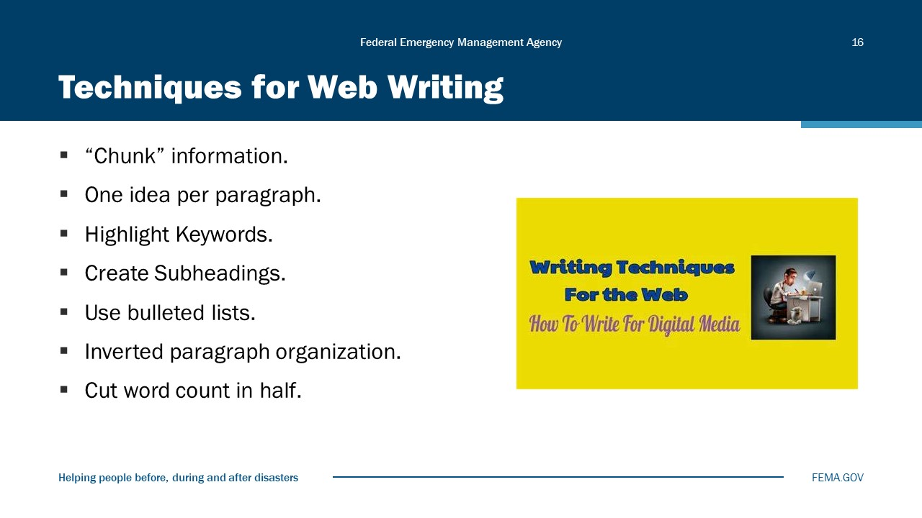
Visual 16, Techniques for Web Writing

When writing for the Web, create “scannable” content that makes finding key information easy for the reader:
- Highlight keywords (hypertext links, typeface variations, different color).
- Create meaningful subheadings.
- Use bulleted lists (a bulleted list becomes a chunk).
- Include numbers where appropriate—digits enhance the “scanability” of content—but spell out numbers that don’t represent facts.
- Use one idea per paragraph (if the first few words don’t grab the reader’s attention, they will skip it).
- Write content in the inverted pyramid style, starting with the conclusion.
- Cut your word count to half (or less) than conventional writing.
Cut extraneous information out of your copy.
Web expert Jakob Nielsen coined the term “blah-blah text” for a block of words that Web users typically skip when they arrive at a page. People’s eyes go directly to more actionable content, such as services, bulleted lists, or links.
- Brevity is best.
- Space is at a premium.
- Make every word count:
- Place most useful info at top.
- Break up text into chunks.
- Keep sentences and paragraphs short.
- Create narrow, bulleted lists.
- Eliminate white space.
The bottom line is to keep it simple, concise, and focus on answering two questions:
- What? (What will the reader find on this page—i.e., what’s its function?)
- Why? (Why should they care—i.e., what’s in it for them?)

Multimedia Options
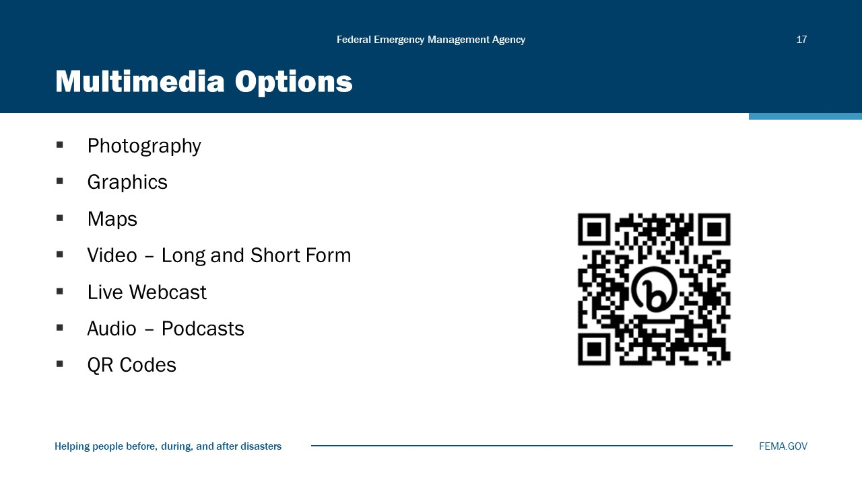
Visual 17, Multimedia Options

Activity 5.2: Make it Social
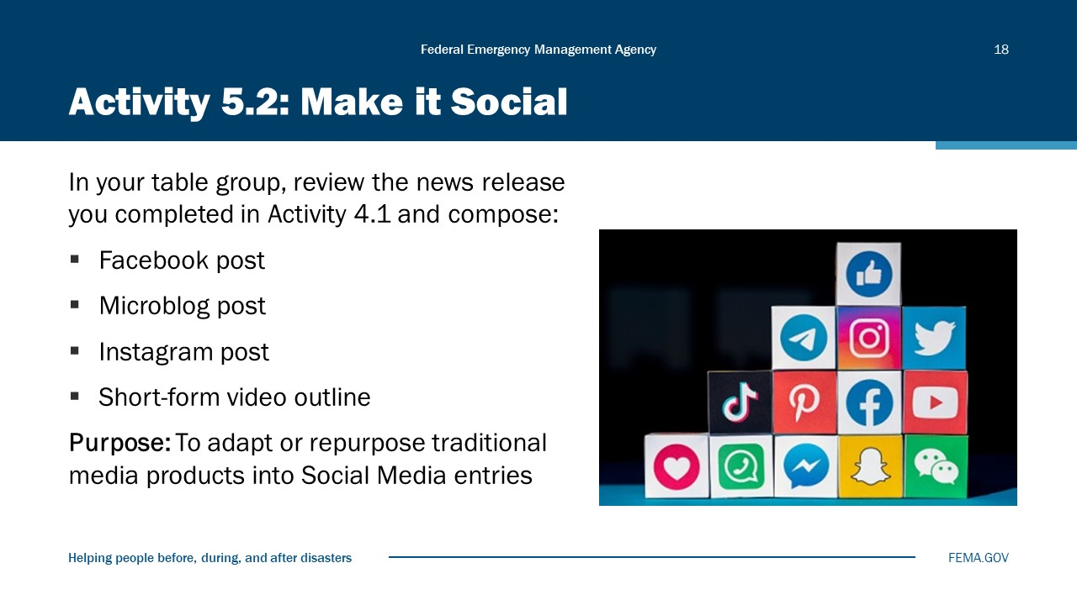
Visual 18, Activity 5.2: Make it Social

Total Time for the Activity: 15 minutes
Purpose of the Activity: To adapt or repurpose traditional media products into Social Media entries.
Instructions:
- You will work in table groups for this activity. Review the news release you completed in Activity 4.1 and write one each of the following:
- Facebook post
- Microblog post
- Instagram post
- Short-form video outline
- 1 Tweet
- 1 Facebook entry
- 1 idea for YouTube
- You have 15 minutes for this activity.
- If you are short on time, you can divide this work amongst the table, then get together to review it before reporting your work.

Social Media Training Resources
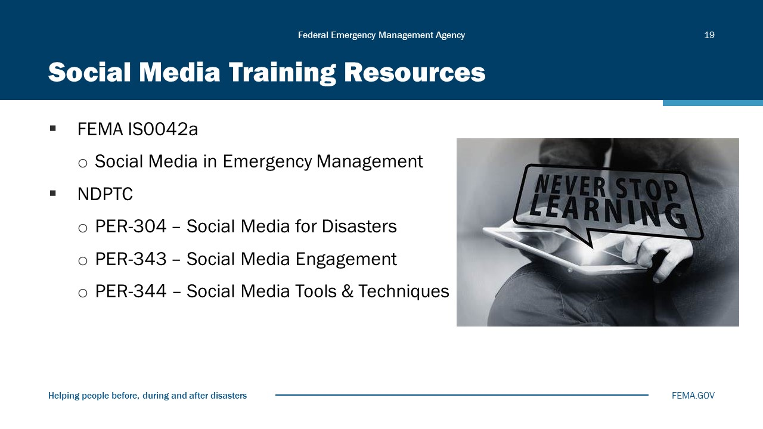
Visual 19, Social Media Training Resources

Independent Study course:
Go to the NDEMU Independent Study courses (https://training.fema.gov/is/)
- Search for IS0042.a, Social Media in Emergency Management.
- Take the free, online training course at your own pace.
- Resident course:
- PER-304: Social Media for Natural Disaster Response and Recovery. Information available through your state emergency management training office or enter the search term PER-304 social media on your favorite search engine.
Check your state and local training offices for additional resources.

Emergency Messages
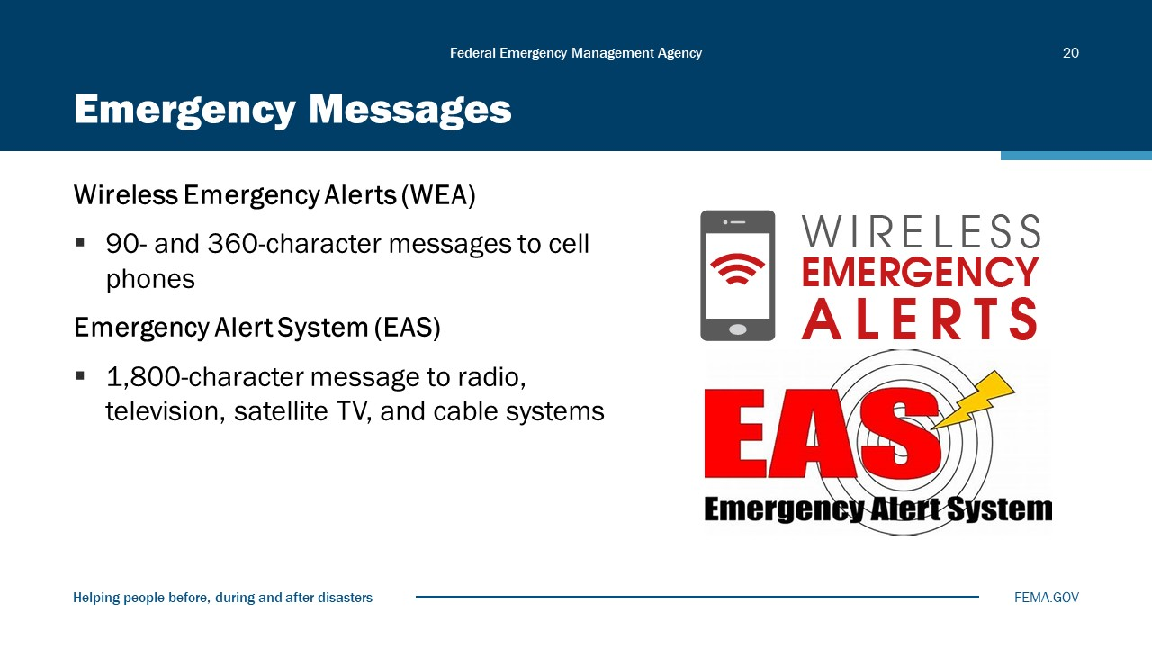
Visual 20, Emergency Messages

Wireless Emergency Alerts (WEAs) are short emergency messages from authorized Federal, state, local, tribal, and territorial public alerting authorities that can be broadcast from cell towers to any WEA‐enabled mobile device in a locally targeted area. Wireless providers primarily use cell broadcast technology for WEA message delivery. WEA is a partnership among FEMA, the Federal Communications Commission (FCC), and wireless providers to enhance public safety.
WEAs can be sent to your mobile device when you may be in harm’s way, without the need to download an app or subscribe to a service. WEAs are messages that warn the public of an impending natural or human-made disaster. The messages are short and can provide immediate, life-saving information. WHAT IS THE SMEM GUIDANCE TOOL?
Types of Wireless Emergency Alerts
- National Alerts are a special class of alerts only sent during a national emergency.
- Imminent Threat Alerts include natural or human-made disasters, extreme weather, active shooters, and other threatening emergencies that are current or emerging.
- Public Safety Alerts contain information about a threat that may not be imminent or after an imminent threat has occurred. Public safety alerts are less severe than imminent threat alerts.
- America’s Missing: Broadcast Emergency Response (AMBER) Alerts are urgent bulletins issued in child-abduction cases. Rapid and effective public alerts often play a crucial role in returning a missing child safely. An AMBER Alert instantly enables the entire community to assist in the search for and safe recovery of the child.
- Opt-in Test Messages assess the capability of state and local officials to send their WEAs. The message will state that this is a TEST.
The Emergency Alert System (EAS) is a national public warning system commonly used by state and local authorities to deliver important emergency information, such as weather and AMBER alerts, to affected communities. EAS Participants—radio and television broadcasters, cable systems, satellite radio and television providers, and wireline video providers —deliver local alerts on a voluntary basis, but they are required to provide the capability for the President to address the public during a national emergency.
The Federal Emergency Management Agency (FEMA), the FCC, and the National Oceanic and Atmospheric Administration’s (NOAA) National Weather Service (NWS) work collaboratively to maintain the EAS and Wireless Emergency Alerts, which are the two main components of the national public warning system and enable authorities at all levels of government to send urgent emergency information to the public.
FEMA is responsible for any national-level activation, tests, and exercises of the EAS.
The FCC’s role includes establishing technical standards for EAS Participants, procedures for EAS Participants to follow in the event the system is activated, and testing protocols for EAS Participants.
Alerts are created by authorized Federal, state, and local authorities, typically through the Federal Emergency Management Agency’s Integrated Public Alert and Warning System. The FCC does not create or transmit EAS alerts.
Most EAS alerts originate from the National Weather Service in response to severe weather events, but an increasing number of state, local, territorial, and tribal authorities also send alerts. In addition, the NOAA Weather Radio All Hazards network, the only federally sponsored radio transmission of warning information to the public, is part of the EAS.

Emergency Messages Guidance
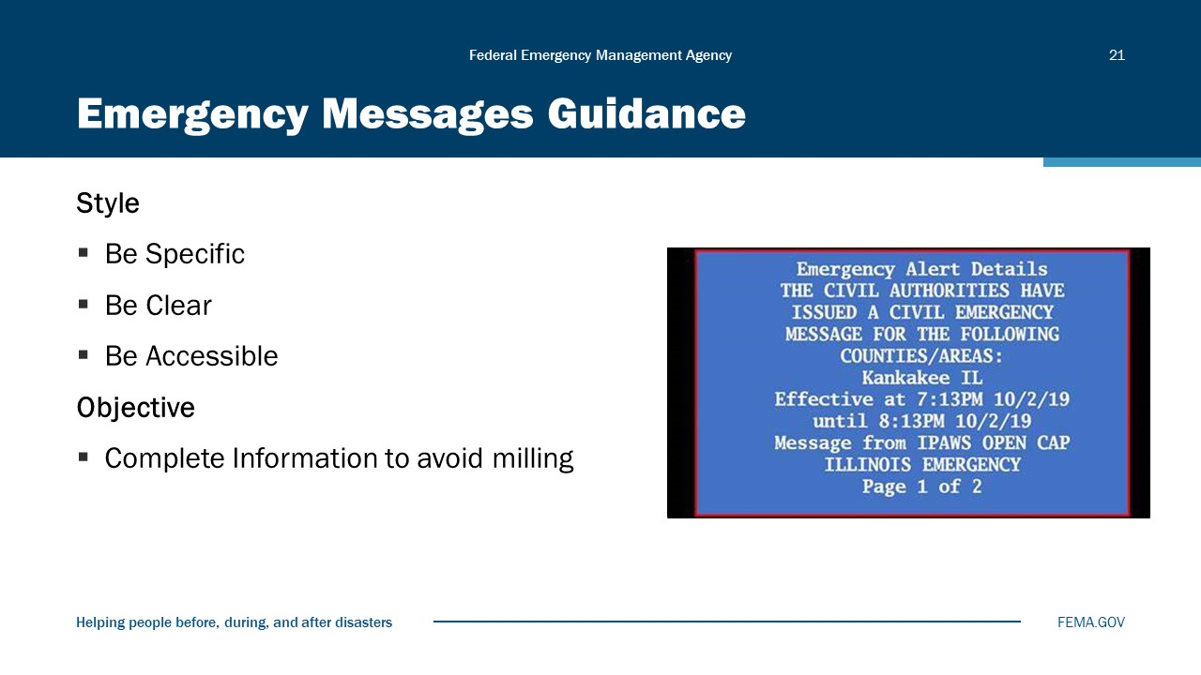
Visual 21, Emergency Messages Guidance

Message Anatomy – Wireless Emergency Alerts (WEA)
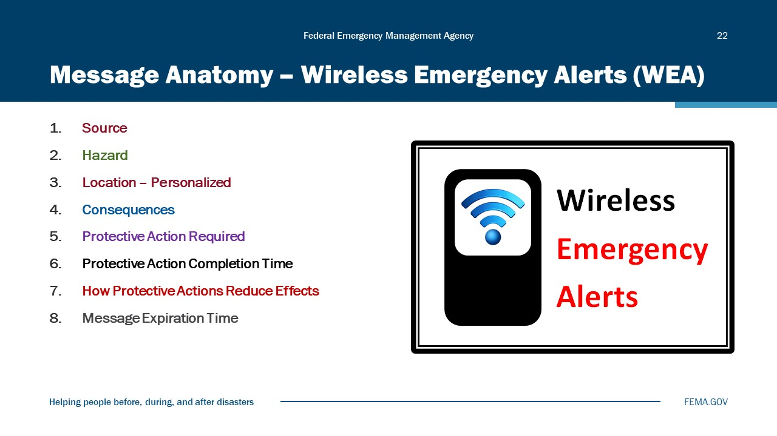
Visual 22, Message Anatomy-Wireless Emergency Alerts (WEA)

Roles of FEMA and Alerting Authorities
- The Integrated Public Alert and Warning System (IPAWS) is a FEMA communications system made accessible to Federal, state, local, tribal and territorial (FSLTT) officials for warning the public of an imminent threat and/or public safety incident and providing information on corresponding protective actions.
- FEMA’s position on public Alert, Warning and Notification (AWN) is that emergencies are local and therefore it is the responsibility and discretion of elected local officials, or their designees, to provide timely notification to their jurisdiction(s). The decision to issue a Wireless Emergency Alert (WEA) to the public is a matter of local emergency official communication plans, policies and procedures.
- FEMA does not provide nor place limitations or restrictions on criteria for authorized Alerting Authorities (AAs) to issue a WEA to the public. FEMA does not monitor, review, modify, approve, or disapprove the message text content of WEAs drafted and disseminated by AAs1. Alert content, time of transmission, utilized event code, targeted area, duration, and the decision to update or cancel an AWN is the sole responsibility of an AA.

Compose Effective WEA Messages
- Effective WEA messages include sufficient information for the public to validate the incident and risk to guide and urge the public to take appropriate protective action.
- Effective WEA messages include and clearly communicate: the trusted source sender; description of event; location of incident; protective action to be taken; guidance/expiration time or duration of the incident; and a URL or phone number to direct people to more information.
- Many mobile phones in use today support WEA messages of up to 360 characters. FEMA encourages AAs to use the longer message space to provide more complete information, and to include a Web address if more detailed and/or visual information will assist the public to take appropriate action. A basic 90-character message requirement, in addition to the optional 360-character message, is in place for the foreseeable future as wireless carriers complete modernization of their networks.
- WEA supports English and Spanish languages. FEMA recommends including a Spanish language version of your WEA for a broader reach.
Establish Protocol to Assist Decision-Makers
- Proper protocol must be established and should be documented to assist decision-makers in determining whether to send a WEA. This includes reviewing criteria applicable to local threats and hazards in accordance with local emergency plans, policies, and procedures:
  - Does a situation require the public to take immediate action to avoid or mitigate damage to life and property?
  - Is there a high degree of probability a situation will occur and you need to warn the public quickly?
  - Is there a missing and endangered person that the public should be aware of?
  - Does the public need to be notified of a public safety situation such as 911 outage, boil water advisory, or ongoing response or recovery resources?
  - Does the event demand immediate notification, regardless of time of day, or can it wait?
  - Will the distinctive audible tones that accompany a WEA disturb recipients or disrupt activities unnecessarily? Mobile phone behavior and the sound accompanying a WEA are intentionally disruptive to call attention to an urgent situation and may alarm an individual and the public.
  - Approximately half of mobile phones do not yet support WEA location-based “enhanced geo-targeting.” It is likely that many mobile phones that are 20+ miles away from a targeted alert area will receive a WEA intended for the public inside the alert target area.
- FEMA advises Alerting Authorities and Alerting Administrators to develop and implement robust policies and procedures, coupled with routine training and exercise(s), using the FEMA IPAWS Technical Support Services training and demonstration environment.
- The IPAWS Office within FEMA’s National Continuity Programs provides guidance on the effective use of IPAWS services. Upon request, the IPAWS Office can review Alerting Authorities’ plans and may recommend ways to eliminate gaps and improve internal safeguards.
- When issuing a WEA, AAs must review pertinent message fields before transmission. Rushed alerts with poor wording can be ineffective and further complicate an incident. To avoid errors, pre-script messages with as much information as possible before an event.
- The Alerting Authority should establish security procedures to prevent inadvertent or unauthorized alert transmission. All Alerting Authorities should have a plan to follow up and correct any alert sent in error.

Example WEA Message
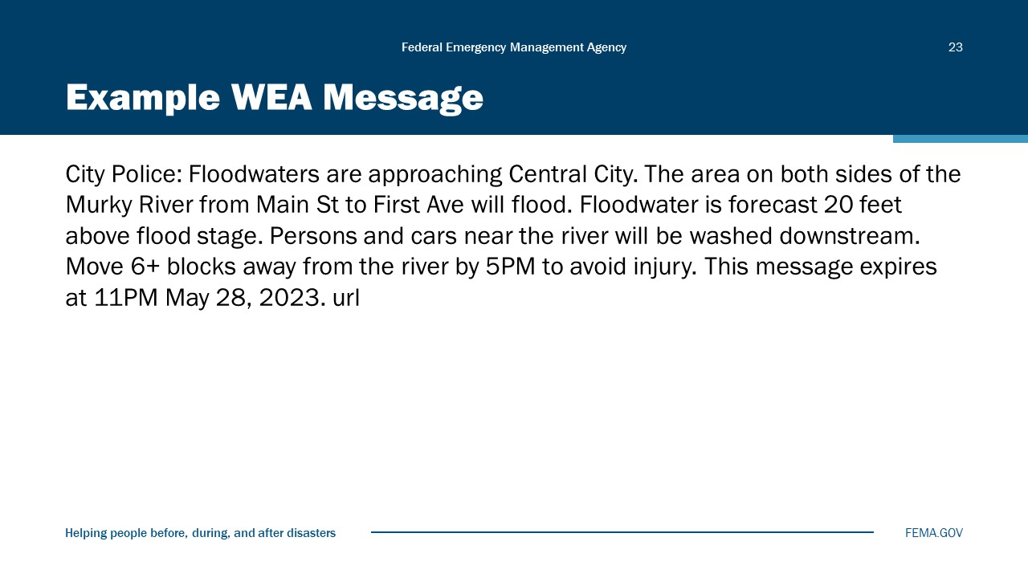
Visual 23, Example WEA Message

City Police: Floodwaters are approaching Central City. The area on both sides of the Murky River from Main St to First Ave will flood. Floodwater is forecast 20 feet above flood stage. Persons and cars near the river will be washed downstream. Move 6+ blocks away from the river by 5PM to avoid injury. This message expires at 11PM May 28, 2023. url

Basic Concepts Do Not Change
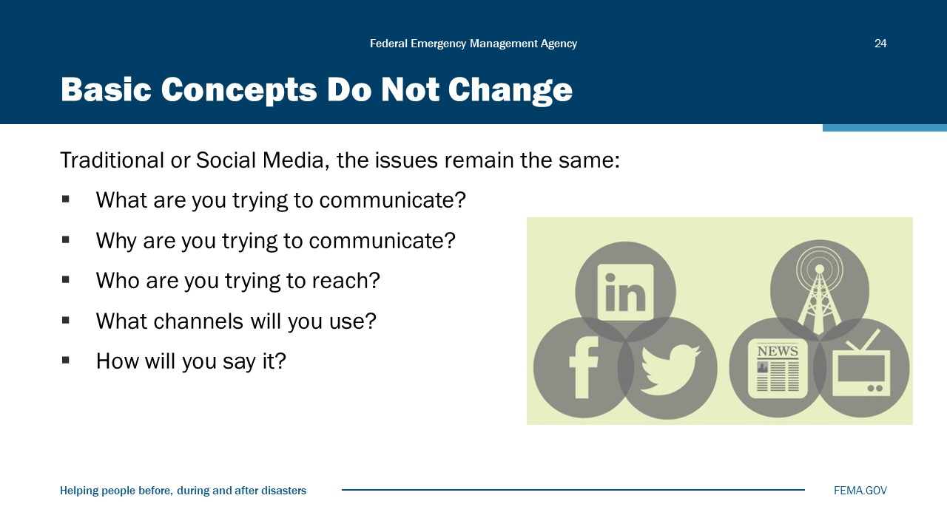
Visual 24, Basic Concepts Do Not Change

- Basic concepts in information management do not change with the inclusion of social media tools. You still need to answer the basic questions:
  - Why are you communicating? (Your objective)
  - Who are you trying to reach? (Your audience)
  - What will you say and how will you say it? (Your medium)
- Ultimately, new communication technology is all about speed. There is an expectation from the public that their government agencies will not only be transparent and responsive, but that the response must be customized to the incident and as rapid as the flow of electrons.
- People have an expectation of being engaged and involved, and they don’t want to wait for it. By establishing a presence in the Web 2.0 world and knowing how to use the tools to communicate official information from your agency, you can help to shape the perception of the event along with possibly providing important life-saving information to those who need it.
- Remember: It’s all about getting the right information to the right people at the right time so they can make the right decisions.

Bottom Line: Communicate!
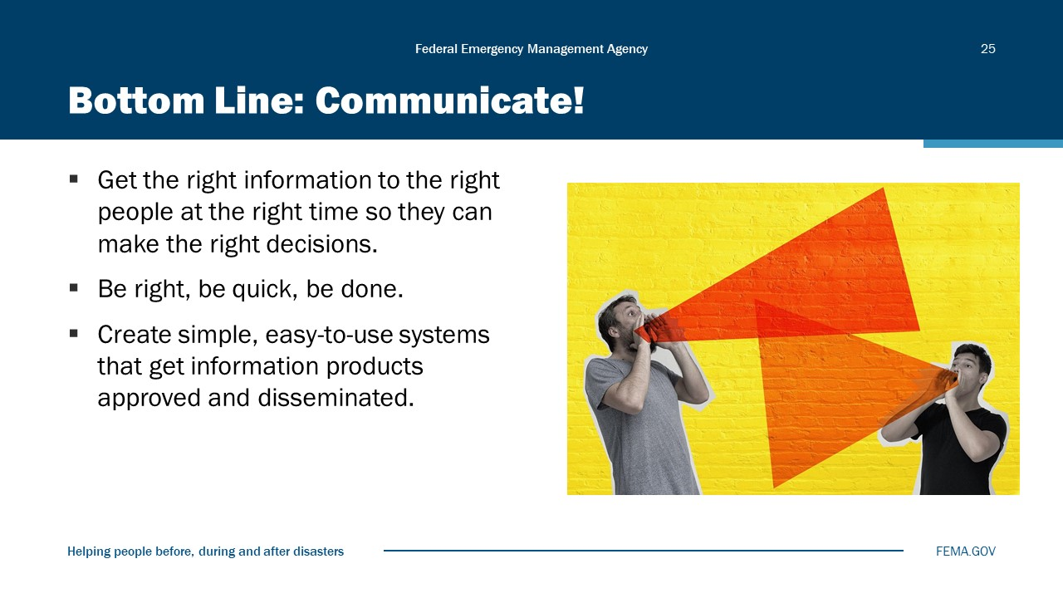
Visual 25, Bottom Line: Communicate!

Module Summary
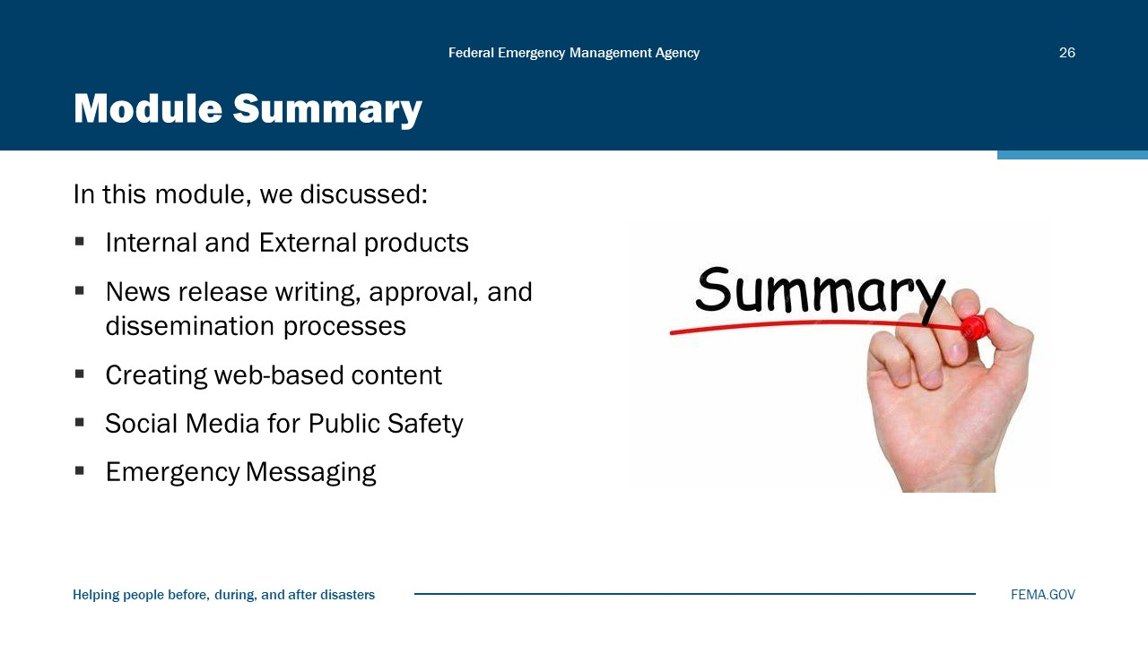
Visual 526, Module Summary

Reference List
U.S. Facts: Adults Over 16 (https://literacyproj.org/)

IS0042.a: Social Media in Emergency Management (https://training.fema.gov/is/courseoverview.aspx?code=IS-42.a&lang=en)

PER-304-W: Social Media Platforms in Disaster Management (https://ndptc.hawaii.edu/training/catalog/23/#course-description)

PER 343: Social Media Engagement Strategies (https://ndptc.hawaii.edu/training/catalog/31/#course-description)

PER-344: Social Media Tools and Techniques (https://ndptc.hawaii.edu/training/catalog/32/#course-description)

Wireless Emergency Alerts (https://www.fema.gov/emergency-managers/practitioners/integrated-public-alert-warning-system/public/wireless-emergency-alerts)

Emergency Alert System (https://www.fema.gov/emergency-managers/practitioners/integrated-public-alert-warning-system/public/emergency-alert-system)

Module
6
Interview Skills

Administration
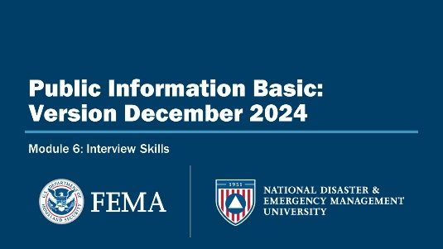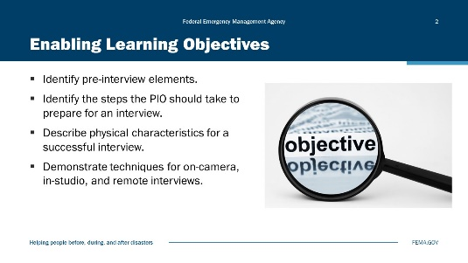
Visual 1, Interview Skills Visual 2, Enabling Learning Objectives

Duration
4 hours

Terminal Learning Objective (TLO)
By the end of this module, you will be able to identify and use proper interview techniques.

Enabling Learning Objectives (ELOs)
By the end of this module, you will be able to:
- Identify pre-interview elements.
- Identify the steps the PIO should take to prepare for an interview.
- Describe physical characteristics for a successful interview.
- Demonstrate techniques for on-camera, in-studio, and remote interviews.

Determining the Objective
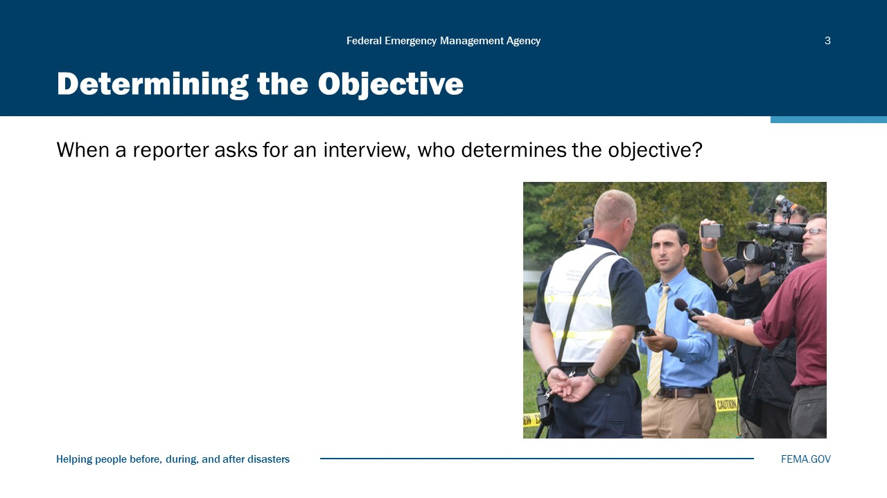
Visual 3, Determining the Objective

Understanding the Audience
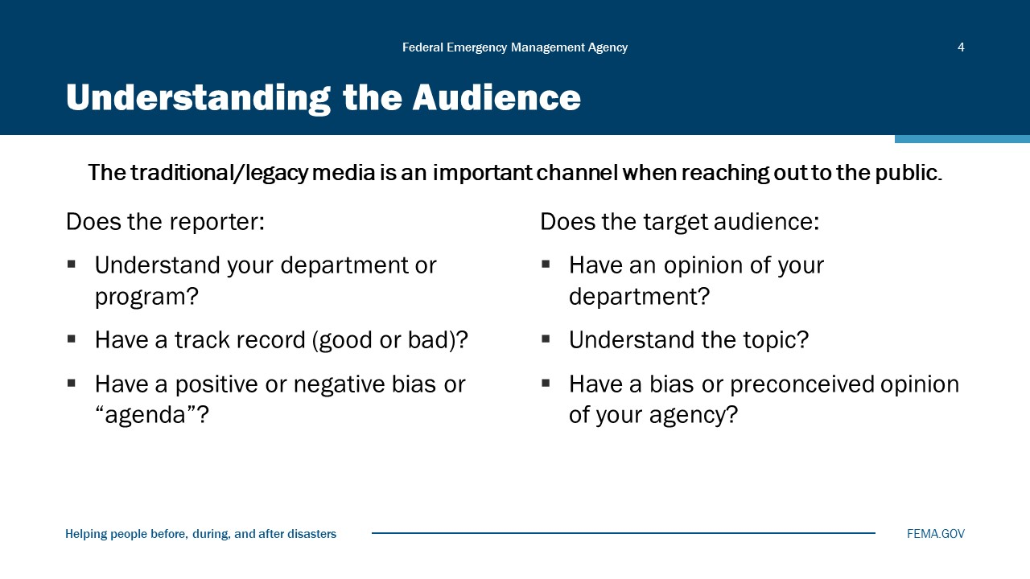
Visual 4, Understanding the Audience

The traditional/legacy media is an important channel when reaching out to the public.
Does the reporter:
- Understand your department or program?
- Have a track record (good or bad)?
- Have a positive or negative bias or “agenda”?
Does the target audience:
- Have an opinion of your department?
- Understand the topic?
- Have a bias or preconceived opinion of your agency?

Developing the Message
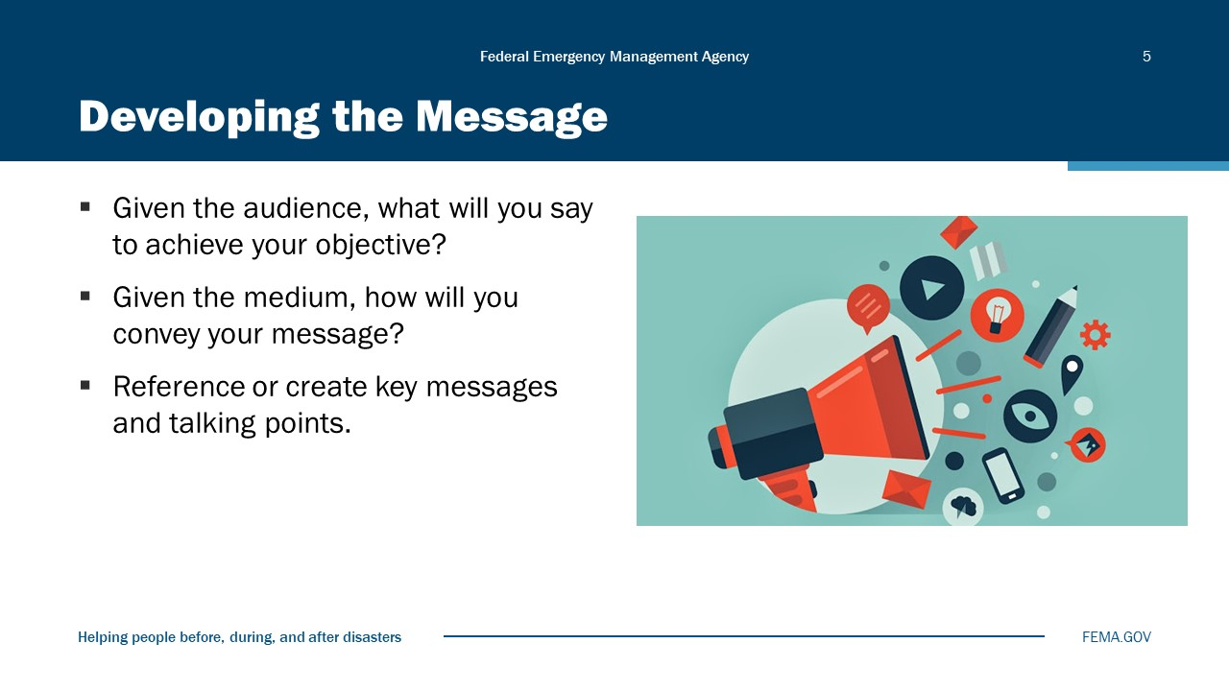
Visual 5, Developing the Message

Preparing for the Interview
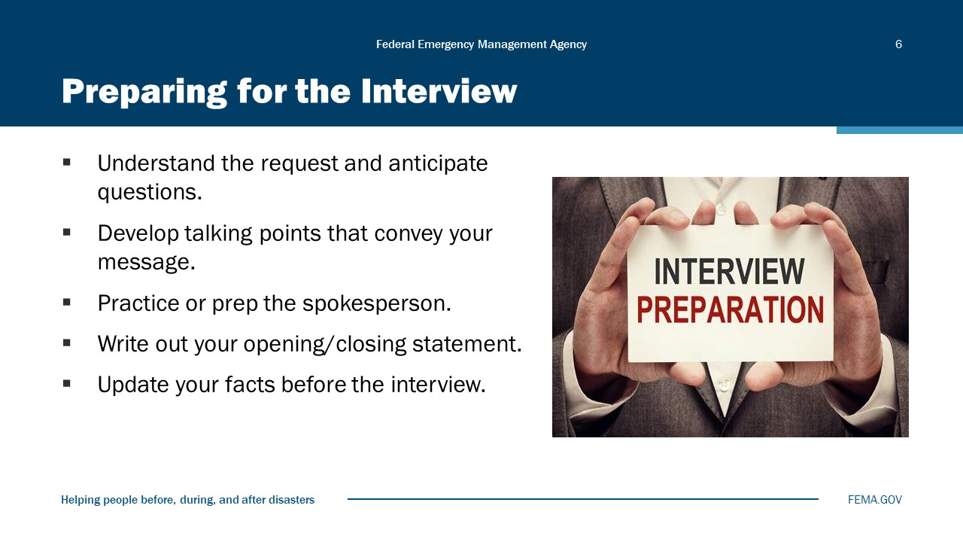
Visual 6, Preparing for the Interview

Now that you’ve taken care of the basics—objective, audience, and message—you are ready to prepare for the interview using the following steps:
STEP 1: Understand the request and anticipate questions.
- This may seem obvious, but sometimes a request is slightly off-target, or the reporter doesn’t have enough data to know what to ask for. The better you understand their interest, the better the interview for you and the reporter. If you are unsure, ask for clarification.
- There is a difference between asking “What are you going to ask me?” and “Tell me what your interest is so I can have the right person participate in the interview.” Don’t ask the former; do ask the latter.
- Also, consider what questions you should expect and be prepared to answer them.
STEP 2: Develop talking points that convey your message.
- Once you know what you want to say, how can you express it in a sound bite that is clear, concise, and memorable?
- Get in the habit of writing down the sound bite; practice saying it out loud.
- Keep it simple. Write down a few ways of emphasizing the main message without sounding like you are repeating.
STEP 3: Practice, or if you are not the person who will speak for the organization, prep the spokesperson.
- Even a few minutes of practice can make a big difference in how well you do in an interview.
- When you practice, make sure you think and talk in 9- to 12-second sound bites.
- If you are not the spokesperson, prep the spokesperson by providing talking points and perhaps playing the reporter role in a practice interview.
STEP 4: Consider writing out your opening statement or phrases. Consider writing out your closing statement. Write down your answer when the reporter or interviewer asks: “Is there anything else you’d like to add?”
STEP 5: Last, but not least: Update your facts. Make sure you have the latest information.

Size Up the Situation
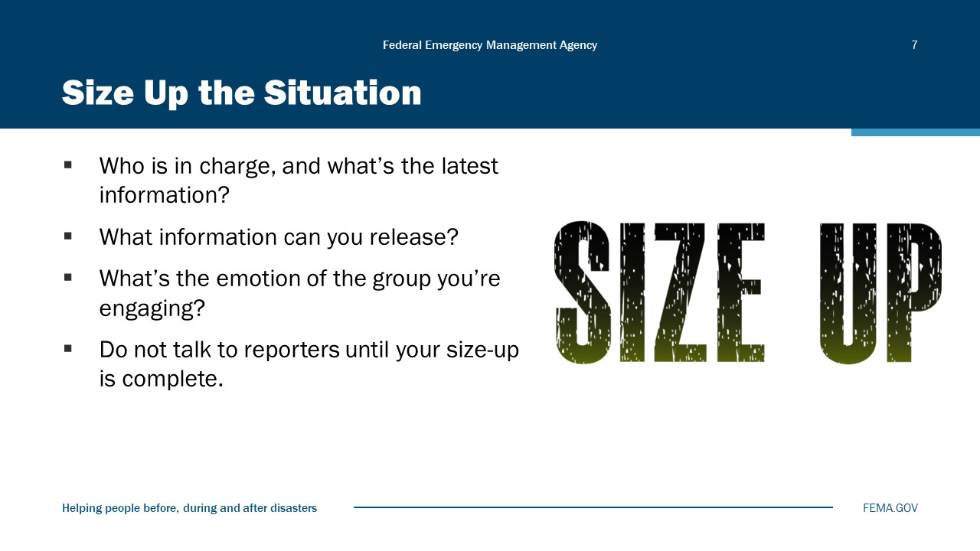
Visual 7, Size Up the Situation

Outward Perceptions of the PIO
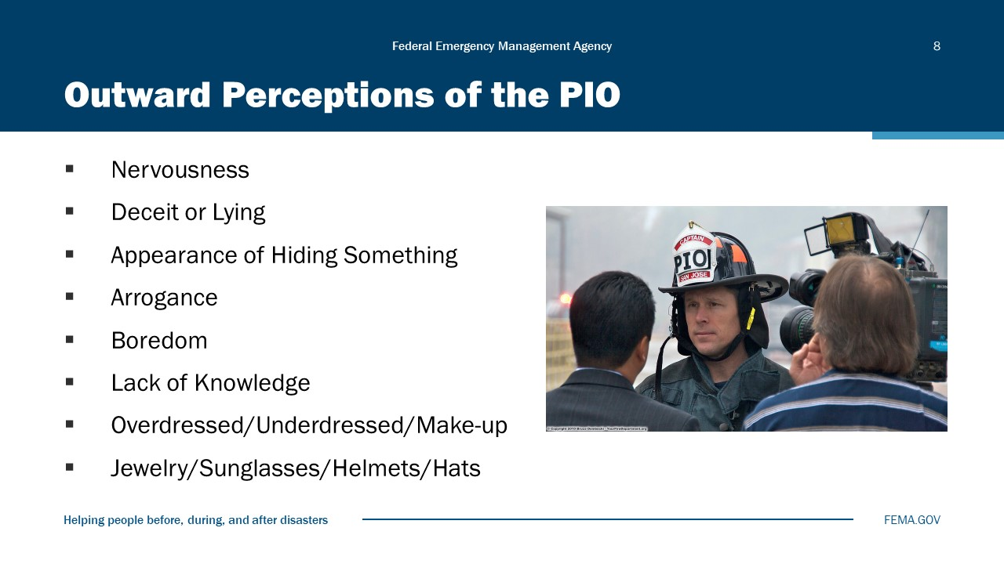
Visual 8, Outward Perception of the PIO

When preparing for an interview, or just when working with the public, it is important to understand how others interpret body language.
Demonstrate by saying: “I am so excited to be instructing this course today,” but show boredom or something else.
Then ask for volunteers and have each volunteer read one of their talking points, or the module objectives, to demonstrate a behavior using only body language (not using any words); or better yet, have them all give the same statement, but have each person demonstrate one of the following:
- Nervousness
- Deceitfulness
- Appearance of hiding something
- Callousness/arrogance
- Boredom
- Jewelry, sunglasses, helmets, hats
- Lack of knowledge

Nonverbal Communication Tips
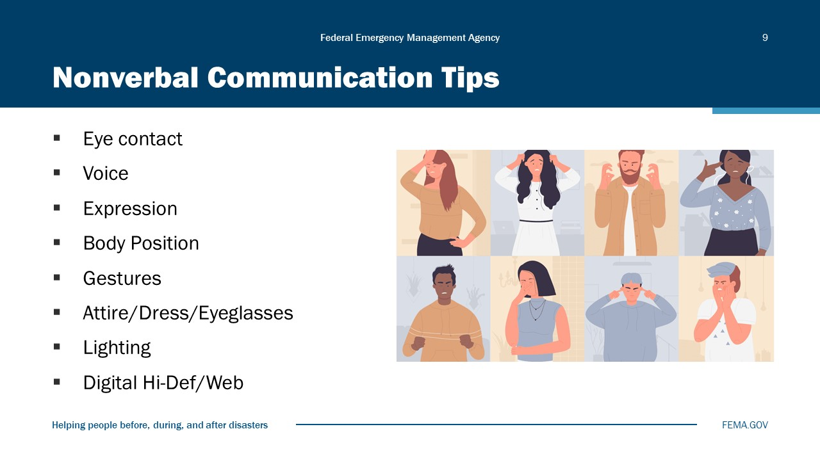
Visual 9, Nonverbal Communication Tips

Any interview can be improved by paying attention to nonverbal communication:
      - Eye contact: ALWAYS look at the reporter, not the camera. Avoid looking down. Avoid rolling your eyes or looking up to the sky.
      - Voice: Speak clearly and modulate your voice by varying tone and volume. Slow down for emphasis when making important points. Pause to gather your thoughts rather than use fillers like “er,” “um,” or “you know.”
      - Expression: Appear attentive. Show emotion as appropriate (sincerity). Assume that the camera is always on. Even if your words are not being taped, your facial expression will be conveying a message. Make sure it is the message you want to convey.
      - Body position: Stand straight and align your body with the interviewer. In some instances, the camera operator may position you for the shot. Be aware of what’s being photographed in the background. Always be mindful of scene safety for both you and the reporter.
      - Gestures: Use natural, but not “big” gestures. Keep your hands away from your face. Don’t cross your arms, raise your eyebrows, or shrug your shoulders. Avoid jerky movements.
      - Movement: If standing, do not lock your knees, but don’t sway or bounce either. Don’t jingle jewelry or change in pockets. Don’t jiggle legs or spin or rock in the chair if sitting. Sit on your coat tail to keep your jacket from riding up.
      - Attire/Dress: Consider your audience, market, and communication channel when dressing for an interview. You don’t want your appearance to be “louder” than your message.
- Wear your uniform or neat, conservative attire if non-uniformed.
- Avoid bright whites, stripes, plaids, and complicated patterns.
- Remove dark glasses/sunglasses.
- Be aware of lighting, especially bright backgrounds, and lack of light on your face and body.
- Know your agency’s policy on showing your badge in public; some agencies discourage it to minimize fraudulent duplication.
- Remove hat to avoid shadows on your face.
- Remove distracting, overly shiny, or noisy jewelry (including body piercings).
- Consider covering tattoos and minimizing body piercing jewelry.
- If something in your appearance significantly detracts from your message, eliminate or fix it.
- Digital, High-definition (HD), and Web:
- Digital and HD television is high quality and not only shows clothing imperfections but also has problems with specific colors (e.g., bright colors may cause issues with color balance and appear too vivid on some broadcasts). DOT ANSI (American National Standard for High Visibility) vests are bad for digital TV. Some badges and collar pins can also glare.

Managing the Interview
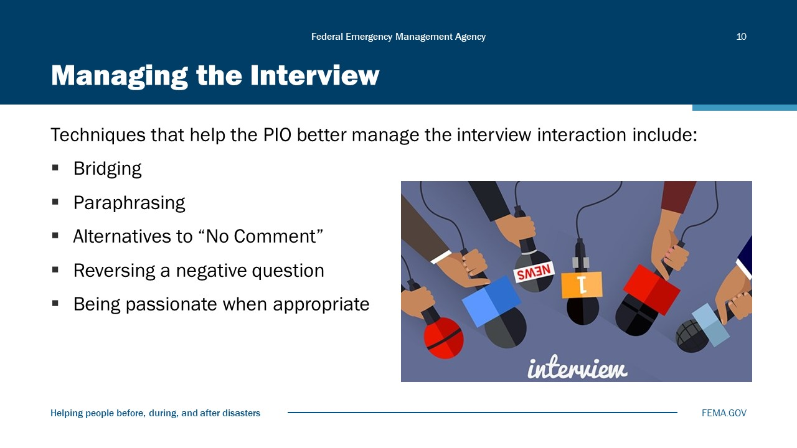
Visual 10, Managing the Interview

Transitional Phrases or “Bridging”
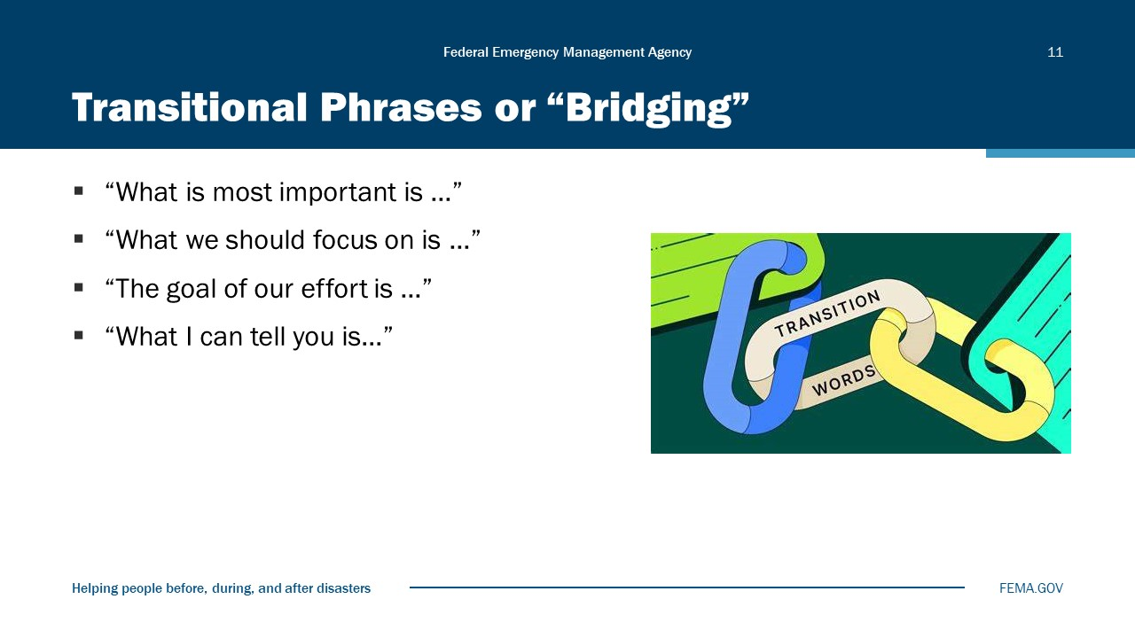
Visual 11, Transitional Phrases or “Bridging”

- In some interviews, you may find that you are not provided with the right question to present your message. You can bring the focus back by building a bridge between the question and your message.
- Transitional phrases are tools that help you build such a bridge and put the interview back on track to your talking points and central message.

Paraphrasing
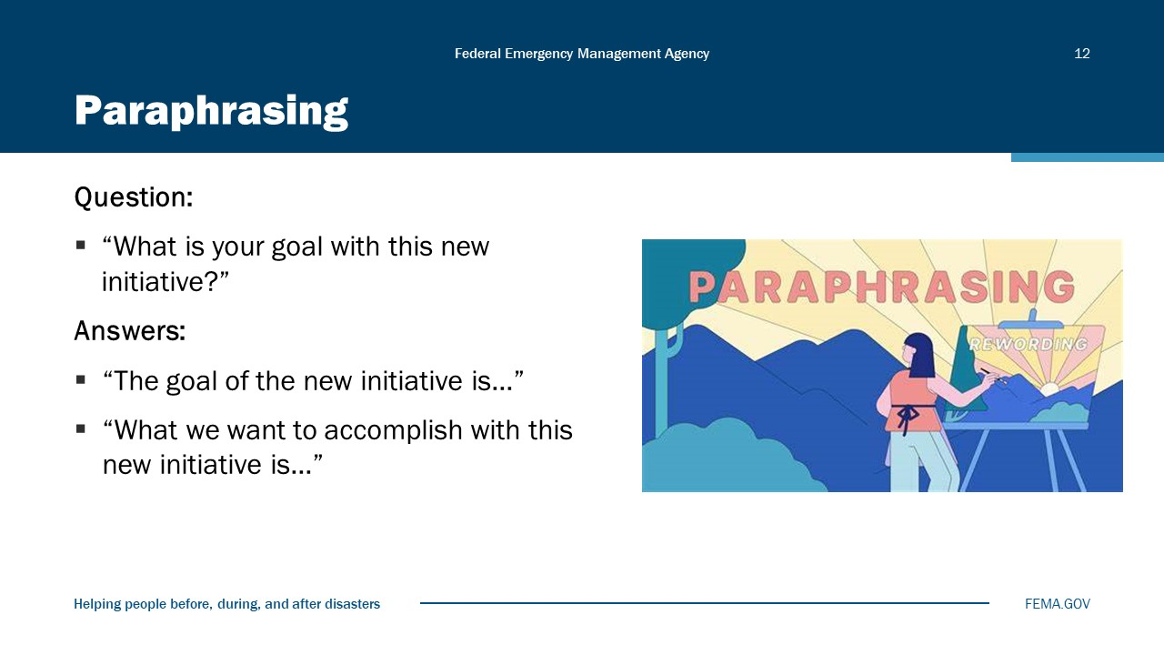
Visual 12, Paraphrasing

Alternatives to “No Comment”
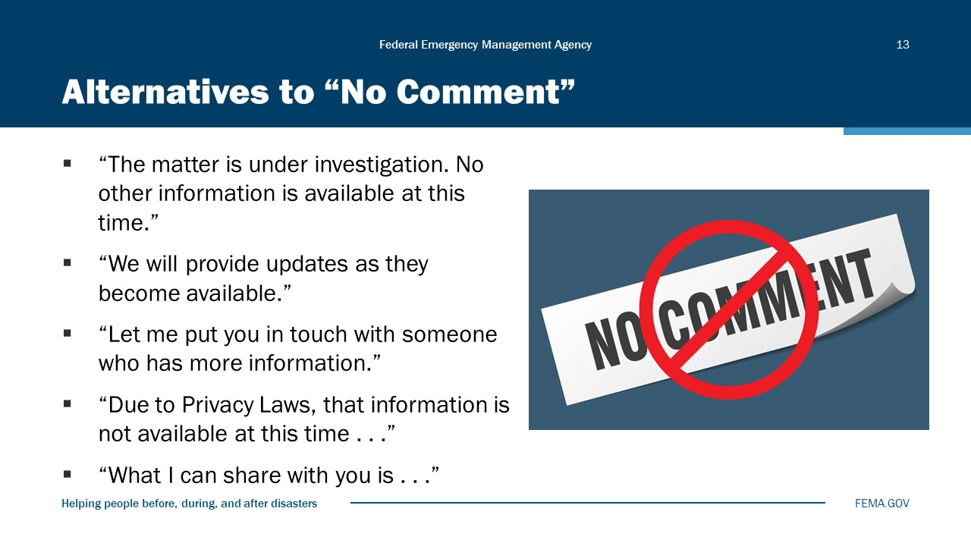
Visual 13, Alternatives to “No Comment”

- When you can’t answer a question, make sure your response is suited to the situation, truthful, and as forthcoming as possible.
- The visual displays some options to “no comment.”
- The first two options are suitable when dealing with an unfolding situation. Do not promise updates, however, unless you plan to provide them.
- If you cannot answer a question but someone else can, the third response is appropriate. Make sure you follow up and connect the reporter with the appropriate spokesperson or say that you cannot do so.
- The fourth response is a good option when you are restricted from providing some information, but you can offer general information that conveys your key message.
- Have several planned responses. “What I can share is….” Or “What we do know is…”
- How would “you” address a “no comment”?

Reversing a Negative Question
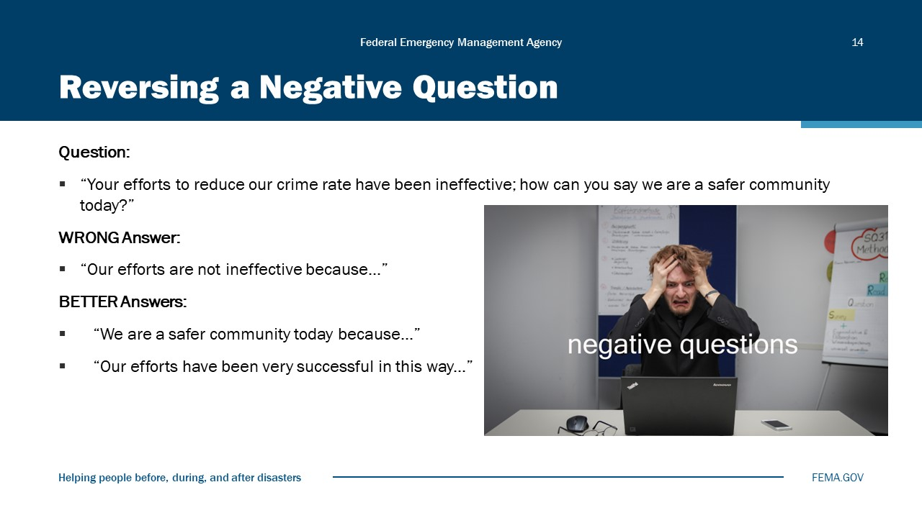
Visual 14, Reversing a Negative Question

Reversing a negative:
- Never start an answer by repeating a reporter’s negative question. If you do, they will have you on tape reinforcing the statement, even if you clarify your message immediately afterward (afterward they may edit your clarification out of the final piece and show only the negative statement).
- Remember, they don’t have it on tape if you don’t say it.
- Try to stay positive in your response. You have a message. Use it.
- How do you address a “no comment”?

Hostile Reporter Interviews
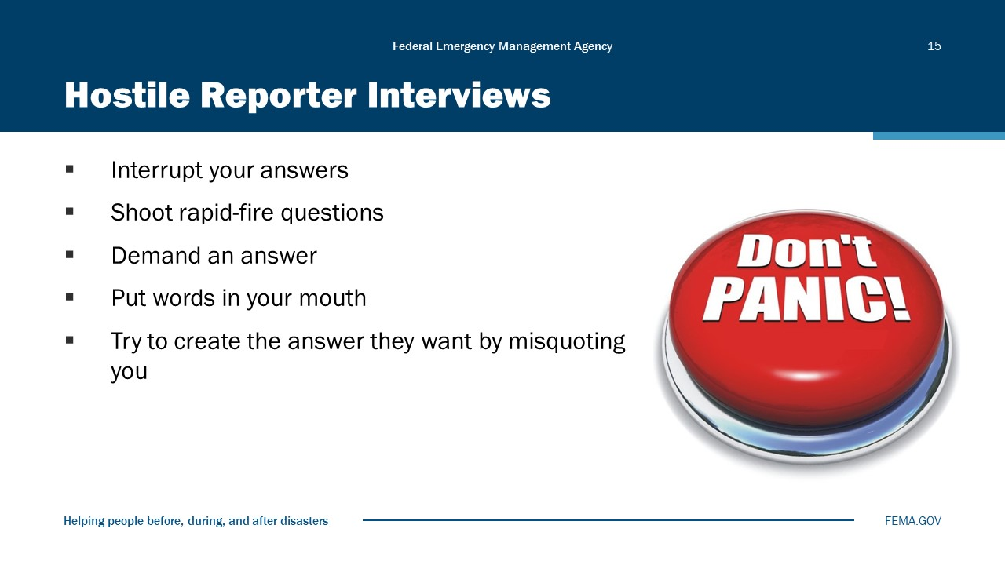
Visual 15, Hostile Reporter Interviews

You should never lose your cool no matter how hostile the interview turns.
If a reporter:
- Interrupts you: Be polite but assertive; you may finish your point in the next question by bridging.
- Misquotes you or puts words in your mouth: Restate your answer or message and correct the mistakes.
- Shoots rapid-fire questions: Pick one or two questions you feel comfortable with, answer them, and ignore the rest. Emphasize your message.
- Demands an answer to something you don’t know: Stick to your response. For example: “That information is not available at this time.” Or “Let me get back to you with more information.”
- Put words in your mouth or try to create the answer they want by misquoting you: Prepare talking points for the good, bad, and ugly interview questions, preferably three to five of each.

Mental Checklist
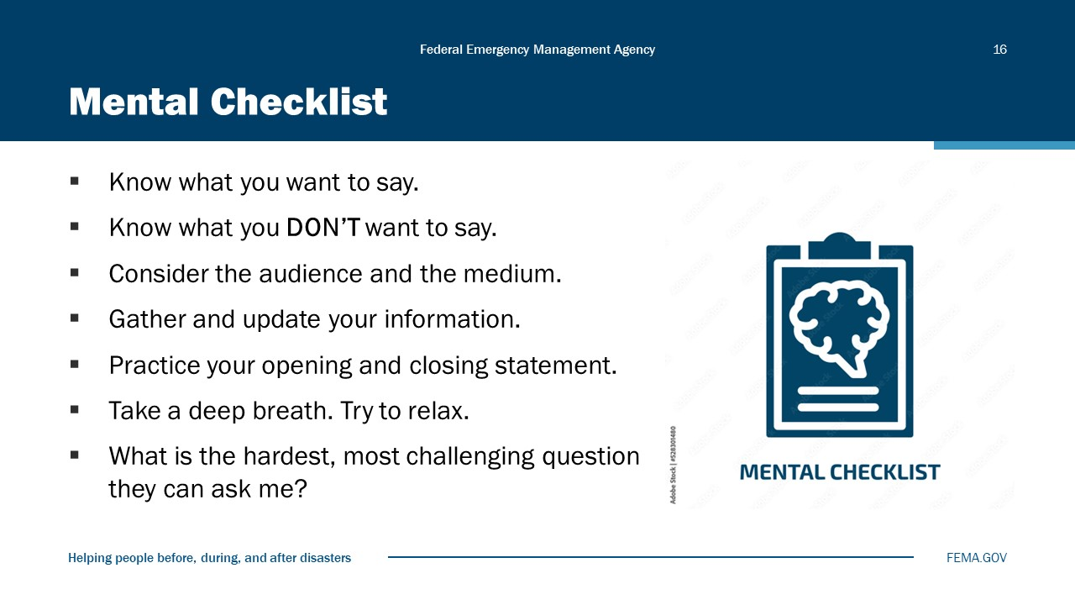
Visual 16, Mental Checklist

Interview Types and Locations
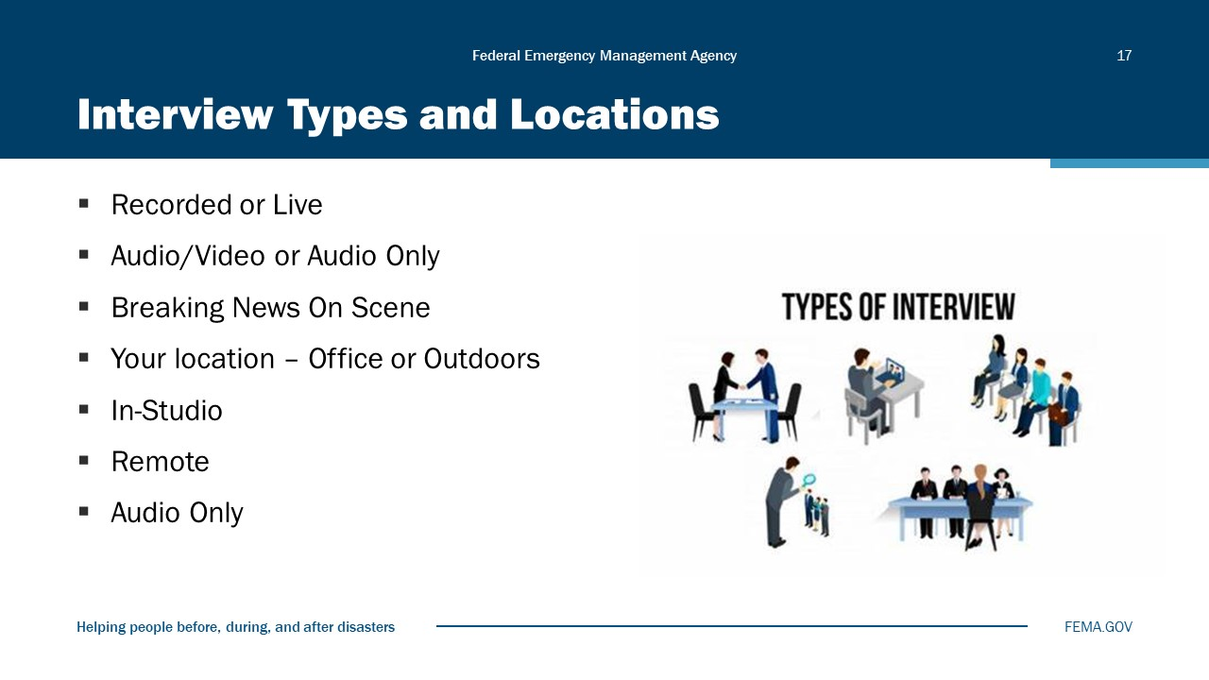
Visual 17, Interview Types and Locations

Interview Environment
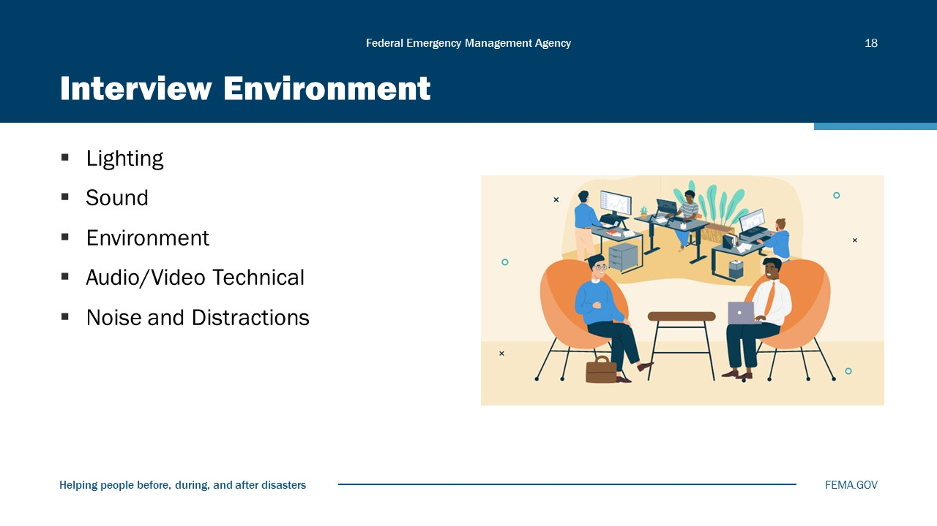
Visual 18, Interview Environment

Lighting: Are you positioned so that you are well lit and the background isn’t brighter than your body and face?
Sound: Are you in a relatively quiet area so your voice is the primary sound source during the interview? If you’re in a noisy environment, can you move somewhere less noisy?
Is the location or environment just too busy? Again, can you move to an area that has fewer distractions?
As best as possible, have you optimized the audio and video for your interview? This is especially important for “Zoom” or other remote interviews.
Have you minimized noise and distractions? If you’re outdoors in a busy environment, do you need a spotter or security to keep people out of your background? If in the office, lock the door or put a sign on the outside of the door so you’re not interrupted. If at home, minimize distractions as best as possible.

On-Scene “Breaking News” Interviews
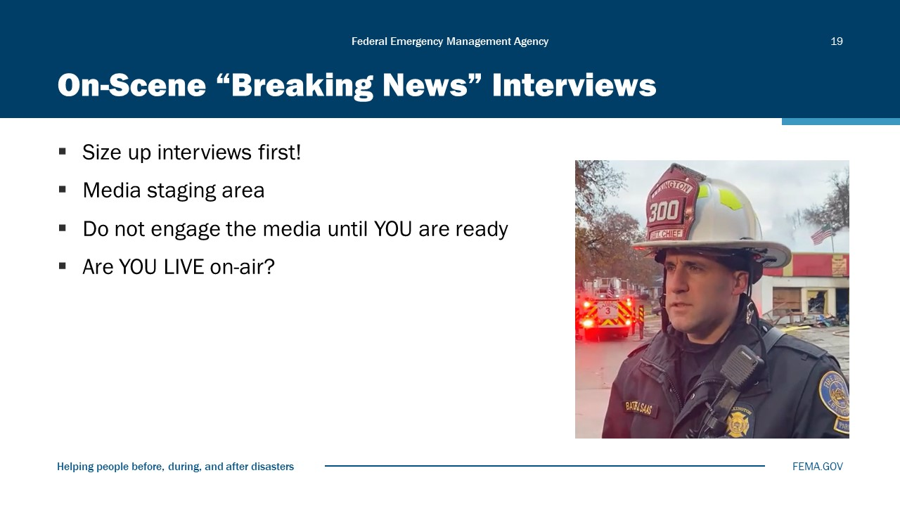
Visual 19, On-Scene “Breaking News” Interviews

Remember that television and cable news outlets no longer need a large satellite truck or remote van to broadcast live. A cell phone can broadcast your interview around the world. Most, but not all, news videographers use “backpack” video systems that can send high-quality audio and video back to the newsroom in real-time.
Always assume that a nearby microphone is LIVE and YOU’RE being recorded.

Your Location
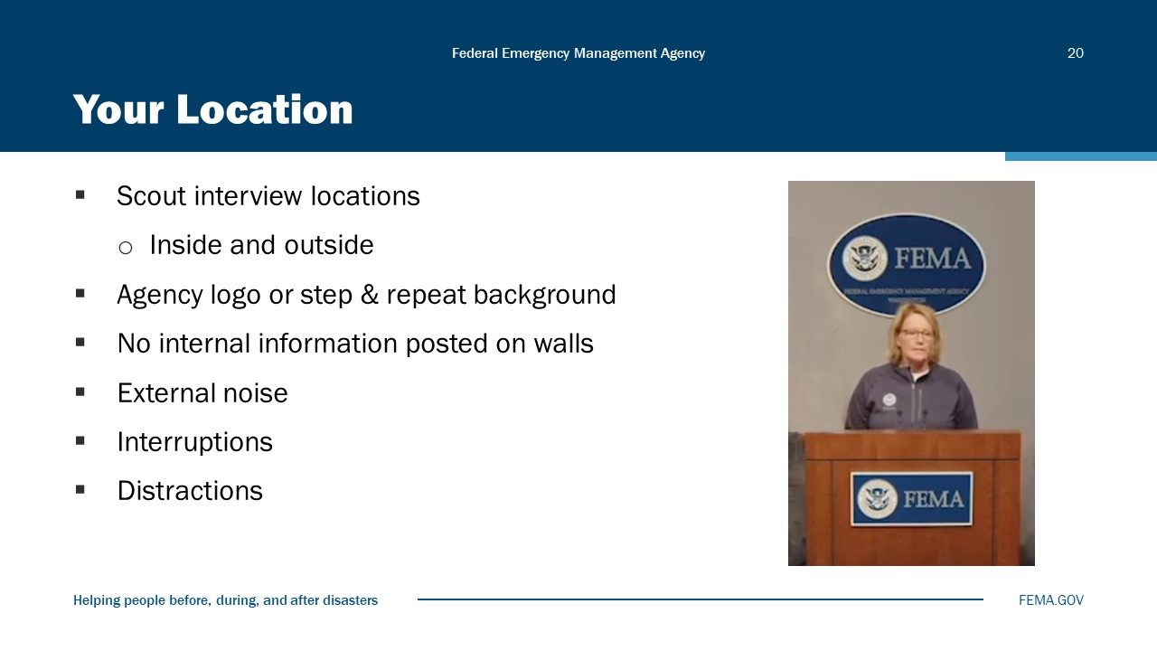
Visual 20, Your Location

In-Studio Interviews
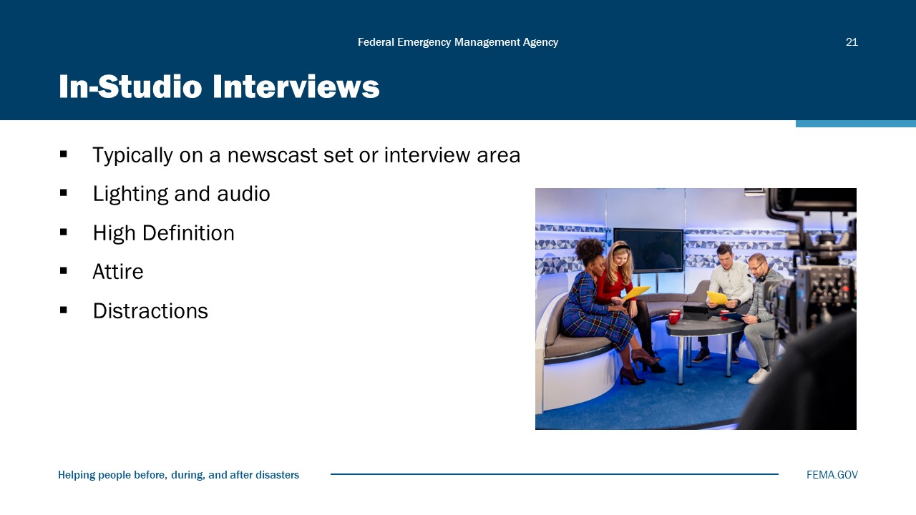
Visual 21, In-Studio Interviews

In-studio interviews will be handled by television station staff. Know that a microphone may be placed underneath a shirt or blouse. Keep your attire simple—avoid bright whites and yellows and tight patterns, such as herringbone. Avoid flashy bracelets, necklaces, and earrings.

Remote Interviews
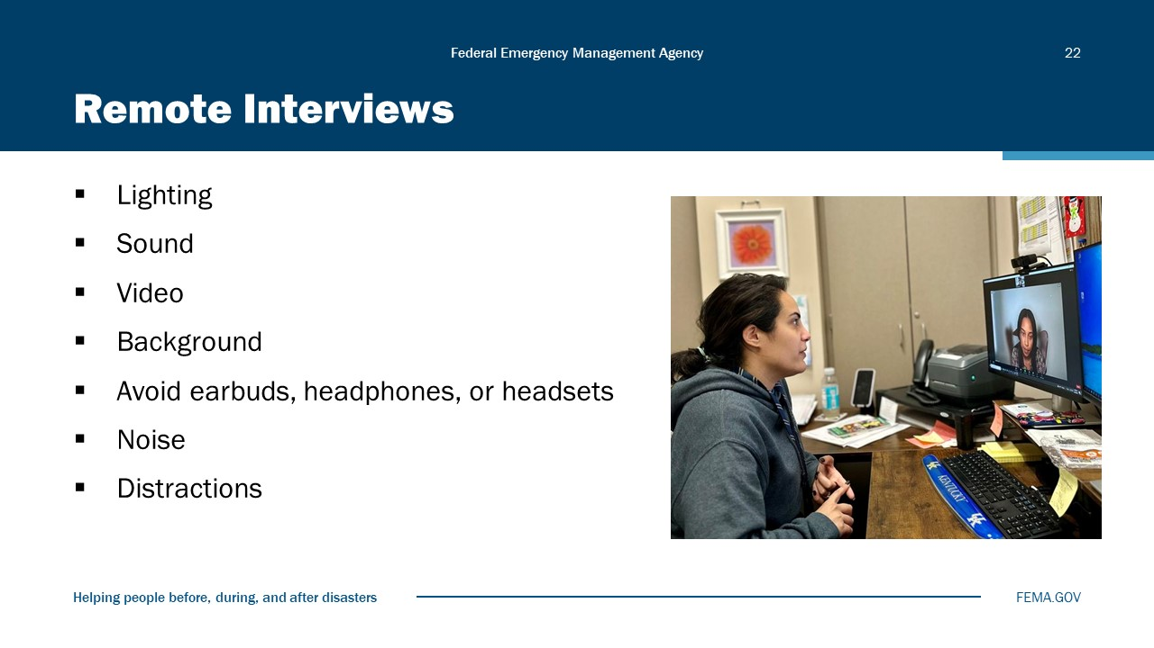
Visual 22, Remote Interviews

The PIO is usually responsible for the technical operation of the remote or “Zoom” interview. This means that for the PIO to look their best, they need to ensure that the technology makes them look as good as possible.
- Lighting: Many PIOs will use a ring light or other small lights on either side of the computer or camera. Be careful not to be too close to the lights.
- Sound: Laptop microphones are notorious for producing “tinny” sound. Consider using the microphone in a stand-alone webcam.
- Video: Laptop cameras may not be high quality for broadcast interviews. Consider using a high-quality external webcam.
- Avoid earbuds, headphones, or headsets.
- As best as possible, avoid and eliminate noise and distractions in the background.

Pre-Interview Checklist
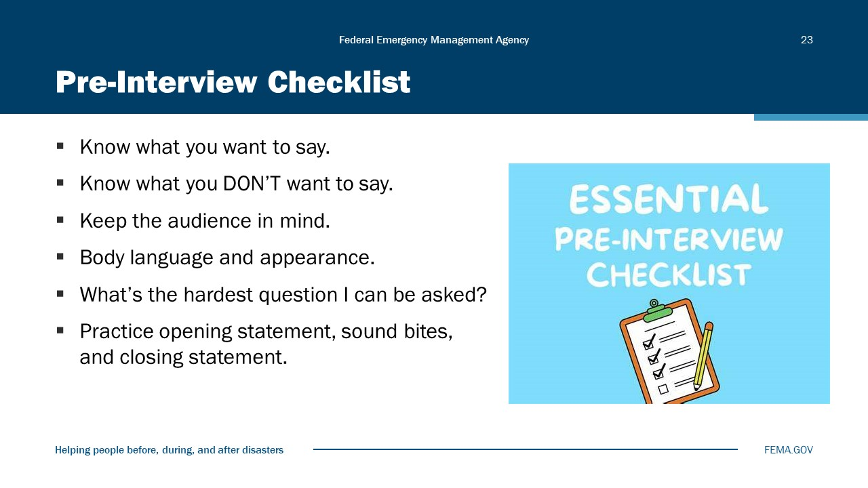
Visual 23, Pre-Interview Checklist

Post-Interview
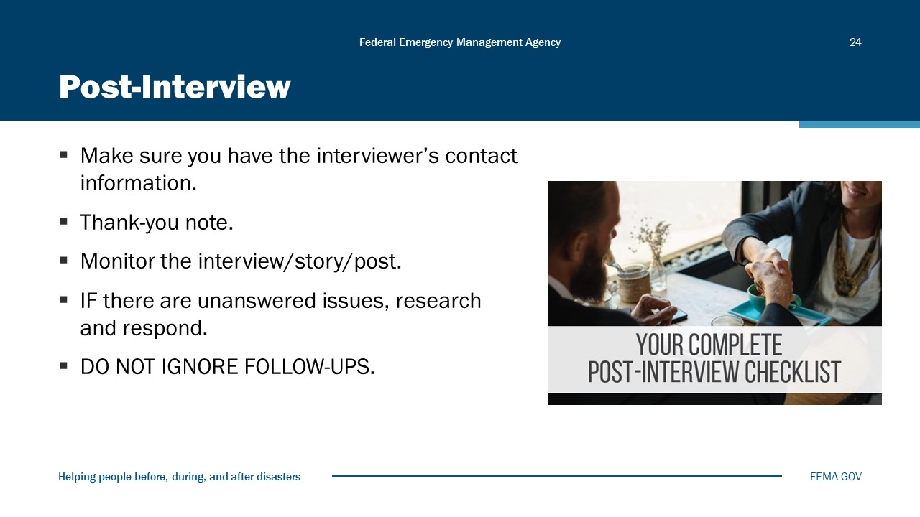
Visual 24, Post- Interview

What Can You Do Now?
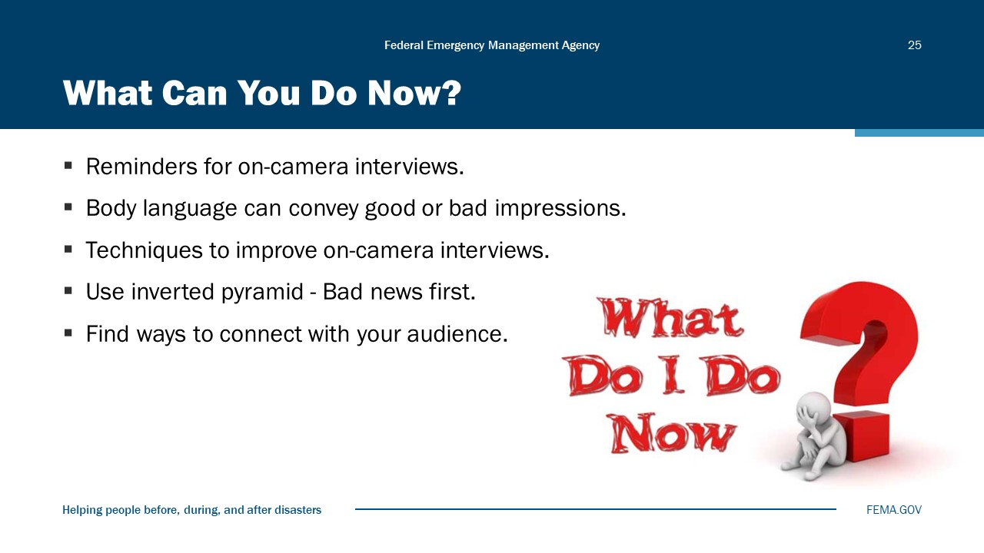
Visual 25, What Can You Do Now?

Activity 6.1: On-Camera Interviews
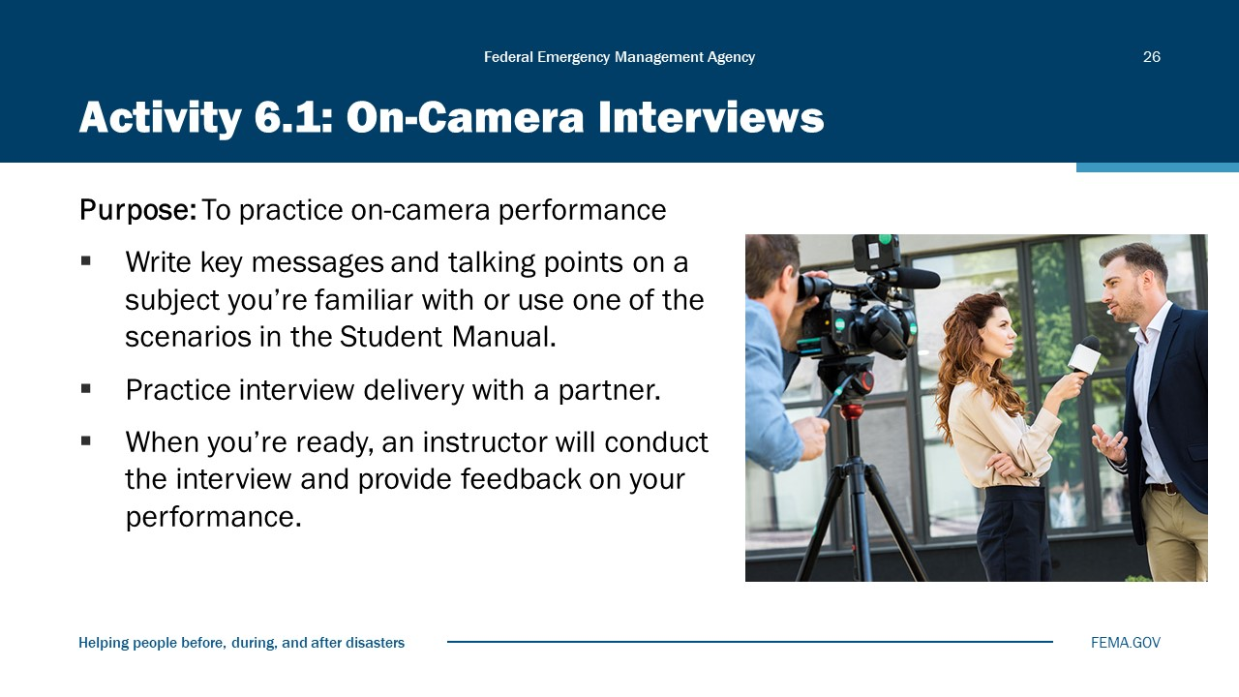
Visual 26, Activity 6.1: On-Camera Interviews

Total Time: 2 hours
Instructions
- Select a topic you know and write talking points for your interview. Most participants choose a public awareness campaign they are familiar with, an event they want to promote, or a recent emergency or incident operation they participated in.
- If you cannot think of any topics, you may use the news release in the Student Manual and draft your own talking points for your interview.
- Practice your delivery. If you have time, ask a fellow participant to record you while you practice delivering the talking points; watch the recording and adjust your delivery as needed.
- The interview will follow this format:
- The reporter will ask you to say and spell your name and title.
- Then the reporter will ask you a basic question about your topic. This is your cue to start delivering your message.
- The reporter may ask you a series of follow-up questions. Be ready to answer both easy and challenging questions.
- Demonstrate the interview techniques covered in the module if needed.
- For the activity, you can assume the interview you are giving is being taped for later broadcast; it is not live, unless you prefer it to be live.
- Your instructor will review the recording and give you feedback after your interview.
HEAR THE BEEP WHERE YOU SLEEP. EVERY BEDROOM NEEDS A WORKING SMOKE ALARM!
Location matters when it comes to your smoke alarm. That’s the message behind this year’s Fire Prevention Week campaign, “Hear the Beep Where You Sleep. Every Bedroom Needs a Working Smoke Alarm!”
Along with firefighters and safety advocates nationwide, (Your Fire Department) is joining forces with the nonprofit National Fire Protection Association (NFPA) during Fire Prevention Week, October 4‒10, to remind residents of the importance of having working smoke alarms in every bedroom, outside each sleeping area, and on every level of the home, including the basement.
“In a fire, seconds count,” said (Your name, title). “Half of home fire deaths result from fires reported at night between 11 p.m. and 7 a.m. when most people are asleep. Home smoke alarms can alert people to a fire before it spreads, giving everyone enough time to get out.”
According to the latest NFPA research, working smoke alarms cut the chance of dying in a fire in half. Meanwhile, three out of five fire deaths resulted from fires in homes with no smoke alarms or no working smoke alarms.
This year’s Fire Prevention Week campaign includes the following smoke alarm messages:
- Install smoke alarms in every bedroom, outside each separate sleeping area, and on every level of the home, including the basement.
- Interconnect all smoke alarms throughout the home. This way, when one sounds, they all do.
- Test alarms at least monthly by pushing the test button.
- Replace all smoke alarms when they are 10 years old or sooner if they don’t respond properly.
- Make sure everyone in the home knows the sound of the smoke alarm and understands what to do when they hear it.
- If the smoke alarm sounds, get outside and stay outside. Go to your outside meeting place.
- Call the fire department from outside the home.
The (Your Town/City) Fire Department will be hosting activities (list specific events) during Fire Prevention Week to promote “Hear the Beep Where You Sleep. Every Bedroom Needs a Working Smoke Alarm!” Through these educational, family-oriented activities, residents can learn more about the importance of having a working smoke alarm in every bedroom.
To find out more about Fire Prevention Week programs and activities in (Your Town/City), please contact the (Your Town/City) Fire Department at (provide your phone number or appropriate contact information). To learn more about smoke alarms and “Hear the Beep Where You Sleep. Every Bedroom Needs a Working Smoke Alarm!” (https://www.nfpa.org/downloadable-resources/lesson-plans/hear-the-beep-where-you-sleep-mini-lesson-plan)

Module Summary
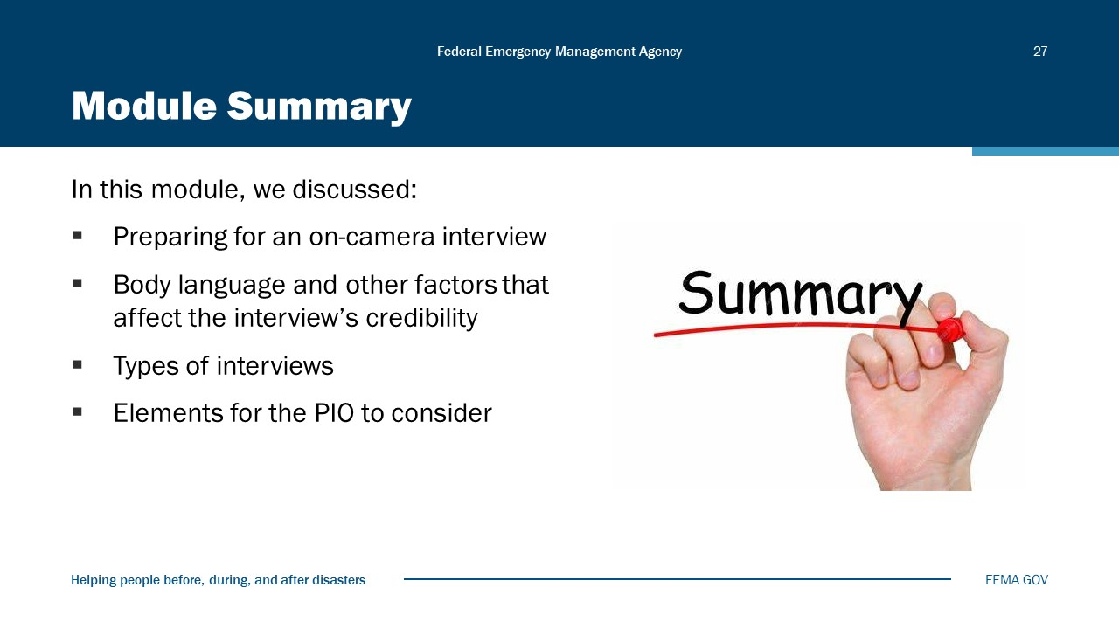
Visual 27, Module Summary

Reference List
None

Module
7
Crisis/Emergency Communications

Administration
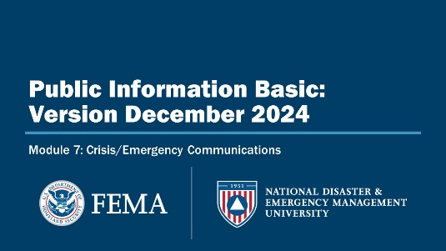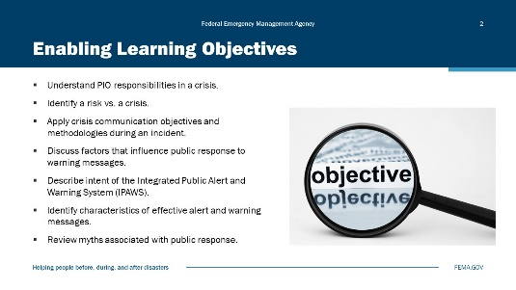
Visual 1, Crisis/Emergency Communications Visual 2, Enabling Learning Objectives

Duration
1 hour; 30 minutes

Terminal Learning Objective (TLO)
By the end of this module, you will be able to apply crisis communications methodologies to include warning messages during an incident.

Enabling Learning Objectives (ELOs)
By the end of this module, you will be able to…
- Understand PIO responsibilities in a crisis.
- Identify a risk vs. a crisis.
- Apply crisis communication objectives and methodologies during an incident.
- Discuss factors that influence public response to warning messages.
- Describe intent of the Integrated Public Alert and Warning System (IPAWS).
- Identify characteristics of effective alert and warning messages.
- Review myths associated with public response.

8-Step Communications Model
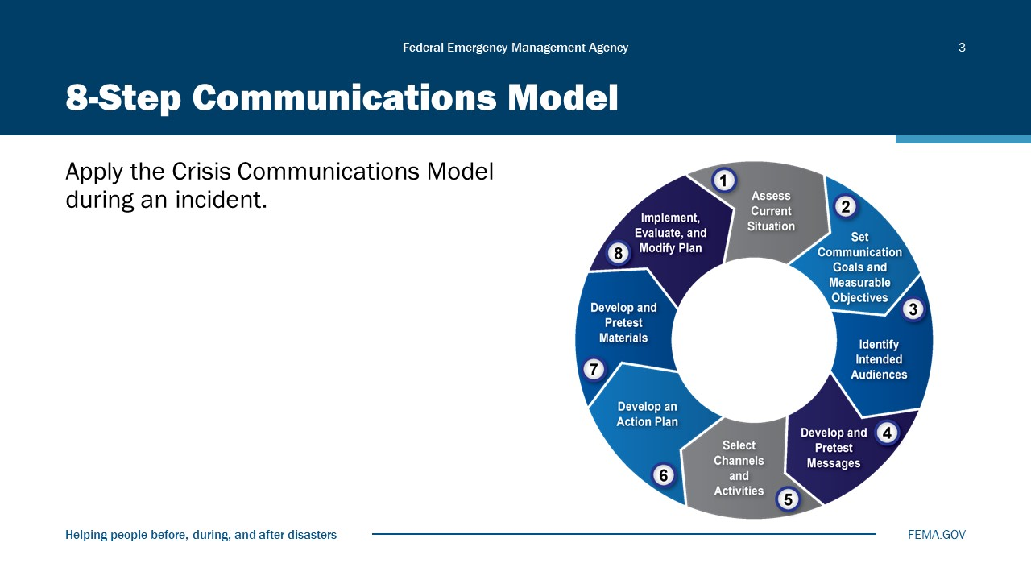
Visual 3, 8-Step Communications Model

Activity 7.1: Crisis Communications Intro Part 1
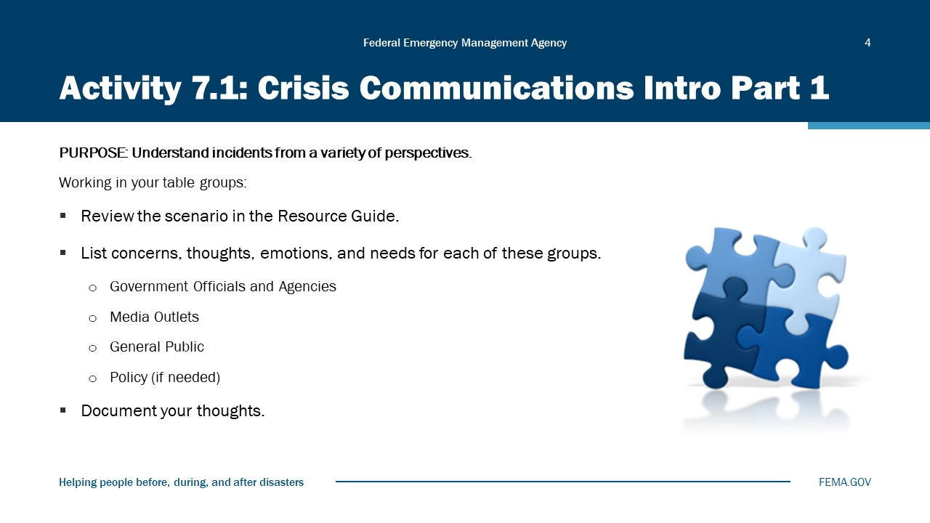
Visual 4, Activity 7.1: Crisis Communications Intro Part 1

Crisis Communications Part 1 Scenario
Over the past 18 months, all Central City Police, Fire, and EMS have been under tremendous scrutiny for slowed response times and troubled services. In response, both the Fire and Police Chief have also been critical of 911 dispatch personnel, blaming them for the delays. Unions for all three divisions agree there are problems with 911 Center personnel, but they also blame current administrative and city leadership as causes for fueling this criticism. Currently there exists a long period of finger-pointing and blaming. Recently the Police, Fire, and EMS Chiefs have raised concerns about EMS field personnel “hiding out” at hospitals, taking themselves out of service for extended periods or claiming unsubstantiated communication problems, with both radio and mobile data terminals.
A month ago, Carlos Alejandre called 911, and Police, Fire, and EMS were dispatched to his Central City home. The initial call was for an “ill infant.” Mr. Alejandre is a nationally known Civil Rights and Immigration expert. He has served in the past as an advisor to several Presidents; he is a University Professor and the recipient of numerous national and international awards and recognitions. Recently, Carlos has been very outspoken regarding the diversity of local first response and Central City governmental agencies and their agency hiring practices.
The initial response to the Alejandre home took more than 18 minutes for the first CC Police Officer to arrive. Fire and EMS units arrived several minutes later. After an evaluation of the child, EMS paramedics suggested a cold bath for the child’s high fever and for the family to call their family physician. All units then left the Alejandre home. Within 30 minutes of leaving the Alejandre home, units were called back to an infant in cardiac arrest. Sadly, the child died.
News of the death moved quickly through the community and has at times reached a boiling point. The EMS Chief has had no explanation other than to say the first ambulance dispatched for the second call caught fire while enroute and a second ambulance was needed to be sent from a greater distance away. Police to date have taken a hands-off stance as have fire leadership. They simply are insisting they have no comment. It has also come to light since that no less than three ambulances have caught fire, two of which were destroyed by these fires in weeks leading up to the Alejandre request.
The Alejandre family has retained legal representation and here is what legal inquiries have discovered. This has also been shared with the community and local media since the death of their child:
- Several ambulances have caught on fire prior to and since the Alejandre call.
- The training and certification records of the Fire and EMS personnel records do not exist anywhere in system. No records.
- The initial Alejandre call to the 911 Center was identified at the “Alpha” level, indicating low priority. (So was the second call reporting a Pulseless Non-Breathing Infant.)
- Police were wandering around the house while EMS and Fire were with patient and family. Alejandre’s claim is that they were searching the house illegally.
- There was another Central City ambulance even closer (only two blocks away) when Alejandre called 911 a second time. The crew appears to have remained silent, failing to indicate their proximity to the Alejandre home.
- According to the Alejandre family, when paramedics arrived the second time, they came in without equipment, having to return several times to the ambulance to get things they needed. It also appeared as though the EKG equipment was not working.
- Carlos Alejandre’s anger was further escalated when police began to interview him and his wife. He claims to have been treated like a guilty individual, even as paramedics worked on his child.
- Communications equipment failures have dogged all departments, and problems have been well known and lasted for years prior to the Alejandre call. Recently the public learned that the Central City new computerized dispatch system was also failing. The system sends ambulances and fire trucks to the wrong location or even to locations outside their assigned areas, has failed to dispatch the nearest vehicle, or has sent emergency vehicles in the wrong order. Occasionally, the system attempted to dispatch a vehicle already assigned to other emergencies while ignoring available vehicles. Front-line staff have complained they have received no training prior to the system’s activation. Fire Chief Kendal Bravery’s tenure has generally been considered to be very troubled, with controversies over hiring and promotions, training, and even firefighter grooming, as well as multi-million-dollar equipment failures.
- The recent appointment of Scott Werth as EMS Director has led to a number of investigations. Werth’s tenure has been plagued by repeated scandals, including several involving his very own hiring. Other controversies during his tenure include several expensive uniform changes, higher overtime pay, new communication policies, charges of lying over how to count EMS runs in the city, and retaliation against numerous department employees. Controversial changes and ambulance staffing have never been implemented. Even today, active controversies exist over costly fire engine and ambulance repairs, the availability of vehicles for emergencies, and the location of vehicles.
Background Information:
The troubled CC EMS Division has continued to have problems for a couple of years. Former Kingston, EMS Director Scotty Werth, was named CC Chief of EMS, even though he personally…as well as…. the Kingston EMS Division were being sued by the family of James Elvord, who died of gunshots wounds while being treated by Kingston EMS paramedics. Elvord’s family argued that Director Werth ordered responders to stop treating the victim in the mistaken belief that Elvord had a gunshot wound to the head and was already dead.
Ten African American firefighters and paramedics filed a racial discrimination suit accusing Central City of tolerating a racist work environment within its first responder employees. The suit names about 10 white male firefighters who were accused or convicted of crimes— including assault (sometimes with knives), sexual harassment (emailing images of their genitals to female colleagues), illegal possession of a firearm, public nudity in the firehouse, and stalking— but never disciplined. However, the city always punished or terminated black firefighters accused or convicted of similar crimes. The lawsuit also alleged that the department purposefully allowed a current promotions list (which had many black candidates on it) to expire.

PIO Activities: 95% is Preparation
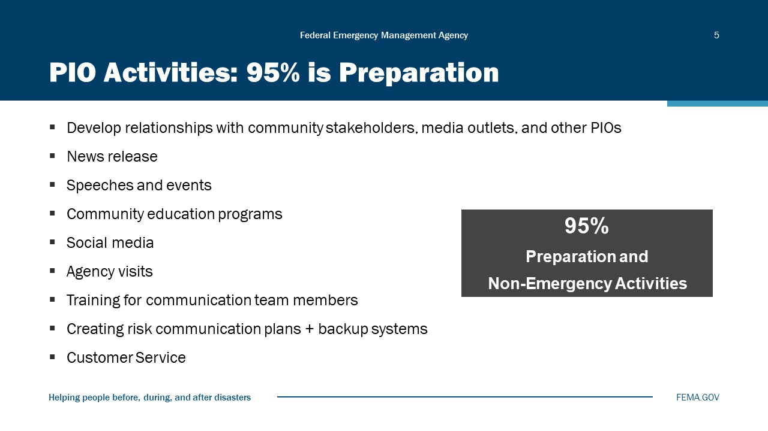
Visual 5, PIO Activities: 95% is Preparation

PIO Activities: 5% is Crisis
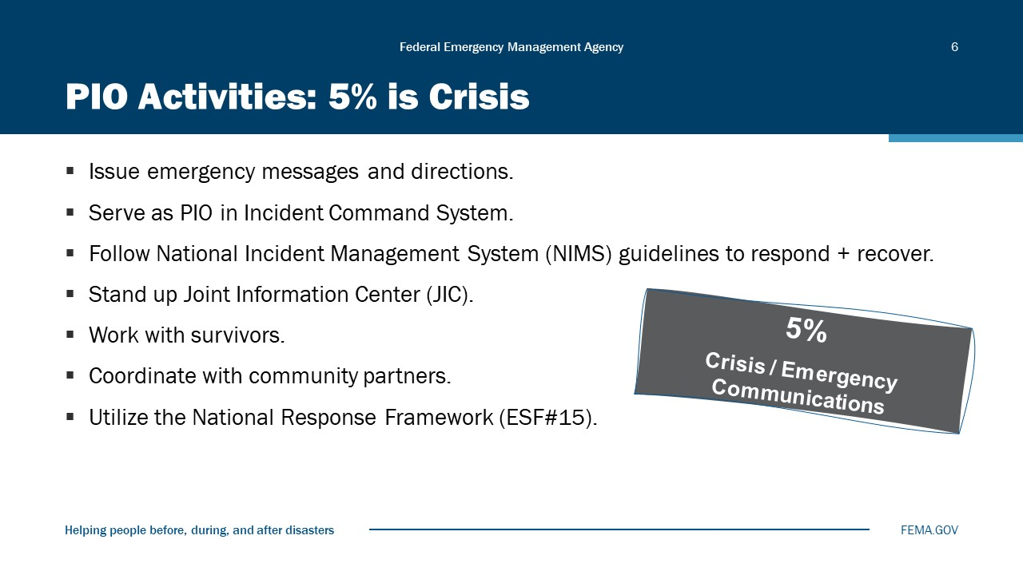
Visual 6, PIO Activities: 5% is Crisis

Risk vs Crisis
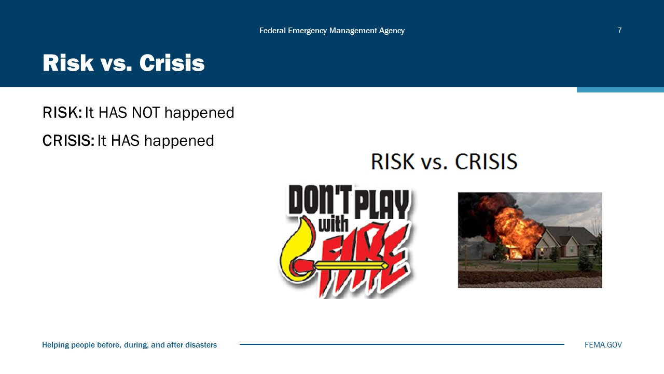
Visual 7, Risk vs. Crisis

Crisis Can Originate from...
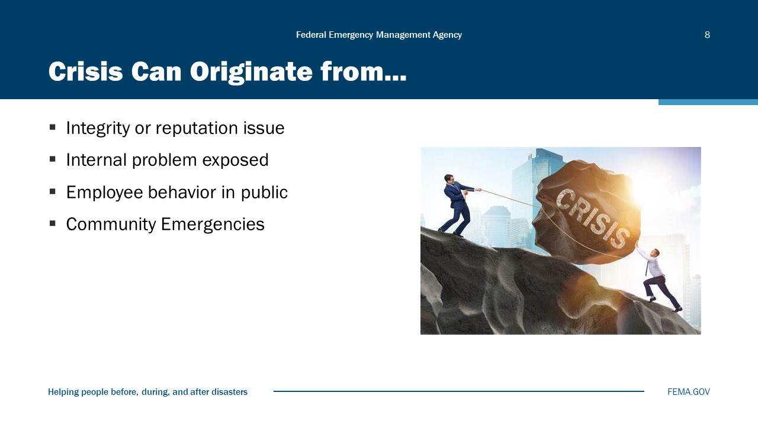
Visual 8, Crisis Can Originate from…

Example: Single Organization Crisis
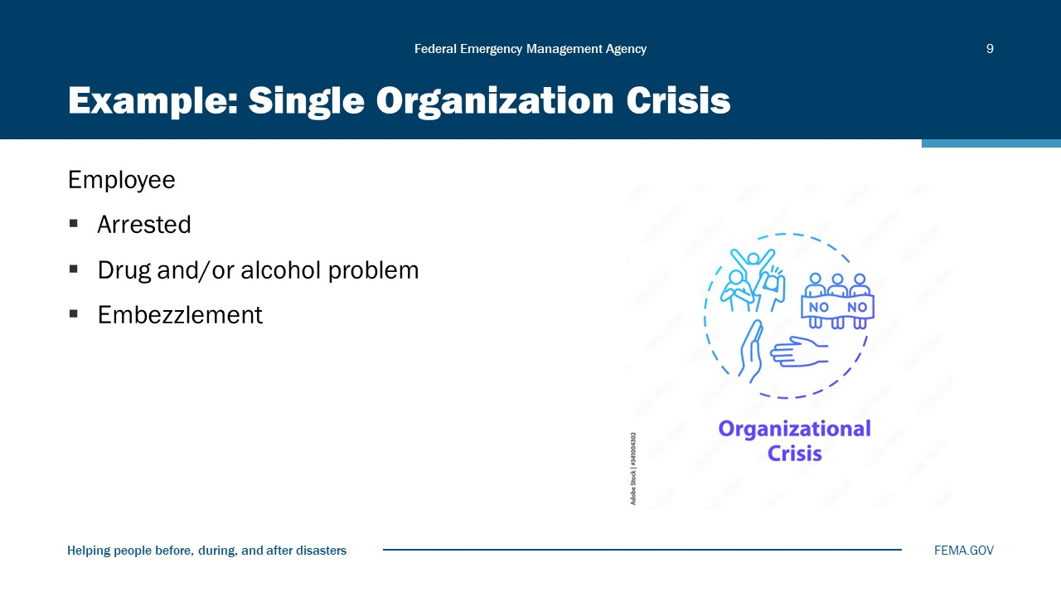
Visual 9, Example: Single Organization Crisis

Can you think of other examples?

Multiple Organization Crisis
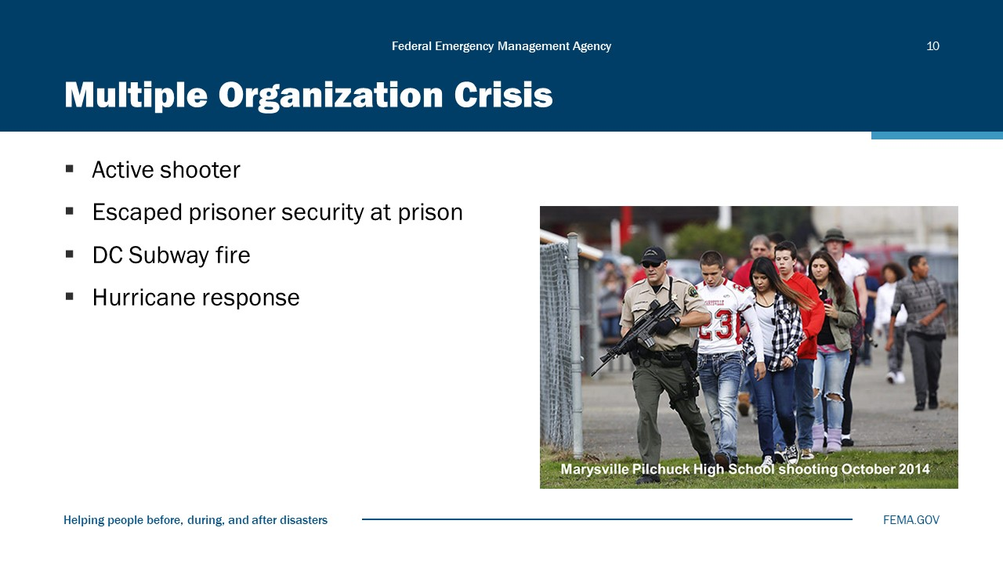
Visual 10, Multiple Organization Crisis

Can you think of other examples?

PIO Primary Goal
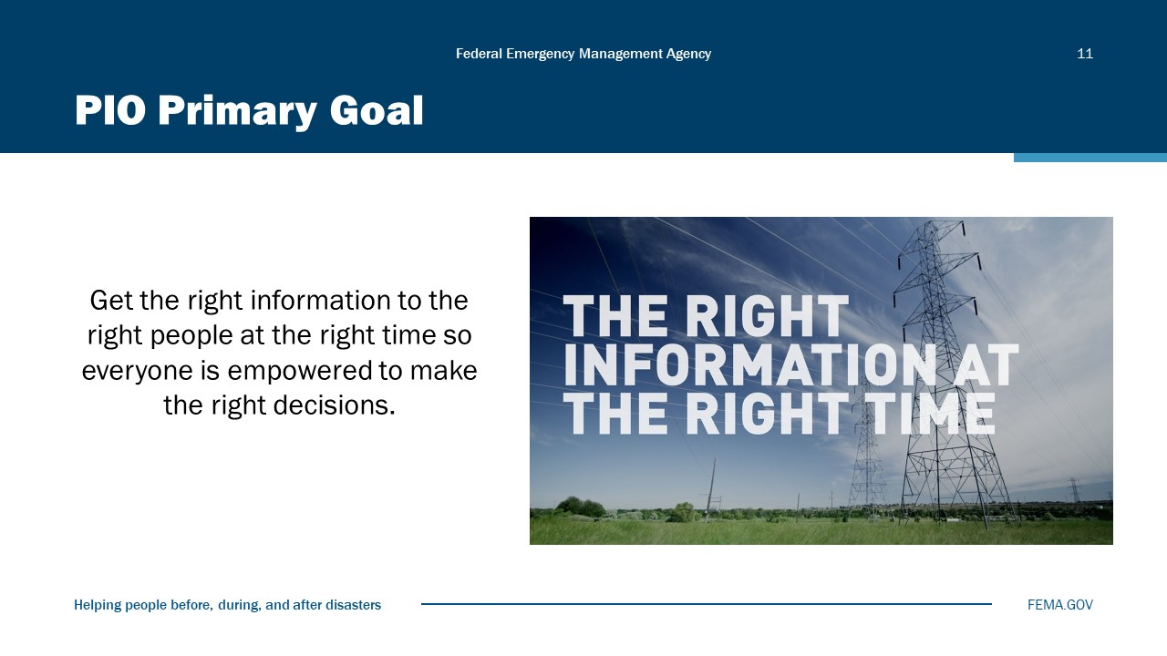
Visual 11, PIO Primary Goal

Objectives During a Crisis
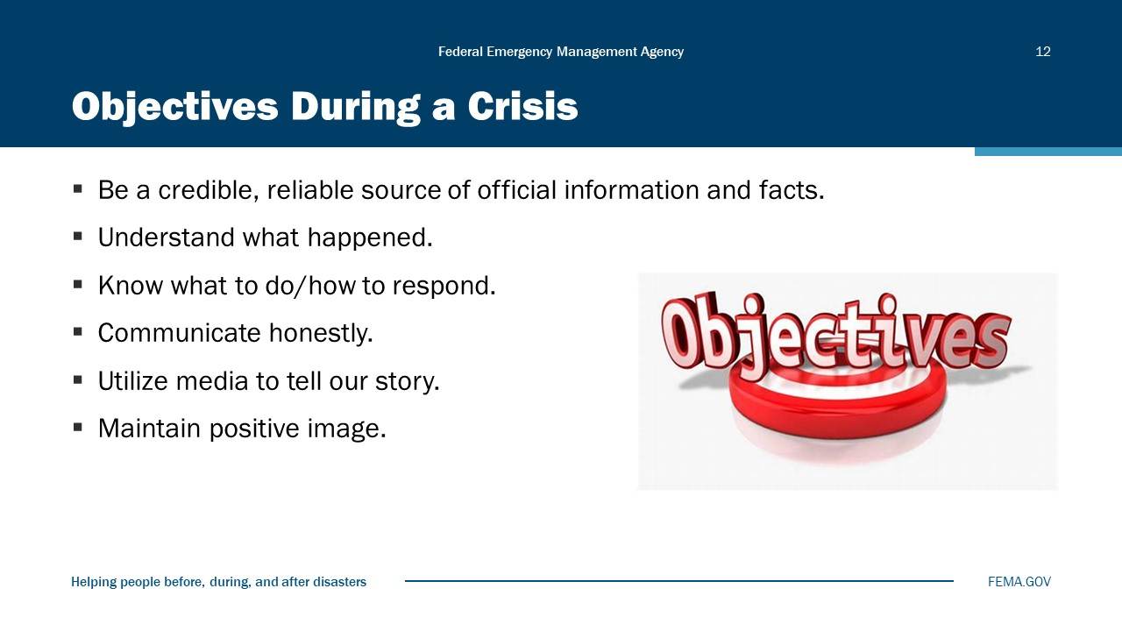
Visual 12, Objectives During a Crisis

Disclosure with Minimal Delay
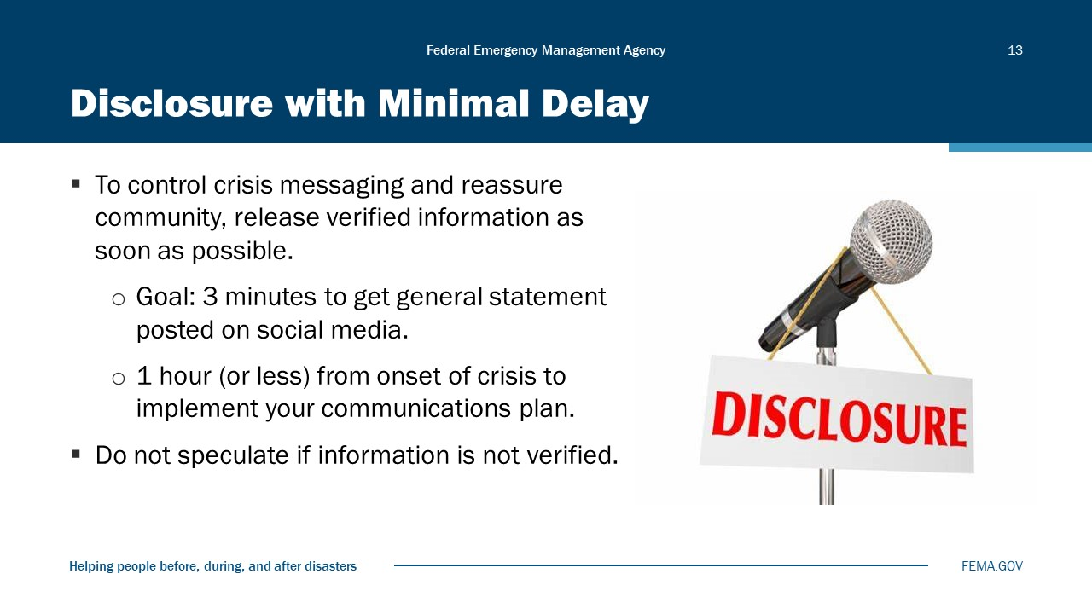
Visual 13, Disclosure with Minimal Delay

Communication Tools
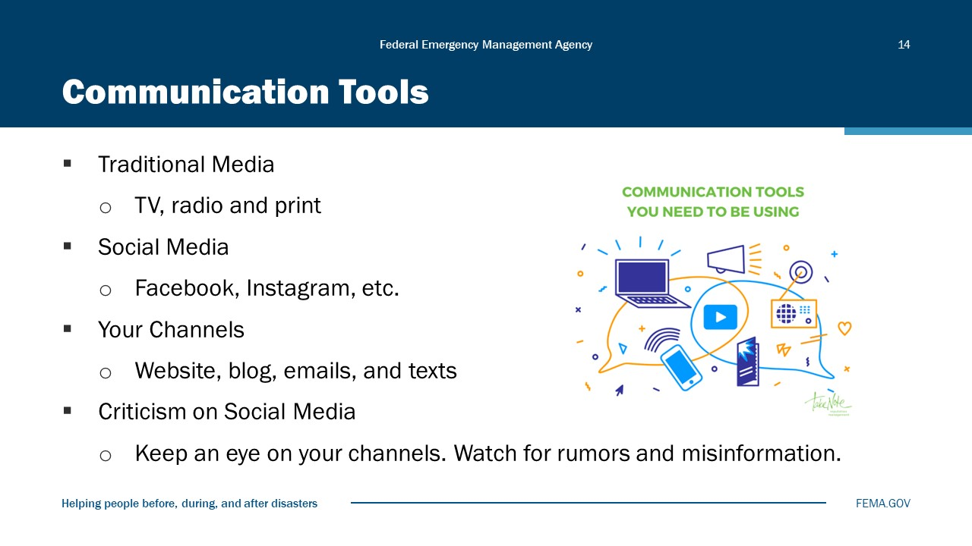
Visual 14, Communication Tools

7 C’s of Communication
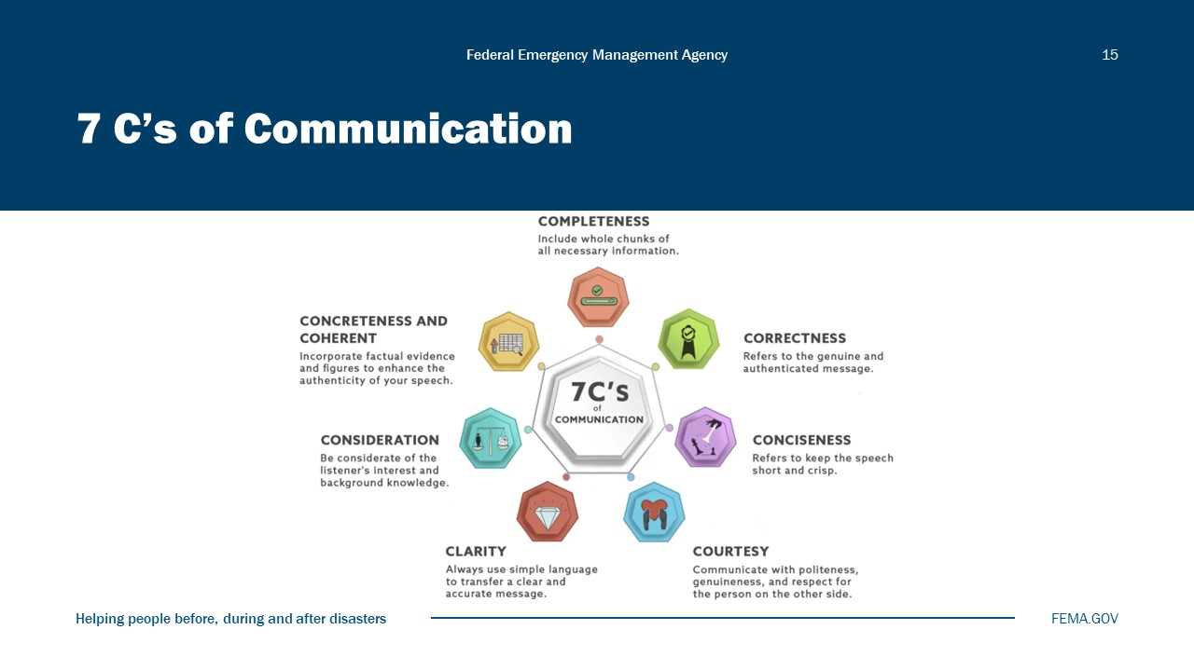
Visual 15, 7 C’s of Communication

- Completeness
This is one of the most significant aspects of effective communication. Completeness refers to giving full information about something rather than just saying it in bits and pieces. It’s the right of the recipient to receive access to the whole chunk of information to be able to follow the sender’s line of reasoning in regard to the matter being discussed.
- For example, when Peter told “write a short passage on data science and send me”, Shawn couldn’t understand the context whatsoever. He had too many questions in his head about the topic, its length and the style of writing, where this piece of writing go, etc.
- Instead, Peter could frame his instructions as “Shawn, I want you to write a 100‒200-word short essay on the recent trends in data science. Submit it to me by the end of this day. I need it for our blog.”
Completeness holds much higher salience during the delegation of tasks when the subordinates need detailed instructions to pursue a task at hand.

- Correctness
The genuineness and the value of your speech lie in its correctness and authenticity. It’s better to keep quiet rather than talk about something that you aren’t so sure of. The correctness of the speech would reflect directly on your personality and so it should be given utmost prominence.
The legitimacy of the information, the language used, and grammar are some of the aspects of correctness amongst others.
If your audience spots any errors or blunders in your speech, it is no longer valued, and they are likely to be distracted. The credibility of the speaker would also receive a massive hit and therefore the effectiveness of the communication will be compromised.
- Conciseness
Conciseness is to keep the speech short and crisp. Nobody likes listening to someone who delivers long and draggy speeches because people lose interest and attention very easily. When interacting or delivering the speech, the ultimate objective is to make sure that the message is received in its intended form. Lack of conciseness will lead to the loss of essence in the content. Make sure to keep your speech brief and precise.
For example,
- Intended message: “Could you please receive Amanda from the airport?”
- Delivered method: “Yesterday was a tiring day. Last night I couldn’t sleep properly. My wife had a severe migraine and she’s down. I couldn’t have breakfast in the morning, and I am tired. Amanda has taken her flight from Indonesia last night. She would reach here in some time. It would be nice if someone could pick her up from the airport.”
In this example, the message was simple. Yet, the sender makes it seem complicated and leaves the recipient feeling puzzled, irritated, or exhausted. Also, he may deny the request. Such delivery of a message makes the message lose its value.
- Courtesy
Courtesy refers to communicating with politeness, genuineness, and respect for the person on the other side of the conversation. It will naturally scale up the value of communication. Courtesy is a tendency which stems out of empathy for people.
To be courteous doesn’t mean just use polite, magical phrases like “thank you”, “sorry”, “please”, and “excuse me.” It also means to be honest, respectful, and empathetic of people and not make sarcastic or any other form of passive-aggressive remarks.
- One classic example would be from the infamous movie “Mean Girls”, where Regina would tell a fellow classmate about how she loves the skirt she was wearing. As the girl leaves, Regina would tell her friend Cady how that was the ugliest skirt she has ever seen. This is an example of how you should not communicate.
In many instances, people use the power of their intellect and status to belittle the plight of others. This is so especially among those who bully the perceivably weaker ones for their timidity, racial backgrounds, gender, and color, among many other aspects.
- Clarity
Clarity is to transfer accurate and easily comprehendible messages to the receiver. Before choosing to talk, be clear about your goals for the conversation. Let the other person know what your objective is for the interaction. To make your speech clear, always use simple language rather than using intricate phrases that would make comprehension difficult.
The recipient shouldn’t be made to “read between the lines.” Even if the content is complicated in nature, try to divide your ideas, distill it, and make it as simple and clear as possible as that would make it easy for the receiver to grasp the information well.
- Consideration
Consideration is quite like that of courtesy. It means to consider the other person and to address them putting you in their place. In other words, you talk to someone in a way you would want someone to talk to you.
- For example, if you prefer someone to talk to you with respect and politeness, you will exhibit the same behaviors towards others. Just as that of courtesy, one should be inherently empathetic to be able to show consideration for the other person. When you are considerate, you sincerely regard people’s interests and benefits.
To be considerate also means to acknowledge the situational factors of the audience that you address. If you are going to give a talk on astrophysics amongst a bunch of 7-year-olds, the only response you would receive would be the sound of yawning and snoring; maybe even a giggle here and there if you’re lucky.
So, when you talk to someone, remember to acknowledge their background such as their age, language proficiency, culture, literacy level, mental state, character, interests, etc,. so that you may be relatable to your audience and your intended message reaches them successfully.
- Concreteness
Concrete communication denotes your message being specific, meaningful, and focused. You don’t beat around the bush to get to a point. Rather it is solid and concise. You avoid vague and ambiguous messages and only strive toward making your information well received by the recipient. Your speech is crisp yet brimming with beneficial information. You incorporate factual evidence and figures to enhance the authenticity of your speech.
- For example, when you say, “Depression is a global issue”, you don’t just bluntly make that claim but also pitch in the statistical values and empirical evidence to support your statement.

Holding Statements by Onset of Event
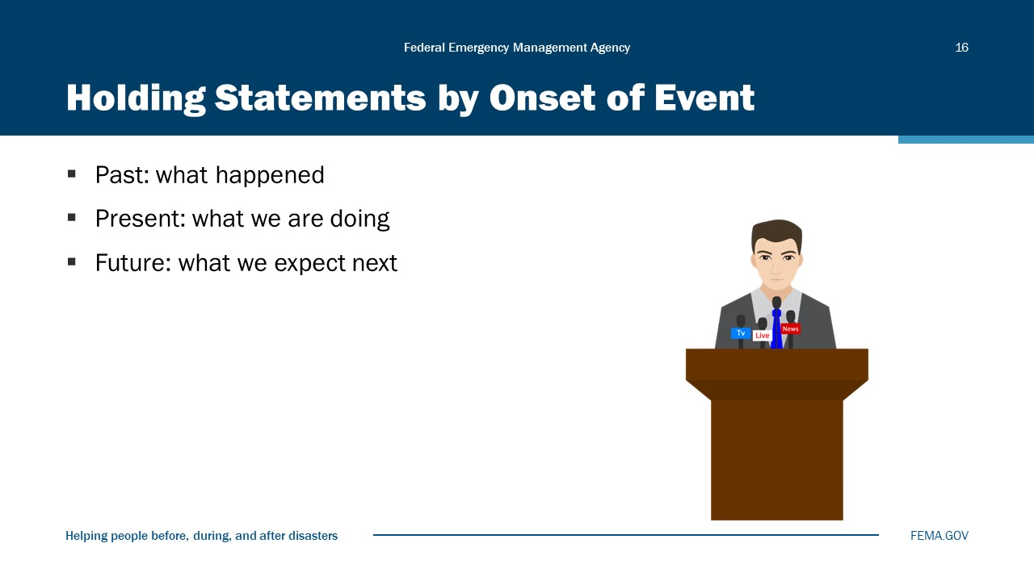
Visual 16, Holding Statement by Onset of Event

EXAMPLE:
There is an accident at the intersection of Elm Street and Oak Road. Police, Fire, and EMS are on the scene. Please avoid this area. We will provide further updates as they become available.

Use Your 27-9-3 Message Map
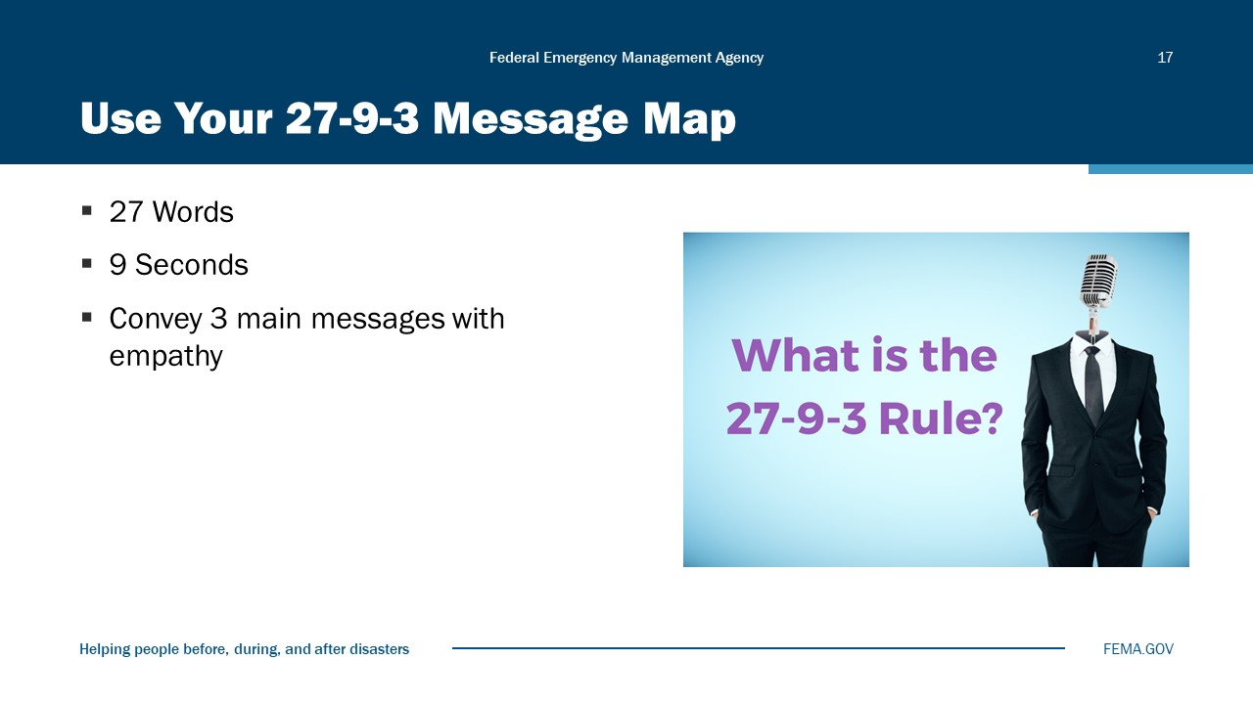
Visual 17, Use Your 27-9-3 Message Map

Media Interview Preparation
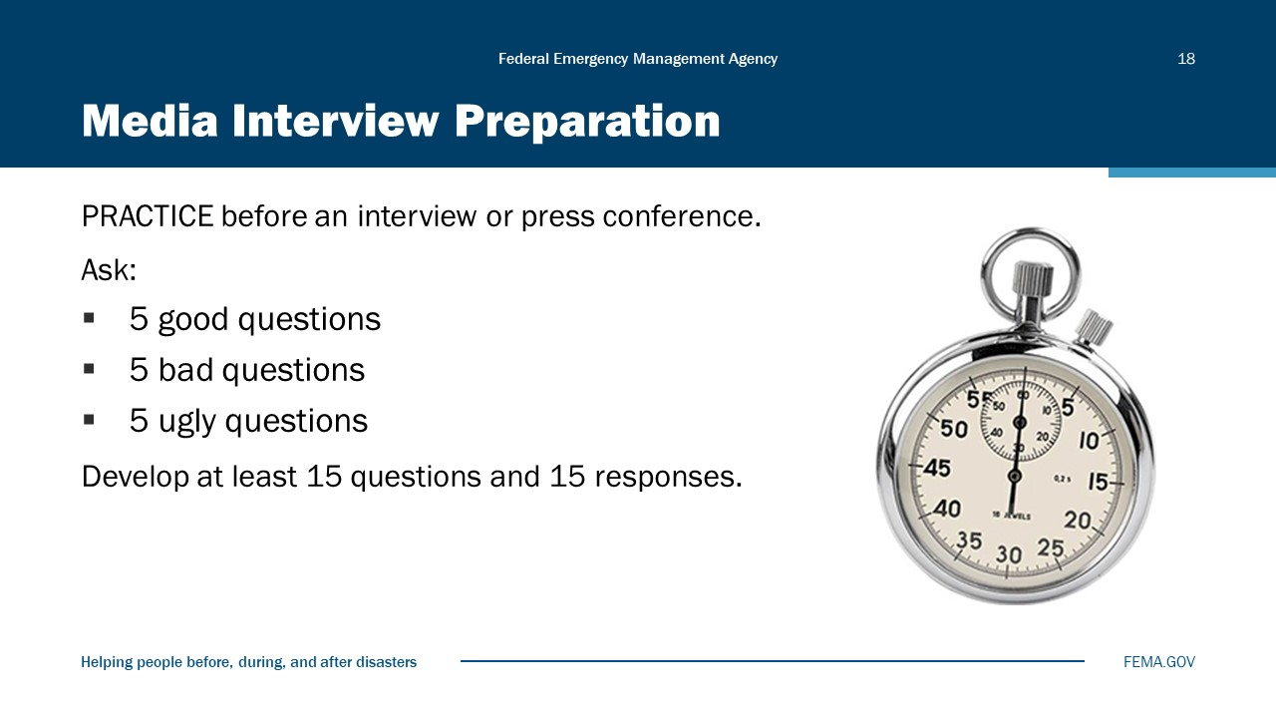
Visual 18, Media interview Preparation

The Three “C’s” of Crisis Media Relations
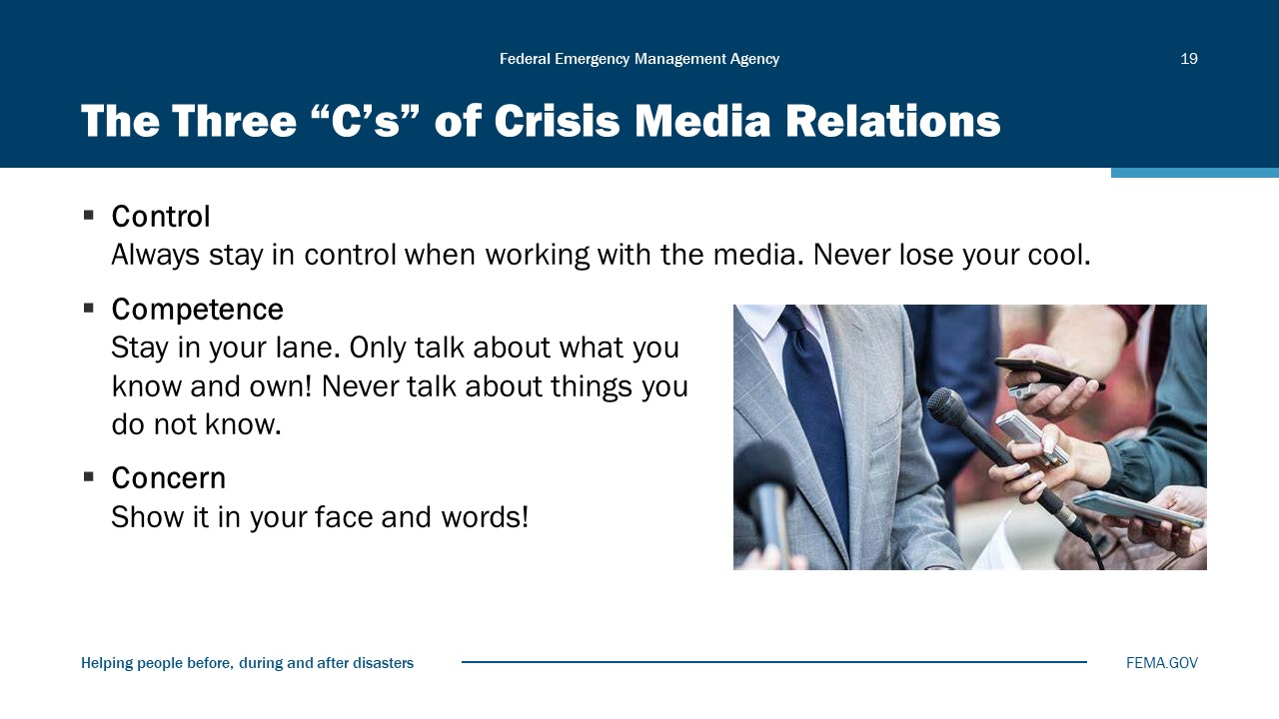
Visual 19, The Three “C’s” of Crisis Media Relations

Common Barriers to Releasing Information
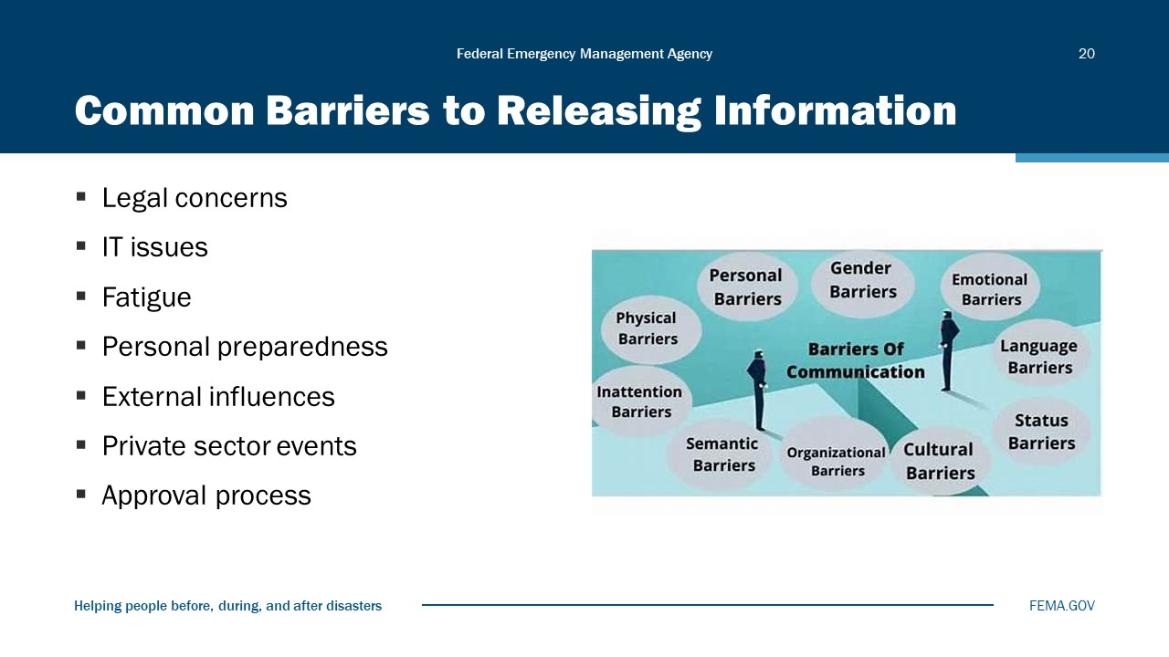
Visual 20, Common Barriers to Releasing Information

Factors Affecting Public Response
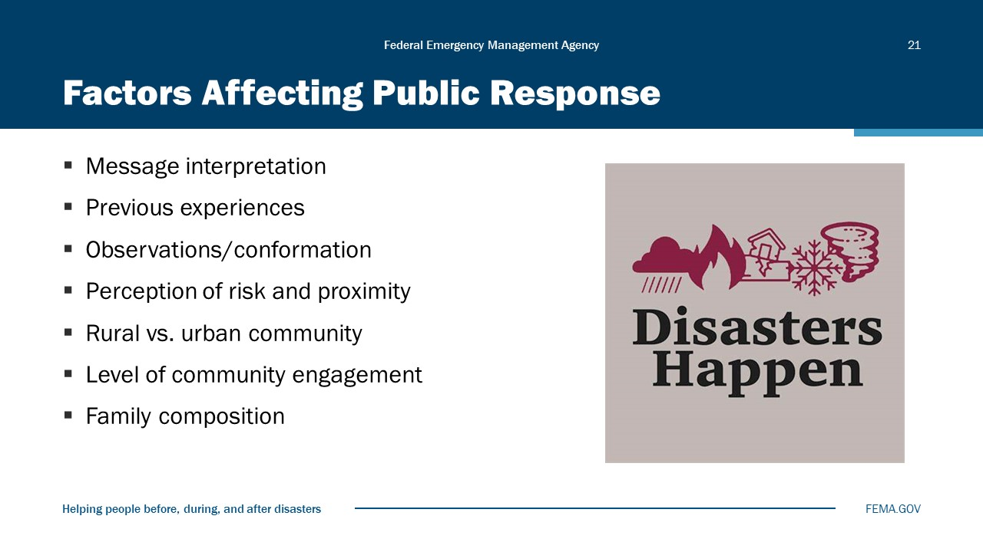
Visual 21, Factors Affecting Public Response

KEY POINT: The clearer and more specific you can be, the higher the compliance.
- Interpretation: When different people listen to the same message, there may be a variation in what they hear, leading to different interpretations and responses.
- Experience: People often rely on their experiences with the hazard to determine what actions they’ll initially take (or don’t take)
- Observations: Most people will seek some form of confirmation, such as environmental cues and other trusted sources. Optimism bias—disasters happen to other people—is overcome with confirmation.
- Perception of risk: People tend to make a rapid assessment of the relative safety of the location. If their risk perception is high, people will act quickly vs. when low, they will delay acting.
- Community: Rural communities may have more difficulty receiving warnings than those living in urban areas.
- Community engagement: People who have more contacts in the community will receive more warnings, making them more likely to act and trust officials.
- Family composition: Families tend to heed evacuation warnings more than individuals. Research indicates people tend to confer with family, extended family, and friends prior to deciding to ensure loved ones are safe.
- Family network: People are more likely to act if they have relatives nearby who may warn them and offer short-term shelter.
- Children: Concern for children’s safety will elicit a quicker response from parents.
Pets: People will take action to protect them and may endanger their own lives by refusing to evacuate if public shelters do not allow pets.

Activity 7.2: Crisis Communications Part 2
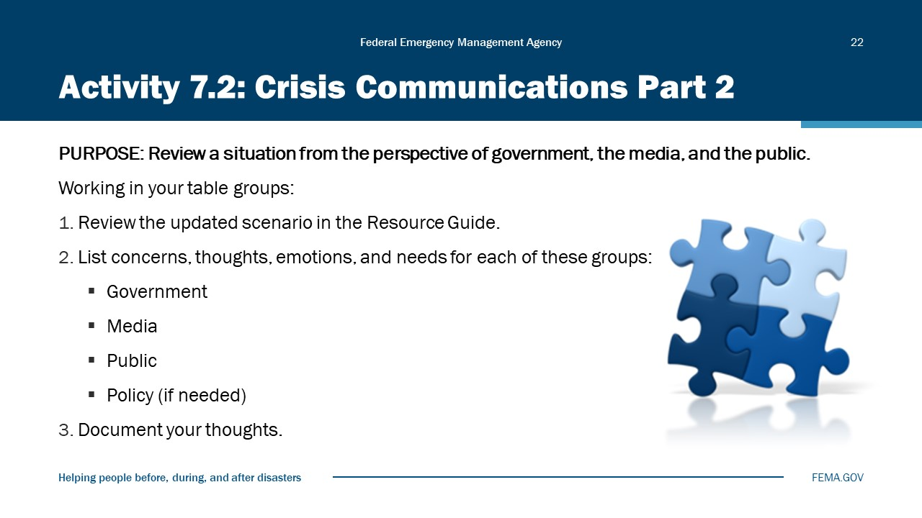
Visual 22, Activity 7.2: Crisis Communications Part 2

Crisis Communication Part 2 Scenario
Two weeks ago, in an incident described by the Liberty County Sheriff in his own words as a “botched SWAT operation,” an officer sustained a significant lower leg gunshot wound. While SWAT officers approached 1720 B Street, the individual being sought emerged from 1723 B Street and opened fire on officers. Following a brief exchange with officers, it was discovered that K-9 Sgt. Robert Luther, an 18-year veteran of the Liberty County Sheriff’s Department, had sustained a significant leg wound. While ballistics are still being examined, it would appear that Sgt. Luther’s wound was a result of “friendly fire.” An immediate request for EMS was made to 911. The shooter was “wasted” quickly according to the Sheriff.
Initially, in all of the confusing radio traffic, 911 dispatchers were of the belief that only the deceased was shot. So instead of EMS being dispatched, the Liberty County Medical Examiner was summoned, not EMS. Approximately 10 minutes later, as Sgt. Luther lay bleeding on the ground, officers made inquiry about the EMS they requested. It was then the mistake was discovered by 911 dispatchers and Central City EMS dispatched. After waiting another 5 minutes and while watching Sgt. Luther’s condition rapidly deteriorate, officers applied a makeshift tourniquet to his leg just below the knee. It took EMS another 13 minutes to arrive, as the original EMS unit dispatched could not be started while in the Fire Station #4. The EMS unit from CC Fire Station #6 was able to respond from a greater distance away. Since this incident, the Sheriff has been incensed at Central City Fire and Central City EMS leadership regarding equipment condition and trustworthiness to respond. He blames CC Fire and CC EMS for the suffering by his officer. The Liberty County Law Enforcement Officers Association, joined by the State Law Enforcement Officers Association, blame the Sheriff for not including EMS in operational training and operational response. Association leadership has long requested EMS and medical treatment be available during these operations. The Sheriff has consistently declined to include EMS, claiming “there is no reason to exposed untrained firefighters and EMS to dangerous situations.”
Because of delays and the improper tourniquet, Sgt. Luther still struggles in Central City Hospital with his recovery and resulting infections. Medical professionals, concerned about the potential for blood clots and possible pulmonary emboli, made the decision to amputate the officer’s leg at the knee. This will require long-term recovery. However, the community has taken a great interest in his recovery, seeing numerous photos in social media of the officer in the hospital being visited by “Candy”, his 3-year-old partner German Shepherd. Candy has been a popular and frequent visitor to all county schools and is loved by many children.
In addition, a 77-year-old man lost his life this past weekend outside a Central City Fire Station at approximately 1 in the afternoon. Mr. David Couch, an African American resident and neighborhood activist, while taking in the Liberty County Celebration of Arts and Music activities, collapsed in a parking lot next to CC Fire Station #9. Couch’s family, seeing their father and grandfather collapse, immediately ran to his aid. Several family members ran around to the front of Station 9 and rang the doorbell several times. After a short time, new recruit firefighter Bill Tobias answered the door and when told of the cardiovascular emergency replied….”Sorry, but we cannot leave the station without a 911 call”….and simply closed the door on the family.
Several minutes later, a CC police officer on patrol rolled up on the parking lot commotion. Then seeing a passing ambulance, the officer stopped the paramedics who then administered aid to Mr. Couch, now pulseless. At some point, a 911 call was placed, and two of the four station personnel came to the parking lot without any equipment.
Although this event occurred just 3 days ago, here are the facts the media and public now know from the family and interviews.
- Firefighter Tobias closed the door on the family after telling them to “call 911,” without offering a phone for such a call, or any other assistance.
- Firefighter Tobias (fearing repercussions) did not report the emergency to his supervisor. His Fire Captain had retired to her bedroom after finishing a large lunch with the harsh instructions…she was “not to be disturbed unless this fire station was actually on fire.”
- A third firefighter assigned to Engine 9 was also fast asleep in front of a television in the Station #9 day room. Days of our Lives was playing on the television at the time.
- The fourth firefighter and the Engine Apparatus Operator was in the Station 9 library studying for an upcoming promotional exam and was unaware of the parking lot emergency, thinking the doorbell was most likely a visitor.
- The fire department did not respond immediately and was of no help to the family. Family now believes, as does the community, this was a racially centered decision by Firefighter Tobias (white male) and the members (all white) of Station 9. An attorney has already been hired.
- The mayor has declined to comment.

Types of Warning Systems
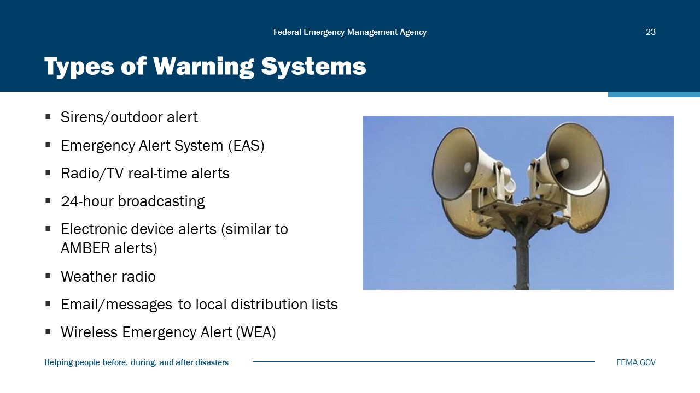
Visual 23, Types of Warning Systems

- Personal mobile devices/short text messages
- Email/messages to local distribution lists
- Wireless Emergency Alert (WEA)
- Recorded messages (manual or automatic)

Warning Systems
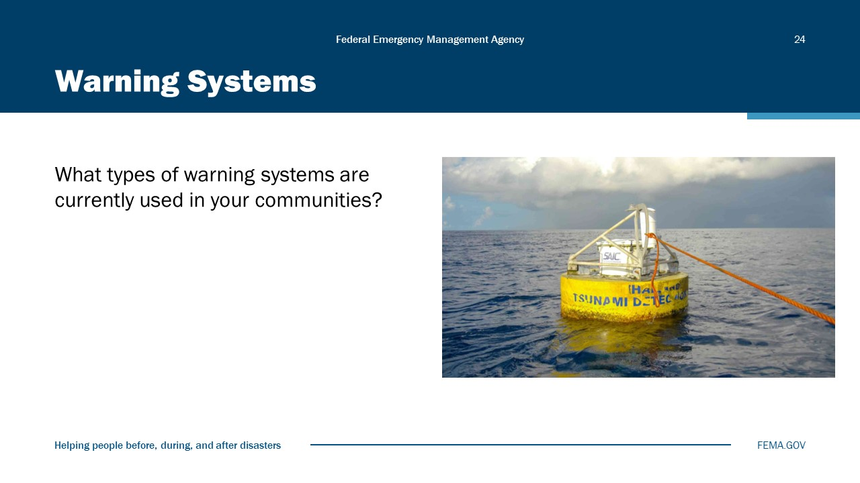
Visual 24, Warning Systems

Integrated Public Alert and Warning System (IPAWS)
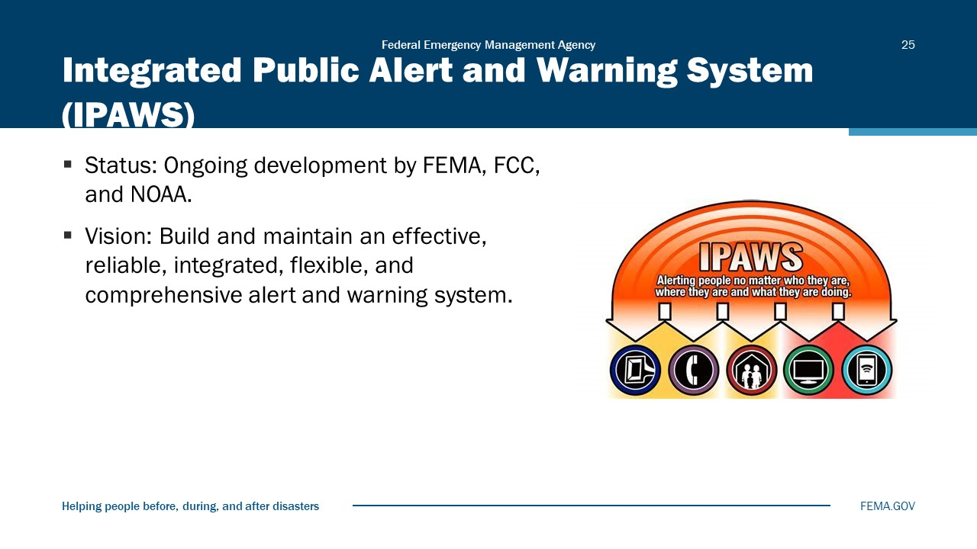
Visual 25, Integrated Public Alert and Warning System (IPAWS)

IPAWS Video
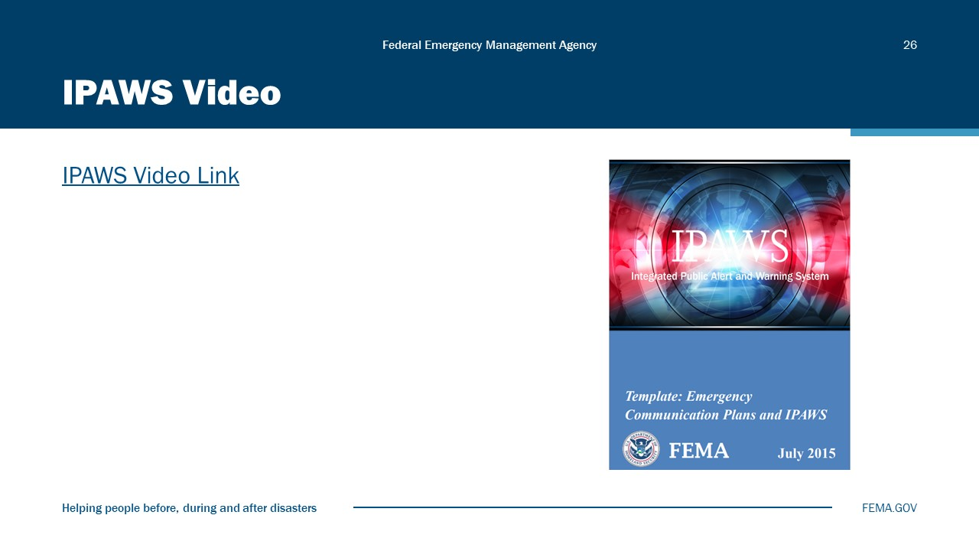
Visual 26, IPAWS Video

IPAWS Video Link
FEMA IPAWS Video Transcript
For the past 70 years, the National Emergency Alert System has played a crucial role in keeping our community safe and informed.
If there’s an emergency today, are you and your family prepared?
Do you know what’s right around the corner?
IPAWS is continuing to evolve, keeping up with the latest advancements in technology so that we are always prepared for what comes our way.
Through devices like your TV, phone, and radio, you can be alerted no matter where you are, anywhere, anytime.
From local notices to national emergencies to regular testing, IPAWS is America’s trusted system for local emergency alerts.
IPAWS has a variety of alerting pathways that are always ready to make sure that you get the information you need to act in emergencies.
Wireless Emergency Alerts or WEA send verified messages right to your mobile phone.
The Emergency Alert System or EAS for sure delivers important information from trusted officials right to your radio or television.
And NOAA Weather radios can deliver both weather and non-weather-related emergency messages via these special devices.
Through IPAWS, alerting authorities can send alerts to specific geographic areas, ensuring that you have the information you need to take action.
In an emergency, every second counts.
IPAWS is always ready to deliver simple and trusted alerts that you can rely on, delivering authenticated messages and lifesaving information.
No matter what devices are nearby, you can stay informed.
IPAWS, the Integrated Public Alert and Warning System, FEMA’s national system for local alerting, provides authenticated emergency and life-saving information to the public.
More information is available online at Integrated Public Alert & Warning System (https://www.fema.gov/emergency-managers/practitioners/integrated-public-alert-warning-system)

IPAWS Emergency and Warning
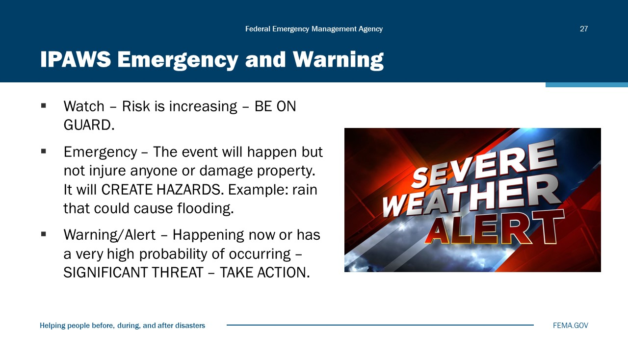
Visual 27, IPAWS Emergency and Warning

Warning Message Components
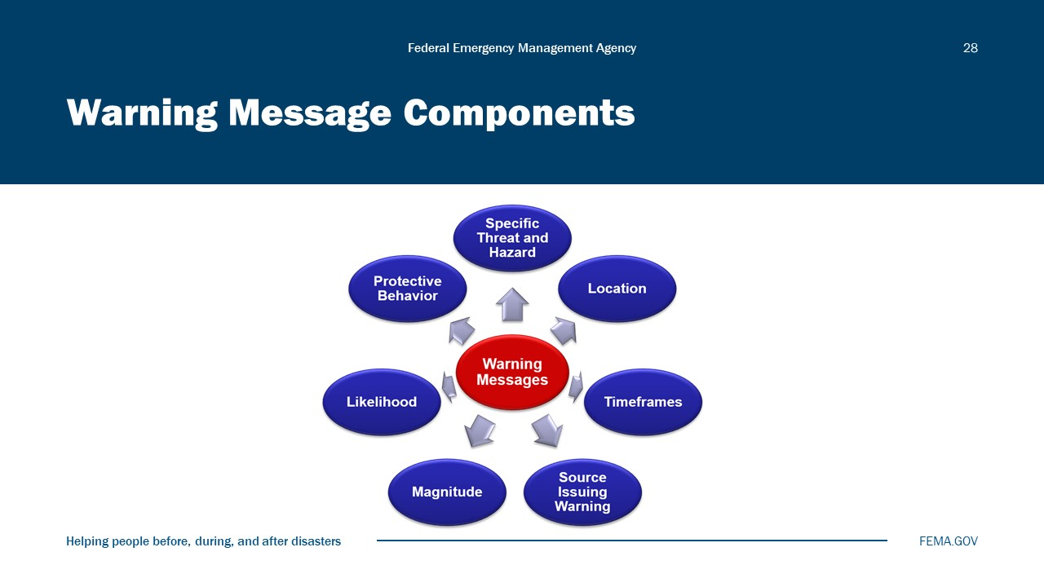
Visual 28, Warning Message Components

Deciding whether to issue a public warning can be a difficult decision. Ultimately it will be a matter of local judgment; however, it will be helpful to have an outline of decision criteria to assist you with the process.
Check that your local emergency plan has clear criteria and procedures for issuing warnings. Your state or local EAS plan or other emergency plans may provide criteria for issuing public alerts, including activating the Emergency Alert System, and if so, should be incorporated into your local procedures.
The following are examples of criteria that are used in the IPAWS:
- Does the situation require the public to take immediate action?
- Does the situation pose a serious threat to life or property?
- Is there a high degree of probability the situation will occur?
The alert authoring software provides fields that correspond to these questions, each with a list of values to select from. In order to be routed to the Commercial Mobile Alert System, the values for these fields must reflect “Imminent Threat”: Urgency (Immediate or Expected), Severity (Extreme or Severe), and Certainty (Observed or Likely).
Effective warnings are those that result in members of the public taking recommended actions to protect themselves. To help ensure that warning messages are effective, they must be issued in a timely manner and should include the following components:
- Specific hazard: What is/are the hazards that are threatening? What are the potential risks for the community?
- Location: Where will the impacts occur? Is the location described so those without local knowledge can understand their risk?
- Timeframes: When will it arrive at various locations? How long will the impacts last?
- Source of warning: Who is issuing the warning? Is it an official source with public credibility?
- Magnitude: A description of the expected impact. How bad is it likely to get?
- Likelihood: The probability of occurrence of the impact.
- Protective behavior: What protective actions should people take and when? If evacuation is called for, where should people go and what should they take with them?

Warning Message Example
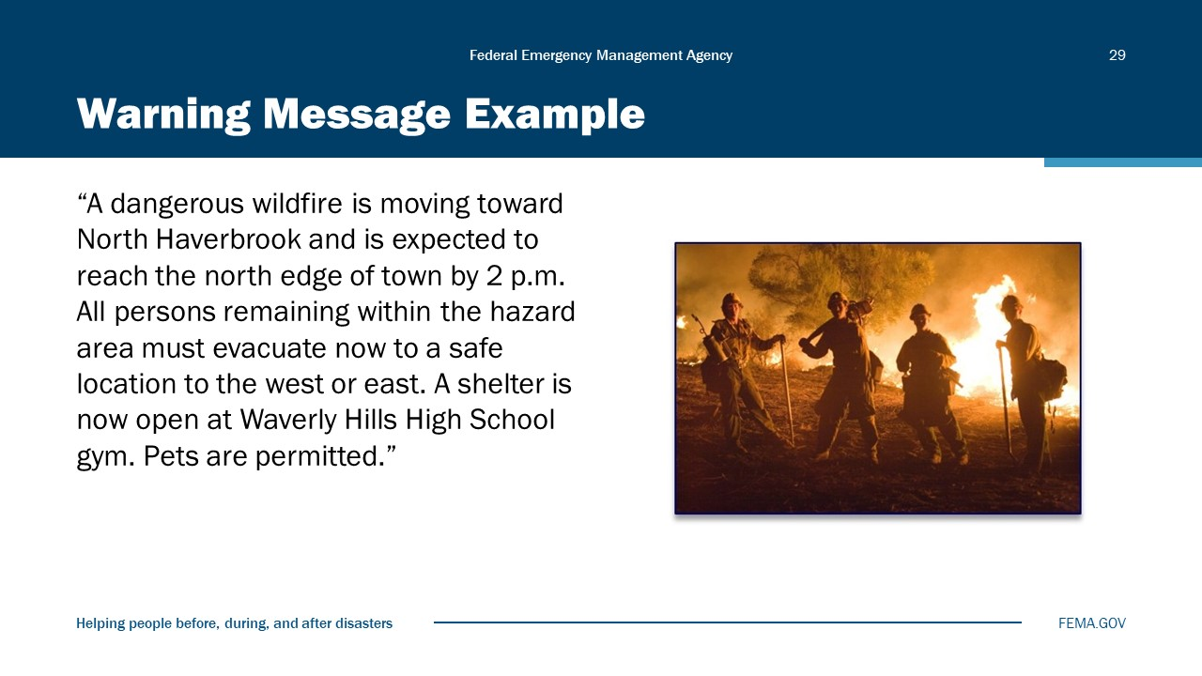
Visual 29, Warning Message Example

The use of templates, tailored to those threats and hazards likely in your warning area, can help prevent errors or omissions that can occur in moments of urgency. Using a template that incorporates pre-approved language can reduce delays in issuing alerts and warnings. Another advantage is that, if you need to use a language in addition to English, your templates can be translated in advance.
Your alert authoring software may provide the capability to create and reuse templates. If not, you can use word processing software to store your template and create your message to copy and paste into your alerting software.
It is recommended that if you do use templates, they should be customized for the types of threats and hazardous events that may occur in your area.

Improving Compliance
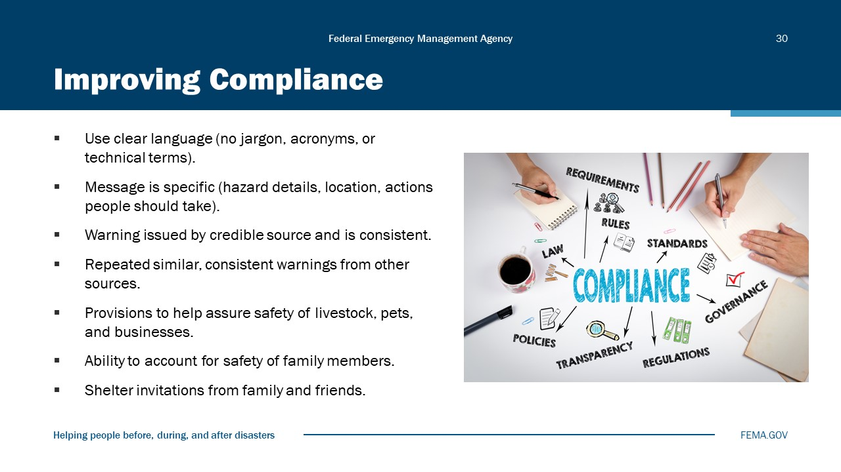
Visual 30, Improving Compliance

Creating Accessible Messages
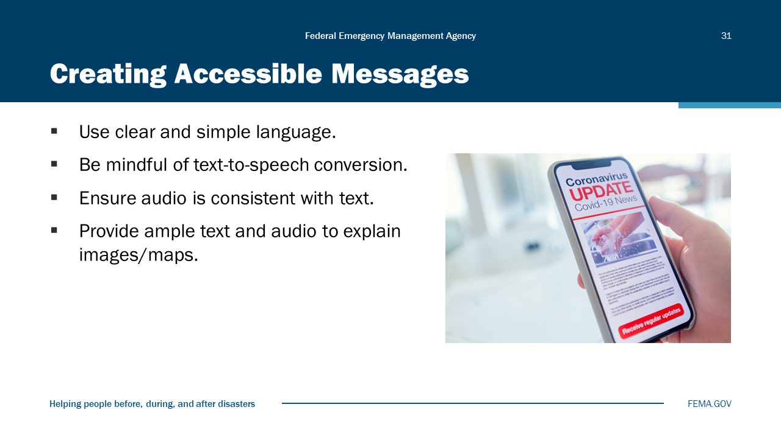
Visual 31, Creating Accessible Messages

Public Response Myths: Fake or Fact
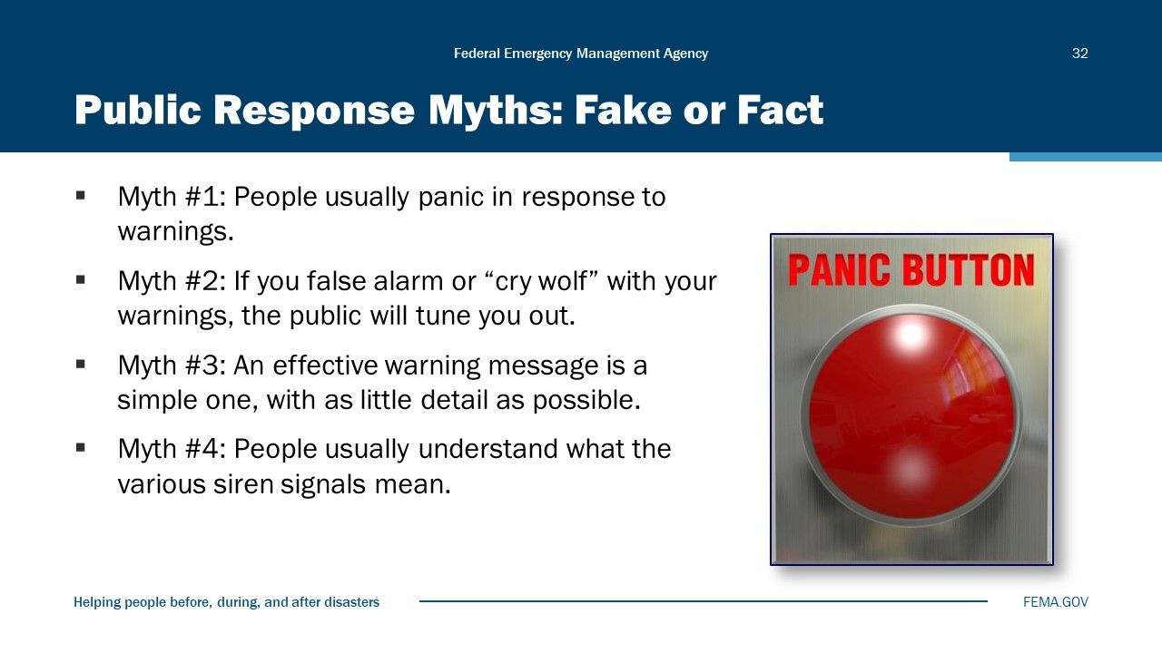
Visual 32, Public Response Myths: Fake or Fact

Below are several popular myths associated with public response to warning messages, along with the related facts:
Myth: People usually panic in response to warnings.
Fact: People DO NOT panic in response to warnings. People do not go running wildly through the streets when they hear a warning. Rather, they seek additional information to make a response decision.
According to Erik Auf der Heide, in “Common Misconceptions about Disasters: Panic, the ‘Disaster Syndrome,’ and Looting”:
The problem with the panic misconception is that the public, the media, and even emergency planners and public ofﬁcials believe it. Because of this, ofﬁcials may hesitate to issue warnings because they are convinced that the resulting panic will cause more damage than the disaster itself. This belief has led to recommendations to avoid panic by (1) providing minimal information to occupants in the event of a building ﬁre and (2) carrying on normal activities until the last possible moment. In places of entertainment, it has been suggested that the band should continue to play if there is a ﬁre and that panic can be avoided by having telephones located in areas where people cannot overhear calls to the ﬁre department.
A more relevant concern for these public ofﬁcials should be how to create warning messages that the public will heed.
Myth: If you false alarm or “cry wolf” with your warnings, the public will tune you out.
Fact: While there is a limit to the public’s trust, the “cry wolf” syndrome is NOT a problem IF “false alarms” are well explained and understood. People do consider that officials are making difficult decisions to protect them from harm.
Myth: An effective warning message is a simple one, with as little detail as possible.
Fact: The “less is more” principle does not apply to public warnings. Research has shown that people need sufficient information to validate their risk and spur them to take appropriate action.
Myth: People usually understand what the various siren signals mean.
Fact: People DO NOT always understand what the various siren signals mean. The best use of outdoor warning sirens is to alert people to immediately seek additional information about an imminent threat.

Emergency Operations Plan
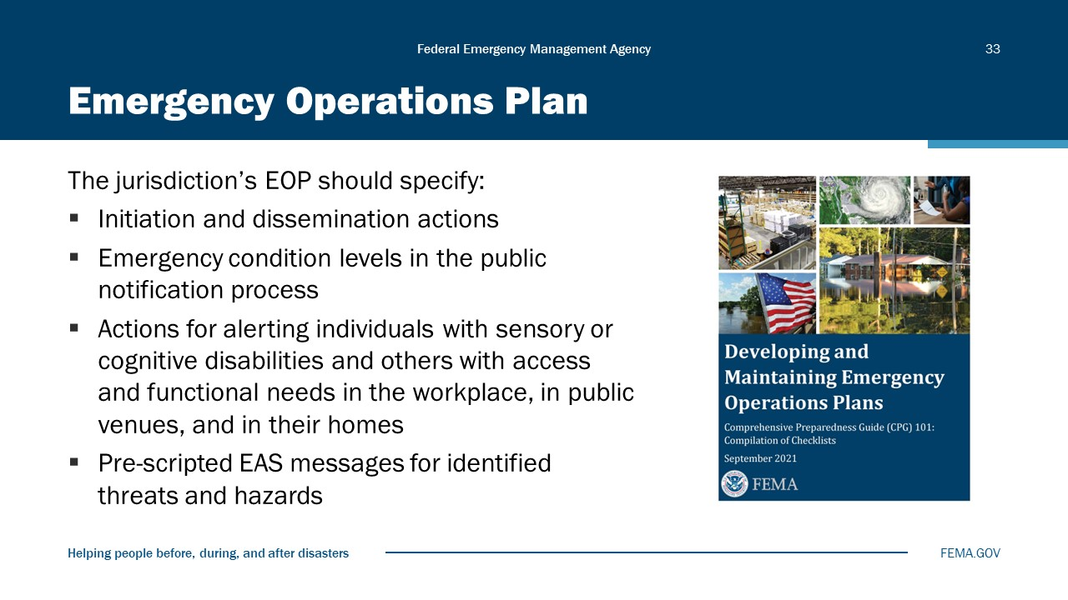
Visual 33, Emergency Operation Plan

You can find examples of how different jurisdictions handle alerts and warnings by conducting a Web search for “EOP Alert and Warning.”
The Communications Plan and Emergency Operations Plan (EOP) work together.

Activity 7.3: Warning Message
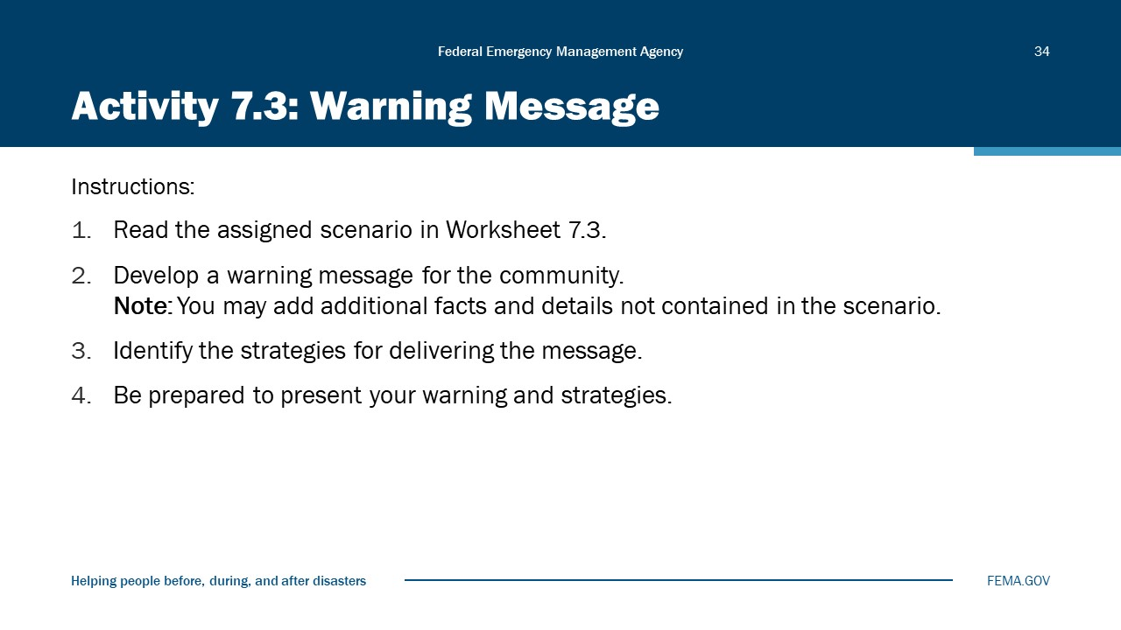
Visual 34, Activity 7.3: Warning Message

Purpose: The purpose of this activity is to develop a warning message based on a provided scenario.
Instructions: Develop a warning message and identify delivery strategies as described in Worksheet 7.3 below.
- Scenario 1: Multiple EF4 tornadoes are forecasted to strike the central business districts of Central City (pop. 149,000, located in Liberty County) and Capital City (pop. 265,000, located in Grand County) during peak occupation at 2 p.m. on a Wednesday. It is now 1 p.m.
- Scenario 2: It has been raining heavily. A major power-generating dam is showing stress. Concern is rising that a dam failure may occur, resulting in the downstream flooding of three towns. The dam failure would eliminate the power for the surrounding towns, potable water supply, and fire suppression capability. Currently, the engineers are unsure of the probability or timing of potential failure.
- Scenario 3: Three local chemical distributors have reported the theft of corrosive and other hazardous materials. There is a need to warn the community of the potential for the use of these chemicals at public gatherings and to elicit the community’s assistance in apprehending the suspects.
- Scenario 4: It is a particularly bad cold and flu season. The jurisdiction is contemplating closing nonessential public services and schools to stop the threat. There is a need to communicate the plan to the community and elicit their assistance in stopping the spread of the flu.
- Scenario 5: A hazardous materials accident has just occurred, shutting a major roadway. Evacuations are being ordered for the homes within a 1-mile radius of Highway 1. A shelter at the high school is opening that allows pets.

Worksheet 7.3
Develop a warning message for the community. You may add additional facts and details not contained in the scenario.

Identify strategies for delivering the message:

Crisis Communications Preparedness
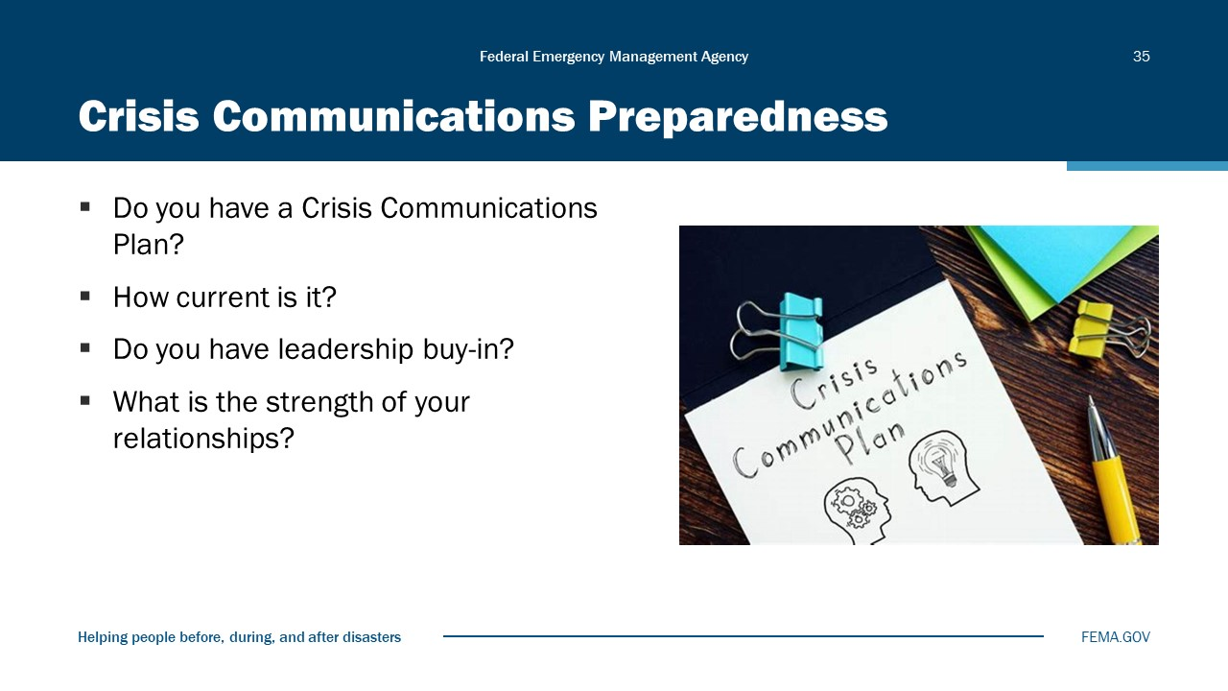
Visual 35, Crisis Communication Preparedness

Reaching the Whole Community
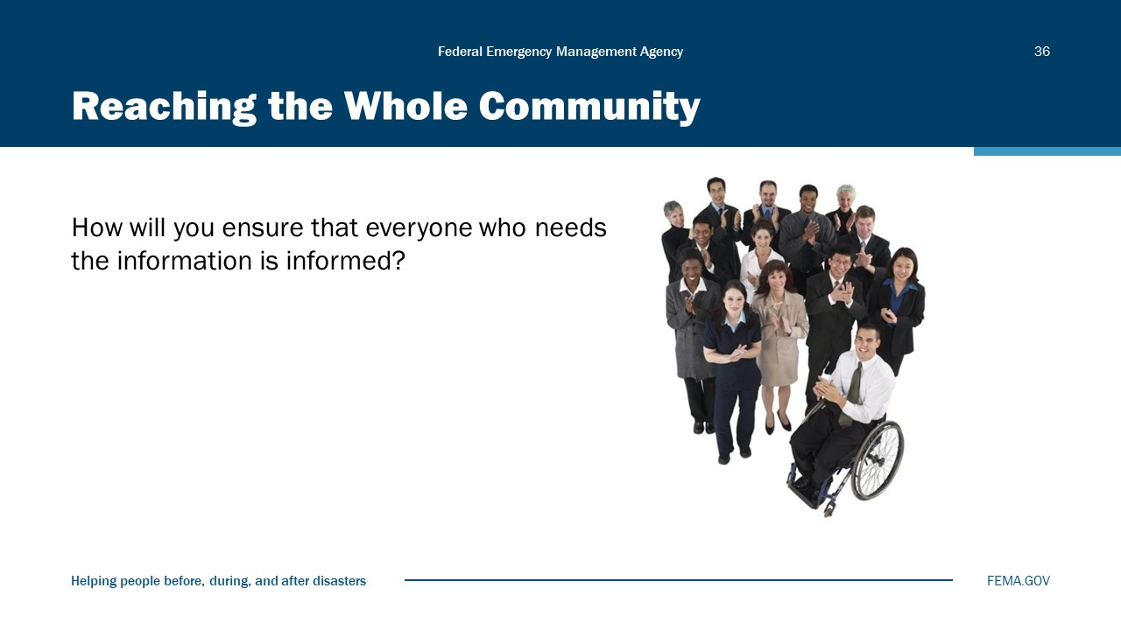
Visual 36, Reaching the Whole Community

The combination of warning systems and strategies should be designed to reach the whole community, including:
- Persons with access and functional needs, such as those who are deaf, hard of hearing, blind, or who have low vision.
- People with limited English proficiency.
- People in offices, schools, hospitals, nursing homes, college campuses, or other group settings.

Module Summary
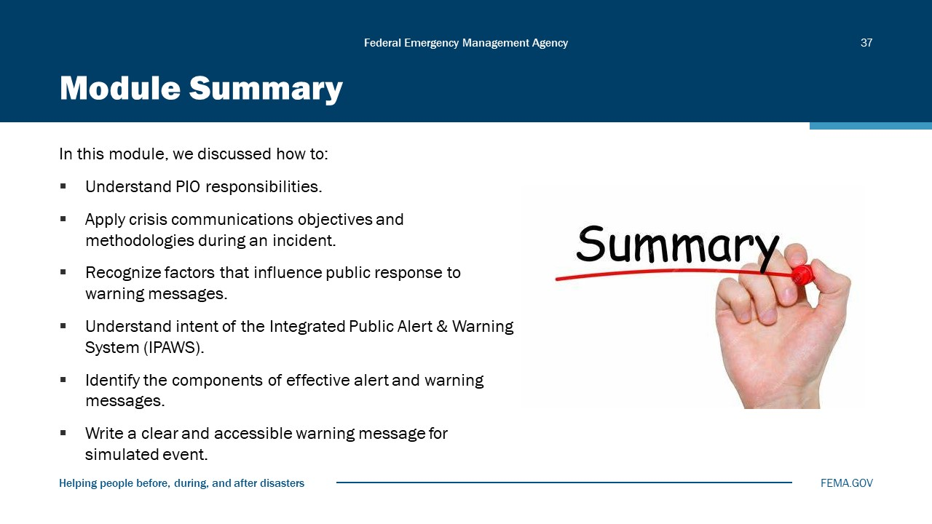
Visual 37, Module Summary

In this module, we discussed how to:
- Understand PIO responsibilities.
- Apply crisis communications objectives and methodologies during an incident.
- Recognize factors that influence public response to warning messages.
- Understand intent of the Integrated Public Alert & Warning System (IPAWS).
- Identify the components of effective alert and warning messages.
- Write a clear and accessible warning message for simulated event.

Reference List
FEMA’s Developing and Maintaining Emergency Operations Plans – Comprehensive Preparedness Guide (CPG) 101 (https://www.fema.gov/pdf/about/divisions/npd/CPG_101_V2.pdf)

Warnings Research (https://www.osti.gov/servlets/purl/6137387)

Writing Accessible Alerts and Warning Messages: “Carl and Ruth Shapiro Family National Center for Accessible Media” (https://www.wgbh.org/foundation/services/ncam)

IPAWS (https://www.fema.gov/emergency-managers/practitioners/integrated-public-alert-warning-system)

Module
8
Media Relations at the Scene

Administration
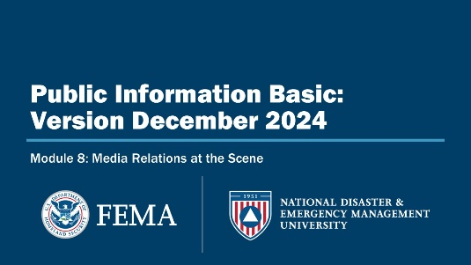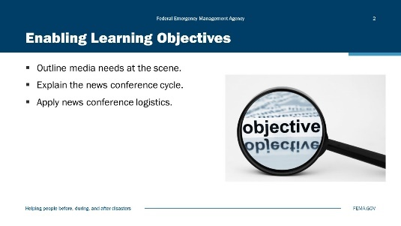
Visual 1, Media Relations at the Scene Visual 2, Enabling Learning Objectives

Duration
2 hours; 30 minutes

Terminal Learning Objective (TLO)
By the end of this module, you will be able to outline and explain media needs at a disaster.

Enabling Learning Objectives (ELOs)
By the end of this module, you will be able to…
- Outline media needs at the scene.
- Explain the news conference cycle.
- Apply news conference logistics.

Why Coordination at the Scene Matters
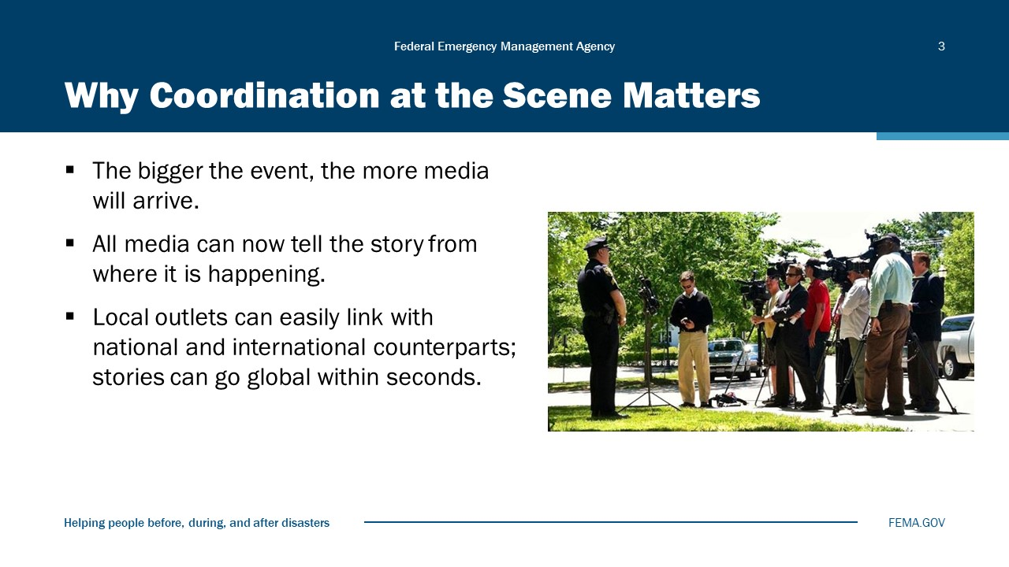
Visual 3, Why Coordination at the Scene Matters

Advances in technology and growing competition between news outlets are pushing reporters to try and cover any incident from “the scene”—or as close to the scene as they can get.
Lead a discussion around the following information:
The media WILL arrive at the scene:
- To get the most current information.
- To capture any images they can use in telling the story.
- To add a sense of excitement and immediacy to the story.
- All media now have the ability to tell the story from where it is happening.
- Remote broadcast equipment makes “live updates” possible from almost anywhere.
- Access to freeway cameras, weather cameras, etc., provides additional on-scene information.
- Many television stations have helicopters.
- Print/Web/wire service reporters can digitally transmit stories and photographs and video instantly.

Media outlets can link with their national and international counterparts to transmit a story globally within seconds.
With technology, often no more than an iPhone/camera PIOs can provide info to media outlets directly in lieu of reporters being on scene.

To Make It More Interesting . . .
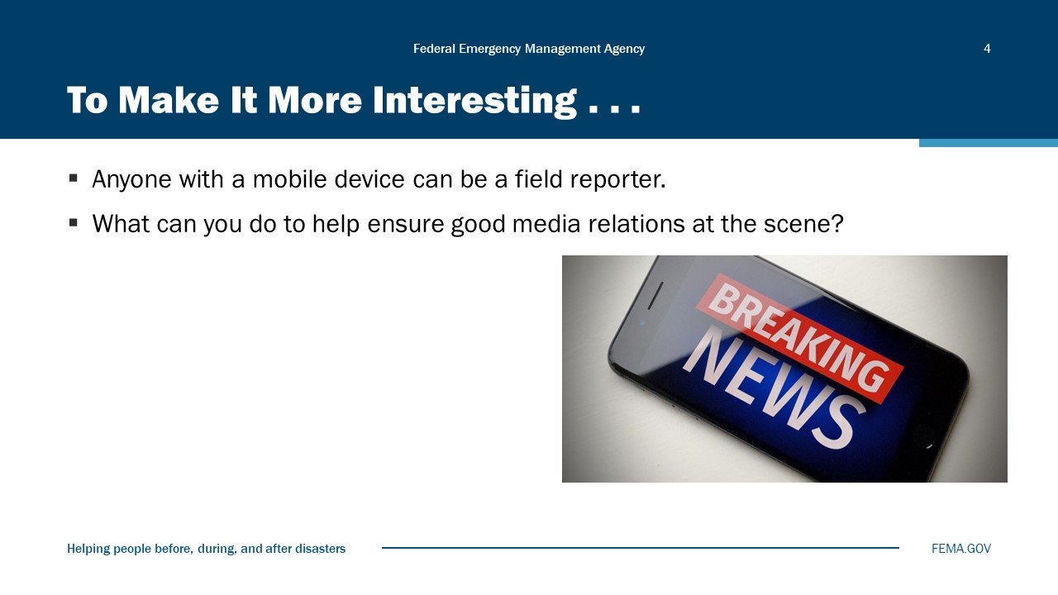
Visual 4, To Make it More Interesting…

Amateur/citizen journalists are everywhere. The images, sound, and information they capture can be used by more traditional news organizations and broadcast globally.
Provide the same information to amateur journalists that you would a news organization.

Initial Actions That Can Make It Work
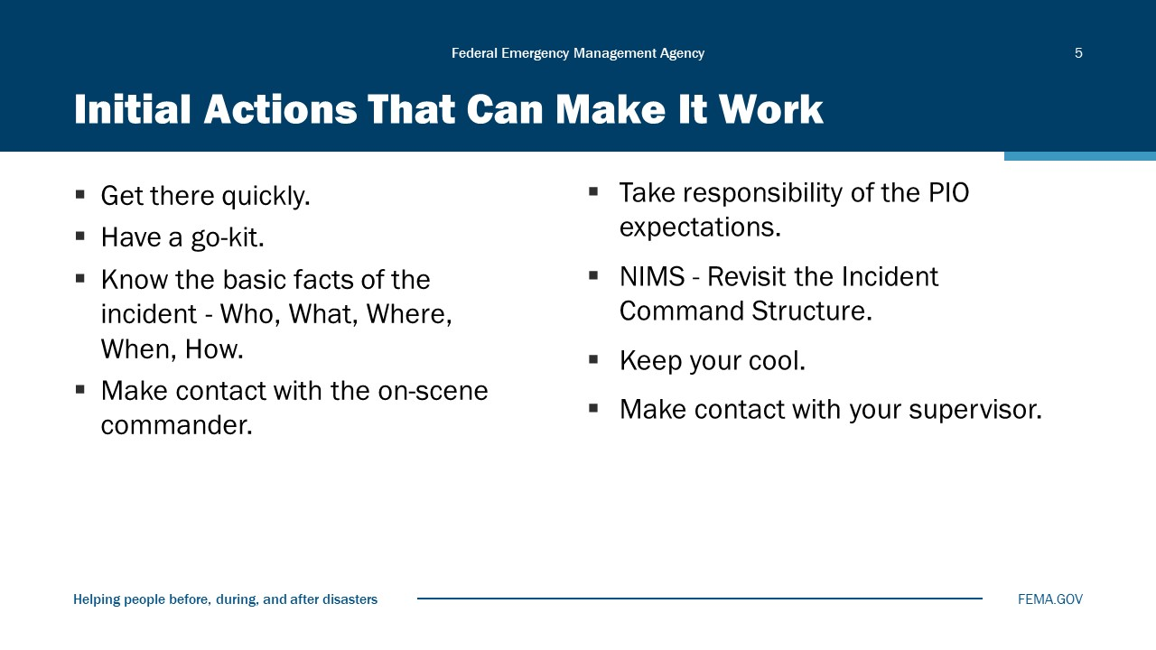
Visual 5, Initial Actions that Can Make it Work

Actions by PIOs that contribute to on-scene successes:
- Most importantly, get to the scene as quickly as possible (and bring additional PIOs if the situation warrants).
- Be prepared—have a go-kit filled with the tools you will need to succeed (phone, digital recorder, business cards, etc.). Have plans, contact information, and other vital documents with you always (these can be stored digitally in a data phone, notebook computer, etc.—make sure you have battery power or a way to recharge in the field).
- Be educated ahead of time—know who does what job, whom to talk to about what issues, what the law is concerning access, sunshine laws, etc.
- Contact the on-scene commander to gather information—prior to making any statement to the media.
- Take responsibility of the PIO expectations—don’t let the media call the shots.
- Always keep your cool. A crisis can be a stressful situation and can lead people to sometimes act before they think. Remember, if you lose your temper on camera, you become the story.
- If the event is large enough, begin considering where to stage the media.
- Don’t be afraid to make the media wait for ACCURATE information (but not too long). Social Media tools allow you to compartmentalize information and release verified information in chunks instead of waiting for the whole to be verified. Use this technique when necessary.
- Establish contact with your leadership—let them know what the media are doing, what they are asking, what they might be reporting, and any issues they should be aware of. Establish yourself as a trusted advisor but remember to keep the information at a high level for the organizational leadership.

Know the Law Ahead of Time!
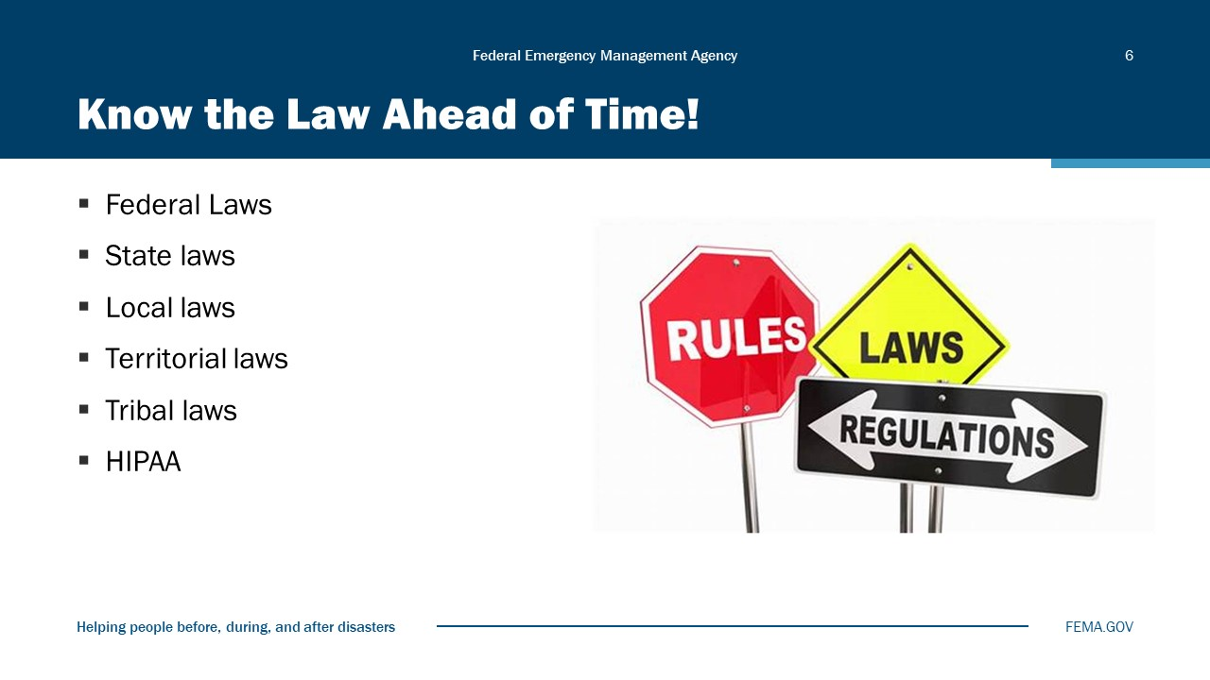
Visual 6, Know the law Ahead of Time

- Media access is an important issue. If you do not have a media relations/access policy, you should involve your agency leadership, legal counsel, and local media in the development of a policy beneficial to all.
- For agencies whose work involves Federal highways, be aware that news media who are working within the boundaries of a highway must wear high-visibility safety vests when covering incidents on public highways (see 23 C.F.R. §634).
- Other Federal laws involving media at the scene include temporary flight restrictions (TFRs).
- HIPAA - Health Insurance Portability and Accountability Act, a U.S. law designed to provide privacy standards to protect patients’ medical records and other health information provided to first responders including medics and firefighters, health plans, doctors, hospitals, and other health care providers. Any identifying information of a patient cannot be released and is protected by this law. This includes name, address, images, medical condition, age, hospital location, etc.

The PIO-Media Partnership
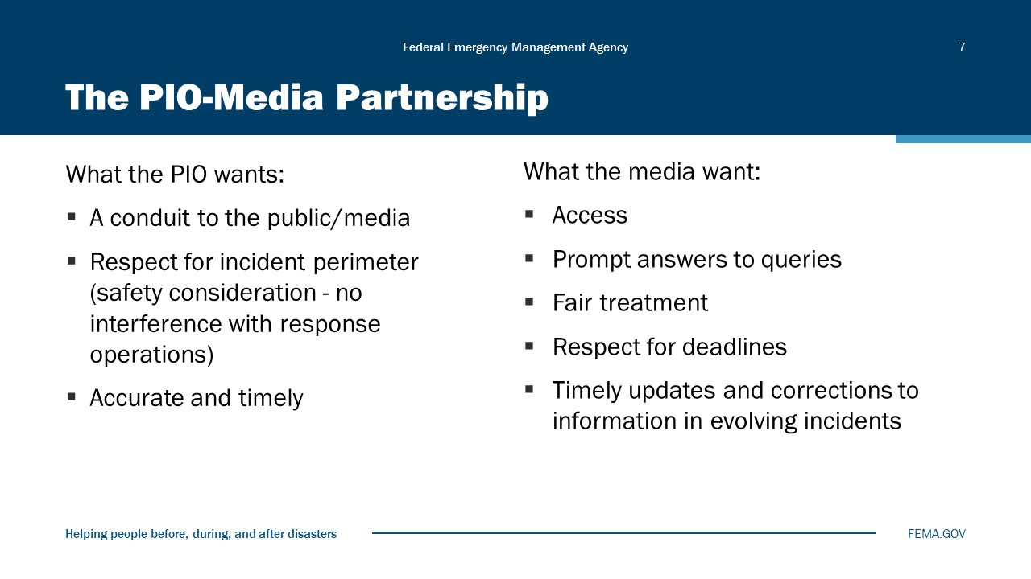
Visual 7, The PIO-Media Partnership

The PIO and the media both have jobs to do, and they need each other to do those jobs. They also have specific needs at the scene of an incident:
Review the basic needs of the PIO and the media.
The PIO wants:
- A conduit to the public.
- Respect for incident perimeter (no interference with response operations).
- Accurate and fair reporting.
The media want:
- Access.
- Prompt answers to queries.
- Fair treatment.
- Respect for deadlines.
- Timely updates and corrections to information in evolving incidents.

Media Needs at the Scene
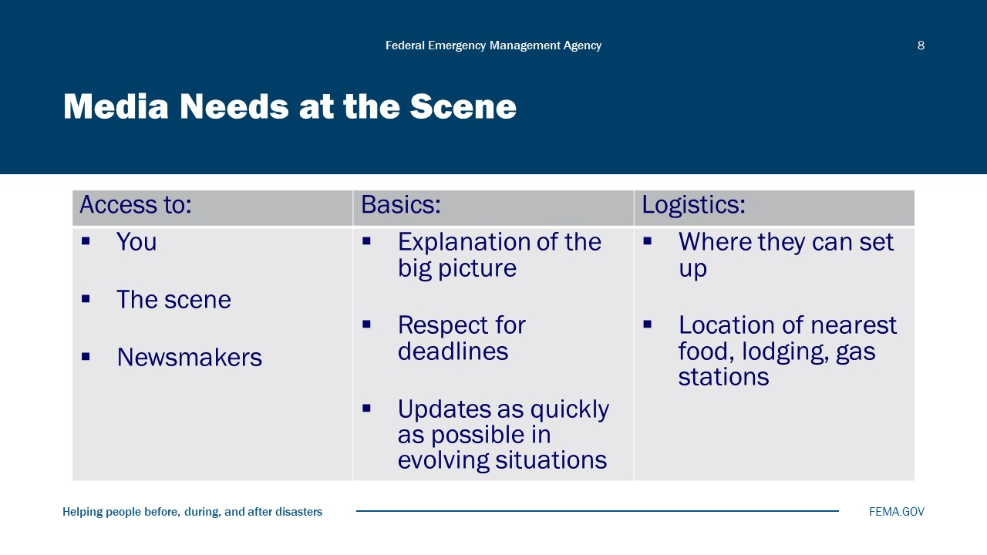
Visual 8, Media Needs at the Scene

Use the following points to discuss needs at the scene:
- The media’s most basic needs at the scene are access to information and images. If you anticipate what they will want, you will have a better chance to control the scene and help guide the story.
- The media will want:
- Access to the scene (for reporters and photographers or video journalists).
- Access to YOU (where you are located and how can they get in contact with you).
- Access to newsmakers or persons in charge of the scene or centrally involved in the story.
- An explanation of the big picture.
- Respect for deadlines.
- Updates as quick as possible in evolving situations.

- Continue to review media needs at the scene:
- Where they can park and set up microwave or live satellite trucks. (Satellite trucks need unrestricted southern skyward view for satellite uplink.)
- Location of nearest food, lodging and gas stations.

PIO Needs at the Scene
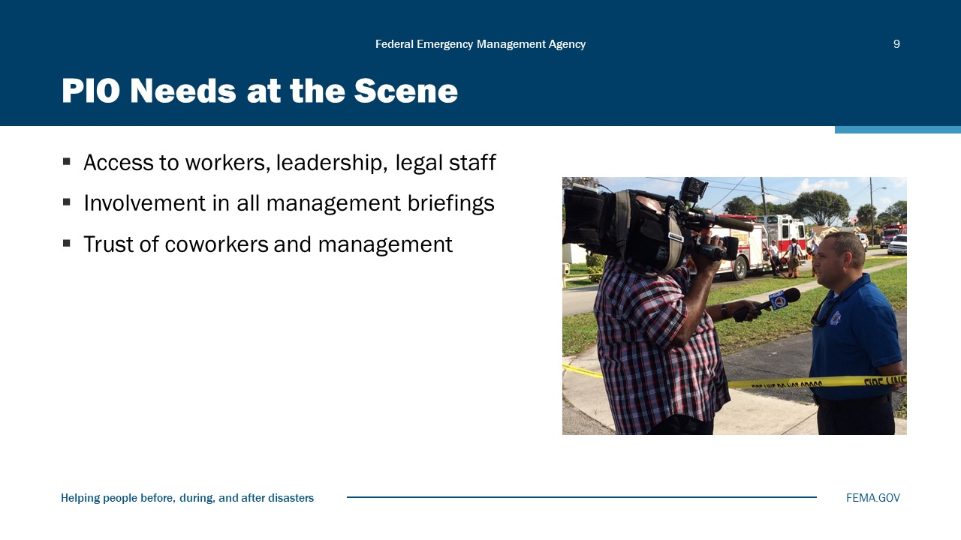
Visual 9, PIO Needs at the Scene.

- What PIOs need at the scene is complete access.
- PIOs need to be able to talk to workers, leadership, and legal staff.
- PIOs should be involved in all management briefings so they can answer questions and anticipate potential issues involving the media.
- PIOs need the trust of their coworkers and administration. PIOs work for their agency, not for the media.

Media Staging Areas
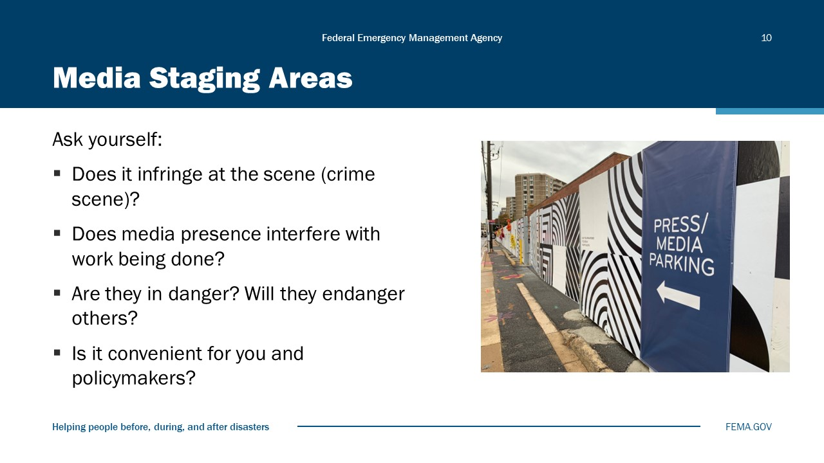
Visual 10, Media Staging Areas

Staging areas are set up at incident sites to facilitate the flow of information between the PIO and the media (see Resource Guide). Prior to establishing the location of a staging area, there are several factors to consider:
Does it infringe at the scene (crime scene)?
- Many times, the site of a crisis or disaster may be considered a crime scene and may need to be processed by forensic units. To keep the “integrity” of the scene and enhance the possibility for a successful investigation and subsequent prosecution, the scene must be kept clear of all nonessential personnel.
- Does media presence interfere with work being done?
- The goal of all public safety endeavors is to save lives, protect property, and preserve the environment—and almost all reporters would agree that their needs will come after these important tasks. Members of the media do not want to interfere with these important tasks, but if they can get close enough to observe/photograph, they will be happy.
- Are they in danger? Will they endanger others?
- In their zeal to “get the story”, reporters may not always recognize the potential for danger to themselves. Work to keep them out of danger as you would any member of the public. Also, it may be necessary to explain to them the danger, and how if they fail to heed the warnings and become injured, they may endanger others who would have to then go in to rescue them (e.g., passing into the plume of a Hazmat area, traveling over an unsafe structure that may collapse, or moving into the line of fire of an armed suspect).
- Is it convenient for you and policymakers?
- To keep a consistent two-way flow of information with the media at the scene, it is important to make it relatively easy to communicate with them face to face.

Media Staging Areas (additional information)
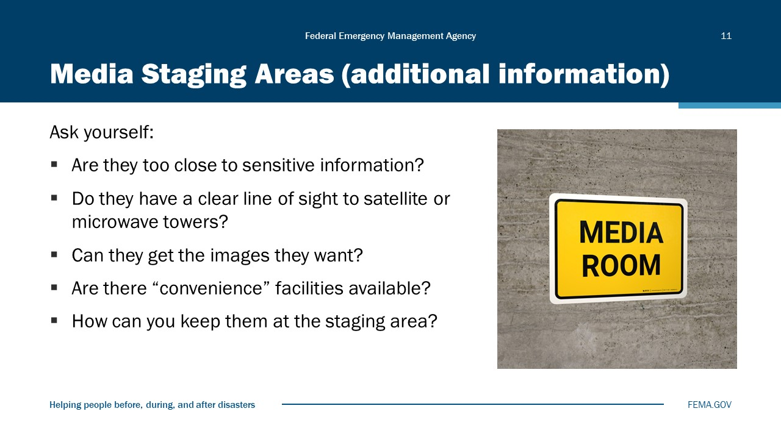
Visual 11, Media Staging Areas (Additional Information).

Review considerations for a media staging area:
Are they too close to sensitive information?
- Zoom lenses, parabolic microphones, and just plain observant reporters may be able to discover sensitive or protected information from your incident command post (e.g., zoom shots of maps, recorded conversations, etc.). Make sure the staging area is far enough away or your workspaces are shielded from prying cameras, microphones, and eyes.
Do they have a clear line of sight to satellite or microwave towers?
- Depending on where the staging area is, the media will need to be able to connect with their microwave towers or uplink with a satellite. Check with them to see if the location selected for a staging area will allow them to accomplish this.
Can they get the images they want?
- The media will want to get as close as possible to get pictures/audio/interviews.
- If there is a reason that the media cannot be allowed access to the scene, consider using a media pool to restrict access while allowing them to get the images and interviews they desire.
- If a media pool is not an option, consider providing professional quality images to the media in the form of video and stills.
Are there “convenience” facilities available?
- While it is not the responsibility of the PIO to provide food or facilities for the media, a little kindness in this area can go far in building a positive relationship with the media—especially if the incident occurs in a remote area where few if any comfort facilities exist (e.g., if the incident is in a remote field, a porta-john will go a long way in making friends!).
How can you keep them at the staging area?
- You can’t—and don’t expect them to stay there all the time. They will go other places to get other information (local citizen reactions, sidebar stories, etc.).
- You can entice them to stay by giving them regular “official” updates and letting them know that if they are absent, they may miss something important or interesting.

Media Pools
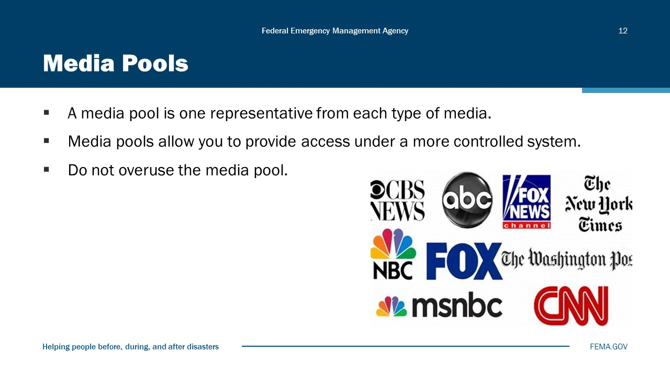
Visual 12, Media Pools.

Occasionally it is necessary to restrict access to an area from the multitude of members of the media, but you still want to provide access under a more controlled system. When this occurs, you have the option of using a “media pool.”
- A media pool is simply one representative from each of the types of media (television, radio, print, Web) who will be allowed access to a restricted area. These representatives are allowed access with the understanding that any video, audio or interviews they acquire will be shared with all the rest of the media.
- The media will work within a pool because it’s always better to get something rather than nothing. They may not always be happy about it but given a choice between getting information/images via a pool or getting nothing, they will always choose the pool.
- Sometimes they need to bring more than one person from each media type (e.g., a television station might need to bring a reporter and photographer, or a newspaper might also want to bring a reporter and photographer). This is a normal occurrence and should be allowed.
- How do you ensure that what the media pool gets will be shared? This is an internal issue with the media. They will police themselves in this area. And finally, don’t use a pool simply to make your job easier. Make sure there is a valid reason (such as safety concerns or integrity of a crime scene) if you are going to use a media pool.

News Conference Responsibilities
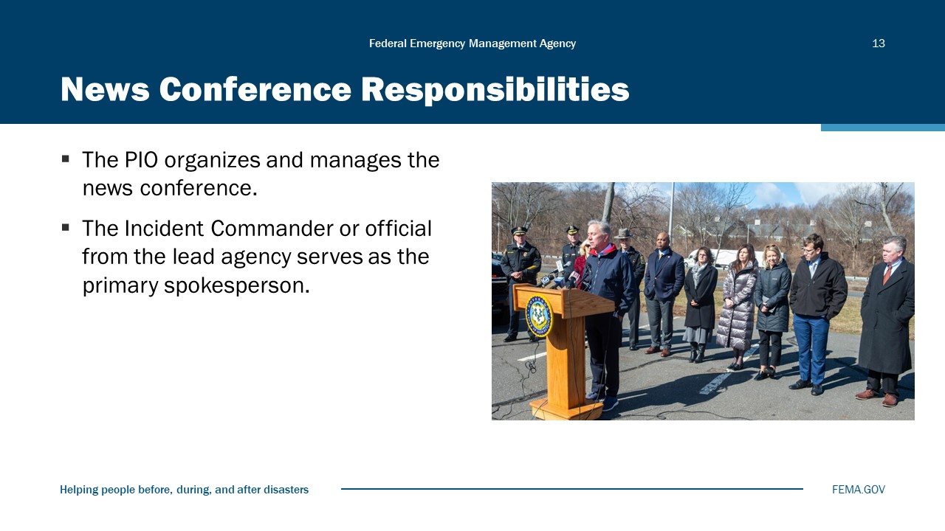
Visual 13, News Conference Responsibilities

News conference responsibilities:
- The PIO is responsible for organizing and managing a news conference. Others should assist the PIO in facilitating the conference.
- The Incident Commander and/or most senior official of the lead organization should be the primary spokesperson. If multiple agencies/organizations are involved under unified command, the official from the agency with primary responsibility in the event should be the primary speaker. All speakers should be briefed on anticipated questions, relevant issues, and stagecraft immediately prior to the start of the news conference.
- Elected officials can often act in a calming capacity, assuring the public that everything is being done to resolve the situation and get things back to normal. Other participants should only talk about their agencies and their areas of expertise and responsibility.
- Try not to have a long parade of speakers with long statements. This only detracts from what your key messages are and often leads media covering the news conference live to cut back to regularly scheduled programming. Better to have these individuals on hand to answer questions if they arise. Two to three primary speakers should suffice for most incidents.

Location, Location, Location
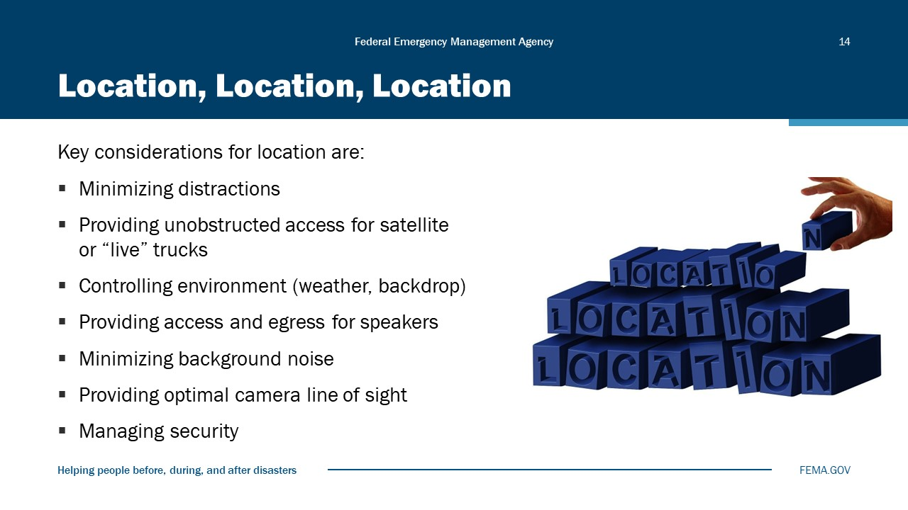
Visual 14, Location, Location, Location

You may not have many choices when it comes to the location for a news conference, but when you do, you should consider the following:
- Will it be covered “live”?
  - Satellite or “live” trucks will need an unobstructed area to park in. Satellite trucks need a clear southern exposure to access their satellite. Live trucks will need to access their station reporter. Find out where it is and try to plan for where the trucks may park.
- What can you control in the environment?
- Rain, snow, wind, and other environmental conditions can detract from what the speaker is saying.
  - An indoor, controlled environment is usually the best option.
  - Pick a place with a clean backdrop.
    - Keep the area behind the briefing free from distractions (e.g., people milling about, vehicles moving, smoke or flames, etc.).
    - Make sure cameras cannot move behind the speakers for a “reverse shot” of the news conference.
  - Provide speakers clear access and egress without having to pass through reporters. (If speakers do not have a clear exit, the media will continue to ask questions.)
- Think about potential “sound” issues.
  - Try to minimize background noise so speakers can be heard clearly. If possible, select a place for your news conferences where external noise can be reduced or eliminated. Sounds from heavy machinery, airplanes, trains, or other sources can be distracting to the public who may need to hear the information you are sending out.
  - Occasionally these noises can be so loud as to drown out what is being said by the speaker entirely.
  - If you are inside a building, consider the “echo” factor.
  - Have an audio “Mult box.” This box allows just one microphone to be placed in front of the speaker, eliminating a microphone “tree” and providing clearer audio.
  - Make sure you get your own recording of the news conference for transcription and possible legal issues.
- What do you need to do to facilitate the cameras?
  - Make sure that the cameras have a clear line of sight to the speakers.
  - Try to set up in an area where the cameras will be at the same level as the speakers.
  - When the camera is shooting down from a position of higher elevation, the image tends to diminish the speaker and the message being presented.
  - When the camera is shooting up from a position of lower elevation, the image tends to place the speaker in a position of greater authority—which is not recommended.
- What do you need in terms of security?
  - A location filled with cameras and various officials about to make a statement can be an opportunity for someone who may want to cause a disturbance or promote an “alternative” viewpoint. Also, media satellite/live trucks contain a considerable amount of high-value equipment. Security should be provided both for members of the media and for the news conference participants.
  - Security staffing should be visible but not intrusive and can be stationed near where the news conference will take place or possibly out by the news media satellite/live trucks.
  - Often local law enforcement may offer to assist in providing security.
Have a backup plan in case weather or other events make the briefing location impractical!

News Conference Cycle
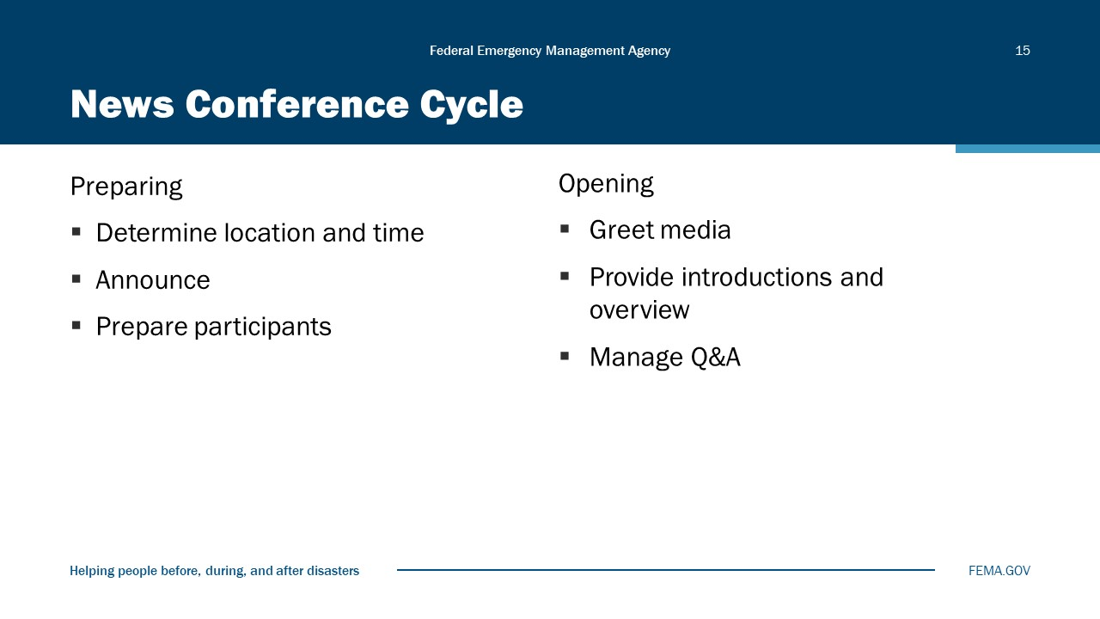
Visual 15, News Conference Cycle.

Think of news conference activities as a cycle that includes:
- Preparing
- Opening
- Closing
- Following Up
The PIO’s role in preparing includes:
- Determining location and time, which we have already discussed.
- Announcing the news conference to internal and external entities.
  - If a Joint Information Center (JIC) is active, make sure all members of the JIC team are aware of the news conference and know what their responsibilities will be in relation to it.
  - Invite all media outlets, including:
    - Local, regional, and national TV, radio, and print outlets
    - Non-English news outlets
    - Certified sign language interpreters
    - Wire services

News Conference Cycle (additional information)
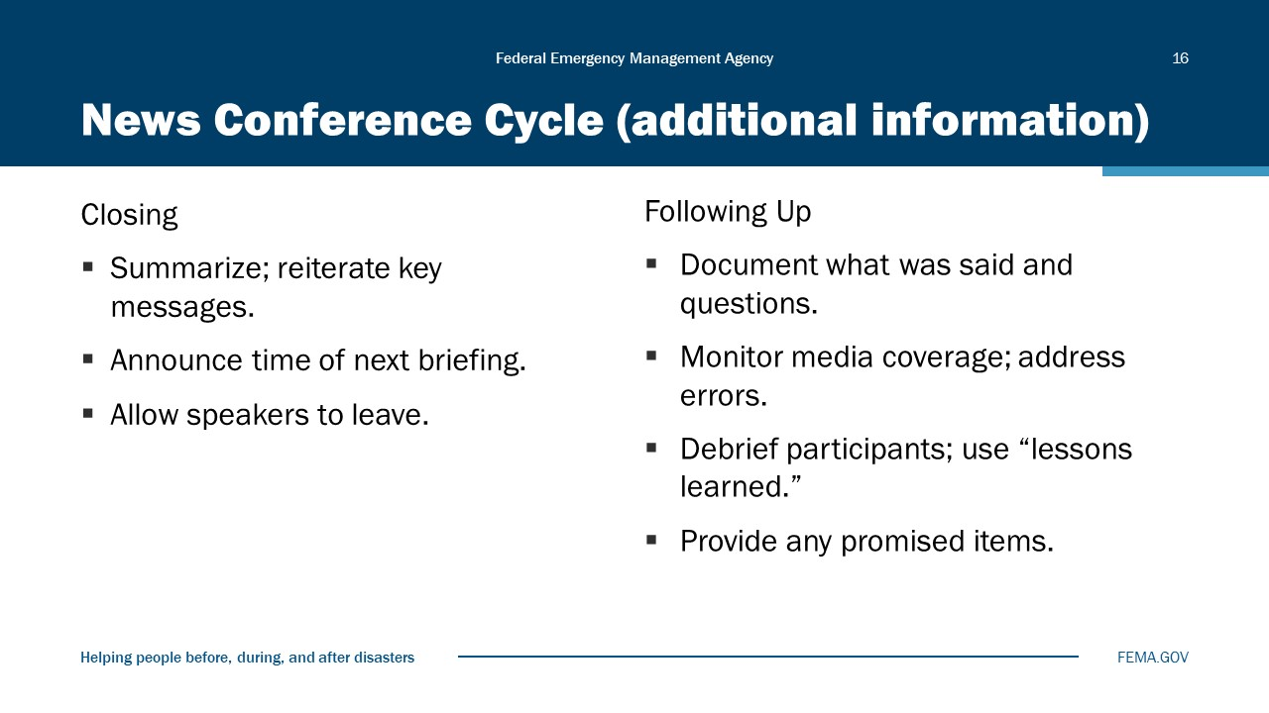
Visual 16, News Conference Cycle (additional Information).

The PIO’s role in closing the news conference includes:
- Summarizing, reiterating key points.
- Acknowledging actions you now will take.
- Advising time of next news conference.
- Closing and leaving.
- Using your PIO/moderator as a facilitator.
- Asking if there is further information they would like.
Following the briefing, the PIO needs to:
- Document what was said and media questions.
- Monitor media coverage.
- Actively correct any media inaccuracies.
- Debrief all participants afterward.
- Identify additional personnel you may like.

Module Summary
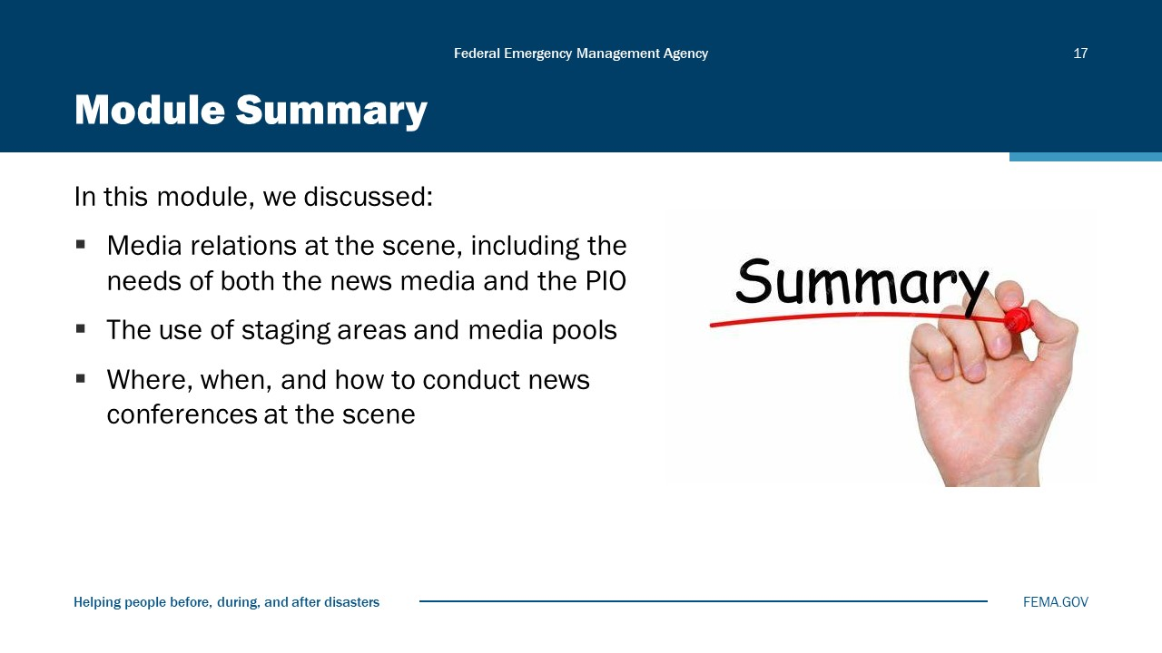
Visual 17, Module Summary

Reference List
None

Module
9
Leading a Joint Information Center

Administration
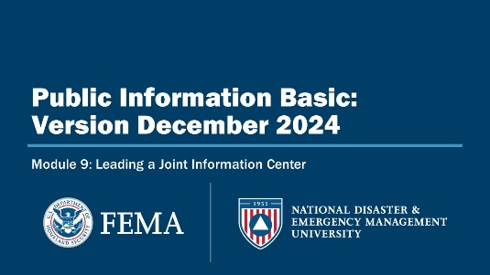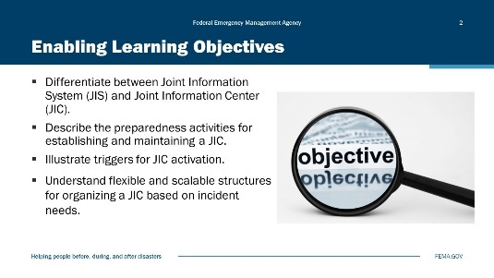
Visual 1, Leading a Joint Information Center Visual 2, Enabling Learning Objectives

Duration
1 hour; 30 minutes

Terminal Learning Objective (TLO)
By the end of this module, you will be able to differentiate between a Joint Information Center (JIC) and a Joint Information System (JIS).

Enabling Learning Objectives (ELOs)
By the end of this module, you will be able to:
- Differentiate between a Joint Information System (JIS) and a Joint Information Center (JIC).
- Describe the preparedness activities for establishing and maintaining a JIC.
- Illustrate triggers for JIC activation.
- Understand flexible and scalable structures for organizing a JIC based on incident needs.

Activity 9.1: (Table Group)
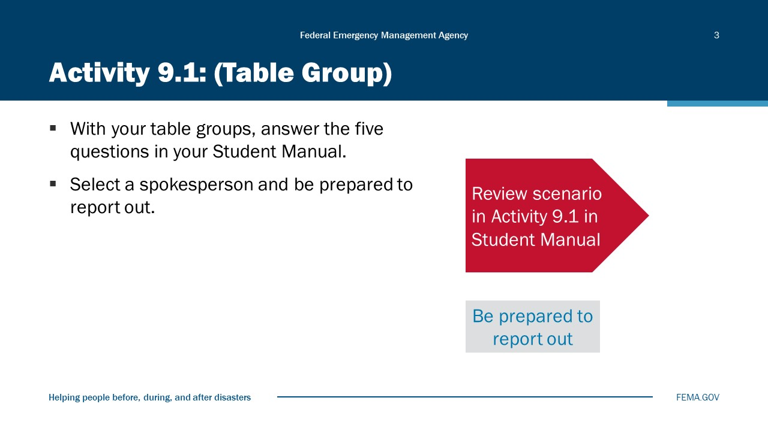
Visual 3, Activity 9.1: (Table Group)

Activity 9.1 Scenario
- There has been a report of a chemicals released into the local water supply.
  - There is a sheen on the water.
  - The Central City Water Department has issued an order to stop using tap water.
- Residents within a three-block area of the fire have started reporting to Central City and Faith Hospitals with complaints of respiratory distress.
- The mayor has signed a State of Emergency for Central City and on recommendation of the Incident Commander ordered an evacuation in a radius between 1 and th3 miles from the fire.
- The Central City EOC is activated, triggering full multiagency coordination.

Activity 9.1: (Report-Outs)
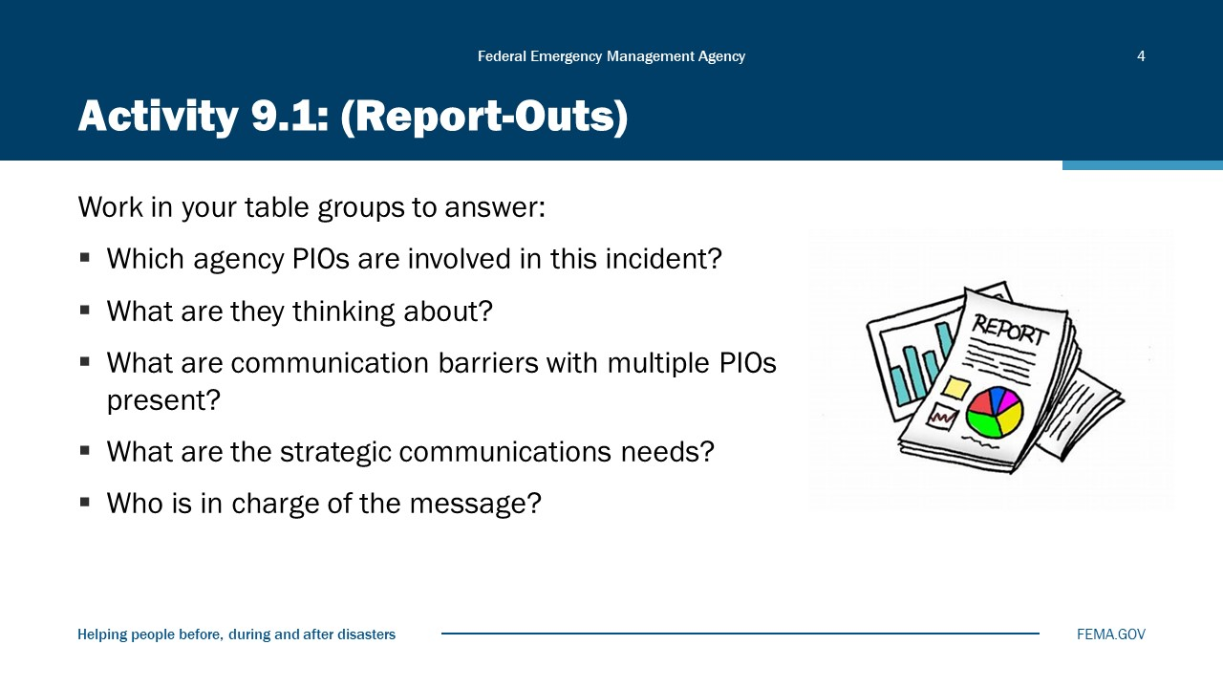
Visual 4, Activity 9.1: (Report-Outs)

Activity Time:
- Table group discussion: 10 minutes
- Debriefing: 5 minutes
You will meet in your table groups and discuss the following questions:
- Who are the new PIOs now involved with this incident?
- What are you thinking about?
- What are the new barriers to communications now that there are more PIOs present?
- What are the new strategic communications needs?

What is a JIS? What is a JIC?
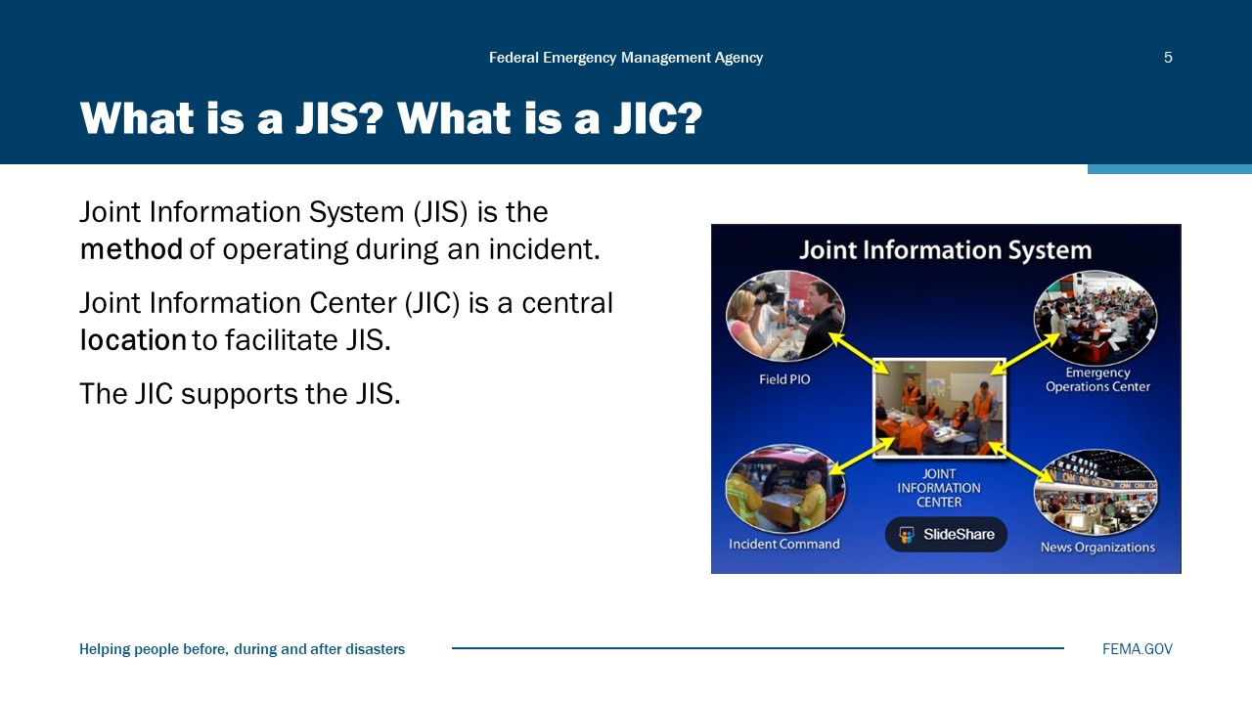
Visual 5, What is a JIS? What is a JIC?

Benefits of a JIS
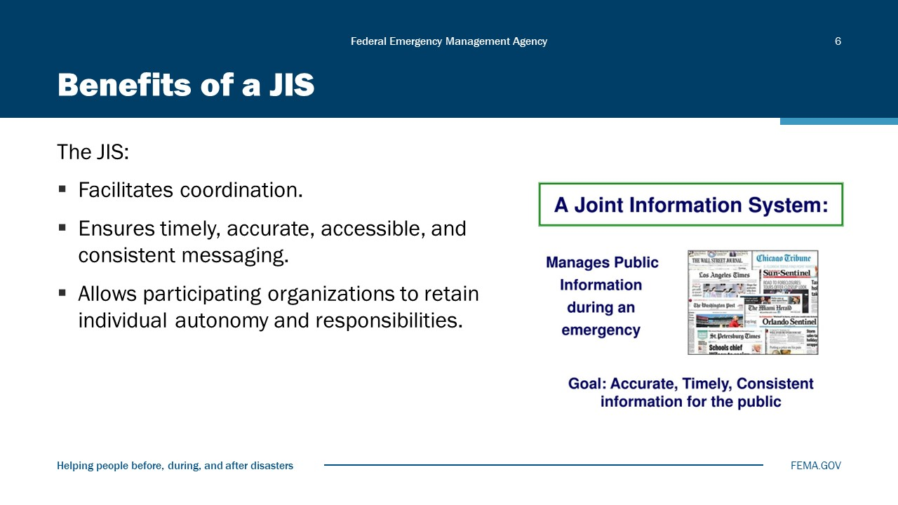
Visual 6, Benefits of JIS

It is common PIOs from different jurisdictions and departments to interact on a regular basis to share information and ideas. When an event occurs that prompts activation of Incident Command, however, JIS will be activated, and these working relationships become formalized and structured. JIS supports the NIMS principles of public information systems: JIS is the method of operating during an incident that allows multiple PIOs to coordinate information and integrate messages to avoid confusing the public.
Public information functions must be coordinated and integrated across jurisdictions and across functional agencies; among Federal, state, local, and tribal partners; and with private-sector and nongovernmental organizations. Organizations participating in incident management retain their autonomy.
The PIO is responsible for knowing when and how to activate the JIS.

Benefits of a JIC
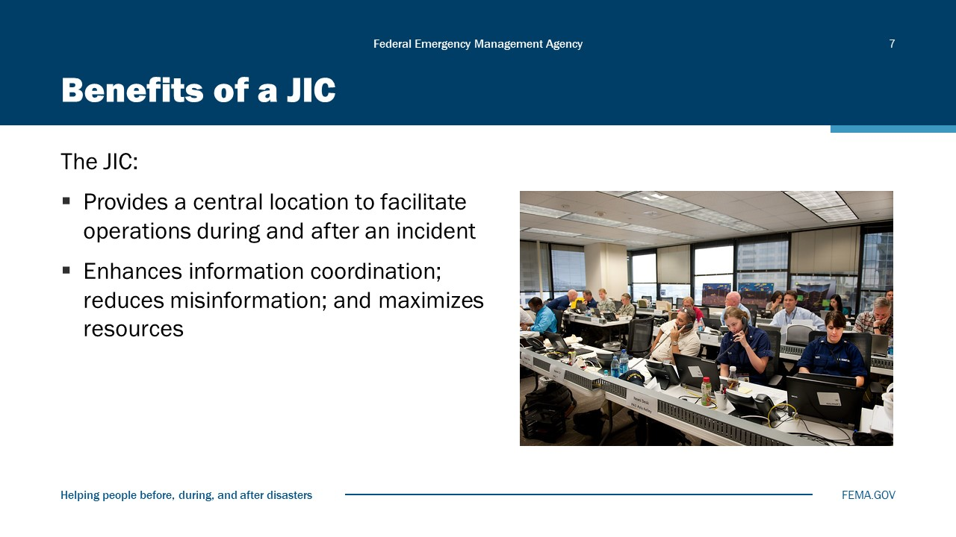
Visual 7, Benefits of a JIC

Barriers to Getting Information Out
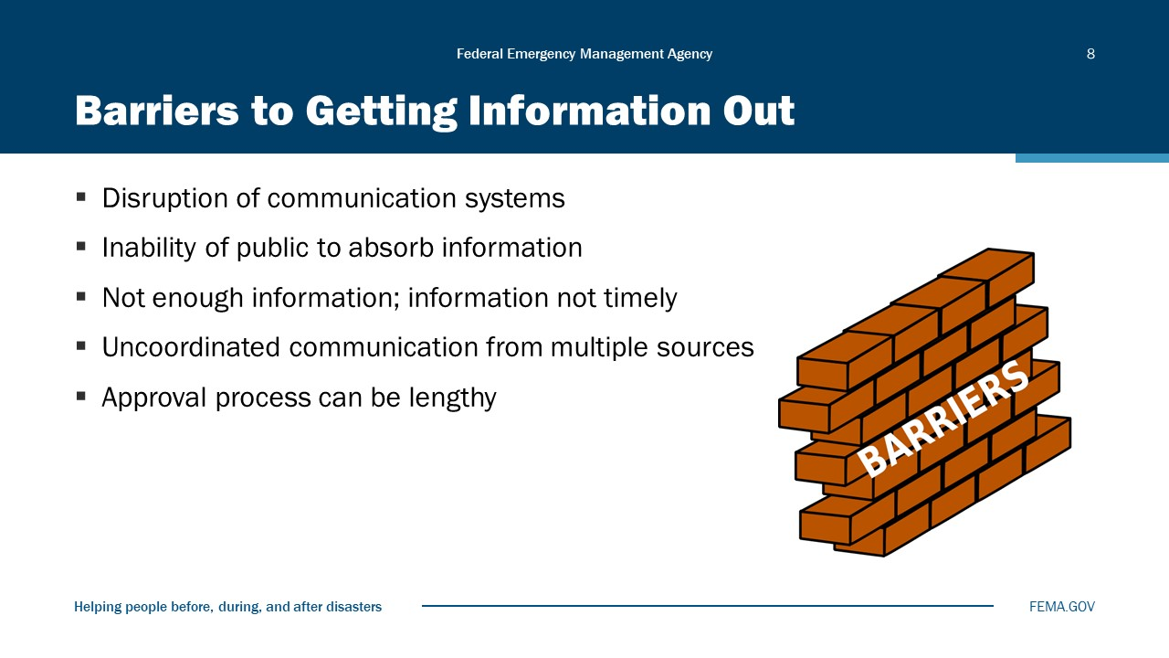
Visual 8, Barriers to Getting Information Out

Challenge of Multiple Audiences
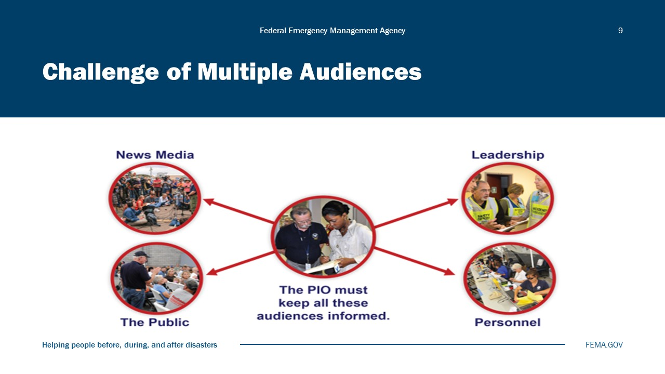
Visual 9, Challenge of Multiple Audiences

How a JIS Meets These Challenges
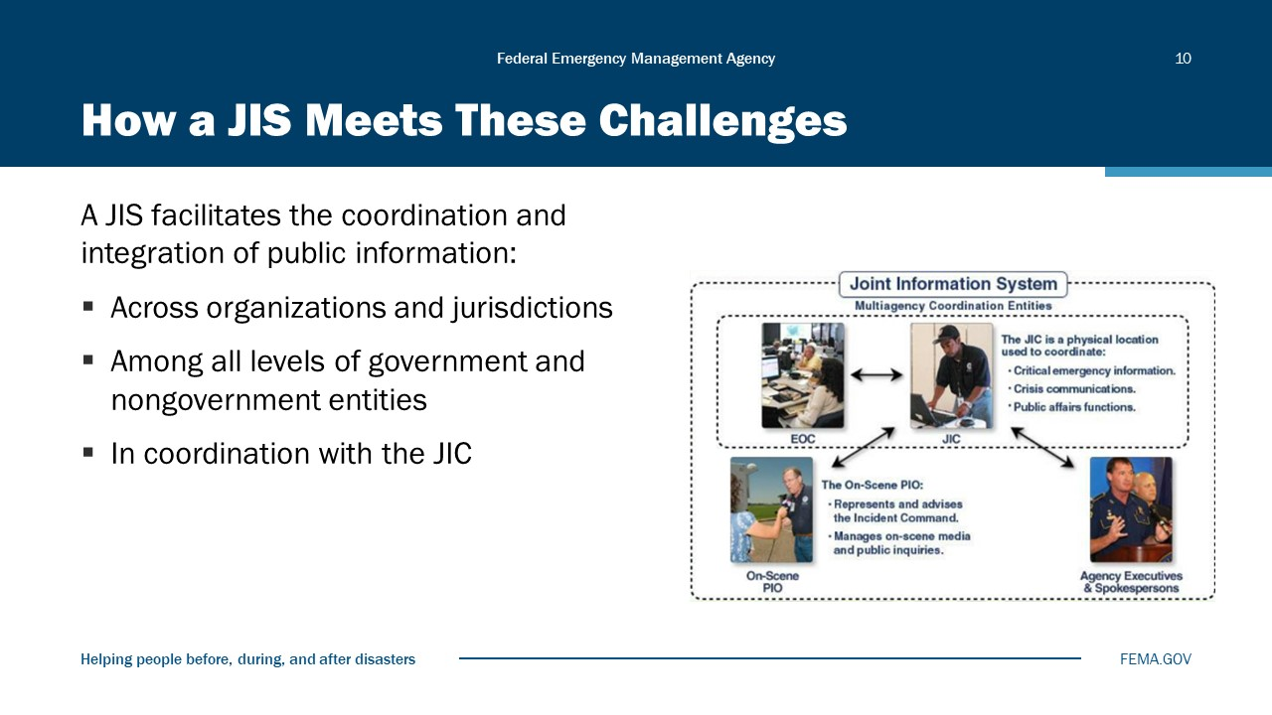
Visual 10, How a JIS Meets These Challenges

Triggers for JIC Activation
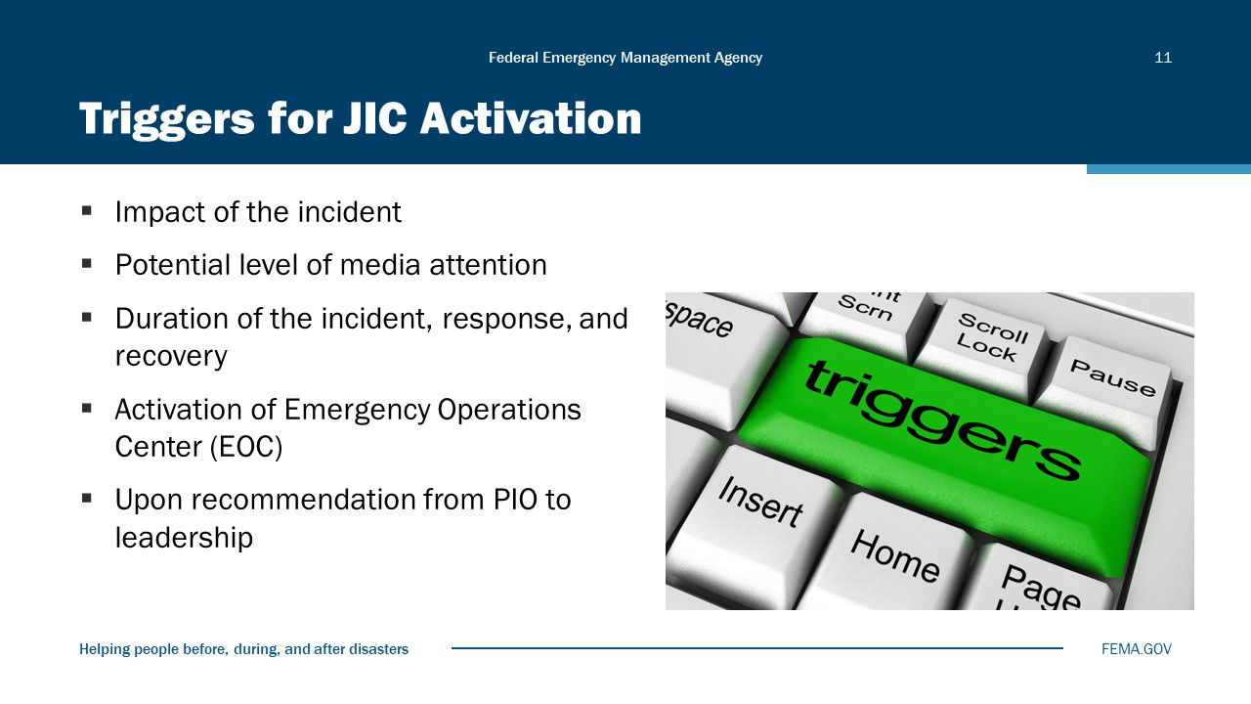
Visual 11, Triggers for JIC Activation

The concept of using a JIC to facilitate the dissemination of emergency public information is not new. The idea initially emerged in the late 1970s after unsuccessful attempts to communicate crisis information to the media and public during the Three Mile Island Nuclear Power Plant incident.
It is important to remember that the JIC is simply a tool to facilitate the JIS. The JIS is the key to any crisis communication effort.
Through the co-location of public information professionals, the JIC speeds information release time, enhances information coordination and analysis, reduces misinformation, maximizes resources, and helps build public confidence in response efforts.

What Does a JIC Look Like?
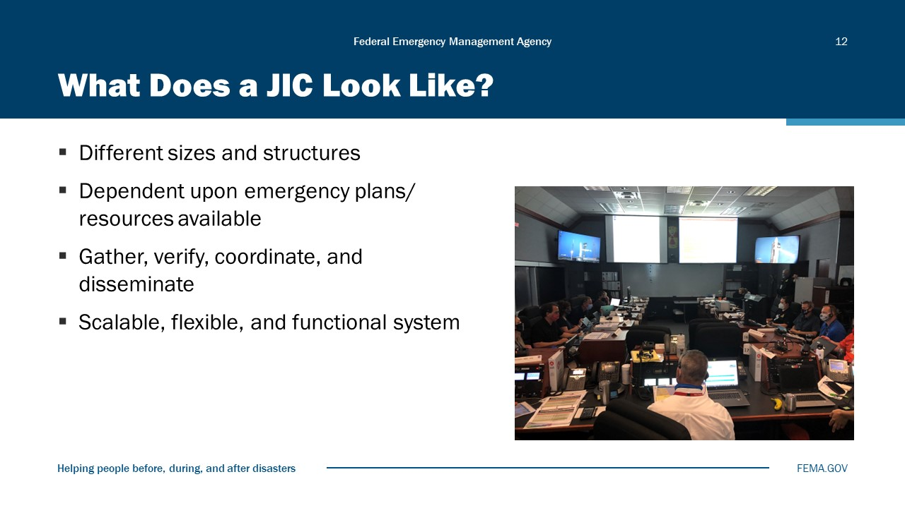
Visual 12, What Does a JIC Look Like?

Types of JICs
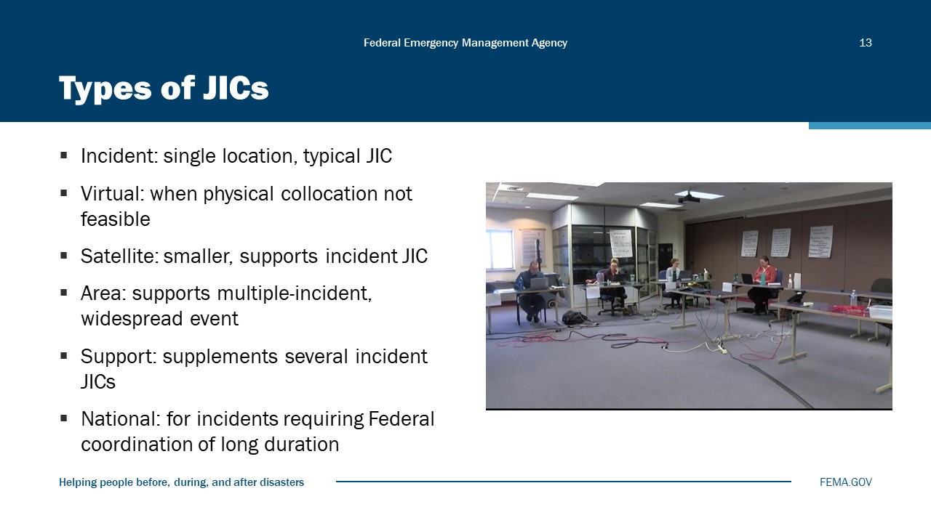
Visual 13, Types of JICs

- Incident JIC. Typically, an incident-specific JIC is established at a single, on-scene location in coordination with Federal, state, tribal, and local agencies, or at the national level, if the situation warrants. An incident JIC provides easy media access, which is paramount to success. An incident JIC is the typical JIC.
- Virtual JIC. A virtual JIC is established when a physical co-location is not feasible. It connects PIOs through e-mail, cell/landline phones, faxes, video teleconferencing, Web-based information systems, etc. For a pandemic incident where PIOs at different locations coordinate information electronically, it may be appropriate to establish a virtual JIC.
- Satellite JIC. A satellite JIC is smaller in scale than other JICs. It is established primarily to support the incident JIC and to operate under its direction; a satellite JIC is not independent of the incident JIC. A satellite JIC is typically located closer to the scene.
- Area JIC. An area JIC supports multiple-incident ICS structures that are spread over a wide geographic area. It is typically located near the largest media market and can be established on a local, state, or multistate basis. Multiple states experiencing storm damage may participate in an area JIC.
- Support JIC. A support JIC is established to supplement the efforts of several incident JICs in multiple states. It offers additional staff and resources outside of the disaster area.
- National JIC. A national JIC is established when an incident requires Federal coordination and is expected to be of long duration (weeks or months) or when the incident affects a large area of the country. A national JIC is staffed by numerous Federal departments and/or agencies, as well as state agencies and nongovernmental organizations.
Pre-identified incident communications protocols are established and ready for use during large-scale incidents and incidents requiring a coordinated Federal response.
- National Incident Communications Conference Line (NICCL): The NICCL was created to be a single source of coordination for DHS with all other Federal agencies. It can work as a call-in conference or as an open line that can be monitored 24 hours a day for the exchange of information and updates. It is primarily for Federal-to-Federal information sharing but can also include communicators from the primarily impacted state and local community.
- State Incident Communications Conference Line (SICCL): The SICCL was created primarily to bring states together to share information and discuss issues that influence all of them following an incident. This line is typically used during a multiple-state disaster such as a hurricane where impacted states may request support from other states. The SICCL is not a 24/7 line. Instead, it is a scheduled conference call, which would be set up as needed to address issues.

JIC Location
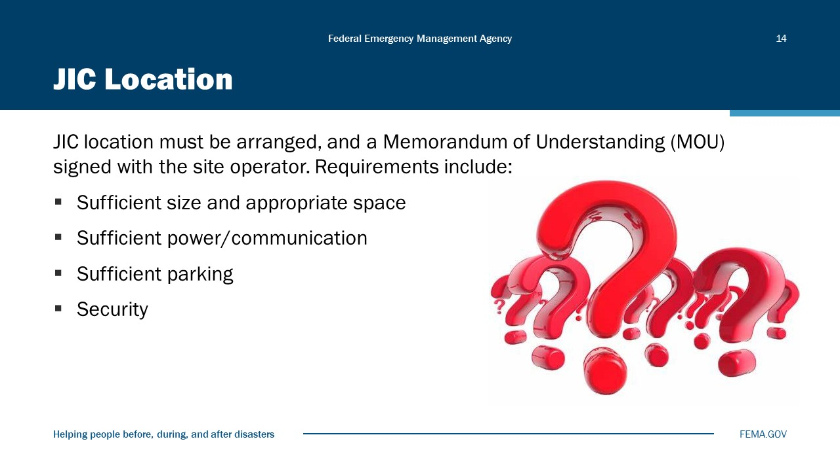
Visual 14, JIC Location

How to Make this Happen in a JIC
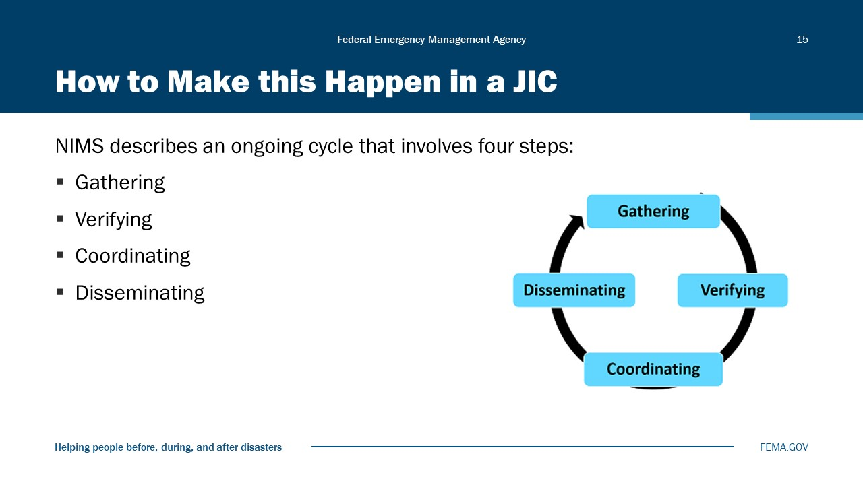
Visual 15, How to Make this Happen in a JIC

GATHERING INFORMATION
Gathering information is the first step in the process of getting information to the public and additional stakeholders. Information is collected from:
- On-Scene Command: A source of ongoing, official information on the response effort.
- On-Scene Public Information Officers: Report to the JIC what they are observing at the incident from the news media, elected officials and their staff, and the public.
- Media Monitoring: Used to assess the accuracy and content of news media reports. It also helps to identify trends and breaking issues.
- News Media: A valuable source of developing information and current issues.
- Public and Elected/Appointed Officials: Inquiries from elected/appointed officials, community leaders, and the general public point to the specific concerns of those in the affected areas.
VERIFYING INFORMATION
The next step in the process is to verify the accuracy of the information that has been collected, by consulting the following sources:
- Other Public Information Officers in the JIC: Comparing notes—especially with the lead Public Information Officer and Public Information Officers who are liaisons to the various assistance programs or response/recovery partners—is one way to verify information accuracy.
- EOC Sources: Including program leads, who should be asked to confirm information.
- On-Scene Public Information Officers: A valuable source for checking the accuracy of information reported to the EOC with reports from the news media, the offices of elected officials, and people on the scene.
COORDINATING INFORMATION
The next step in the process is to coordinate with other Public Information Officers who are part of the JIS. These Public Information Officers include both those represented in the JIC and those working from another location who are part of the JIS. Coordinating information involves:
- Establishing Key Message(s): After gathering information from all sources, unified messages are crafted that address all informational needs and are prioritized according to the overall Federal, state, tribal, and local response/recovery strategy. The mission includes getting accurate, consistent information to the right people at the right time so they can make informed decisions.
- Obtaining Approval/Clearance From Those With Authority: Ensuring that the information is consistent, accurate, and accessible. The approval process should be streamlined, however, to ensure that the information is released in a timely manner.
DISSEMINATING INFORMATION
The next step in the process is to disseminate information to the public and additional stakeholders. This step involves:
- Using Multiple Methods: In an emergency, there may not be many options. Phone calls and interviews might be the primary means of getting information to the news media. Personal visits or town meetings may be the most effective avenue for the public, elected/appointed officials, or other stakeholders. These outreach efforts can be supported by providing talking points and fliers to on-scene Public Information Officers.
- Monitoring the Media: Media monitoring is invaluable for ensuring that the message is understood by the news media and reported accurately and completely. Important inaccuracies should be addressed before they are reported incorrectly a second time.

JIC Functions
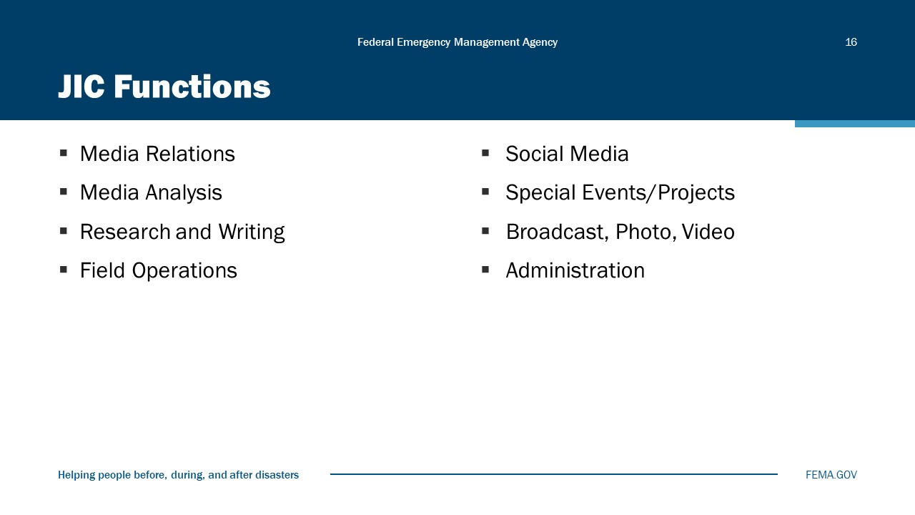
Visual 16, JIC Functions

A “Lead” PIO
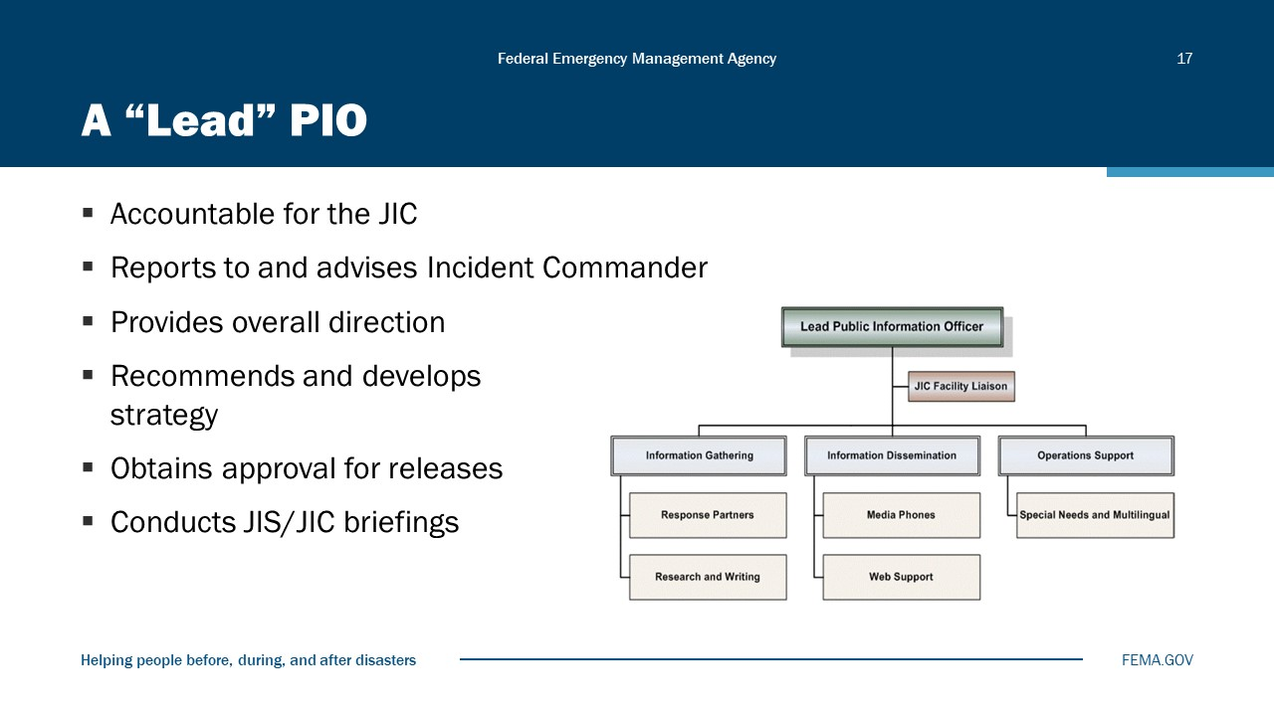
Visual 17, A “Lead” PIO

If leading a team, don’t micromanage—delegate and support!
- The Lead Public Information Officer (PIO) comes from the agency that has the lead in handling the crisis. This individual reports to the Incident Commander/Unified Command and acts as an advisor on all issues relating to public information.
- The Lead PIO is a management function and should provide overall direction and policy rather than getting involved in “hands-on” details. Unlike other functions, there can be only one Lead PIO.
- PIOs from other agencies do not report to the Lead PIO. They represent their own agency but work with the Lead PIO to provide support.
- The Lead PIO provides overall guidance and direction to the Group Supervisors of the various functional areas in the JIC.
- He/she acts as a liaison between the function and other sections in the organization. The Lead PIO reports directly to the EOC Director or Incident Commander.
- If at all possible, the Lead PIO should NOT be the on-camera spokesperson or the Logistics Liaison. He/she will not have the time to both lead the JIC and perform these functions.
- The Lead PIO must make the big decisions needed, such as overall strategy, wording in critical releases, staffing, and resolving conflicts.

Logistics
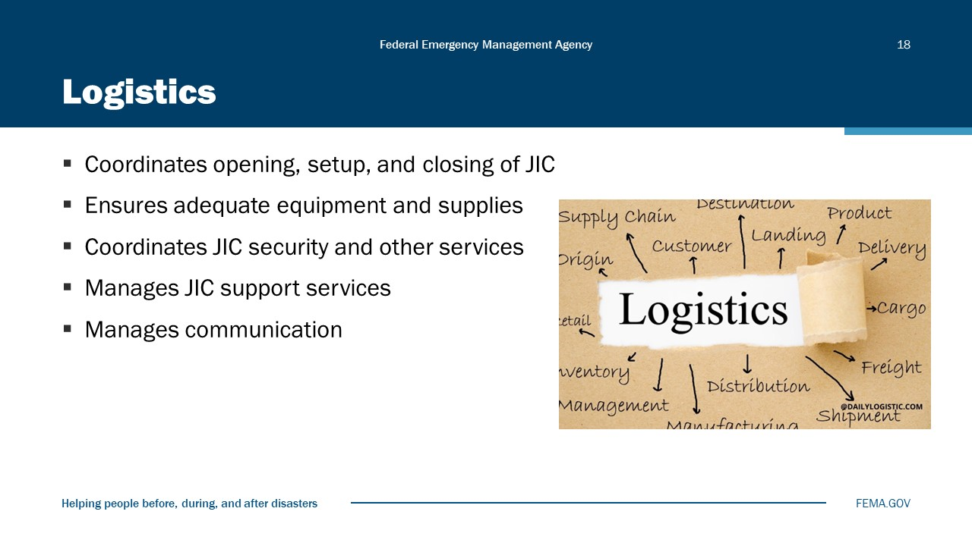
Visual 18, Logistics

Liaisons
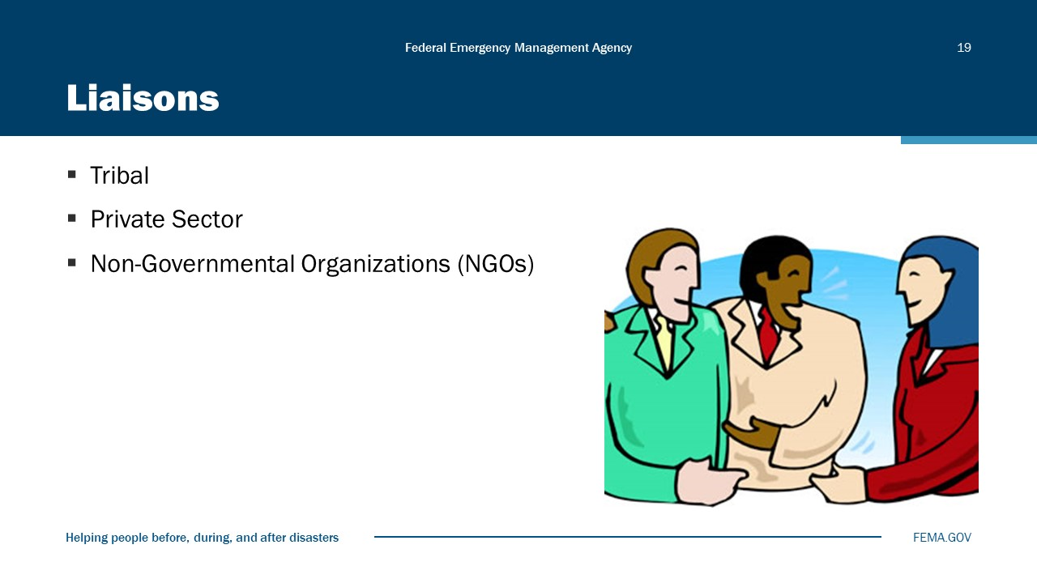
Visual 19, Liaisons

The Liaison function provides a coordinated, two-way communication link with key program areas and other entities involved in the response and recovery operation (e.g., elected officials, community leaders, VIPs, and other governmental and nongovernmental support agencies). This is different than the Liaison Officer in the Command Staff. Note that the Liaison Officer in the Command Staff is responsible for establishing and coordinating interagency contacts, while this PIO function is to provide two-way communication with key program areas.
The liaisons are the “human face” of the crisis response. The power of the liaison is in face-to-face contact with the people (and the media) in the affected area.
The liaisons report back to the JIC information they observe or receive while out in the affected area. This includes community concerns, media issues, or direct observations such as crowded highways, unruly crowds, or problems in shelters.
In addition to Field Liaisons (Field PIOs), a JIC may have VIP Liaisons who:
- Work closely with VIPs (e.g., high-level political or other visitors) in the field.
- Provide VIPs with the latest information.
- Send information back to the JIC—issues, activities, and concerns.
- Help brief and prepare VIPs prior to interviews.
- Coordinate with VIPs’ staffs at all times.
- Liaisons will also work with PIOs from other agencies who may be in the field but not represented at the JIC (and at the scene of major interest) to coordinate information and provide a unified front for media stories.

Other JIC Positions
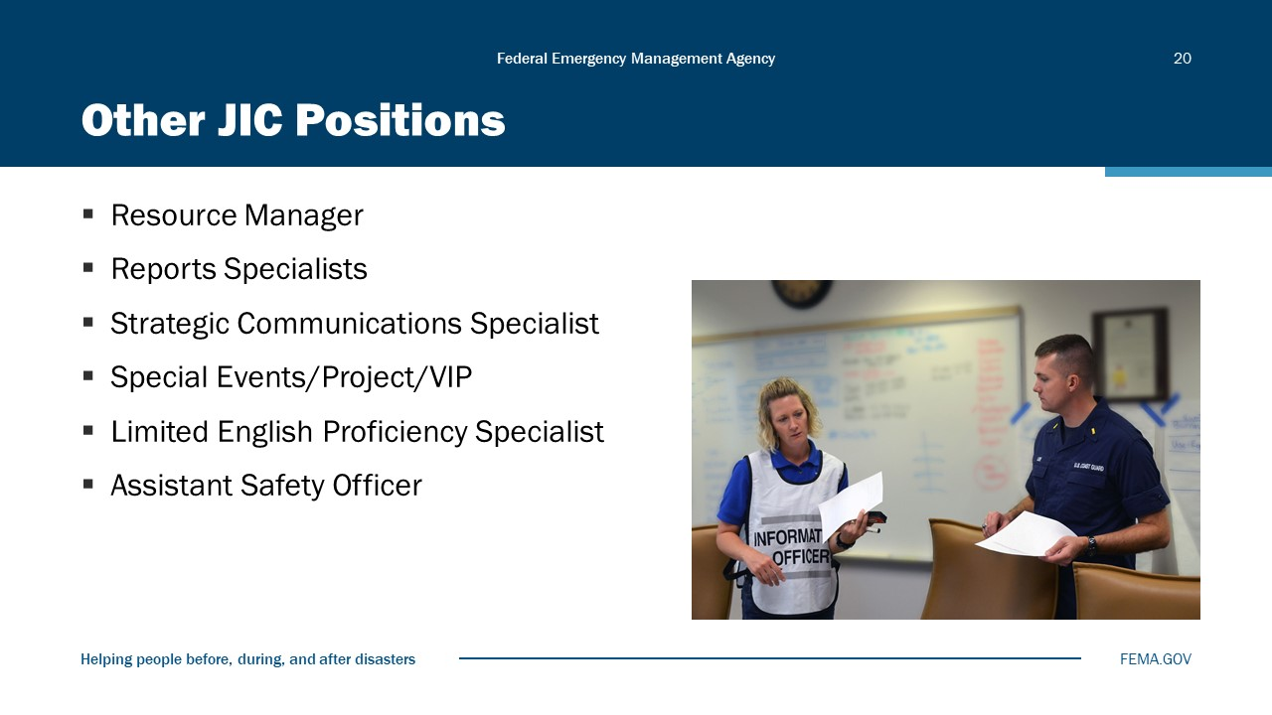
Visual 20, Other JIC Positions

People with access and functional needs must be able to access and benefit from emergency programs, services, and activities equal to the general population.
Equal access applies to emergency preparedness, notification of emergencies, evacuation, transportation, shelter, distribution of supplies, food, first aid, medical care, housing, and application for and distribution of benefits and communications.
People with access and functional needs must be given information that is comparable in content and detail to that given to the general public. It must also be accessible, understandable, and timely. The Joint Information Center must keep this in mind when disseminating information to the public. It is important to know the community, and to have systems in place to reach the whole community when providing emergency public information.
Auxiliary aids and services may be needed to ensure effective communication. These resources may include sign language interpreters through on-site or video (for example, during press conferences); and interpretation aids for people who are deaf, deaf-blind, hard of hearing, or have speech impairments. People who are blind, deaf-blind, have low vision, or have cognitive disabilities may need large-print information or people to assist with reading and filling out forms.

Multiple Roles
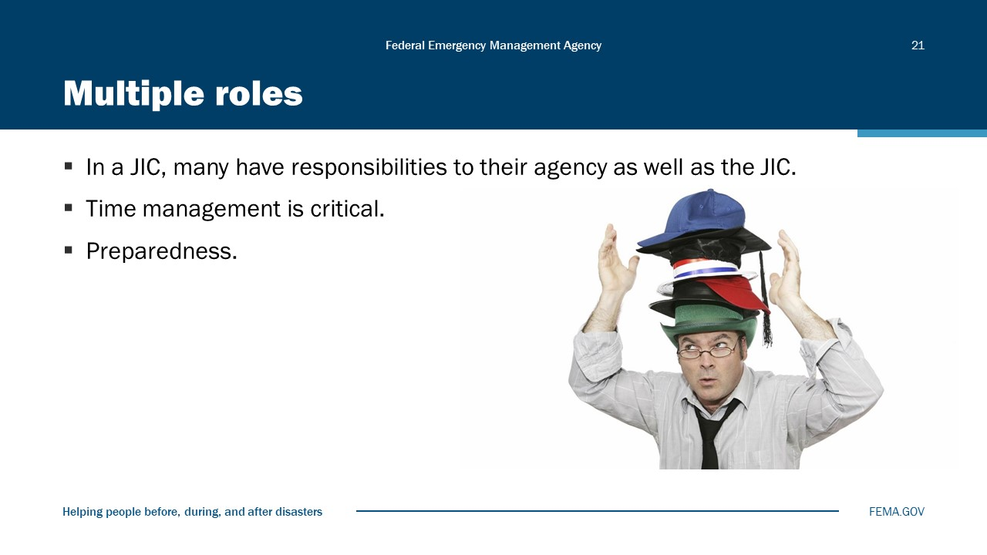
Visual 21, Multiple Roles

In a JIC, PIOs have responsibilities to their agencies as well as the JIC. Many PIOs at the tribal, state, and local levels perform a function within the JIC while maintaining communications and responsibilities to their agencies. Time management is critical when working in a high-stress environment.

Dealing With Stress
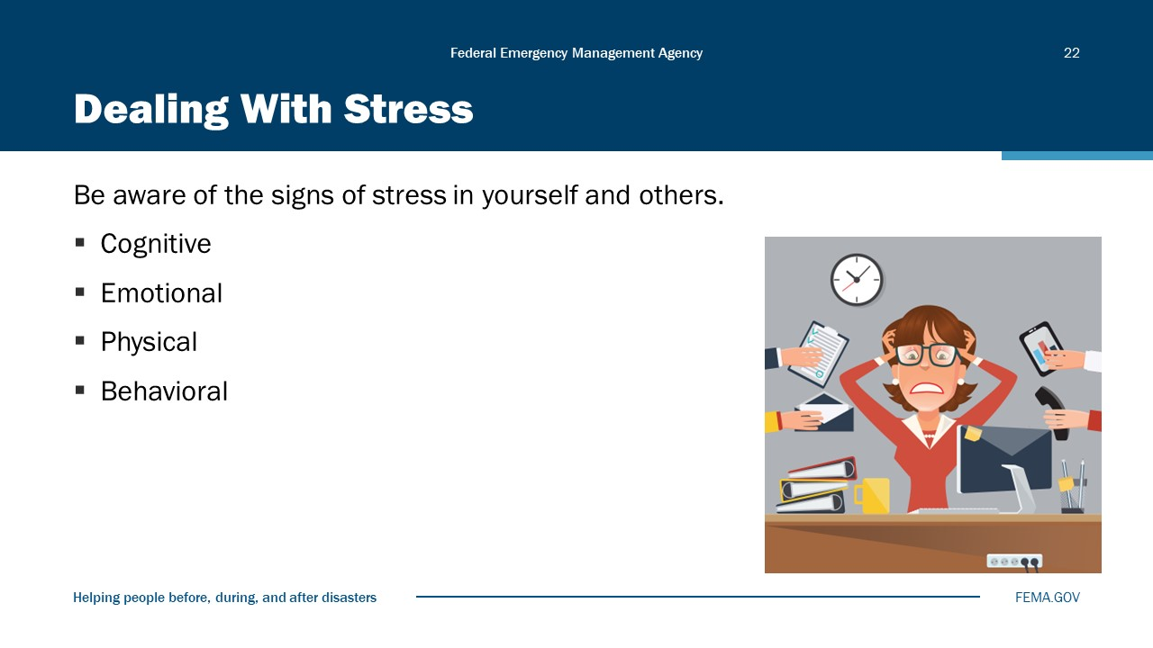
Visual 22, Dealing with Stress

Module Summary
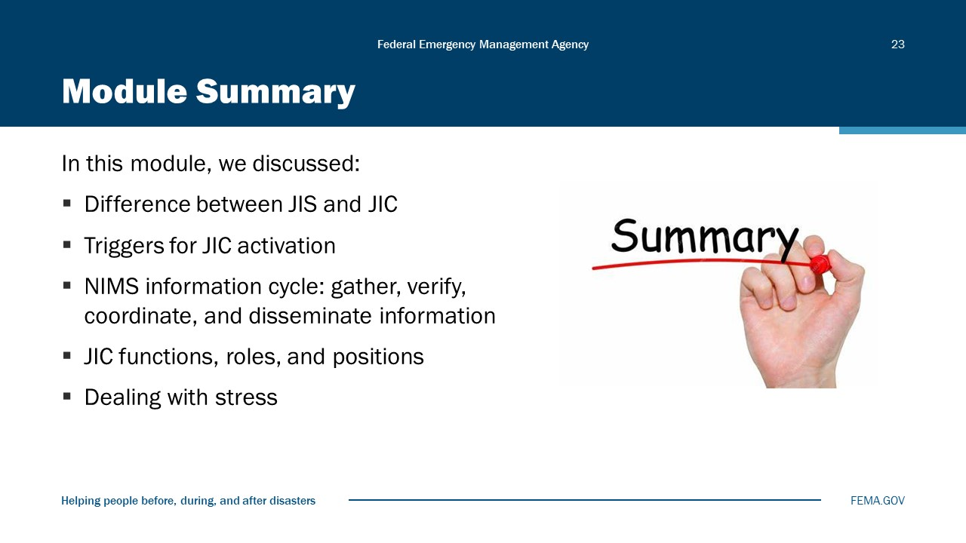
Visual 23, Module Summary

Reference List
Joint Information System Toolkit (https://preptoolkit.fema.gov/web/nims-toolkit/jis)

Crisis Counseling Assistance & Training Program (https://www.fema.gov/fact-sheet/crisis-counseling-assistance-training-program)

Module
10
Wrap-Up Exercise

Administration
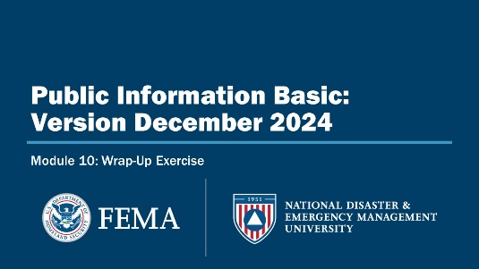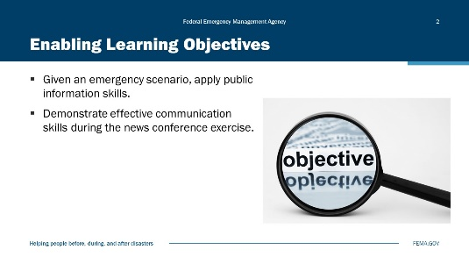
Visual 1, Wrap-Up Exercise Visual 2, Enabling Learning Objectives

Duration
4 hours; 30 minutes.

Terminal Learning Objective (TLO)
By the end of this module, you will be able to apply public information skills to an emergency scenario.
Enabling Learning Objectives (ELOs)
By the end of this module, you will be able to:
- Given an emergency scenario, apply public information skills.
- Demonstrate effective communication skills during the news conference exercise.

Activity 10.1: News Conference Activity
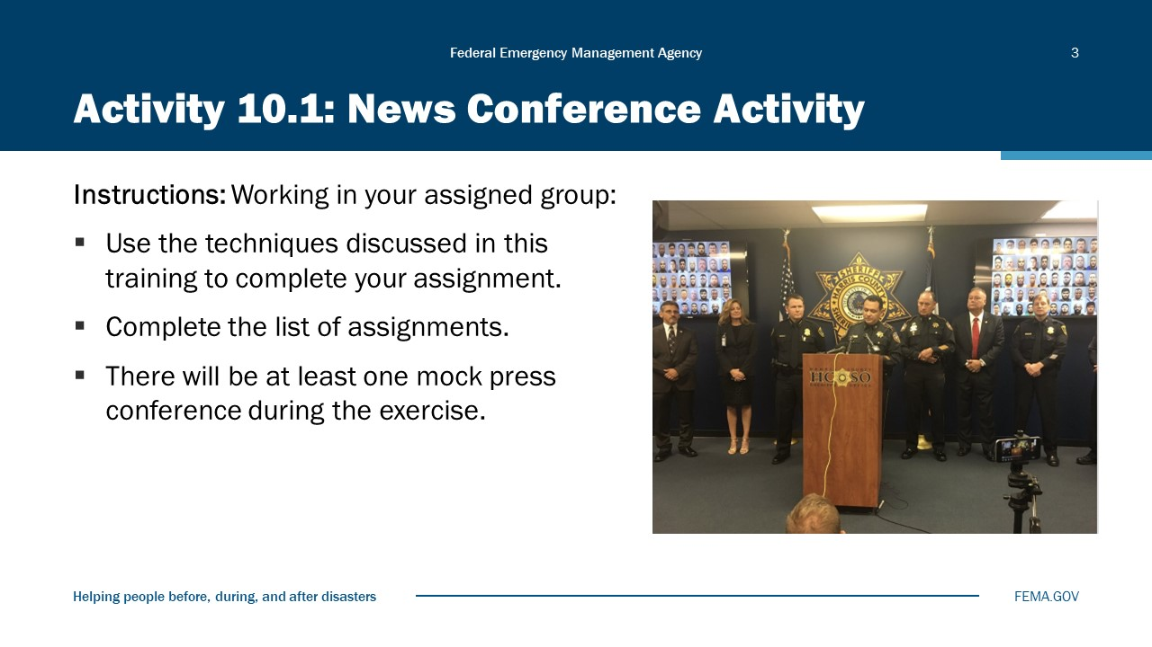
Visual 3, Activity 10.1: News Conference Activity

Instructions: This is a group activity. Based on a scenario:
- Analyze the chosen scenario/problem to determine the steps necessary to conduct an effective news conference.
- Select and use current communications techniques as presented in the news conference lecture.
- Identify and perform appropriate speaker and support roles.
- Deliver the news conference.
- Participate in a Debriefing.
Purpose:
- You are to demonstrate effective communication skills during the news conference exercise.
- To give you an opportunity to gain practical experience by participating in a simulated news conference.
Instructions:
Each team will pick a minimum of three presenters. (Can add more)
Presenters will be:
- Lead PIO (setting ground rules)
- Mayor or City Manager
- City Department Executive to be represented at the news conference based upon the scenario chosen by the team.
Each press conference will be 10 minutes long total, including questions from the press and will be followed by a 10-minute critique.
News conferences will be timed. Team will be signaled at 5- and 1-minute intervals before the end of the conference.
Teams should approach each presentation seriously as though they are getting their message across in an emergency situation as per the scenario chosen.
Equipment will be set up during the team design session.
Teams will be evaluated on:
- Professionalism of the news conference.
  - Start/end on time.
  - Clear ground-rules
  - Demeanor of the presenters
- The delivery of the speakers.
  - Key Messages
  - Articulate
  - Statement content
- The handling of the media corps during the news conference.
  - Responses
  - Selection of questions
  - Managing noise
  - Ending the news conference

Scenario #1: Explosion at Fusse Stadium at a Collegiate Final Football Game
Without warning, there was an explosion inside the Buford T. Fusse Stadium at SLUDMAR State University. The explosion occurred during the fourth quarter of an evening football game between the SLUDMAR University team and its rival for the division title. The stadium was filled with fans.
A possible chemical agent is suspected as people are choking, coughing, and losing consciousness. Several people are reportedly injured or dead. It is unknown if suspects are inside the stadium. People are running for the exits in panic.
Scenario #2: Air Crash Scenario
A big jet with 224 passengers and a crew of 12 was flying from Los Angeles to Oakland. A small jet carrying six people and crew of three was also flying to Oakland. The jets collided over the City of SLUDMAR.
The small jet crashed immediately east of Wilton Place and East First Avenue. There are no survivors from the small jet, but there are numerous injuries on the ground as well as structure fires.
The big jet sustained significant damage and declared an in-flight emergency. The collision caused one engine of the big jet to fall off and land in a field at the south end of President’s Canyon at the County border with SLUDMAR. A small brushfire erupted. The big jet crashed within minutes of its radio transmission on East Sixth Avenue between “F” Street and “H” Street.
The debris field from the big jet extended west and north from East Sixth Street and “F” Street. There are no survivors from the big jet, but numerous people are injured on the ground and there are structure fires.
Scenario #3: Proposed Public Safety Ballot Measure
You are members of a Public Information team for the Santa Luisa del Mar Police Department. The Department is seeking a special sales tax increase of ½ cent in the city. The increase is to provide additional funding for public safety in SLUDMAR. The funding will support additional personnel, equipment, and needed improvement in aging police facilities. It is several months prior to election. The measure has been placed on the ballot with the support of the City Manager, the other department heads, the Mayor, and the City Council. The passage of the measure is not a sure thing. The City of SLUDMAR has recently attempted to increase sales tax for other seemingly worthy purposes, but the measures failed.
Scenario #4; SLUDMAR Earthquake
On today’s date at 1215 hours, a 7.1 Richter magnitude earthquake struck SLUDMAR. The epicenter was approximately 8 miles northwest of SLUDMAR on the Eminem. Several incidents were reported.
The top several floors of the SLUDMAR Bank Building have collapsed. Fatalities and numerous injuries are reported. There is also a building collapse at Lakeview Jr. High. Multiple buildings have collapsed in the 1800 block of R St. The southbound off-ramp on I-9 at Kilometro Calle is damaged and unusable. There is a major traffic accident at Shoreline Drive and Bayshore Boulevard, and a gas tanker is leaking there. Traffic signals are out throughout the city. A structure fire is reported at the Cal-Agra-Hydra Chemical facility at East 2nd and I Street (possible hazmat). There are four single structure fires in the city. There is also a fire in the CSUSL Biological Sciences building. There is a strong smell (possible hazmat incident) at an industrial building near Cannery Park. There is a gas main leak at M Street and East 21st Avenue. The school district has reported two students are critically injured at Santa Luisa High School. The cause is still unknown. The EOC was activated at 1300 hours and is on 12-hour shifts at full staffing. All city resources are committed at this time. Mutual Aid has been requested, but the estimated time of arrival is unknown. Situation Assessment is on-going for a more complete picture on the total damage to the city.
Scenario #5: Mall Explosion
On today’s date, the Santa Luis Mall was holding its annual mall-wide sale. The prices in mall stores are drastically reduced, and the sale attracts thousands of shoppers. At 12:30 p.m., two explosions occurred simultaneously at the mall. The first blast occurred inside the mall near the entrance to Muldowney’s Department Store. The second explosion occurred at the mall entrance to the Santa Luisa luggage store. The blasts caused significant structural collapses and fires to adjacent businesses in the mall. Some parked cars outside, near the luggage store and the mall entrance near the department store, are damaged and on fire. There are many injuries and fatalities. Structures adjacent to the mall sustained broken windows. Flying glass injured pedestrians who were nearby when the explosion occurred. The fire engulfed spaces on the second floor.
The fire department is on-scene and established a command post in the mall parking lot. The police department is on scene and co-located their command post with the fire department. Police units are attempting to control traffic and evacuate shoppers and employees from the mall. Traffic in the mall parking lot and on streets around the mall is congested.
Scenario #6: HAZMAT
On today’s date and time, a traffic accident occurred involving a large panel truck and three passenger vehicles. The accident occurred in downtown SLUDMAR at Washington Avenue and Kilometro Calle. The unmarked panel truck struck the three cars while going through a red-light and overturned. The truck was carrying ten 50-gallon drums in the back. The drums fell into the street and began leaking a yellow fluid.
The lone passengers in each of two of the vehicles were killed instantly. The third vehicle swerved onto the sidewalk crashing into a bus stop. A passenger in the vehicle was ejected and died at the scene. The driver was trapped in inside. Several bystanders at the bus-stop were injured.
The driver and a passenger from the panel truck were seen climbing out of the vehicle and running away. A witness reported that one of the occupants brandished a weapon. An examination of the interior of the truck produced the several interior and exterior photographs of the SLUDMAR city hall.
Both fire and police are on scene and are beginning to organize their response.

Scenario #7: Protest Demonstrations/Civil Unrest
On today’s date at 1700 hours, approximately 500 people gathered in Central Park in SLUDMAR to protest the verdict in a police officer use of force case announced at the nearby courthouse. The protesters are carrying signs showing their anger over the verdict. The crowd that gathered was initially peaceful and had previously conveyed their peaceful intentions to city authorities.
They planned to march to the courthouse and stage a showing of their discontent in front of the building. After dark, as the protesters walked the streets to the courthouse, they began to block traffic and became increasingly agitated.
Upon arriving at the courthouse, the crowd had grown, and the marchers had broken several windows, overturned cars, and set buildings on fire on the way to the courthouse.
Scenario #8 Flooding
After a very dry couple of years and a few wildland fires, the hills in northern SLUDMAR have been left barren of trees. Lack of rainfall has also been an issue in that it has caused a drought in the city.
The weather is turning, however, and rain is on the way. On today’s date and time, a much-needed winter rainstorm has arrived. The needed water is showing up in a torrent coming down in President’s Canyon in the county. Floodwaters have risen the canyon walls, chasing out hikers and at the mouth of the canyon in the south, flooding is spreading in the neighborhoods, both in the county and in the city. The main area of flood damage is along the river coming out of the canyon and overflowing into streets and homes. Guadalupe Park, Guadalupe Elementary School, and Memorial Hospital are all experiencing severe flooding.
The storm is anticipated to last another 4 to 5 hours with a break and another serious storm following in 24 hours.
Scenario #9: Wildland-Urban Interface Fire
A 2-year drought has left SLUDMAR extremely dry. The hills in President’s Canyon and in the Tucker National Forrest are ripe for a conflagration.
On today’s date, about 5 hours ago, a brushfire broke out in Tucker National Forrest. It is spreading fast in the dry timber and winds. It has spread to where fire authorities and local government officials are fearful it may reach SLUDMAR homes lying in its path within hours.
Scenario #10: SLUDMAR City Scandal
The SLUDMAR City Manager has become aware of potential wrongdoing alleged against members of the City Council and the Mayor related to possible illegal and unethical procurement practices of city equipment and services for the Fire and Public Works Departments. The City Manager learned of the problems from a “whistle-blower” who is a non-sworn employee of the Police Department.
The allegations include contracts being awarded to contractors who are friends and relatives, the procurement of sub-standard fire and police equipment, violating the city bidding processes and, in some instances, sexual favors being granted in return for city business. The City Manager has asked the Police Department to investigate these allegations. The public is starting to become aware of what is happening.
Scenario #11: Mardi Gras
The City’s annual Mardi Gras festival is fast approaching. The event involves a parade through the downtown area, ending at City Hall with speeches and a street fair lasting into the evening. For the past years, unruly crowds have resulted in numerous injuries to police and fire personnel as well as participants in the festival. Numerous arrests have been made for public drunkenness, disturbing the peace, and vandalism. The violence has marred the celebration.
Reluctantly city leaders agreed to allow the Mardi Gras festival to take place with some additional precautions and restrictions in place.

Exercise Brief-Out
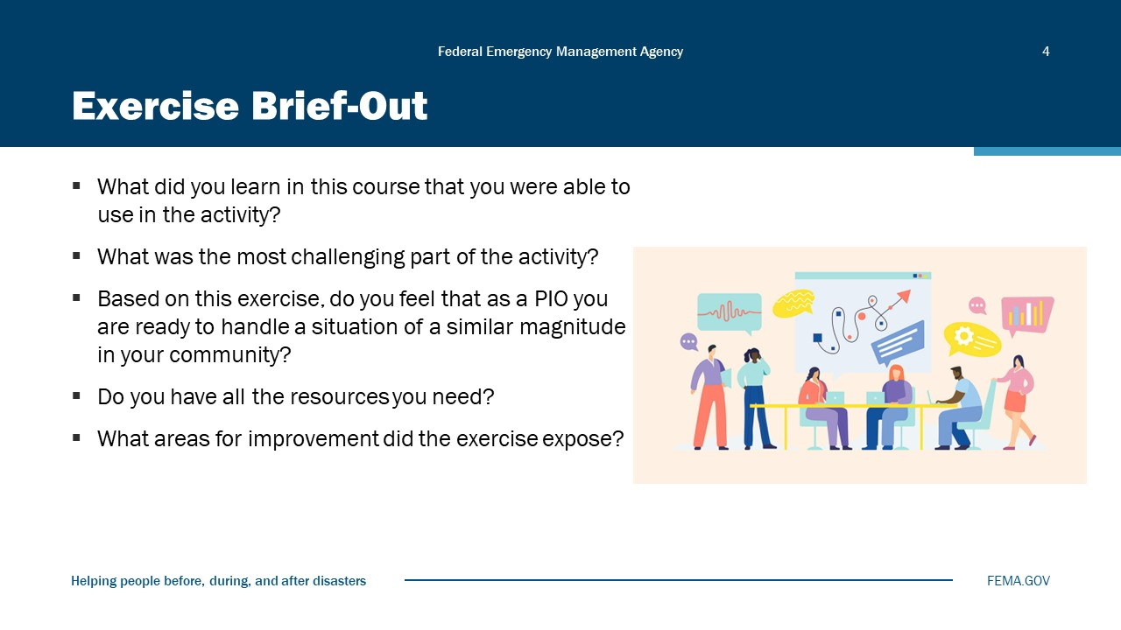
Visual 4, Exercise Brief-Out

Module Summary
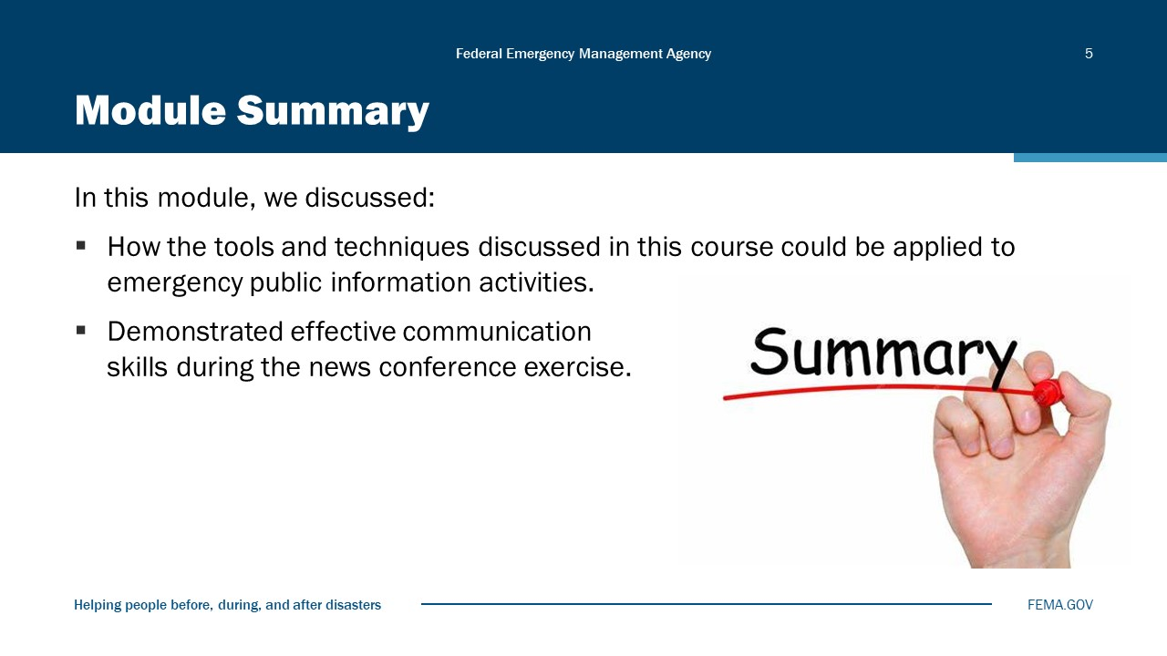
Visual 5, Module Summary

Reference List
None

Module
11
Course Summary

Administration
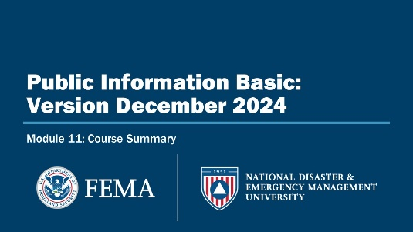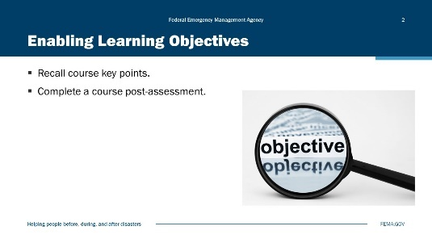
Visual 1, Course Summary Visual 2, Enabling Learning Objectives.

Duration
1 hour; 30 minutes

Terminal Learning Objective (TLO)
By the end of this module, you will be able to understand PIO roles and responsibilities and how they function before, during, and after an incident.

Enabling Learning Objectives (ELOs)
By the end of this module, you will be able to…
- Recall course key points.
- Complete a course post-assessment.

Did We Meet Our Course Goal to…?
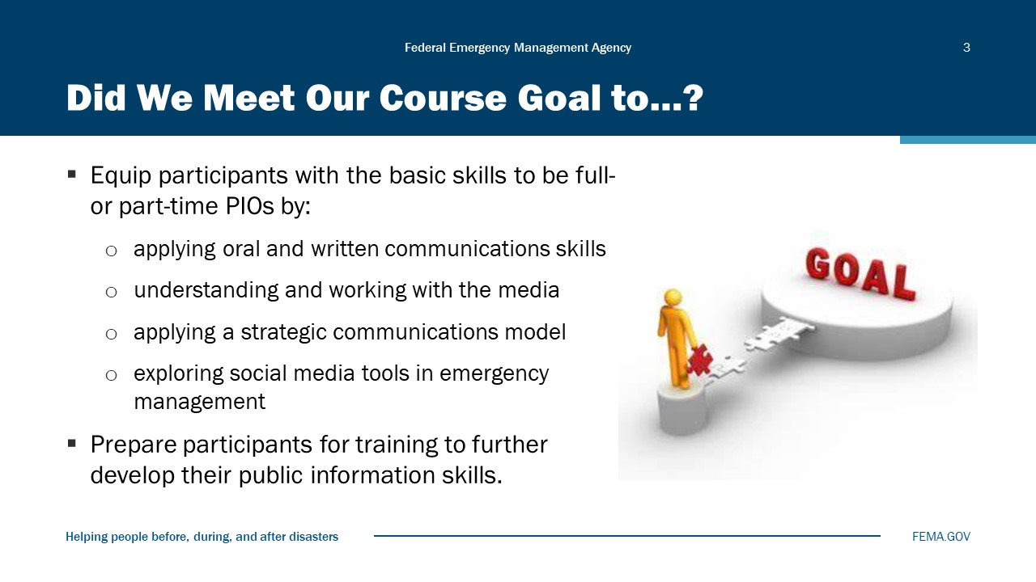
Visual 3, Did We Meet Our Course Goal to…?

Continuing Your Development
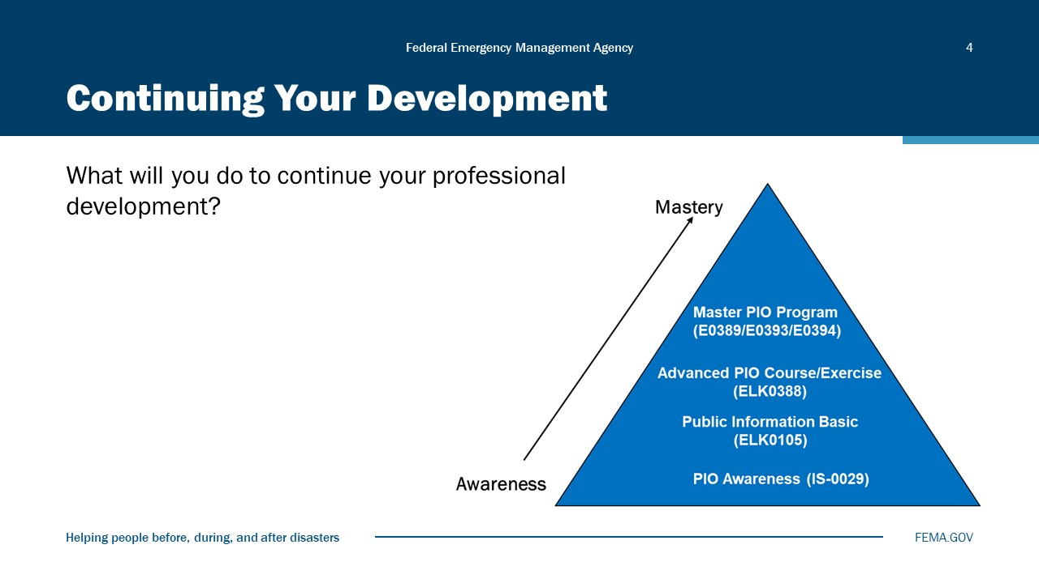
Visual 4, Assessment

You can continue your professional development by progressing through the Public Information Training Series curriculum, including:
      - E/L/K0105: Public Information Basic
      - E/L/K0388: Advanced Public Information Officer (PIO)
      - E0389/E0393/E0394: Master Public Information Officer Program
You can also expand your knowledge of public information and emergency management by completing FEMA Independent Study (IS) courses (https://training.fema.gov/is/). Independent Study courses are free. Here is a sample list of the courses available:
- IS0100.c: Introduction to Incident Command System, ICS 100 (or ICS course for specific specialty: Healthcare, Public Works, etc.)
- IS0909: Community Preparedness: Implementing Simple Activities for Everyone
- IS-0042.a: Social Media in Emergency Management
- IS0200.c: Basic Incident Command System for Initial Response, ICS 200 (or discipline specific course)
- IS0201.a: Forms Used for the Development of the Incident Action Plan (Waived if ICS-300 completed)
- IS0251.b: Integrated Public Alert and Warning System (IPAWS) for Alerting Authorities
- IS0700.b: An Introduction to the National Incident Management System
- IS0800.d: National Response Framework, An Introduction

Assessment
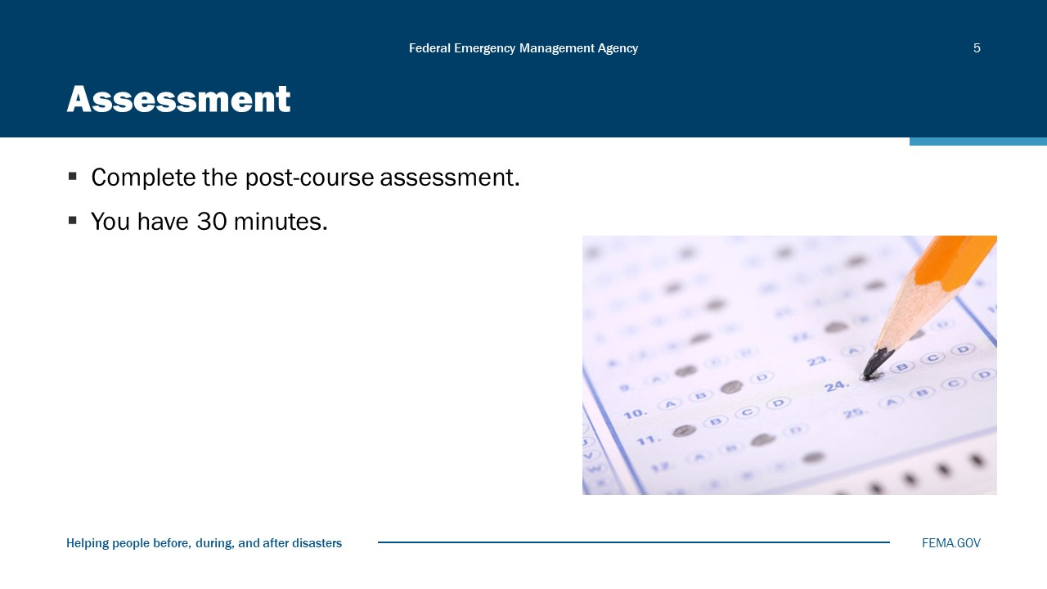
Visual 5, Assessment

Purpose: To assess knowledge gained through this training
Estimated Time: 30 minutes.
Instructions:
- Take the post-course assessment. This is an individual effort.
- You have 30 minutes.

Feedback
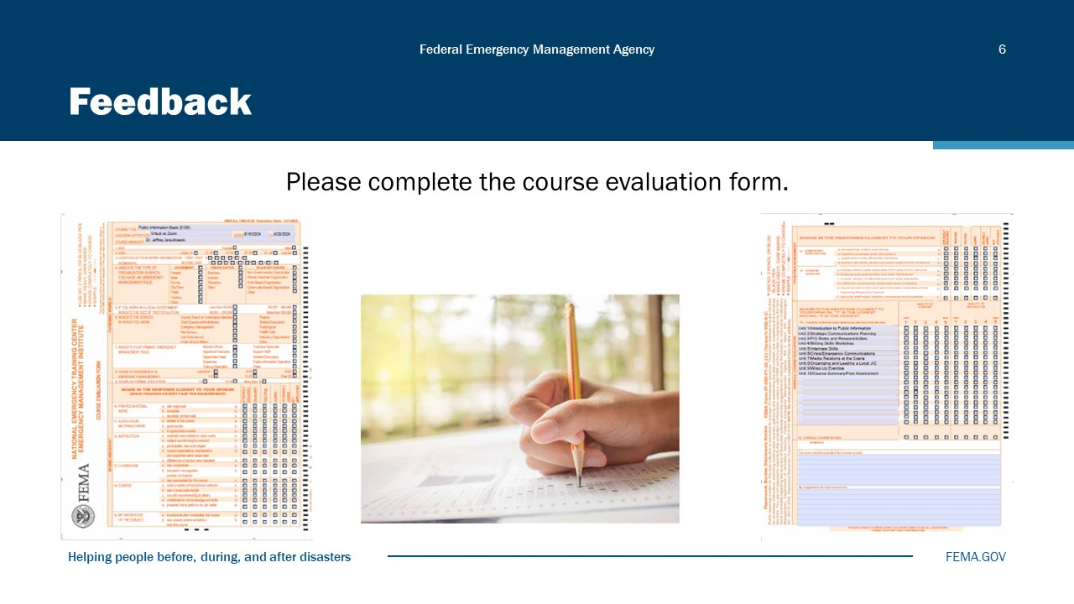
Visual 6, Feedback.

Module Summary
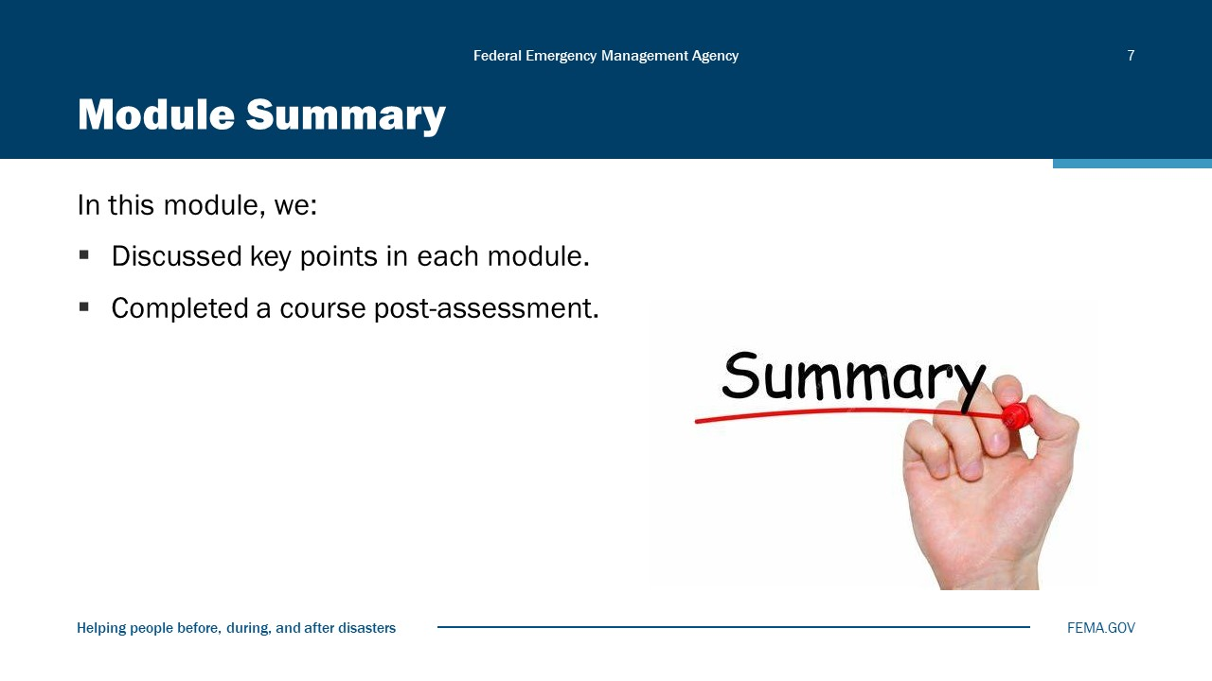
Visual 7, Module Summary

Reference List
Emergency Management Professional Program (EMPP) (https://training.fema.gov/programs/empp/)

Public Information Office (PIO) Program (https://training.fema.gov/programs/empp/pio/)

Independent Study Homepage (https://training.fema.gov/is/)

National Domestic Preparedness Consortium (https://ndpc.us/)

