Appendix III
NIMS ICS All-Hazards Optional Exercise Scenarios

This page intentionally left blank

Table of Contents
Scenario 1: Chemical Incident 5
Scenario 2: Earthquake Incident 7
Scenario 3: Anhydrous Ammonia Incident 9
Scenario 4: Hurricane 11
Scenario 5: Improvised Explosive Device 15
Scenario 6: Land Search and Rescue 17
Scenario 7: Pandemic Influenza 19
Scenario 8: Port Incident 21
Scenario 9: Post-Flood 23
Scenario 10: Power Outage – Winter Storm 25
Scenario 11: Radiological Incident 27
Scenario 12: Stadium Collapse 31
Scenario 13: Tornado 33
MAPS 35
State of Columbia Map 37
Liberty County Map 38
Central City Map 39

This page intentionally left blank

Scenario 1: Chemical Incident

November 11, 20xx
Thousands of citizens from Liberty County and surrounding areas are enjoying a crisp, beautiful fall day in Central City as they await the beginning of the annual Veteran’s Day Parade. The beautiful weather has resulted in a much larger than expected crowd along T Street and other adjoining streets along the parade route. The parade route will travel along the primary business district including City Hall (south on T Street then west on 21st Street).
The parade begins with hundreds of veterans, government officials, schools, and local celebrities participating. Many of the participants are on foot with others on horseback and in cars, trucks, and flat-bed trailers. The parade is well underway with loud marching band music and crowd noises filling the air. As one of the truck-drawn flatbed trailers carrying the Mayor of Central City and other public officials passes City Hall, a slight explosion “popping” sound is heard by the participants on and in the direct vicinity of the trailer. The driver of the truck hauling the trailer stops thinking a tire has blown out. The momentum of the Central City High School Marching Band, directly behind the suddenly stopped trailer, causes several band members to converge on and surround the trailer. With that the music stops and within a few seconds a moist colorless, odorless substance begins to fill the air and exposes those on and around the trailer. The exposed individuals fall to the ground and begin experiencing difficulty breathing, involuntary urination and diarrhea, and vomiting. At least a few of them have fallen unconscious. Within a few minutes, downwind members of the crowd and parade participants begin experiencing similar symptoms. Panic ensues amongst the crowd as people begin to realize the danger and attempt to evacuate the area.
Dozens of citizens in the vicinity use their cell phones to call 9-1-1 while police officers serving as security for the parade radio for assistance as they fight to not become victims themselves. Dispatchers’ early estimates are that at least 50-60 people are in immediate need of medical assistance and that the bulk of them are concentrated near City Hall. Fortunately, a number of fire, EMS, and police units are nearby or already on scene as they work their way through the panicked crowd to attend to the victims and find the source of the substance, which continues to emanate through the area. At least 40-45 adults and children appear unconscious in the immediate area of the trailer while numerous others downwind are having seizures and convulsions. A number of horses have also collapsed, which along with the abandoned vehicles along the parade route, form a barrier to responders trying to approach the scene as well as parade members and attendees trying to evacuate the area. As people attempt to leave the area in their vehicles, major traffic jams are formed and one major multiple vehicle accident has occurred at the intersection of T Street and 21st Street in Central City. At least 5 people are reportedly injured in the traffic accident; the severity of their injuries is unknown.
Members of the Liberty County and Central City fire departments and HazMat teams have donned Level A suits to locate and shut off the source emitting the substance. As they crawl under the trailer they are able to locate two concealed containers with spraying devices, only one of which is operating. After several minutes they are able to shut off the active device and disengage both devices from the trailer. One of the responders who helped disengage the devices notices a barely legible “VX” marking on one of the containers. Because this was clearly an intentional act, the Central City Police Department has declared the area as a crime scene. The containers/sprayers will serve as key pieces of evidence and will hopefully help to lead law enforcement authorities to the culprit(s).
Investigators estimate that at least one of the spraying devices was activated for approximately 20 minutes. In addition to the numerous victims transported by ambulance, 200-250 citizens transported themselves to area hospitals including Central City Hospital, Faith Hospital, Fisherville General, and St. Dorothy’s. Symptoms range from severe respiratory and gastrointestinal disorders to less severe ailments such as headaches, red eyes, runny noses, chest tightness and sweating.
As victims converge on the hospitals in the area, shortages of resources including personnel, beds, medication, and equipment (including resources needed to assist with decontamination) have become an issue across the region. Obtaining additional resources to address the needs of the overwhelming number of victims is a priority. The Liberty County Emergency Operations (EOC) Center is fully activated to assist with coordination of the response including acquisition of needed resources.
As word of the incident spreads on local and national news, the Liberty County EOC as well as local hospitals are inundated with telephone calls from concerned citizens including family and friends of the victims. The Central City Hospital and Faith Hospital are overwhelmed with critical and non-critical patients. Demands of worried-well appearing at hospitals throughout the region are further stressing the medical system’s ability to identify and triage patients.
November 12, 20xx
Area hospitals have seen over 400 patients related to the incident with at least 150 in critical condition. Fatalities are numerous with the latest numbers at 82. At least 30 of these victims died on scene at the incident site. The number of deceased is beyond the number that local morgue services can handle.
November 14, 20xx
Law enforcement and public health personnel are continuing an investigation into the details of the incident and the people involved in the attack. Evidence obtained from the two spraying containers/devices and the trailer to which they were attached led investigators (including the FBI) to two suspects. A search of one of the suspect's apartments turned up numerous articles on nerve agents including detailed reference materials on VX agent and sarin nerve gas.
Coincidentally, it was determined that VX agent was the chemical identified in both containers, which were equipped with sprayers set with timers. Fortunately, only one of the sprayers activated.

Map Reference: Central City Map
ICS Forms for this scenario: ICS 202, ICS 203, ICS 204, ICS 205, ICS 206

Scenario 2: Earthquake Incident

It is Friday evening in Central City, Liberty County. A long-advertised concert by local bands is gathering in the North Side Park, awaiting the first act to begin. The concert is estimated to draw about 5,000 people. Many office workers who have not left their office jobs watch from their multi-story office buildings surrounding the community park. An earthquake lasting 34 seconds hit the county along the Apple Valley Fault. The earthquake measured 5.8 on the Richter scale. Buildings began to fail and utility gas and water pipes broke throughout the city. Other public services experienced failures also, sub-stations failed affecting electricity, and telephone lines on power poles fell and snapped causing phone outages. After shocks are occurring, with the greatest being a 3.9 on the Richter scale.
There are reports that a six-story building located at the intersection of T and 12th Streets has a pancake collapse of the upper 3 floors. The building is 80’ x 80’ dating pre-1920’s; of masonry construction. There are an unknown number of people trapped and bodies can be seen in the rubble.
Many roads are impassible due to debris, sink holes, or road surface destruction. The overpass at Interstate 107 and 20th Street has collapsed. There is an after-school activities bus from Hoover High School is under the rubble. There are reports of 17 students, two coaches and 1 driver on the bus. Other motorists are trying to get to the bus. Other bridges are heavily damaged including DD and 5th Street; 5th above RR and SS Streets; Railroad Bridge at A Street and Interstate Bridge 107 over the railroad.
Concerned citizens are reporting looting of damaged business in down town area along the river front. Several have reported looters carrying guns. There are estimated to be about 25 looters.
The Central City Pounders, a “Double-A” affiliate of the Baltimore Orioles, were playing an exhibition game at the Fluman Sloane Stadium when the earthquake hit. It was a sold-out crowd of 9700 with parking for 5100 and numerous cookouts going on in the parking lot during the game. There are reports of damage to the stadium and numerous walking wounded.
The local media are broadcasting live from downtown Central City amidst the rubble. News helicopters are flying over head creating dust storms. National news services are reportedly enroute and are already asking for interviews with local officials. Citizens are using Twitter, Facebook and You Tube to send messages and videos of the destruction out.
In general, the community has come to an abrupt standstill with traffic halted and persons fleeing buildings. Emergency vehicles are having difficulty navigating through the rubble and destroyed roadways. The gathering of 5000 people in the park has experienced issues from totally bewildered persons to the elderly experiencing heart attacks. Fires can be seen throughout the community. Calls are overwhelming 911 center’s staff. Local hospitals are overwhelmed by walking wounded and many hospitals are running on backup generators.
The mayor has just issued an emergency declaration and is requesting assistance from the state. The state estimates that it will take at least four hours for personnel, equipment and supplies to begin arriving. An Incident Command Post has been established at the City Hall located at AA and 21st Streets. A Staging Area is being established at Hoover High School at LL and 22nd Streets.
Liberty County in the State of Columbia is the largest county in the State in terms of population, and includes Central City, the largest and densest population center in the State of Columbia. The population is approximately 302,412. Central City serves as a major transportation hub within the state with commercial river traffic, rail, air, and interstate traffic. Central City is 40 miles from the Port of Charlotte, on the Big Ocean.

Map Reference: Central City Map, Liberty County Map
ICS Forms for this scenario: ICS 202, ICS 203(Pt 1&2), ICS 204, ICS 205, ICS 206

Scenario 3: Anhydrous Ammonia Incident

On an overcast, unseasonably mild December day with temperatures hovering around 55 degrees, Central City is bustling with rush hour traffic and people making their way to the Central City Mall and downtown shops for last minute Christmas shopping. State Road (SR) 17, a two-lane highway which serves as the main thoroughfare for large commercial transport vehicles is busier than usual today as vacationers and shoppers add to the typical rush hour traffic. It has been raining for the past two days making the roads very slick; however, the rain has finally stopped but the clouds overhead remain.
At 5:15 PM, a northbound tractor-trailer on SR 17 carrying compressed anhydrous ammonia comes around a sharp curve in the road where it is suddenly upon a major multiple vehicle accident that occurred only a few seconds earlier. The driver of the tractor-trailer instinctively slams on the brakes and swerves to avoid hitting the vehicles that have completely blocked both the north and southbound lanes. As the tires screech, the massive tractor trailer, rocking back and forth violently, veers to the right of the mass of wrecked vehicles and tumbles down a steep ravine, finally settling on its side in a creek. The anhydrous ammonia tank onboard the tractor-trailer is ruptured and ammonia gas immediately begins to leak, rapidly filling the air with deadly, toxic fumes.
A number of drivers arriving onto the accident scene pull over and get out of their cars to assist the accident victims. Unaware of the dangers posed by the leaking gas, they are overcome by the toxic fumes. A considerable plume has now formed and continues to grow as the ammonia leaks from the ruptured tank. The white-colored plume is moving to the northeast in the direction of the Central City Mall and, beyond that, downtown Central City.
Emergency responders including fire/EMS, the State of Columbia Highway Patrol (CHP), and county and city law enforcement have difficulty approaching the scene of the accident due to the backed up traffic along SR 17. CHP is first on scene followed shortly thereafter by Liberty County Fire/EMS. They survey the scene from a distance upwind and determine from the ruptured tank placard and white color of the plume that the leaking substance is anhydrous ammonia. They are able to identify at least 25 victims from the traffic accident and/or ammonia exposure. They also begin to set up incident command in the upwind area. With the ruptured tank continuing to leak, the fire/EMS responders don personal protective equipment (PPE) to allow them to attend to the numerous victims.
The plume continues to grow and move in a northeasterly direction toward the Central City Mall (approximately ½ mile away) and downtown Central City (approximately ¾ of a mile away). Numerous residential areas and two elementary schools are also in the direct path of the plume. Fortunately, the elementary schools are not in session due to the Christmas holidays and are likely unoccupied.
Meanwhile, many stranded drivers on SR 17, now backed up for miles are abandoning their vehicles and trying to determine the cause of the backup. Fire/EMS personnel, donned in SCBA PPE, have begun treatment and rescue of the accident and ammonia-exposed victims. Four people have already died including the driver of the tractor-trailer. Seven others were seriously injured in the vehicle accident and have also now been exposed to ammonia. There are a number of additional ammonia-exposed victims across the immediate area.
Among the vehicles in the backed up traffic near the incident scene is the local WGSD radio station van. The van is now broadcasting live that a “large white toxic plume is moving in the direction of the Central City Mall.” As a result of this broadcast, the Liberty County and Central City Emergency Operations Centers are becoming inundated with phone calls from concerned citizens on what to do to protect themselves. Many are asking specifically whether or not they should evacuate, and if so, in which direction.
The CHP continues to work with Liberty County and Central City law enforcement personnel to try and alleviate the massive traffic congestion problem to allow EMS ingress and egress to the incident scene to tend to the numerous victims. Area hospitals have been notified of the situation and told that incoming victims have been exposed to anhydrous ammonia gas in addition to any other injuries they may have incurred.

Map Reference: Central City Map, Liberty County Map
ICS Forms for this scenario: ICS 202, ICS 203(Pt 1&2), ICS 204, ICS 205, ICS 206

Scenario 4: Hurricane
Landfall minus 96 hours
Coastal communities in the State of Columbia including Central City are enjoying a warm, clear sunny day in early September. With Labor Day now passed, the tourist season is winding down in Central City and residents are back into their regular post-summer vacation routines. Meanwhile, local meteorologists for the National Weather Service along with the National Hurricane Center (NHC) are monitoring Tropical Storm Zelda in the Atlantic currently with maximum sustained winds of 73 miles per hour. The storm is expected to rapidly increase in intensity over the next 24 hours and become a major hurricane. The NHC is highly concerned with the track of the storm as most storm tracking models are in agreement that it will make landfall somewhere in Newton County or neighboring coastal counties within the next 4-5 days. Based on the current data and potential threat to the area, the local National Weather Service (NWS) has issued a Public Information Statement that indicates that Tropical Storm Zelda could pose a threat to Central City as a major hurricane by the weekend and that residents and visitors should keep a close watch on the progress of the storm throughout the week.
Landfall minus 72 hours
As expected, the storm has strengthened considerably over the past 24 hours and is now Hurricane Zelda. The National Hurricane Center (NHC) and local NWS continue to closely monitor Hurricane Zelda, located east of the Virgin Islands currently with sustained winds of 125 mph. Hurricane Zelda has been traveling towards the United States at a rapid pace of approximately 20 mph. A Hurricane Watch has been issued for Newton County and other counties along the coast of the State of Columbia. Current prediction models indicate that Hurricane Zelda will make landfall in the Newton County region sometime within the next 72 hours. Emergency response agencies for the State of Columbia, Newton County and Central City are ramping up preparedness and response operations including preparation for evacuation of coastal areas in the path of the hurricane.

Landfall minus 48 hours
Hurricane Zelda has strengthened into a Category 4 storm with sustained winds of 135 mph. It is currently located 600 miles southeast of the State of Columbia and is moving rapidly in a west-northwesterly direction. Based on available radar data and flight observations, Hurricane Zelda severe weather conditions reach as far as 100 miles from the eye of the storm. Coastal and surge/flood prone areas of Newton County including Central City have begun evacuations. As evacuation continues, traffic congestion increases across the county and State with a number of accidents and abandoned cars (from running out of gas) reported along the evacuation routes.
Landfall minus 24 hours

Hurricane Zelda has grown in size, but sustained winds have decreased to 130 mph making the storm a strong Category 3 on the Saffir-Simpson Scale. The NWS has issued a Hurricane Warning for Central City and Newton County. At its current speed, the eye of the hurricane is projected to make landfall at Central City in approximately 24 hours. Evacuations of most coastal and flood/surge prone areas are complete while some are still ongoing.

Landfall [September 10th/1400 hours]
Hurricane Zelda made landfall in Central City as a Category 3 hurricane. Sustained winds are 115 mph as the storm continues to move in a west-northwesterly direction at about 15 mph. Power outages are widespread (estimated at 150,000 customers) throughout the impacted region and landline and cellular telecommunications have been disrupted as well. The Governor has issued a disaster declaration to activate state resources to assist with preparedness and response efforts. Local and national news outlets are reporting that areas directly impacted by the storm have already received 5-8” of rain. There are reports of traffic congestion on all major roadways. Fire/EMS, law enforcement, and public works crews among others are reporting that many roadways are entirely blocked as a result of debris, flooding, and downed power lines and trees. Many of the downed and/or up-rooted lines are energized creating extremely dangerous conditions for the public and responders. Search and rescue teams are working throughout the community in damaged homes and buildings performing confined space operations. Fatalities have been reported, though only a few, and no trapped victims have yet been found.
[Landfall plus 24 hours]
Many Central City residents who chose to ride out the storm are finding themselves isolated with no running water, electricity or ability to communicate via landline/cellular telephone or internet. In addition, many are unable to venture out due to extensive flooding, dangerous downed power lines, fallen trees/limbs and other debris blocking transportation routes. For those who stayed home as well as returning evacuees who did not prepare properly, critical resources such as food, water, ice, batteries, fuel, generators and other disaster supplies are not available at retail outlets, most of which are closed. Numerous reports of break-ins of abandoned residences in evacuated areas as well as looting of grocery stores and other retail establishments are being reported through fusion centers and law enforcement channels. Security resources are strained and additional qualified law enforcement personnel are needed. The State EOC is coordinating with the Columbia National Guard, American Red Cross, Salvation Army and other public/private sector partners to provide adequate resources. Preparations are also underway to request resource support from other states through the Emergency Management Assistance Compact (EMAC).
Landfall plus 48 hours]
Concerned spouses, friends, and family are trying to reach loved ones at shelters, hospitals, nursing homes and other special needs facilities. Between last minute evacuations and storm damage, and disrupted communications, many individuals are still unaccounted for. At the Governor’s formal request due to the extent of damage across the area, the President has issued a presidential disaster declaration for the impacted counties, activating individual and public assistance, and hazard mitigation programs. Local emergency services are concentrated on search and rescue missions, debris removal, looting, resource acquisition/provision, infrastructure restoration (e.g., power, telecommunications, water/wastewater treatment, etc.). Hospitals and clinics are at or near capacity and are not able to provide assistance to residents and visitors that require treatment for minor injuries.
[Landfall plus 72 hours]
Preliminary damage assessments coming in show that Central City suffered major damage and flooding as a result of strong winds and nearly 11” of rain that fell. The State of Columbia EOC has requested federal assistance as well as out-of-state mutual aid through the Emergency Management Assistance Compact (EMAC) to support power restoration activities and provide other resource support. Many buildings and structures have suffered moderate to severe damage and are unsafe and not operational. Incident Command has begun to coordinate with utility companies to identify priority facilities for the restoration of power. With numerous homes and businesses destroyed and others severely impacted by the damaging winds and flood waters of Hurricane Zelda, the residents have a long rebuilding and recovery period ahead of them. Local emergency service agencies will have a big hand in helping the city to recover over the next several months and years.

Map Reference: Central City Map, Liberty County Map, State of Columbia Map
ICS Forms for this scenario: ICS 202, ICS 203(Pt 1&2), ICS 204, ICS 205, ICS 206

This page intentionally left blank

Scenario 5: Improvised Explosive Device

November 11, 20xx
Thousands of citizens from Liberty County and surrounding areas are enjoying a crisp, beautiful fall day in Central City as they await the beginning of the annual Veteran’s Day Parade. The beautiful weather has resulted in a much larger than expected crowd along T Street and other adjoining streets along the parade route. The parade route will travel along the primary business district including City Hall (south on T Street then west on 21st Street).
The parade begins with hundreds of veterans, government officials, schools, and local celebrities participating. Many of the participants are on foot with others on horseback and in cars, trucks, and aboard flat-bed trailers decorated as “parade floats.” The parade is well underway with loud marching band music and crowd noises filling the air. As one of the truck-drawn parade floats carrying the Mayor of Central City and other public officials passes through the largest part of the crowd near City Hall, several spectators notice what appears to be smoke coming from the underside of the decorated float. While some speculate it is only exhaust and others fear the float may be on fire, a thundering explosion rocks the air and sends debris flying in all directions. The mayor and other occupants of the float are thrown onto the street and dozens of spectators on both sides of the street are thrown to the ground by the explosion. Several members of the Central City High School Marching Band, who were directly behind the blast are also directly impacted. Many parade participants and spectators injured by the blast scream for help while others lay on the ground motionless. Panic ensues amongst the crowd as people react to the explosion and attempt to leave the area fearing that more blasts may be forthcoming.
Dozens of citizens in the vicinity use their cell phones to call 9-1-1 while police officers serving as security for the parade radio for assistance. Dispatchers’ early estimates are that at least 50-60 people are in immediate need of medical assistance and that the bulk of them are concentrated near City Hall. Fortunately, a number of fire, EMS, and police units are nearby or already on scene as they work their way through the panicked crowd to attend to the victims. At least 20-30 adults and children appear unconscious in the immediate area of the damaged trailer.
The Liberty County Fire Department has extinguished a fire that erupted as a result of the explosion and has uncovered evidence in the debris that the blast was most likely caused by an improvised explosive device (IED). The Central City Police Department is in the process of securing the area as a crime scene and is working with the Bomb Squad to search for further evidence as well as any secondary devices that may be in the area including other vehicles and parade floats that were part of the parade. Based on the evidence, it appears that the explosion was caused by an IED that was secured on the underside of the flatbed trailer that served as the parade float for the mayor and other city officials. Therefore, all other parade floats are being carefully inspected for similar devices.
As law enforcement personnel perform crowd control and attempt to evacuate the area in as orderly a manner as possible, one police officer notices a handwritten note that has been attached to the front door of City Hall. The note states that “the Mayor was only the beginning and more bombs will take other lives on this same day.” The police officer immediately shares this information with his superiors including the police chief.
An incident command post has been established near the area of the explosion as EMS continues to treat and transport the victims to area hospitals. At least 8 people have been killed including the mayor and other occupants of the targeted parade float. Approximately 12 others have sustained life threatening injuries and an additional 35 citizens have sustained injuries ranging from serious to minor.
As word of the incident spreads on local and national news, the Liberty County EOC as well as local hospitals are inundated with telephone calls from concerned citizens including family and friends of the victims. The Central City Hospital and Faith Hospital are overwhelmed with critical and non-critical patients.
November 14, 20xx
No additional IEDs were located at the parade scene, City Hall, or any other buildings in the area. Law enforcement personnel are continuing an investigation into the details of the incident and the persons involved in the attack. Evidence obtained from the scene of the explosion and eye-witnesses who saw two suspicious characters near City Hall “attaching something to the front door” have uncovered two suspects. A search of one of the suspect’s apartments turned up evidence of bomb making materials including dynamite, gasoline, and ammonium nitrate.

Map Reference: Central City Map
ICS Forms for this scenario: ICS 202, ICS 203(Pt 1&2), ICS 204, ICS 205, ICS 206

Scenario 6: Land Search and Rescue

It is early September and the North Central City Middle School (NCCMS) has recently resumed classes for the new school year. NCCMS is located in a highly populated upper middle-class section of the city. Because many of the homes are within easy walking distance of the school, many parents allow their children to walk to and from school. Such practice is not encouraged by the local school board nor the police department but many of the parents justify allowing their children to walk to and from school because of the short distance and the fact that the crime rate for the NCCMS area is extremely low with no major crimes reported in the past five years.
Jimmy and Allison Smith, ages 14 and 12, respectively, are brother and sister who live in close proximity to NCCMS and walk to and from school each day. The two have always walked together and often with a group of other children. Recently, however, Jimmy has joined the football team and must stay after school for practice leaving Allison to walk with other schoolmates on her way home from school.
Friday - 3:30 p.m.
As school adjourns, NCCMS students rush out of their classrooms as their weekend begins. Allison Smith, however, decides to stay late and finish up a project she has been working on. She tells one of her friends that she is going to stay late and to let the others in the group know that she will not be joining them on the walk home today.
Friday – 5:15 p.m.
Jimmy Smith has just arrived home from football practice. His parents, who arrived home just a few minutes earlier are immediately concerned that there are no signs that Allison has returned from school. When they ask Jimmy, he assumes his sister walked home with her friends as usual. He then calls one of Allison’s friends and is told that Allison stayed late at school and must have decided to walk home on her own. Jimmy relays this information to his parents and tells them that Allison may have taken the “shortcut” through a small patch of woods that they sometimes take on the way home from school. Mr. Smith, not being aware of this shortcut, asks Jimmy to lead him to the shortcut route to the school. Mrs. Smith decides to stay at home in hopes that Allison will soon show up and to make more phone calls to inquire about her missing daughter.
Friday – 5:45 p.m.
After several calls to Allison’s friends and teachers, Mrs. Smith confirms through a telephone call with one of Allison’s teachers that Allison voluntarily stayed after school to complete a class project. When she was done with the project, Allison told the teacher she was going to go to the football field and wait on her brother to finish practice so they could walk home together. Hearing this, the teacher allowed Allison to leave on her own knowing that the football field was right next to the school.
Shortly after Mrs. Smith completes her call with Allison’s teacher, Mr. Smith and Jimmy arrive home visibly upset and with some alarming news. As they walked along the shortcut trail to the school they found one of Allison’s shoes along with her school books and what appeared to be blood spattered on one of the books. Mr. Smith told his wife he had already called the police on his cell phone and that they would be arriving to the house at any moment.

Map Reference: Central City Map
ICS Forms provided for this scenario: ICS 202, ICS 203, ICS 204, ICS 205, ICS 206

Scenario 7: Pandemic Influenza

Mid October 20xx: With the beginning of the regular flu season, there have been a slightly below average number of flu cases reported in Central City in comparison to recent years. For the most part, other parts of the U.S. are experiencing normal to lower than average flu cases at this early point in the flu season. Conditions overseas, especially in Western Europe, are significantly more serious as much higher than average outbreaks of severe respiratory illness are being reported. Germany has been hit especially hard with outbreaks of the illness.
Late October 20xx: The German Federal Ministry of Health has announced that the outbreak virus in Germany has been confirmed as H1N1. Human-to-human infections with numerous resulting deaths in the country have also been confirmed. Young adults appear to be the most severely impacted. Outbreaks of the illness continue to spread throughout Western Europe. Although no known cases have been identified in the U.S., officials are closely monitoring the situation and the World Health Organization (WHO) Pandemic Alert phase has been elevated to level 6. The WHO and the Centers for Disease Control and Prevention (CDC) have developed a case definition and have posted it on their website. In the State of Columbia, the Department of Public Health has requested increased surveillance from locals based on the case definition.
Mid-Late November 20xx: The CDC and State public health authorities in three distant States are reporting via the Health Alert Network (HAN) localized outbreaks of the H1N1 virus due to confirmed cases in those areas. The CDC’s Influenza Surveillance System indicates that there is no reason to suspect the virus has reached the State of Columbia but encourages state and public health authorities to remain at heightened surveillance to closely monitor the situation.
National and local media outlets are now covering the reported localized outbreak in the three distant States. State and local public health officials from the State of Columbia and Central City are fielding questions from the media in regards to what public health and healthcare entities around the State are doing to prepare for a potential outbreak. Local clinics and hospitals, which have been on increased surveillance, are now reporting a significantly high number of patients with influenza like illness (ILI) symptoms.
Mid December 20xx: The CDC confirms that H1N1 has been identified in the State of Columbia and two adjacent states. Hospitals, doctor’s offices, and community health clinics in numerous parts of the State of Columbia including Central City are reporting much higher than average numbers of phone calls and patient visits from persons with ILI symptoms as well as those not showing symptoms but concerned that they may have been exposed to H1N1 flu. With outbreaks occurring in multiple parts of the world, the WHO is now confirming a global influenza pandemic.
Late December 20xx: Many hospitals and health clinics in Central City and the surrounding area have reached capacity with others nearing full capacity. The number of available doctors and nurses is significantly reduced due to the outbreak. The Central City public health agency is operating at roughly 60% capacity and other local emergency departments (emergency management, fire/EMS, law enforcement, public works, etc.) are also dealing with significantly reduced workforces. Rates of absenteeism in schools and business also begin to rise, as the public becomes aware of the arrival of the H1N1 and its impending spread throughout the State. As a result of the reduced workforce, those required to work are working extended shifts and are becoming overwhelmed and exhausted.
Antiviral drugs are also growing in short supply as are other critical healthcare supplies such as lab supplies, ventilators, gloves, masks, and gowns. With the shortage of antiviral drugs and the knowledge that a vaccine is not yet available, widespread frustration among the public is heightened. Local call centers are overburdened with calls and are unable to keep up with the public’s need for information. EMS calls are steadily increasing as well as clinics and hospitals continue to struggle to keep up with the overwhelming number of patients.
Early January 20xx: With a statewide outbreak now confirmed, the Governor of Columbia declares a public health emergency and issues a disaster proclamation in order to release resources to contain and manage the spread of H1N1 flu. This includes a request for the Strategic National Stockpile (SNS) managed inventory. National media outlets are locating to the Central City area and requests are coming into the state and local jurisdictions for interviews.
Mid-Late January 20xx: After more than three weeks, Columbia has experienced 51 deaths. National health experts expect the number to slightly increase over the next couple of weeks. Counties are not able to handle the increase of medical examiner cases and are referring to the state to assist. Additionally, proper storage of bodies is a concern as most hospitals are only able to hold a small number at a time.
Best estimates from surveillance of clinics and hospitals are that approximately 10% of the State of Columbia population may be ill at this time (up to 26,950 people), and that the H1N1 virus continues to spread rapidly. Approximately 10% of those persons infected with the H1N1 (up to 2,695 people) may be seeking medical care. However, many more people are seeking medical care than actually need it due to fear about the H1N1 virus. Public health estimates that nearly triple that number (up to 8,000 people) of worried well may be visiting hospitals and other health facilities. Phones at physician offices and health departments throughout the state continue to ring constantly.

Map Reference: Central City Map, State of Columbia Map
ICS Forms provided for this scenario: ICS 202, ICS 203, ICS 204, ICS 205, ICS 206

Scenario 8: Port Incident

It is a clear and beautiful June evening in and around the Bayport Seaport on Masland Island: 75 degrees with a slight breeze out of the southeast. The summer tourists have arrived on the island the current population is approximately 95,000. On this tranquil evening, Masland Island is rocked by an explosion at 1920.
A large fire breaks out at the Bayport Seaport bulk cargo area as crews unload a cargo shipment of ammonium nitrate and ammonium nitrate fertilizer. The fire, causing a series of explosions and requiring overwhelming initial efforts to get it under control, sends toxic fumes into the air around the port. Smoke and fire are seen as far away as Central City. Fear immediately grips those at the scene and nearby residents fear it was a terrorist attack.
The explosion releases a vast amount of toxic chemicals and begins to suffocate workers and Port fire crews nearby. In the surrounding community, people begin to come out of their homes and begin to flee the immense plume quickly working its way towards residential areas.
In addition, containers of fertilizer are partially spilled as machinery was abandoned by crew members fleeing the flames. As water from fire controls and dilution efforts flood the scene, the chemicals begin to runoff into the water around the port, risking contamination of the environment and threatening nearby industry and residents. Bayport Fire Stations 91 and 82 are quickly overwhelmed. Senior officials report a need for greater numbers of fire fighters, fire trucks, hazardous materials equipment, and/or fire boats. Mutual aid resources are requested from Fisherville and other nearby communities.
The plume of toxic smoke begins to move and is rapidly spreading over the island. The 911 Call Center receives numerous calls from concerned citizens complaining of difficulty breathing, coughing, and a strong smell of ammonia.
Due to heavy summer tourist traffic compounded by those trying to flee the island, local fire personnel from Fisherville and surrounding communities have difficulty accessing or even getting near the port. Several car collisions have occurred on the High Rise Bridge, a concrete and steel drawbridge which allows larger vessels to transit through Columbia Bay. The 35-year-old High Rise Bridge is 65 feet above mean sea level and is five lanes wide, accommodating four lanes of traffic, with two lanes going in each direction.
The local media are broadcasting live from the perimeter of the port. News helicopters are flying over head. National news services are reportedly enroute and are already asking for interviews with local officials. Citizens are using Twitter, Facebook and You Tube to send messages and videos of the destruction out.
Waves of victims begin presenting to the Bayport Clinic and Noble General Hospital in Fisherville. Emergency room personnel frantically attempt to maintain control over the number of walk-in patients. Some victims are vomiting, experiencing cramps, and convulsing. During preliminary medical evaluations, most victims report having smelled ammonia.
The Bayport Seaport is located in the city of Bayport on the eastern part of Masland Island. Cargo and cruise ships moor at a special series of docks located east of I-107. West of I-107, private vessels moor at the municipal piers. During World War II (WWII), national strategic requirements resulted in the construction of an oil refinery in Bayport at the eastern tip of Masland Island. This refinery has recently received a major upgrade that increased its overall efficiency. A fuel depot (tank farm) serves the seaport on the mainland just south of Fisherville.

Map Reference: Central City Map, Liberty County Map, State of Columbia Map
ICS Forms for this scenario: ICS 202, ICS 203(Pt 1&2), ICS 204, ICS 205, ICS 206

Scenario 9: Post-Flood

As a mild, rainy winter gradually turns to spring the majority of Liberty County including Central City continues to experience a prolonged period of above average rainfall. As a result, the ground is very saturated and most local waterways including the Roaring River are dangerously near flood stage.
April 12, 20xx – 7:00 AM
State and local emergency officials are extremely concerned as the National Weather Service (NWS) has just issued a Severe Thunderstorm Warning for Liberty County and several surrounding counties. The approaching front is one that formed from a line of severe thunderstorms from the west merging with another weather front from the Gulf of Mexico creating a very powerful, dangerous weather system. According to the NWS, the system has a history of producing rains up to two inches per hour with wind gusts exceeding 60 mph. The area can expect sustained winds between 35 and 45 mph and significant flash flooding. Due to the flooding concern, the NWS has also issued a Flash Flood Warning for Liberty County.
April 12, 20xx – 9:00 AM
Heavy rain, thunder, lightning, and strong winds have been impacting Central City and the surrounding area for over an hour. There are several reports of flooding in low-lying areas within the city limits and beyond. Numerous streets and roadways are impassible due to flooding and downed trees. There are initial reports of flooding in numerous residential areas both in the city and on the outskirts of town where private wells are relied upon rather than public water supply. Columbia Power & Light is reporting more than 10,000 customers are without service throughout Central City and the immediate surrounding area. Reports of high winds and suspected tornadoes have been reported throughout Liberty County and significant wind damage has been reported in numerous parts of Central City. Fallen trees are blocking many streets, homes are damaged, and power lines are down in the area. There are also initial reports of injuries, unknown in quantity, type, and severity.
Government officials are keeping a very close eye on the Roaring River, which is very near flood stage and threatening hundreds of homes, government facilities, and private businesses.
April 12, 20xx – Post Storm
The western edge of the easterly moving storm has exited Central City. The rain has slacked off considerably and the severe weather conditions have passed. The winds are sustained at 10 mph with gusts to 20 mph.
The damage from the powerful storm is considerable and widespread. Major flooding has occurred in numerous parts of the city where waterways have overflowed and storm drainage systems have been overwhelmed. Standing water, fallen trees/limbs, power lines and other debris are making numerous major traffic routes and residential streets impassable, interfering with emergency responders’ ability to assist the injured and stranded population. Three bridges, one of them on a major highway just outside of Central City, have been closed due to flooding and fallen debris.
Residential areas have been hit hard with fallen trees/limbs, power lines and other debris blocking numerous streets. Hundreds of homes and businesses are flooded including those along the Roaring River which has reached flood stage and continues to rise.
Columbia Power & Light is now reporting over 25,000 residents without power in the Central City area. The power outage coupled with the heavy flooding has also impacted the city’s public utilities. Water and wastewater treatment plants as well as private wells throughout the county have sustained heavy flooding and a “boil water order” has been issued by the Liberty County Health Department for the entire county. The Health Department is also highly concerned about the hundreds of flooded homes and health concerns associated with the contaminated standing water. The contaminated water and other health and safety concerns may get worse before they get better as more flooding is forecast as the Roaring River continues to rise.
Public works crews and Columbia Power & Light are coordinating to clear roads and bridges and restore power as quickly as possible. However, power restoration and debris removal operations continue to be slow because of the heavy flooding, and fallen debris including downed trees and limbs tangled in power lines. Many of the downed power lines throughout the county are still active and pose a major safety concern. The debris-blocked and flooded roadways also continue to severely hamper first responders’ efforts including law enforcement, fire and EMS personnel as they attempt to rescue, treat and transport victims impacted by the storm.

Map Reference: Central City Map, Liberty County Map, State of Columbia Map
ICS Forms for this scenario: ICS 202, ICS 203(Pt 1&2), ICS 204, ICS 205, ICS 206

Scenario 10: Power Outage – Winter Storm

It is mid-January and the majority of the State of Columbia has been experiencing extreme winter weather conditions for the past several days. Liberty County and Central City have been hit particularly hard with blizzard conditions and one of the coldest months to date in the recorded history of the county and city.
On January 16, a major part of the State of Columbia including all of Liberty County/Central City is hit with another major snowstorm. The National Weather Service (NWS) is predicting blizzard-like conditions to continue for the next 4-5 days and possibly longer. However, the next day there is an unexpected break in the weather for most of the state as the snowstorm begins to abate and temperatures rise above freezing. Weather forecasters warn, however, that the worst is yet to come as a severe ice storm is approaching.
On January 18, temperatures have plummeted well below freezing as the ice storm takes hold on a large portion of the state. With extremely icy conditions and wind chills at dangerously low levels, Liberty County and Central City emergency officials caution residents to stay indoors as much as possible until the hazardous conditions subside. As weather conditions continue to deteriorate, sporadic then widespread power outages begin to occur across Liberty County as a result of downed power lines and excessive strain on the power grid.
On the morning of January 19, the ice storm has subsided, now turning back to snow but the temperatures continue to drop and are now in the low teens. Downed trees, limbs, and power lines are seemingly everywhere throughout Liberty County including on tops of houses, in yards and across local streets and major highways. Liberty County is experiencing over 75% power outages and Central City has over 85% of its residents without power. The State of Columbia Emergency Operations Center along with most local EOCs across the state including Liberty County and Central City are now activated as emergency management officials work to open generator powered-shelters, acquire badly needed resources and manage the overwhelming number of calls coming in from residents across the area seeking assistance.
In Liberty County, state and local transportation officials are working with law enforcement to clear the roadways and manage the numerous traffic accidents to allow Columbia Power and Light officials to work restore power as they battle the extremely difficult elements. Liberty County and Central City Fire/EMS officials are overwhelmed with responding to calls from the traffic accidents as well as accidents occurring at residences across the region due to fallen trees/limbs on homes and exposure from the extreme temperatures. Many shelters are experiencing long lines as people seek heated space. Law enforcement personnel are spread thin as they respond to security issues at shelters, traffic accidents, and reports of looting at abandoned retail stores and residences. Generators, fuel, cots, blankets and numerous other resources are in high demand not only in Liberty County but across the state and region and supplies are rapidly decreasing. Hospitals across the Liberty County area including the Central
City Hospital, Faith Hospital, Fisherville General, and St. Dorothy’s Hospital are experiencing heavily crowded emergency rooms and shortages of beds for the high number of victims. With the forecast calling for continued extreme cold temperatures and blizzard conditions, emergency response and health/medical officials brace themselves and prepare for the challenges ahead.

Map Reference: Central City Map, Liberty County Map, State of Columbia Map
ICS Forms for this scenario: ICS 202, ICS 203(Pt 1&2), ICS 204, ICS 205, ICS 206

Scenario 11: Radiological Incident

April 21, 20xx
It is a beautiful spring early afternoon in downtown Central City as the business lunch crowd gradually fills the outdoor seating at the many restaurants along the T Street in the main business district. The temperature is a perfect 78 degrees with light winds out of the southwest at 1 to 2 miles per hour.
Traffic is moderate and the streets near the intersection of T Street and 21st Street are slightly busy during the lunch hour. In addition to the considerable crowds at restaurants, there are a large number of people simply mingling outdoors or going for walks along the sidewalks as they take advantage of the lunch hour to enjoy the gorgeous weather.
At 12:45 PM, four coworkers dining together at one of the outdoor restaurants notice an individual illegally parking a large van next to a fire hydrant in close proximity to several restaurants and a small city park area where large numbers of people have gathered. The driver exits the van quickly and appears to be the only occupant of the vehicle. As he walks away from the vehicle one of the coworkers hollers out to the driver informing him that he has parked in front of a fire hydrant when there were several available legal parking places nearby. The driver completely ignores the person and continues to walk away rapidly until he turns down a side street and out of sight. As the coworkers discuss whether to call the police, the vehicle suddenly explodes filling the area with dust and debris while water from the destroyed fire hydrant surges onto T Street.
Numerous customers at restaurants including the four coworkers who witnessed the driver parking the vehicle are injured in the explosion. Others picnicking on park benches and walking along the sidewalk are also injured. Fire alarms sound in several of the surrounding buildings. Occupants begin evacuations but their efforts are slowed by the lingering dust in the vicinity. People in the vicinity of the blast begin to panic as the dust spreads and they begin fleeing the scene on foot or by vehicle. People on the streets in the path of the plume seek shelter in nearby buildings to escape the spreading dust cloud. Other people attempt to escape the oncoming dust cloud on foot or by vehicle causing several small traffic accidents causing gridlock. The 911 call center is immediately flooded with calls. Several people report being injured by shrapnel and flying glass. An unknown number of casualties are lying in the street and sidewalks, unconscious or dead.
The Central City Fire Department is the first response agency on scene and as emergency response vehicles arrive at the incident site, their onboard radiological survey equipment trips, indicating possible elevated levels of radiation in the immediate vicinity. The Incident Command Post is quickly established near the incident site and occupants of the surrounding buildings are instructed to shelter in place and remain indoors until emergency personnel determine the risk to public safety. The Central City Fire Department continuously monitor the incident site to obtain sufficient information to determine the potential radiological release.
People outside along the sidewalks, restaurants, offices and stores continue to panic as the Central City Police Department rushes in to begin crowd control activities. However, before the CCPD can secure the area, dozens of people have fled the scene on foot or by vehicle.
April 22, 20xx
In the past 24 hours, CCPD has ruled out the possibility that the explosion was an accident. The Central City Fire Department conducted decontamination of citizens who were in the vicinity of the explosion. Activities to mitigate the effects of the explosion continue. Curious onlookers continue to attempt to view the site of the explosion, unaware of the threat posed by the radiation. Occupants who were sheltered in place are demanding to be released from their buildings. All of the severely injured victims have been triaged and transported to area hospitals.
Local and State emergency response organizations have responded to the incident. The Liberty County and Central City Emergency Operations Centers (EOCs) were activated shortly after the explosion and remain operational. The State of Columbia EOC is partially activated to provide resource support to the county and city. Local and State public health officials are coordinating with the Liberty County and Central City emergency management and law enforcement officials to track the movements of employees in close proximity to the explosion. People who evacuated the area immediately after the blast have begun calling the Liberty County EOC, local hospitals, and the local public health department with questions about their safety. Search and rescue operations are ongoing in collapsed structures within the blast zone but luckily the building most impacted by the blast was under renovation and vacant at the time of the explosion. The large majority of the blast victims were outdoors at the time of the explosion.
The Liberty County Health Department is actively coordinating and managing all environmental sampling and radiological field monitoring activities at the initial blast zone and surrounding area. Central City Fire/EMS made and recorded ambient radiation measurements at several locations. Radiological samples were collected at the incident site. The Central City Police Department and Fire/EMS’s high and low range survey instruments that read gamma and beta radiation indicate elevated radiation levels at the initial blast zone and surrounding area. Based on the initial monitoring results, the Liberty County Health Department makes recommendations concerning the incident site.
Central City Hospital and Faith Hospital are receiving victims from the explosion. Local emergency rooms report an increase of patients complaining of various symptoms, including respiratory problems, skin abrasions, and cough. While most of the victims arriving at the hospitals received precautionary gross decontamination at the incident site, the hospitals activate their decontamination teams. The victims require treatment for explosion injuries and injuries resulting from exposure to unknown contaminants. The hospitals have found it difficult to secure their perimeters as CCPD has dispatched most of their officers to the incident site and surrounding area.
Word of the incident was picked up by local, national, and international news organizations and broadcast around the world. Reporters and camera crews have been near the scene since the first hour. Reporters are approaching responders or bystanders as they look for any newsworthy reaction or information. Reporters are also contacting the Liberty County EOC, and the CCPD requesting interviews.

Map Reference: Central City Map
ICS Forms for this scenario: ICS 202, ICS 203(Pt 1&2), ICS 204, ICS 205, ICS 206

This page intentionally left blank

Scenario 12: Stadium Collapse

On a slightly cool, clear November Friday night, the Central City High School Panthers prepare to take the field for their final home football game against the arch rival Liberty County High School Eagles. A near capacity crowd of approximately 10,000 is expected for tonight’s game. With kickoff set to take place in a few minutes, the majority of fans have found their seats while late arrivals hurriedly work their way into the stadium from the parking lot. A large number of students are mingling below the stands near the concession area.
Following the conclusion of the national anthem, the crowd enthusiastically applauds its approval as they await the opening kickoff. At that moment a loud explosion rocks the stadium. As smoke and debris fills the air, people in the stands panic as they fight to make their way out of the stadium. Numerous injured spectators cry out for help while others lay motionless in the bleachers and along the aisles. As more and more people attempt to make their way to the exits a deafening sound is heard as the portion of the stadium immediately over the concession area comes crashing down. Dozens of people including students who were mingling near the concessions are immediately trapped and possibly crushed by the stadium collapse. As people continue to rush to get out of the area even more are injured from being trampled upon in the mass confusion.
The Central City Police Department officers assigned to security operations for the football game immediately radio dispatch to report the situation and request medical, security, and search and rescue assistance. The CCPD also reports that a bomb may have been the cause of the stadium collapse and requests that a bomb squad also be dispatched. The limited numbers of officers on hand do their best to assist with an orderly evacuation of the stadium but they are overwhelmed by the large numbers of the frightened, fleeing spectators. A number of football team members from both teams along with the coaching staffs converge into the bleachers looking to assist the injured and find their family members and friends.
As fire/EMS, law enforcement and other responders begin to arrive they are finding it difficult to make it into the impacted area due to major traffic jams and accidents caused by the numbers of people fleeing the scene. Once the responders are able to make it to the area of the blast and stadium collapse they find a horrific scene of injured, dead, and possibly trapped spectators. Initial casualty counts include 12 deceased, 38 seriously injured, and 46 with non-life threatening injuries. It is unknown how many may have been trapped or killed in the concession area where the stadium collapse occurred but the number of victims is thought to be substantial. Plans to begin search and rescue efforts as soon as possible are underway.
Media outlets, some of which were assigned to the football game, and others just arriving on scene are clamoring for information from the responders and school officials as to what caused the blast and speculating that it may be a terrorist act.
The Central City Hospital, Faith Hospital, Fisherville General, and St. Dorothy’s Hospital have been notified of the incident and to be prepared for incoming victims either self-reporting or being delivered by ambulance.

Map Reference: Central City Map
ICS Forms for this scenario: ICS 202, ICS 203(Pt 1&2), ICS 204, ICS 205, ICS 206

Scenario 13: Tornado

Date, 20xx
1:15 PM
A Severe Thunderstorm Warning and a Tornado Watch are declared by the National Weather Service (NWS) for parts of the State of Columbia including portions of Liberty County. The squall line is approaching from the WSW in an east-northeasterly direction. Both advisories are scheduled to last until 5:00 PM. The Emergency Alert System (EAS) has been activated for Liberty County and Central City and TV and radio stations in the area begin broadcasting the alerts.
3:00 PM
Between 2:00 and 2:45 PM, numerous sightings of tornados are reported west of Central City. An F3 tornado has just destroyed numerous residences and buildings in a nearby city and at least one possibly even more powerful tornado is confirmed by the NWS as being headed directly for Central City in an easterly direction. NOAA weather radio notifies that numerous parts of Liberty County including Central City are under a tornado warning. By 3:00 PM, Central City is in the midst of a severe thunderstorm and experiencing steady wind gusts of 75 mph and higher.
3:15 PM
A powerful F4 tornado takes a path directly toward the central business district of downtown Central City. Along or in the direct vicinity of its path are the Central City High School, and numerous private and government office buildings including City Hall and the county jail. At the height of the storm the snapping of trees, roofs being ripped off the tops of buildings and debris flying everywhere can be heard. At least one explosion is heard as the tornado rips through the city.
3:45 PM (Aftermath/Initial Damage Assessment)
The severe weather has now passed but the damage has been done. At least one tornado tore across downtown Central City leaving major destruction in its path. Trees are uprooted and snapped, power lines are down, and landline telecommunications systems are out. Overturned cars and all types of debris are strewn across the entire downtown area. Cellular service is sporadic and very limited. Electric power is out across the area but there are still concerns of live power lines lying on the ground, sidewalks and roadways. Numerous businesses including two hotels and several retail stores sustained moderate to major damage. City Hall only sustained minor damage but other government buildings including the county jail sustained major structural and roof damage. The impact to the county jail has raised security concerns with inmates. The explosion heard during the storm appears to have been from an aboveground fuel tank at the Central City bus depot, which is located near the courthouse and jail along with several other buildings. The fire caused by the explosion appears to be under control but has still not been extinguished completely. There are numerous casualties.
The Central City High School campus took a direct hit from the tornado. The roof of the gymnasium was almost completely blown off and the main building containing the majority of the classrooms was also hit.
4:30 PM –
Casualties to date
Downtown Central City
• 96 with minor injuries
• 28 with serious, potentially life-threatening injuries
• 21 dead
• 18 missing (including 3 inmates from county jail)
Central City High School
• 72 with minor injuries
• 18 with serious injuries
• 8 dead
• 25 missing
City and county responders including fire, EMS, law enforcement, public works, and public health are on scene at both locations. Due to the multiple response efforts and entities involved, there is uncertainty about whom or which agency is in charge of the incident. Security concerns grow as the media and the general public (parents of students, concerned community members, etc.) have converged on the downtown area and the high school campus. The crowds attempting to go into the impacted areas are hampering the ability of the responders to do their jobs. At the high school, a number of students have left or are leaving the campus on their own further complicating accountability efforts as search and rescue efforts continue throughout the area.
The Liberty County and Central City EOCs are activated as they work to coordinate response efforts and secure badly needed resources to support response efforts. They are finding that many neighboring jurisdictions were also impacted by severe weather and tornados, further restricting the availability of regional resources. State assistance has been requested by the Liberty County EOC as well as other counties in the area and the State EOC is now activated.

Map Reference: Central City Map
ICS Forms for this scenario: ICS 202, ICS 203(Pt 1&2), ICS 204, ICS 205, ICS 206

MAPS

This page intentionally left blank

State of Columbia Map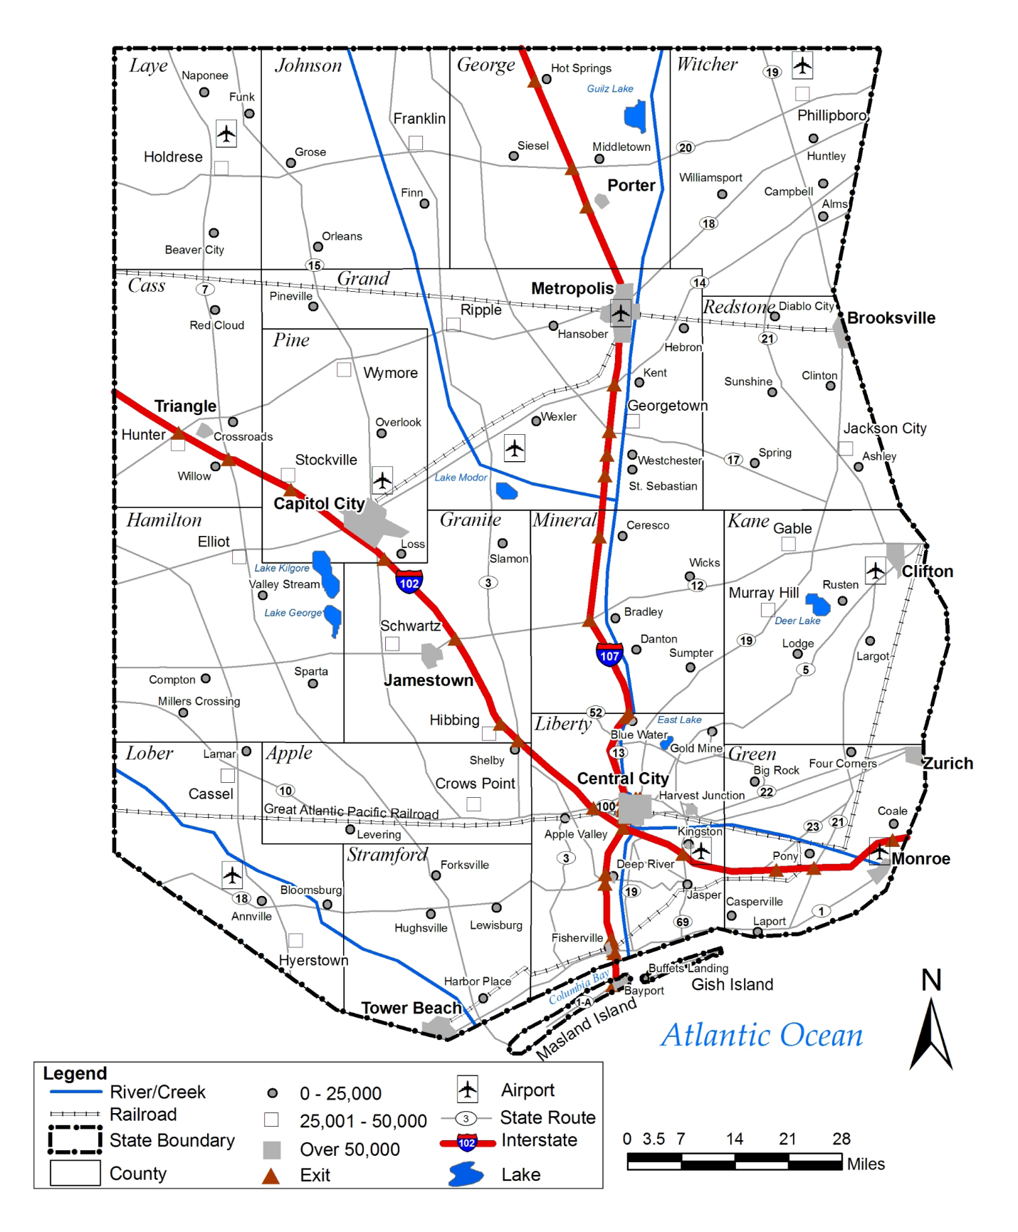

Liberty County Map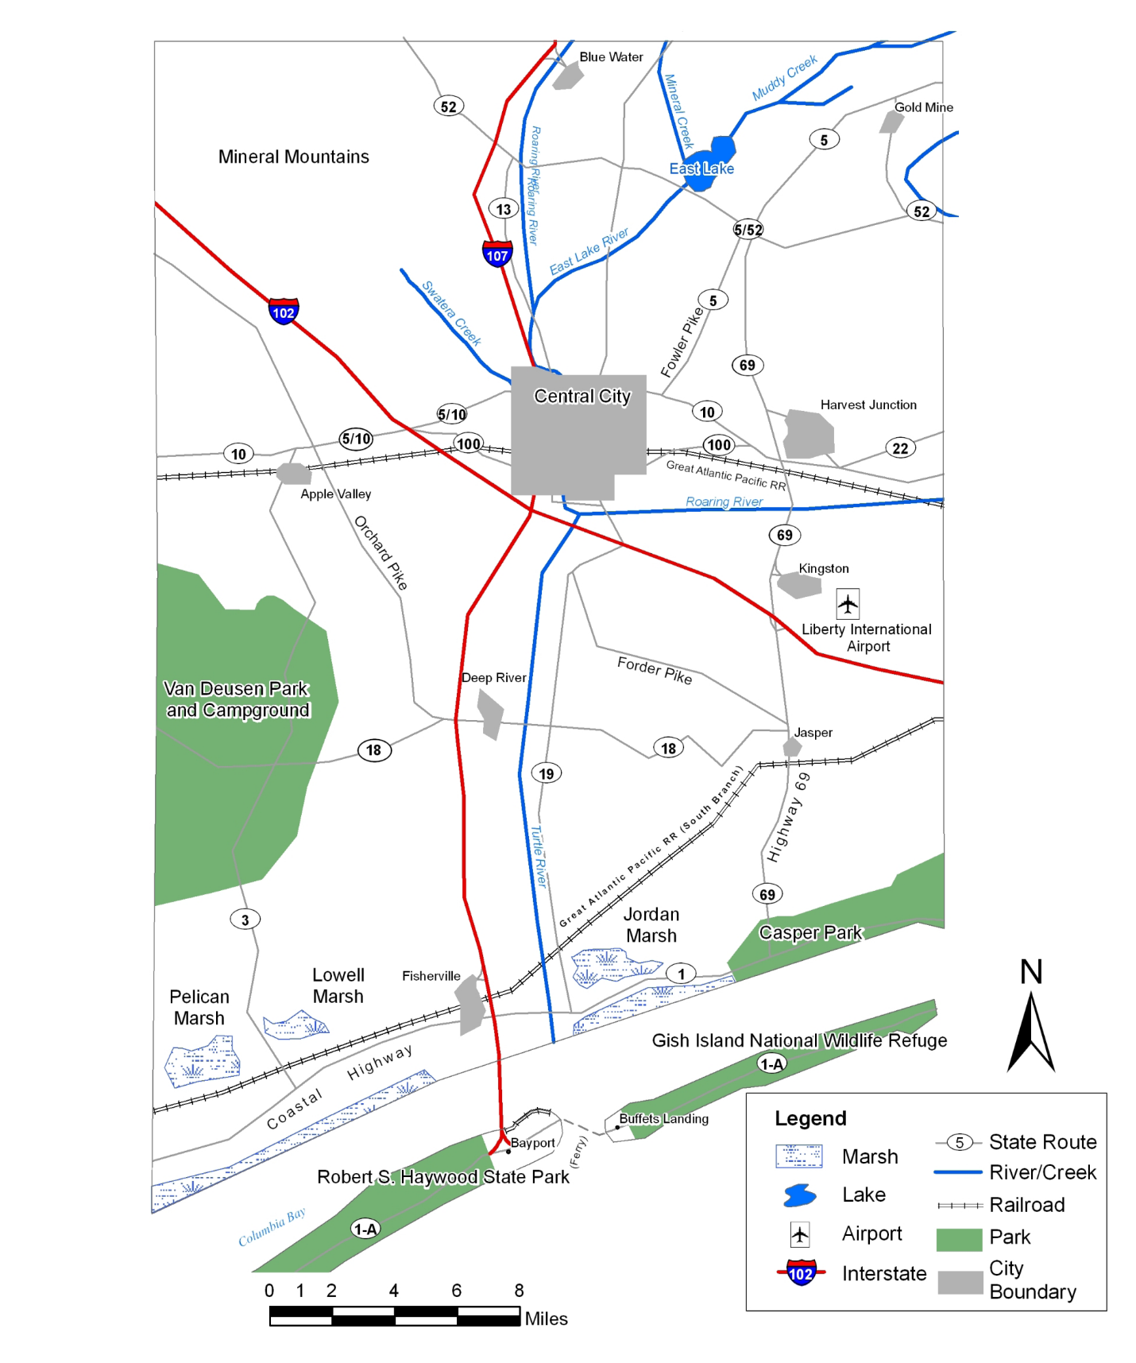

Central City Map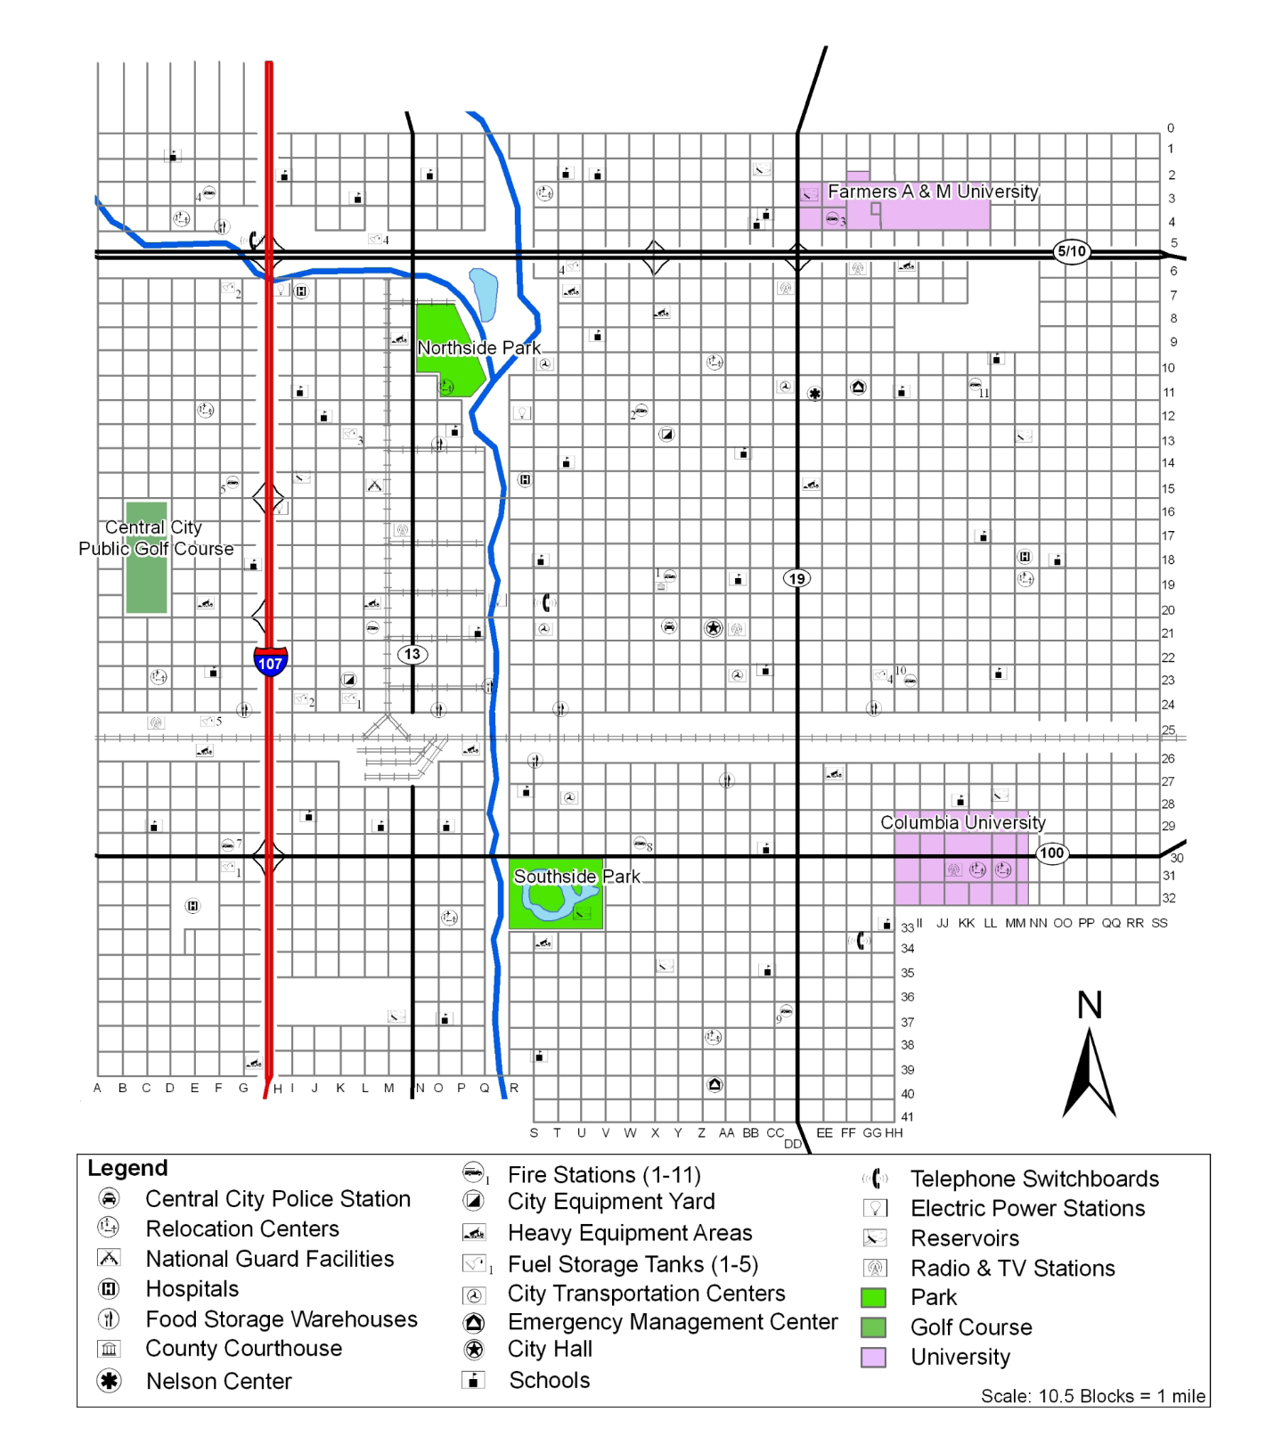

This page intentionally left blank

