**Charlotte-Mecklenburg Police Department (CMPD)**

**Freedom Division - West Service Center**

Ashley Higgins, LCMHC, LCAS – **908-403-5590**

Shannon Slauson, LMFT – **704-488-2307**

Rozelle Gipson – **980-408-8337**

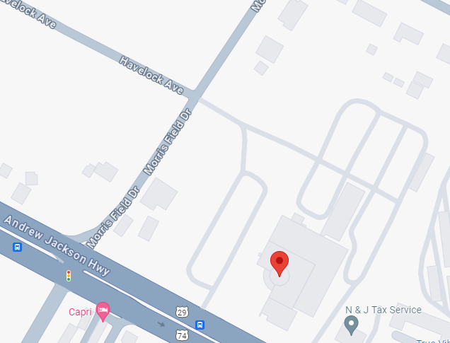

Employee access parking

Parking lot

Charlotte-Mecklenburg Police Department

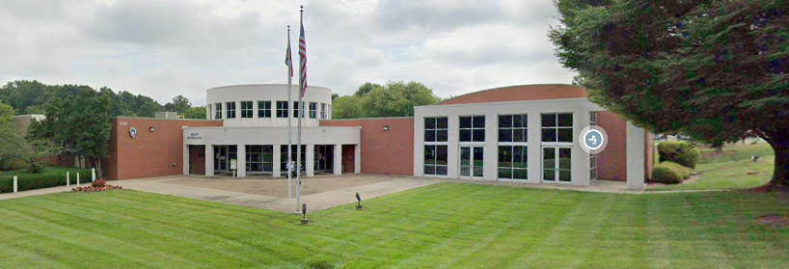

**Address: 4150 Wilkinson Blvd. Charlotte, NC 28208**

***If you need assistance call Office of Wellness main number at (704) 432-6057.***

**Parking**

* The parking lot is located on the left side of the building, indicated by a yellow star in the first photo.
* You may access the parking lot from Andrew Jackson Hwy/Wilkinson Blvd or Morris Field Dr.