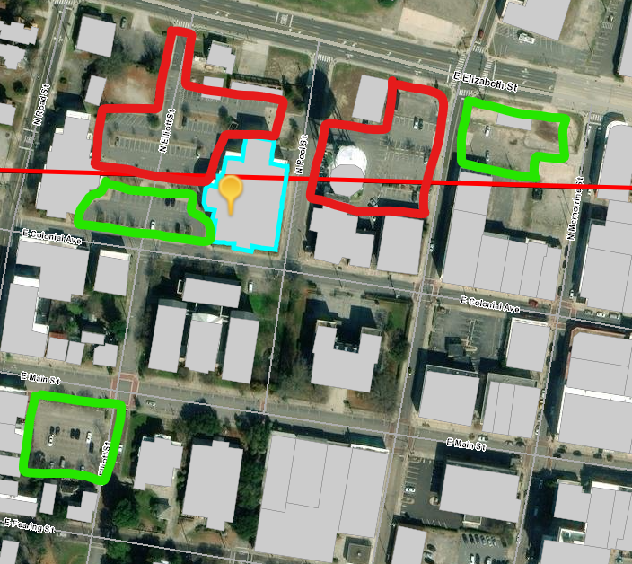**Red - Prohibited Parking Green - Available Free Parking**