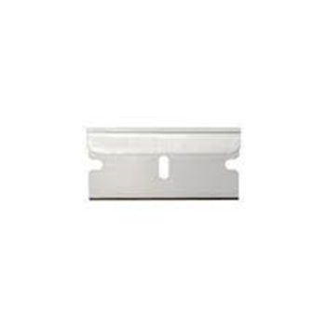
Below is clarification on some of the commonly asked questions about certain packing list items. An image is provide for reference.

- 1 Single Edge Safety Razor: this is just asking for the blade. You do not need the whole razor. This blade is the same one that you would scrape a glass stove top with or scrape the paint of a window.

- 5-10 Feet of Woven Steel Wire: One roll of picture hanging wire will work
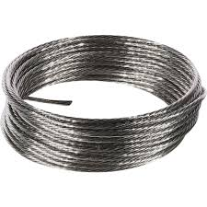

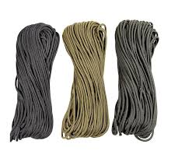
- 50 feet nylon twine or small cordage: 550 Para cord will suffice

- 1 Signaling Mirror: This can be anything that will reflect light but it must have a hole in the center to allow for aiming of the light beam.
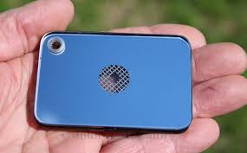

- 1 Shelter Material, 8x10 minimum: This is what you will carry as your field expedient shelter. It can be a light tarp, the rain fly off a tent or even house wrap used in construction. As long as it can shed water and provide shelter from the elements as well as meets size standards

- 1 Metal Cup or Pot: The entire thing needs to be metal and you will need a handle. This is because you will be placing it in a fire and boiling 8oz of water.
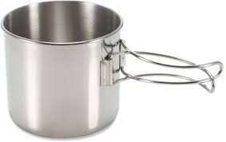

- 1 Orienteering Compass: This is a basic compass that with a clear dial that has orienting lines pointing to 0 and 180 degrees.
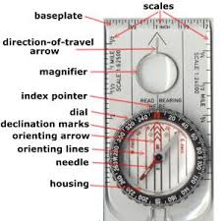
- 1 Tracking Stick, minimum of 42 inches long: The standard is an adjustable hiking pole. I have used everything from boat antennas, broom handles and tobacco sticks. This will serve a bigger purpose than just a “walking stick” and will be explained, demonstrated and learned in the class.
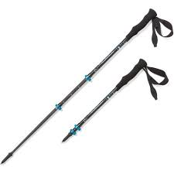

- 1 1” tubular webbing (length suitable for harness): This will be used to make an improvised harness (Swiss seat) so it must be long enough to wrap around your waits multiple times. I would recommend 15-20 feet in length. This will give you more material than you need but it’s better than not enough material.
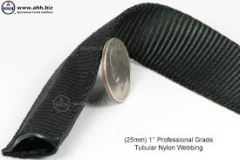
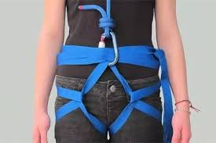

- 2 Prusick Slings (suitable for 8mm to 11mm rope): Please do not purchase the pre-made ones!!! You will be required to tie the prussic knot and will not be able to do it if you have the premade knots. Plus they end up being too short for what you will need. Please bring 7mm-8mm cord in 3’-4’ shots to be able to tie your prusick knots.
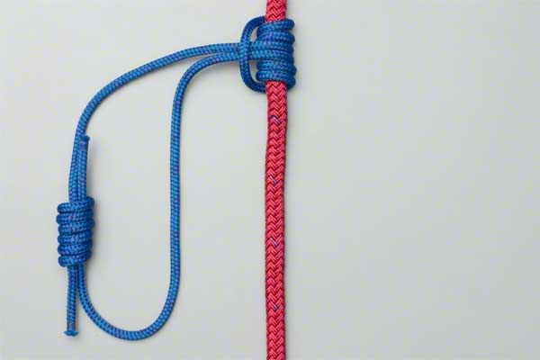

- 2 locking carabiners: These will be used to support your body weight on a rope so they must be locking and rated for climbing. These do not need to be super fancy or expensive, just functioning, lockable and rated for climbing.
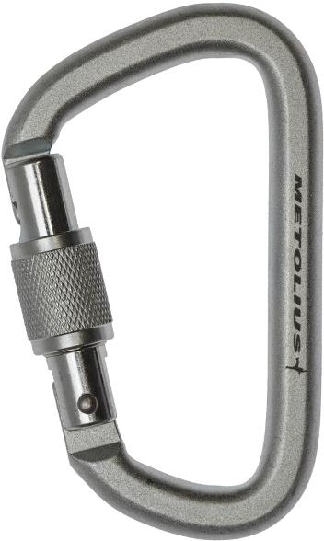

- 1:24000 scale grid reference tool: These will be used for land navigation and map reading. They can be found on amazon fairly cheap for around $4.
