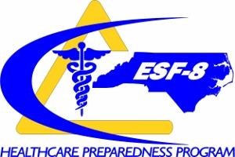
March 2022
NORTH CAROLINA HEALTHCARE PREPAREDNESS COALITION
BURN SURGE ANNEX

Table of Contents

- Introduction............................................................................................................ 3
  - Purpose ....................................................................................................3
  - Scope .................................................................................................3
  - Situations .......................................................................................3
  - Overview of the Coalition ...................................................................4, 5
  - E. Assumptions ............................................................................................6
- Concept of Operations ...........................................................................................6
  - Activation .........................................................................................6, 7
  - Notifications ................................................................................................. 7
  - Roles and Responsibilities ..........................................................................7 - 9
  - Logistics/Supplies............................................................................................ 9
  - Special Considerations...................................................................... 10 - 15
  - Transportation and Tracking ..................................................................14
  - Deactivation and Recovery..................................................................14,15
- Training and Exercises ........................................................................................... 15
- Plan Review and Approval .................................................................................... 15
- Annex Development and Maintenance …………………………………………15
- Acronyms, Definitions................................................................................ 16 - 19
- Appendix..................................................................................................... 20 - 22

I. INTRODUCTION

A. Purpose
This annex provides guidance to support a burn mass casualty incident (BMCI) in which the number and severity of burn patients exceeds the capability of HCC member facilities. The annex will identify the experts and specialized resources that exist within and external to the HCC that must be engaged in a mass burn response, and the mechanisms/processes that will be used to determine which patients go to which facilities.
The Plan incorporates the principles of conventional, contingency, and crisis care to best assign resources appropriate to the scope and magnitude of the incident, addressing triage and coordination of patient transfer, supplementing the ABA’s national preparedness efforts. When the number of burn victims and the severity of their injuries exceeds or is expected to exceed the North Carolina Burn Center resources, other facilities will be requested to surge to provide additional capacity and capability until burn care can be provided with conventional burn care resources. This Plan also includes recommendations for the stabilization and initial management of burn victims for 72 hours when immediate transfer to an ABA verified burn center is not feasible.

B. Scope
This plan is meant to describe response actions at the regional level, within the specific Healthcare coalition and is applicable to the following partners: American Burn Association (C) Verified Burn Centers, North Carolina BURN Surge Facilities, North Carolina Healthcare Preparedness Coalitions (HCCs) and North Carolina Emergency Medical Services (EMS).

Additionally, it takes into account national best practices and lessons learned while leveraging North Carolina specific strengths and weaknesses when faced with a burn surge incident.

C. Situation

- The role of the HCC - advising, coordinating and/or directly responding to the BMCI

- Local risks for BMCI (e.g., rail, industry, mass gathering, wildfire, and pipeline) – reference a hazard vulnerability assessment or jurisdictional risk assessment done for your HCC or by your local health department

- Burn resources or capabilities represented in the coalition (e.g., specialty burn centers or non-burn centers that may need to temporarily provide treatment and supportive care to some patients)

- Burn centers and resources external to the coalition that will be key partners (e.g., ABA regional coordinating center, ABA burn units, telemedicine support, wound care centers.

- Patient transport resources for inter-facility transfer

- This section may also include a comparison of healthcare facilities’ inpatient projected capacity under normal conditions and projections under surge conditions. Note that a burn center is encouraged by the American Burn Association (ABA) to have a 50% burn surge capability.

D. Overview of Coalition and Leading Burn Centers
The North Carolina Healthcare Preparedness Program (HPP) sits within the Division of Health Service Regulation’s Office of Emergency Medical Services. HPP’s mission is to partner with healthcare and emergency response organizations working to prepare for, mitigate, respond to, and recover from emergencies and disasters.

As a part of the NC HPP, there are eight Healthcare Preparedness Coalitions (HPCs) or Regions across North Carolina, each based within a lead hospital:

- Mountain Area Healthcare Preparedness Coalition (Mission Health)
- Triad Healthcare Preparedness Coalition (WFU Baptist)
- Metrolina Healthcare Preparedness Coalition (Atrium Health)
- Duke Healthcare Preparedness Coalition (Duke Health)
- Mid Carolina Regional Healthcare Preparedness Coalition (UNC Health)
- CapRAC Healthcare Preparedness Coalition (Wake Med)
- Eastern Healthcare Preparedness Coalition (Vidant Medical Center)
- Southeastern Healthcare Preparedness Region (Novant Health New Hanover Regional)

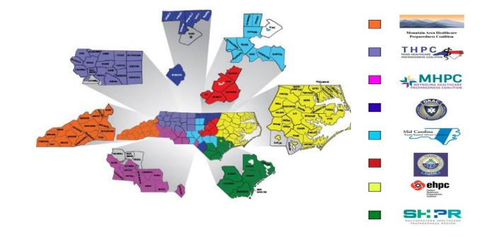
HCC Leading Hospitals

The Jaycee Burn Center at the University of North Carolina (UNC) Medical Center is one of the few in the nation that is American Burn Association verified for adult and pediatric care as well as one of the largest burn centers in the US with 36 beds comprised of 21 Burn Intensive Care (BICU) beds and 15 progressive care ward beds.

The Jaycee Burn Center will admit an average of 1600 patients annually and in coordination with the UNC Children’s Hospital, a third of those admissions are pediatric patients.

Atrium Health Wake Forest Baptist provides optimal patient care through the skills of a multidisciplinary team. Wake Forest is ABA verified for adult and pediatric patients with 8 dedicated
ICU beds and expansion capability using Pediatric Intensive Care Unit (PICU), Trauma Intensive Care Unit (TICU), Surgical Intensive Care Unit (SICU) beds as needed and 17 dedicated step-down med-surge beds with ability to expand throughout the hospital for med surge needs as available.

The Birmingham Regional Emergency Medical Services System (BREMSS) at the University of Alabama serves as the Southern regional Coordination Center (SRCC).

Burn Centers have surge plans to create additional bed capacity by converting existing and available intensive care unit (ICU) beds to burn patient care beds. Some existing non-burn ICU patients may also be transferred to Level I or Level II hospitals for ongoing care to make room for burn victims.

Each HPC includes representation from all jurisdictions of emergency response organizations, to include Hospitals, Emergency Medical Services, Emergency Management, Fire, Rescue, Law Enforcement, Public Health, Dialysis Centers, Long-Term and Continual Care Facilities, Home
Health & Hospice Agencies, Durable Medical Equipment Agencies, Pharmacies, ancillary Healthcare organizations, Volunteer Organizations Active in Disasters (VOADs), and other relevant members.

Each of these HPCs have similar responsibilities during a BURN Surge Response.
  - Provide situational awareness and information sharing to the Coalition and State partners
  - Support continuity of operations
  - Augment medical surge
  - Coordinate healthcare resource allocation
North Carolina has licensed acute care hospitals, many of which are part of larger healthcare systems which include hospitals, urgent care centers, specialty transport entities, physician offices, home health & hospice, skilled nursing facilities etc. Healthcare systems and hospitals have well-developed surge plans and crisis-standards process plans that allow them to manage significant medical surge incidents without any external support.

E. Assumptions
- That all hospitals providing emergency care may receive burn patients and should be able to provide initial assessment and stabilization.
- That agencies - EMS, HCCs, Public Health, and Emergency management within the jurisdiction will have primary responsibility for response including initial casualty distribution and subsequent triage of patients for forward movement.
- State Public Health, Emergency Management or facilities that will have primary responsibility for support of the emergency response will coordinate transfers with the closest burn center/ABA regional coordinating facility in accordance with established regional protocols.
- Burn centers and Level 1 and Level 2 trauma centers should plan for a major role in the receipt and care of burn patients and understand their role in a BMCI in their community or state.
- Care of critical burns is extremely resource-intensive and requires specialized staff, expert advice, and critical care transportation assets.
- Severe burn patients often become clinically unstable within 24 hours of injury, complicating transfer plans after this time frame.
- Federal resources (e.g., ambulance contracts, National Disaster Medical System teams), though potentially available to assist, cannot be relied upon to mobilize and deploy for the first 72 hours.

II. CONCEPT OF OPERATIONS

A. Activation
The NC HCC will mobilize according to the HCC Base Plan with the following specific considerations:

To establish situational awareness, HCC’s should confirm the nature of the incident, obtain location of incident, obtain the projected number of patients and confirm that the number of burn patients will challenge or exceed the usual burn capacity.

- Local receiving facilities may notify HCC to assist with coordination and resource sharing as needed.
- If local response agencies are overwhelmed, HCC will coordinate with medical facilities and transport agencies) to help inform in-state patient distribution and resource coordination. Use of in-state Burn Center(s) may be coordinated through this level of response, if not already involved.
- If out of state assistance for patient care, burn bed availability, and/or resources is required, the Southern Regions Burn Coordination Center may be activated. The NC HPP, HCC will maintain situational awareness.

  - To request SRCC assistance contact BREMSS at 800-359-0123 and advise them of all known details of the Burn Mass Casualty Incident (BMCI).

  - The SRCC may be activated by the Burn Attending Physician (or their designee) from the local BC most directly impacted by the BMCI. It may, however, by extrinsic protocol be activated by other SRCC BCs, American Burn Association (ABA) Regional Coordinator(s), the ABA central office, the Department of Health & Human Services (DHHS) or their designee. To avoid unnecessary or redundant activation, the SRCC should NOT be activated directly by the HCC, EMS, NC Emergency Management, state Emergency Operation Center (EOC) or other local/state response agencies/personnel.
  - Upon notification the SRCC may activate the Southern Region Burn Disaster Plan, and will conduct a bed census of southern region BCs for 02, 12, 24, and 72 hour intervals.

  - If activated, the SRCC will further support and assist with regional efforts for patient triage and will coordinate requests for patient transfer between referring and receiving BCs.

B. Notification
Once a public health alert has been received by the Coalition, the Preparedness Coordinator or designee will relay appropriate information to healthcare facilities, providers, and partner agencies within the respective region. Information may be shared through several means of communication including email, situational report, SMS texting, telephone, NC VIPER and in-person delivery using multiple notifications systems such as Ready Op and the TERMS Notification system.

Information provided may include but is not limited to:
- Nature and summary of the incident including location
- Date/time of issuance of alert
- Recommended actions
- How to receive additional information
- Availability of specific resources to support the event

C. Roles and Responsibilities
Each partner agency or facility within specific NC HCC is responsible for establishing and following their own agency applicable policies and procedures in regards to triaging, treating, transferring and/or transporting patients under their care. Local organizations and agencies within the impacted jurisdiction will have primary responsibility for response, including initial triage and casualty distribution.

Primary Agencies
- NC Healthcare Coalition
- Establish the HCC to support burn surge event, either in person or virtually in response to a local or regional burn response.
- Distribution and coordination of situational awareness information to and from healthcare Organizations and Public health.
- Coordination of medical and non-medical resource needs for healthcare organizations.
- Provide communications materials and support for healthcare information and communications needs.
- Hospitals
- Provide medical care for patients during a burn surge event.
- Identify any medical or nonmedical establish resource needs.
- Provide timely situational awareness information utilizing communications systems in place
- Achieve a base level of preparedness to be able to appropriately decontaminate, manage and/or transfer patients with burn injuries including burns caused by a HAZMAT incident.
- Provide assistance to other healthcare organizations during a response in line with signed mutual aid agreements.
- Coordinate EMS transportation needs for burn surge transfers
- Non-burn centers should coordinate burn patient transfers with the burn centers utilizing their transfer centers.
- Local Health Districts (Public Health)
- Notify the Regions Public Health, Office of Emergency Preparedness Coordinator
- Share incident information with NC Department of Health.
- Support localities by sharing information from the HCC to local EOCs, local health districts, and other public safety stakeholder
- Local Emergency Management
- The HCC will work with local emergency management on behalf of the local healthcare system to coordinate any non-medical resource request and unmet needs.
- Other Primary Agencies (may include)
- Private EMS, Local Law Enforcement, Community Based Organizations such as the Red Cross, Blood banks, Department of Health and Human Resources

All plans and strategies implemented within the HCC should reinforce that events begin and end locally, that assets and resources should be employed under that premise. In accordance with the strategic approach outlined in the current Coalition Preparedness Plan, events and occurrences would be escalated from a local origin, to the Coalition and to the HPP Shift Duty Officer at the state-level. Review further coordination outlined in applicable State plans.

In consideration of events impacting specialty care such as pediatric or burns, escalation of notifications should be made at the earliest possible time in order to engage specialty services such as specialty care transport units both air and ground, trauma and tertiary care centers, neonatal intensive care units, etc.

D. Logistics/Supplies
As with plans; supplies and equipment are maintained at the most local level as feasible to meet the needs of Coalition partners. The location, capability, status of supplies and equipment should be tracked electronically to the extent possible. NIMS standards for common terminology and resource typing should be implemented to the extent possible, and capability-based mission ready packages are developed when appropriate in order to expediently facilitate responses to mutual aid requests.

While there are no burn-specific supply caches maintained at the state level, each of the state’s verified burn centers should maintain supply-chain relationships with their respective distributors in the event that additional supplies need to be ordered quickly. Regional HCC warehouses may be utilized to receive, store and disseminate these supplies if logistics support is needed.

The Coalition may also provide temporary equipment, shelters, beds/cots, other infrastructure as well as staffing support should the need arise.

- Space

Hospitals should be prepared to receive and treat burn patients during a surge event either in designated emergency treatment areas or in alternate settings in accordance with existing facility surge plans. Spaces conducive to burn care should be identified by each facility and can be further categorized:

- Conventional spaces: Areas where such care is normally provided (e.g., treatment space inside a hospital or physician office space)

- Contingency spaces: Areas where care could be provided at a level functionally equivalent to usual care (adult rooms used as burn rooms, closed units)

- Crisis spaces: Areas where sufficient care could be provided when usual resources are overwhelmed (this might involve non-burn providers and/or ambulatory care burn providers supervising inpatient care, temporary intensive care/ventilator support for patients who cannot be moved, or alternative space.

- Staff
Augment staff as needed in accordance with surge plan of facility. Initiate treatment for burn patients to include identification of injury severity, airway security, and fluid resuscitation, prevention of hypothermia, surgical planning and pain control. Providing just-in-time training to Staff at non-burn center hospitals will be beneficial in areas such as symptoms or signs of inhalational injury, accurate burn measurements, fluid resuscitation and wound care at burn site.

E. Special Considerations
All partner EMS agencies and hospitals of the HCC maintain 24-hour emergency services capable of managing emergent burn patients. Consideration should always be given to utilizing the closest most appropriate facility. Special consideration should be given to consultation and collaboration with specialty care facilities throughout the course of preparedness, response, and recovery planning as the sharing of best practices aligns with the overarching strategy of healthcare coalitions.

- Operations- Medical Care
Secondary triage of patients to an appropriate center for continued care will be critical. This function may have to be delegated to burn experts outside the immediately affected area, due to competing demands for direct patient care and based on available resources within the coalition. Additionally, triage decisions about expectant management for patients with catastrophic burns will require expert input. Additional Resources: Burn care in disaster and other austere settings.

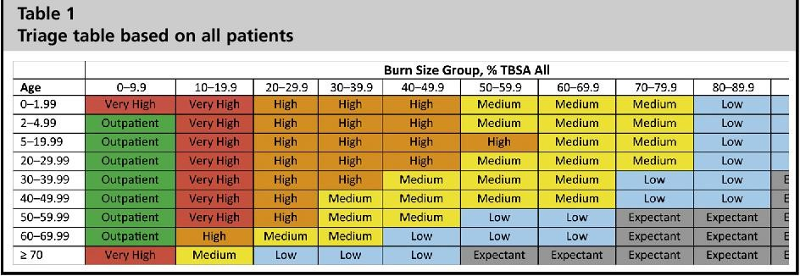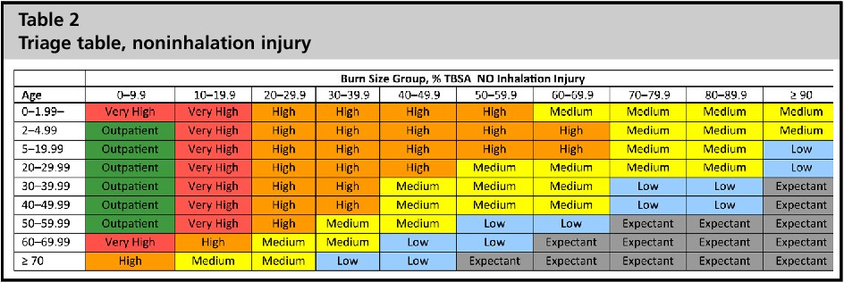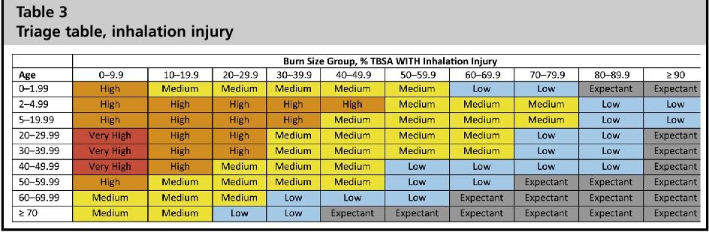

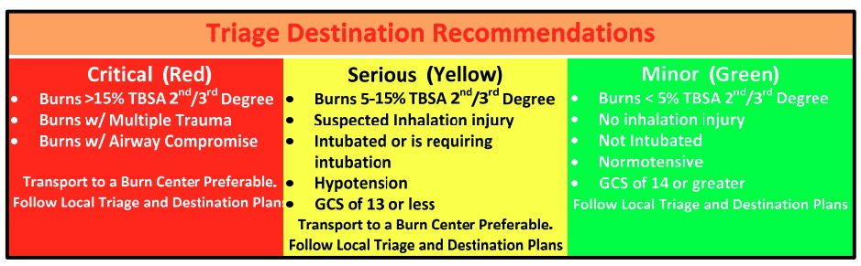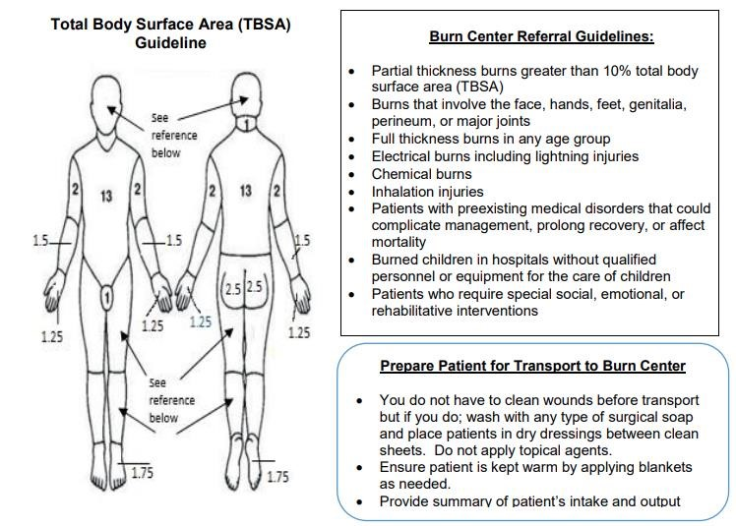

North Carolina Jaycee Burn Center

• Pediatric
Pediatric, especially children under 5 years of age, are at risk during a burn Surge event of psychological and severe physical consequences. Because children are not likely to be able to protect themselves from a burn incident without an adult assisting them, they are at severe risk of suffering an injury or illness.

HCCs should:
- Continue to coordinate with hospital, community, state, and federal disaster planning agencies
- Review Burn Centers Pediatric capability for resource sharing and transportation guidance.

Pediatric patients should receive priority in terms of transportation to in-state burn centers

In order to effectively plan for the care of critically ill and injured pediatric patients during a burn surge event, the healthcare system should ensure they have a baseline level of readiness to treat any pediatric patient injury.

EMS agencies utilize JumpStart for Pediatric patients. See the US Department of Health & Human
Services (DHHS) Pediatric triage JumpStart illustration below

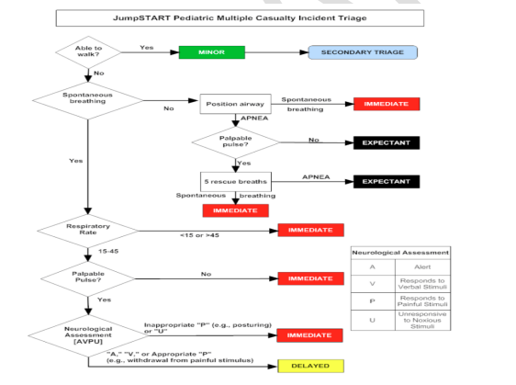

https://chemm.hhs.gov/startpediatric.htm#illustration

- Behavioral Health
Behavioral health is an important aspect of treatment for burn patients. Healthcare facilities are strongly recommended to offer burn survivor support to affected patients. Telemedicine resources should be included in the individual facility plans along with considerations for patient access to a continuum of stepped-care mental health services. This section also includes mental health services for the providers and caregivers. See below list for some resources.

Survivor support has been identified as the most important factor in psychological recovery from burn trauma. Trained volunteers should coordinate with the healthcare facility to provide their assistance and support. Peer supporter teams should work with the professional aftercare staff as well as the department of volunteer services at UNC Health Care to enhance what the Burn Team does on an individual basis. Learn more about behavioral health psychological recovery below:

- Peer Support/SOAR Program
- Center for the Study of Traumatic Stress
- Disaster Behavioral Health
- Recovery and Reintegration for Healthcare Workers
Survivor Events
Currently, North Carolina Jaycee Burn Center offers the following events
- Adult Retreat
- Burn Survivor Reunion
- Camp Celebrate
- Family Camp
- Teen Adventure Weekend

- Combined Injury
Combined injury (i.e., burns with trauma, radiation or chemical injuries) markedly increases mortality and these patients may be better served at trauma and other centers depending on the severity of each injury.

Consider decontamination strategies considering chemical agents that are involved. Initial triage by EMS should always focus on traditional trauma triage guidelines when trauma is present; and secondary triage providers will need to consider the combined injury.

ABA Guidelines for Burn Care Under Austere Conditions: Special Etiologies: Blast, Radiation, and Chemical Injury

F. Transportation and Tracking

Safe and effective prioritization methods should be developed for inter-facility specialty transport of both stable and potentially unstable burn patients. Hospitals needing to transfer burn patients to a Burn or Trauma Center shall employ their normal EMS transport contracts. Many hospitals in the region utilize the same vendors for interfaculty transports. During a large incident, numerous hospitals may all be trying to access the same pool of surge transport capability to include regional resources for ground and air transport for movement of seriously burned patients. Communication during transport is critical.

- Local: The Hospital Emergency Manager (HEM) of the primary effected BURN Center will communicate and coordinate with the transportation of patients to be transferred. The HEM should ensure that appropriate measures are taken so that local EMS transport resources are not overused. The HEM will coordinated with local and state Emergency Management to activate alternative transport means as needed.

- Coalition: If local response agencies are overwhelmed, HCC will assist with the coordination between medical facilities and transport agencies, relaying information to the patient coordination center. Use of in-state Burn Center(s) may be coordinated through this level of response, if not already involved.

- Statewide: If coalition resources are overwhelmed, the HPP, in coordination with the State Burn Centers, will activate appropriate patient movement plans to assist with in-state patient distribution and coordinate the movement of other burn surge resources between coalitions

- Regional (Southeastern, Multi-state): The SRCC will further support and assist with regional efforts for patient triage and will coordinate requests for patient transfer between referring and receiving BCs.

In addition, The North Carolina Air-medical Association (NCAA) supports the advancement of critical care transport through quality, safety and collaboration.

G. Deactivation and Recovery

The HCC will assist with determining when a burn mass casualty incident has concluded, in collaboration with local, state, regional and federal partners. Triggers that would indicate the need for deactivation include decreasing patient volumes and hospital staffing and supplies are at or near normal levels.

The NC HCC will demobilize when these triggers occur, and when there is no longer a need for coordinated burn-specific activities. The NC HCC will initiate the After Action process, soliciting and compiling analysis feedback from all responding agencies. Identified gaps and areas of strengths will be noted in an After Action Report, distributed to all pertinent agencies and partners. Changes to plans and procedures, including this document, will be based off of identified gaps. The NC HCC will also support responding agencies with development of FEMA reimbursement packets as applicable.
- TRAINING AND EXERCISES
Training and exercise priorities will be established annually and outlined in a Multiyear Training and Exercise Plan (MYTEP). Training and exercise activities will be coordinated to provide maximum availability and participation, while minimizing the effort, expense, or other potential barriers for Coalition partners.

Advance Burn Life Support (ABLS) Provider Certification is recommended, at minimum, for Burn
Center staff, ED and Trauma Surgery providers at Level I Trauma Centers, and for Prehospital ALS
Providers. ABLS Provider Certification courses may be scheduled through the ABA’s Southern Region ABLS Coordinator, the Atrium Wake Forest Baptist Burn Center, or the UNC Jaycee Burn Center.
- PLAN REVIEW AND APPROVAL
This Plan is to be revised as needed, reviewed, and approved annually by the Healthcare Preparedness Executive Committee.
- ANNEX DEVELOPMENT AND MAINTENANCE
Each Coalition is responsible for the development of specific standard operating guidelines in support of this annex. This annex should be exercised in coordination with HPP guidance in lieu of actual response. Maintenance, as required, of the general sections of this annex will be done by consensus of all Coalition Healthcare Preparedness Coordinators. The Coalitions’ collective leadership will have authority to make changes as needed to ensure this annex remains functional, efficient, and meets its objectives as outlined. However, maintenance to the Coalition-specific sections of the annex is the responsibility of the respective Coalition Healthcare Preparedness Coordinator.
This annex will be reviewed annually and revised as needed based on after-action reviews of actual incidents or exercises. The Coalition Healthcare Preparedness Coordinator directs the development and annual review of this annex by all Coalition representatives and will coordinate necessary revision efforts. This will include a critique of the actions taken in support of the annex following any event requiring its implementation.

- ACRONYMS AND DEFINITIONS
ABA | ABA American Burn Association
ASPR | ASPR Assistant Secretary for Preparedness and Response
BMCI | BMCI Burn Mass Casualty Incident
DHHS/HHS | DHHS/HHS Department of Health and Human Services
EM | EM Emergency Management
EMS | EMS Emergency Medical Services
ESF8# | ESF8# Emergency Support Function – Health & Medical
FEMA | FEMA Federal Emergency Management Agency
HEM | HEM Hospital Emergency Manager
HCC | HCC Healthcare Coalition Coordinator
ICS | ICS Incident Command System
Jumpstart | JumpStart Pediatric START Triage Tool
MCI | MCI Mass Casualty Incident
NCAA | NCAA North Carolina Air-Medical Association
PH | PH Public Health
PICU | PICU Pediatric Intensive Care Unit
PPE | PPE Personal Protective Equipment
SRCC | Southern Regional Coordination Center
TRACIE | Technical Resource, Assistance Center & Information Exchange

Burn Medical Disaster
In North Carolina a Burn Medical Disaster is defined by having 6 or more burn injured patients with more than 5 percent 2nd or 3rd degree burn.

Conventional Surge Capacity for a Burn Disaster
Relies on the spaces, staff and supplies within a given ED providing care during an MCI, triggers facility EOP, and may require staff to manage some burn injured patients up to 6 hrs with existing staff and existing SPE. Standard of Care is maintained.

Contingency Surge Capacity
The spaces, staff, and supplies used are not consistent with daily practices but maintain or have minimal impact on usual patient care practices. These spaces or practices may be used temporarily during a major mass casualty incident or on a more sustained basis during a disaster (when the demands of the incident exceed community resources).

Contingency Surge Capacity for a Burn Disaster
Relies on the spaces, both within the ED and designated areas within the facility. It relies on staff who are appropriately credentialed but do not routinely manage patients with injuries of this nature and relies on SPE that may be marginally sufficient from on hand stock or available through a rapid deployment from a SMAT II for a period of 6‐24 hrs. Standard of care is maintained but could be only marginally sufficient.

Crisis Surge Capacity
Adaptive spaces, staff and supplies are not consistent with usual standards of care but provide sufficiency of care in the setting of a catastrophic disaster (i.e. Provide the best possible care to patients given the circumstances and resources available.)

Crisis Surge Capacity for a Burn Disaster
Relies on adaptive spaces such as rapidly deployed tents in the parking area, or adjacent
Buildings, relies on staff, mutual aid personnel and volunteers who may or may not be
Routinely credentialed to manage patients with injuries of this nature, relies on SPE from on hand stock, rapidly deployed stock from a SMAT II or other state/federal resources, and still may not initially meet the needs for a period of 24‐120 hours. (Depending on the event, it could extend beyond 120 hours). Some care during this period will be provided outside the typical Standard of Care.

Crisis Standard of Care
This is a standard of care used when the medical needs outstrip the available resources, and the focus changes from appropriate individual care to care that is most appropriate for the group

Conventional Surge Capacity
The spaces, staff and supplies used are consistent with daily practices within the institution. These spaces and practices are used during an MCI that triggers activation of the facility EOP.

NCOEMS, North Carolina Office of Emergency Medical Services – A division of the NC Department of
Health and Human Services, NCOEMS is charged with the responsibility of fostering and oversight of Emergency Medical Systems as well as credentialing emergency medical services personnel within the state of North Carolina.
NIMS, National Incident Management System – A guides for all levels of government, nongovernmental organizations and the private sector to work together to prevent, protect against, mitigate, respond to and recover from incidents. NIMS provides stakeholders across the whole community with the shared vocabulary, systems, and processes to successfully deliver the capabilities described in the National Preparedness System. NIMS defines operational systems that guide how personnel work together during incidents. (Source – fema.gov)

Mass Burn Casualty Disaster
Any catastrophic event in which the number of burn victims exceeds the capacity of the local burn center to provide optimal burn care. Capacity includes availability of: burn beds, burn surgeons, burn nurses, other support staff, operating rooms, equipment, supplies, and related resources.

Primary Triage
Primary triage is triage which occurs at the disaster scene or at the emergency room of the first receiving hospital. Primary triage should be handled according to local and state mass casualty disaster plans. Under the federal bioterrorism legislation and the implementation actions of the Health Resources and Services Agency (HRSA) of HHS, state disaster plans must incorporate burn centers into such plans.

PHEP, Public Health Emergency Preparedness - The Public Health Emergency Preparedness (PHEP) cooperative agreement is a critical source of funding for state, local, and territorial public health departments. The program helps health departments build and strengthen their abilities to effectively respond to a range of public health threats, including infectious diseases, natural disasters, and biological, chemical, nuclear, and radiological events. (Source – cdc.gov)

RRT, Regional Response Team - The NC Hazardous Materials Regional Response program is a system of seven teams strategically located in the state to provide hazardous materials response services to the citizens of North Carolina. The RRTs are available to respond whenever an incident exceeds local capabilities with technical support, manpower, specialized equipment and/or supplies.

SERT, State Emergency Response Team - State and federal agencies, nonprofit relief organizations, faith-based organizations and some private sector companies working to protect the people of North Carolina under the command of the SERT leader, the North Carolina Emergency Management Director.

SMAT, State Medical Assistance Team - A multidisciplinary volunteer team of medical and non-medical professionals established to provide medical support for short- and long-term disasters or catastrophic events. Roles in which the SMAT can provide support include set up and provision of a mobile treatment facility, regional and state logistics support, and community alternate care site support.

SMSS, State Medical Support Shelter – Managed by the NC Office of Emergency Medical Services, the SMSS is established to provide medical care and support for sheltering of disaster victims when general population shelters are not capable of providing for their needs. (Source - nchpp.com)

Surge Capacity
Surge capacity is the capacity to handle up to 50% more than the normal number of burn Patients when there is a disaster. Normal capacity will be different for each burn center, may be seasonal, and will vary from week to week or possibly even day to day.

Secondary Triage
Secondary triage is the transfer of burn patients from one burn center to another burn center upon reaching surge capacity. Secondary triage policy should be put in place at every burn center, with formal written transfer agreements in place.

Southern Region Coordination Center, Southern Region – one of five American Burn Association-designated regions. Refer

TRACIE - Technical Resources, Assistance Center, and Information Exchange (TRACIE) was created to meet the information and technical assistance needs of regional ASPR staff, healthcare preparedness coalitions, healthcare entities, healthcare providers, emergency managers, public health practitioners, and others working in disaster medicine, healthcare system preparedness, and public health emergency preparedness.

WHO, World Health Organization - The directing and coordinating authority on international health within the United Nations system. (Source - who.int)
Southern Region – one of five American Burn Association-designated regions. Refer www.ameriburn.org homepage for a map of all regions.

VII. Appendix

REFERENCES AND RESOURCES
This appendix should include relevant baseline or just-in-time training to support burn surge care evaluation and exercise plan for burn surge.

ASPR Tracie Burn Annex Technical Resource
https://asprtracie.hhs.gov/technical-resources/resource/2294/burn-surge-annex

American Trauma Society
www.amtrauma.org

Understanding Burn Care
http://brc.iaff.org/prevention---education.html

UNC North Carolina Jaycee Burn Center
https://www.med.unc.edu/surgery/burn/wp-content/uploads/sites/679/2018/05/info-foremergency-personnel.pdf

Health.Mil
https://health.mil/Training-Center/US-Army-Institute-of-Surgical-Research/Burn-CenterEducation-Programs

Center for the Study of Traumatic Stress
https://www.cstsonline.org/assets/media/documents/CSTS_FS_Recovery_and_Reintegration
for_Healthcare_Workers_Following_COVID_19_Surges.pdf

American Burn Association
https://ameriburn.org/education/
- Education Resources
- Continuing Education- ABLS Certification

DISTRIBUTION LIST
The agencies and departments listed below have received a copy of the NC Healthcare Preparedness BURN Surge Annex and agree to the responsibilities assigned to them. The Healthcare Preparedness Coordinator for each Coalition will maintain a record of signatures and plan receipt.
NC Healthcare Coalition – BURN Surge Annex Distribution List
Agency | Person/Signatures | Date

RECORD OF CHANGES
NOTE: This should be completed upon any major changes to the Plan. Major changes include any item that changes the intended action/guidance of the plan.

DATE | Section/Page Number | Change Made | Person Completing Change

March 2022

