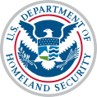

National Emergency Response and Recovery Training Center

Hosted in conjunction with DHS/FEMA National Training Program, Texas A&M Engineering Extension Service (TEEX), Texas A&M University System and the National Emergency Response and Recovery Training Center (NERRTC)

You are invited to Attend

MGT-341 Disaster Preparedness for Healthcare Organizations within the Community Infrastructure

27th and 28th of January 2022
FTCC Law Enforcement Training Center Spring Lake NC

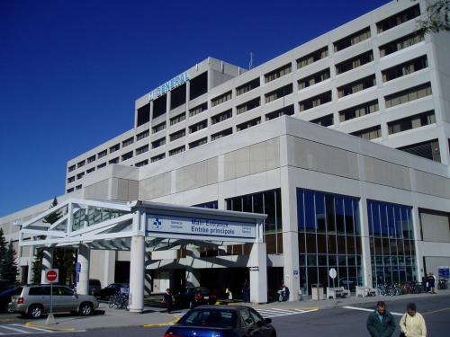
Disaster Preparedness for Hospitals and Healthcare Organizations within the Community Infrastructure: Protecting the critical infrastructure of the United States is essential to the Nation’s security, public health and safety, economic vitality, and way of life. Hospitals and healthcare organizations are part of the critical infrastructure as identified in the National Infrastructure Protection Plan (NIPP). This course brings together those individuals from the hospital and healthcare community who are responsible for ensuring the resiliency of healthcare services during a high-consequence or catastrophic event within a jurisdiction. Focusing on preparedness processes and activities, this course provides hospital and healthcare personnel an opportunity to acquire the knowledge, skills and abilities necessary to help them ensure the sustainability of their facilities and organizations during all types of disasters.

Participant Audience:
• Managers and healthcare managers/Health department personnel
• Department heads, directors, assistant directors and senior medical staff
• Regulatory personnel
• Local emergency planning directors/managers/ Emergency preparedness planning personnel
• Healthcare providers/Emergency service managers/administrators

Topics:
• Threats to the Community
• Fundamentals of Preparedness
• Preparing the Response
• Preparing the Recovery
• Assessing Your Preparedness
Registration is free! Please contact:
Name: Your name Email: Your email address
Phone: Your number Fax #: Your fax number

FEMA Student ID Requirement

Prior to course delivery, all participants are required to establish a FEMA Student Identification Number (SID). This can be accomplished by registering at FEMA’s website. Participants must complete enrollment information through the TEEX student portal MGT341.

Recommended

Participants are also encouraged to have completed IS-100PWb, IS-200, IS-700 and IS-800. These courses can be found online at: http://training.fema.gov/IS/NIMS.aspx

