**The DuPont Rescue Experience**

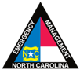

November 10th-12th 2022

Henderson / Transylvania County, NC

Sponsored By:

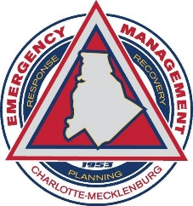****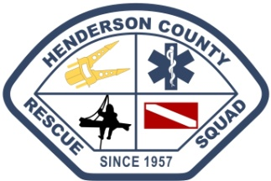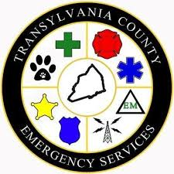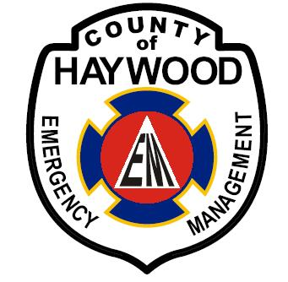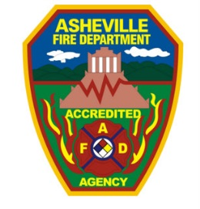

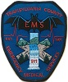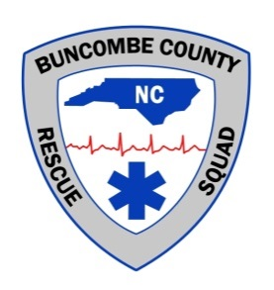

**Purpose:**

The 15th Annual DuPont Rescue Experience will simulate search and rescue operations in a wilderness environment. The Exercise will begin on Friday November 10th at 1800 and will conclude on Sunday November 12th. The exercise will be divided into four (12) hour operational periods and will be managed utilizing the National Incident Management System. Search crews, dog crews, and technical rescue teams are encouraged to participate.

**Training:**

This year the theme of the exercise is “Boots on the Ground”. The planning committee’s desire is each rescuer participate in at least one field-based mission. Training and scenarios all weekend will involve combining knowledge, skills, and abilities to overcome challenges found in the wilderness environment. Training sessions will be held throughout the weekend hosted by DuPont Rescue Experience instructors focusing on Search Management, Technical Rope Rescue, Land Navigation, Wilderness EMS, Mountain Bikes in SAR, Disaster Communications, Wilderness Survival and Incident Management. Participants are encouraged to participate in one or more of these training sessions in conjunction with ongoing search exercise operations. Updated training schedules will be available through <http://www.dupontrescue.com/> and upon check-in for the exercise.

**Special Training:**

This year the Wilderness EMS educational track will consist of a certification. The Wilderness First Aid course is designed for those individuals who spend time in the backcountry hiking and/or biking. It is designed to teach adults the proper techniques to safely administer first aid in a wilderness setting where emergency medical service (EMS) services may be delayed due to location, weather, or mode of transportation. Course Duration is a minimum of 16 hours throughout the weekend. Participants who successfully complete this track will receive a certification from First Response Training International. (Certification is valid for two years)

An incident management team made up of participants will coordinate operations for the entire weekend. This will ensure teams are assigned as quickly as possible for field work. There will be opportunities to serve in various positions within the IMT. If you would like to sign up for a position or to shadow the IMT please be sure to indicate this on your registration. If you are working towards having a position task-book signed (PTB) please indicate this at registration.

**IMT**

The incident command post will be established at Guion Farm within DuPont State Forest and will be operational 24 hours a day during the event. The intent of this exercise is to provide real world scenarios for the participant, in order to enhance his or her overall operational effectiveness.

***Be sure to register early, registration limited to the first 150 participants.***

Education:

Blue Ridge Community College will issue continuing education credits for training participation at no charge to fire, rescue, emergency medical services, emergency management, or any other agency addressed in a N.C. jurisdictional emergency operations plan. All other participants wishing to receive credits will be charged a $130 continuing education fee in addition to the exercise registration fee.

Age Requirements:

Participants age 16-18 should return a completed High School Release form with their registration. Please email [dupontrescue@gmail.com](mailto:dupontrescue@gmail.com) for the current release form.

**Accommodations:**

A limited amount of primitive camping sites are available at base camp. Overnight stays on site are not required. All meals are provided with the registration fee. *Public fire rings are provided for group use*.

**Equipment & Logistics:**

* ATV Use: ***ATV use will be limited to Utility Type Vehicles and ATVs designated as department response vehicles***, these include, but are not limited to: Gators, Mules, Rangers, Etc. Participants bringing these vehicles will attend a special training topic on Saturday before integrating into operations.
* Each discipline requires certain equipment, be sure to review this list in our Participant Guide located on our website. Each participant is required to bring their own search and rescue equipment.

Download the equipment list, directions & participant guide from our website at: <http://www.dupontrescue.com>

Also be sure to find us on Facebook for updates!

***Questions or concerns contact us at*** [***dupontrescue@gmail.com***](mailto:dupontrescue@gmail.com)

DuPont Rescue Experience 2022 Registration

**This year all registration will be done online. Payment may be made by credit card of you can bring a check with you to the exercise or mail it to:**

**Henderson County Rescue Squad**

**ATTN: DuPont Rescue Experience**

**2529 Asheville Highway**

**Hendersonville, NC 28791**

**Make checks payable to: Henderson County Rescue Squad (be sure to mark it “DUPONT”)**

When registering online please be prepared to answer the following information so our staff may plan for the appropriate scenarios and ensure adequate staff is available for safety considerations. “NA” indicates that topic or assignments may not be available. Please select one topic per period only.

***If signing up for training sessions do not sign up for Operations during the same period***

Training Classes: LN-Land Navigation

EMS–Extended Wilderness EMS

ST- Survival Training

Bike-Mountain Bikes in SAR

|  |  |  |  |  |
| --- | --- | --- | --- | --- |
| Training Sessions | LN | Bike SAR | EMS | Survival |
| Friday Night | NA |  |  | NA |
| Saturday Morning |  | NA |  |
| Saturday Afternoon | NA | NA |  |

Operational Periods: ROPES - Rope Operations (Scenarios)

IMT- Incident Management Team

SAR – Ground Search Team

IMT Participants, a follow-up survey will be sent to determine which section you wish to participate in and if you need a PTB signed.

|  |  |  |  |  |
| --- | --- | --- | --- | --- |
| Operational Periods | SAR | Ropes | IMT | Canine |
| Friday 6:30p-Until |  |  |  |  |
| Saturday 8a - 6p |  |  |  |  |
| Saturday 7p - 8a |  |  |  |  |
| Sunday 8a - 1p |  |  |  |  |

***Registration Process:***

***1-All attendees MUST Register Online at:***

<https://web.cvent.com/event/2e7e4533-62b9-413f-9d11-2f41d6871f1c/summary>

***2-All attendees MUST Register Online at NCEM TERMS for DuPont***

[***https://terms.ncem.org***](https://terms.ncem.org)

**Exercise Fee: $65.00 (Includes 6 meals\*** *(no lunch Friday)* **and shirt)**

*\*Non – NC Emergency Services or out of state members add an additional* **$130.00\***

*\*Due to the logistical complexities of this exercise the exercise staff are unable to accommodate participants with special dietary needs, a discount off the registration fee is available to reduce the fee by* **$30.00 (use discount code “meals”)**